Choosing a Location

Choosing a location within WEPS defines the physical location of the field to be simulated. This location information is then normally used within WEPS to automatically select the weather stations (Cligen and Windgen) to be used for the simulation.

State/County Selection Method
Location information is entered through the rightmost panel of the main interface screen, labeled Location (Figure Error! No text of specified style in document..1 Location information panel.). Select the country, if configured to display that input field (Note that the NRCS configured version of WEPS does not display this field and assumes the country is the United States), state (or province) and county (or parish) of interest from their respective drop-down lists by clicking the down arrow to the right of the individual fields. The centroid latitude and longitude coordinates of the county will automatically be displayed. By default, the Cligen and Windgen stations nearest to the latitude and longitude coordinates will automatically be determined, and made available in a sorted list. The nearest stations are selected and displayed by default. The Elevation field will automatically be populated with the elevation of the selected Cligen station.
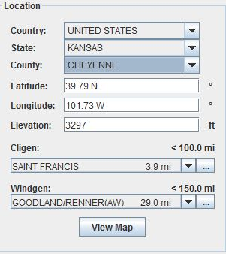
Figure 2-13 Location information panel.

Notice that the Cligen and Windgen fields display not only the station name, but also the distance from the specified lat/lon location above. By clicking on the down arrow to the right of the individual station fields, the user can override the default nearest station selection if desired. The radius range distance used for populating the nearest station lists is displayed immediately above weather station fields. There are other options available that can be used to determine the stations selected. They are accessible via the button left of the weather station fields (This button does not display if only one weather station selection option has been specified in the WEPS configuration settings). These options are discussed later in this section. Note that the default weather station selection behavior can be modified and is in fact configured differently for various WEPS versions, such as the NRCS WEPS releases. Likewise, there are configuration options that control whether the “Country”, “State” and “County” fields are displayed, or the “lat/lon” fields and even the “View Map” button. Thus, the Location panel will often appear somewhat differently than the one shown in Figure Error! No text of specified style in document..1 Location information panel. for those alternatively configured WEPS versions.

Lat/Lon Selection Method
As an alternative, the Latitude and Longitude of the location can also be directly entered, which will automatically display the country (if configured for display), state and county in which the coordinates reside and then select the nearest Cligen and Windgen stations to that latitude and longitude coordinates. Note that the hemisphere is displayed in the lat/lon fields. The “N” (northern) and “E” (eastern) hemispheres are represented as positive values and the “S” (southern) and “W” (western) hemispheres are represented as negative values when a user clicks in those fields to edit them.

Note that the default hemispheres are the Northern and Western hemispheres for the United States. If the Southern hemisphere is desired, the user should select Cligen stations and management files with appropriate operation dates for this hemisphere. Once the stations are displayed, the user can click on the down arrow next to the stations to bring up a list of nearby stations from which to choose an alternative station if desired. The search radius for the list of stations (maximum distance to all stations on the list) is listed to the right of ‘Cligen Station’ and ‘Windgen Station.’ The State and County, as well as the Longitude and Latitude, fields are optional and can be added to or removed from the interface through the ‘Display’ tab of the ‘Configuration’ panel (see the discussion on ‘Configuration’ for more details).

Map Viewer Selection Method
Another alternative method to choosing a location is by using the Map Viewer, if configured to display the View Map button. Clicking on the View Map button (as shown in Figure Error! No text of specified style in document..1 Location information panel.) will bring up a window containing a map of the world zoomed into the region centered about the currently listed lat/lon coordinates, which is highlighted as a red cross (+ sign) on the map (Figure Error! No text of specified style in document..2 WEPS Map Viewer with wind stations displayed.). The user can select any location on the map to change the lat/lon values in the Location panel on the main WEPS interface screen, by moving the mouse cursor to the desired lat/lon location (current mouse cursor lat/lon coordinates are displayed in the bottom right corner of the screen and are continuously updated when the mouse cursor is moved) on the map and double clicking the left mouse button. The Map Viewer window will automatically close and populate the Location panel lat/lon fields as well as update the Country, State and County fields as well as re- select the default Cligen and Windgen stations, if necessary.
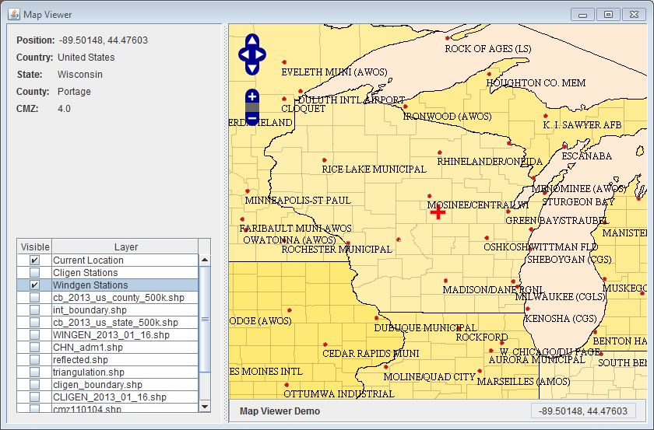
Figure 2-14 WEPS Map Viewer with wind stations displayed.

The user can move the map left, right, up and down by selecting the appropriate directional controls (4 white arrows surrounded by a blue background) at the top left of the screen. By clicking the appropriate arrows, the user can move the map in the specified direction in the window. Likewise, the user can zoom the map in or out by selecting the “+/-“ controls (+/- symbols surrounded by a blue background) that are located directly beneath the directional controls. The user may also perform these functions directly with the mouse and mouse cursor. By selecting a location within the map using the mouse cursor. By pressing and holding the right mouse button down, the user can move (drag) the map left, right, up or down within the window. By clicking the left mouse button with the cursor in the map and then scrolling the mouse wheel, the user can zoom the map in and out on the screen. The currently selected lat/lon coordinates are displayed in the upper left corner of the window and the Country, State and County, including the Crop Management Zone (CMZ) the lat/lon coordinates reside in are also displayed.

Clicking the check boxes at the left side of the Map Viewer window will enable (display) various GIS (Graphical Information System) layers on the map (Figure Error! No text of specified style in document..2 WEPS Map Viewer with wind stations displayed.). Map layers currently enabled by default are: a) world (country) borders; b) U.S. State borders; c) U.S. County borders; and d) the current lat/lon coordinates (identified by a red cross (+ sign) on the map) as listed in the Location panel on the main WEPS screen. Additional map layers available include: a) Cligen station names and locations; b) Windgen station names and locations; c) nearest Cligen station boundaries; d) Cligen polygon regions; e) Windgen polygon regions; f) Windgen interpolation region; g) Windgen triangulation lines (used for displaying station interpolation regions); and f) reflected Windgen stations (identifies location of “reflected” stations outside the interpolation region for use in interpolation calculations near the interpolation region border).

Alternative Weather Station Selection Methods
As mentioned previously, WEPS can be configured to automatically select both Cligen and Windgen stations differently than the default method specified above. All methods will be described here, including the NRCS method (last method listed), which employs several of the other methods, depending upon where the lat/lon location resides.

- Station Choice List
- This is the default method and has been explained above. Briefly, a list of stations within a specified radius of the lat/lon location is determined and sorted by distance from the lat/lon location. The nearest station in the list is displayed as the default choice, but the user has the option of overriding that selection, if desired.
- Nearest Station
- This method selects and displays the nearest station to the lat/lon location specified. No option is available to override this selection.
- File
- This method allows the user to specify a previously generated weather file (in the Cligen or Windgen format) to use rather than having the weather generators create them automatically prior to the WEPS simulation being run. This option is useful for developers and researchers if they need to use field weather data for research needs, etc. This option is not normally selected for use in typical WEPS usage.
- GIS
- This option allows GIS (Graphical Information System) map (shape) files consisting of polygon maps with stations assigned to the polygons to be used. If the lat/lon location resides within a polygon, the assigned station is selected and displayed. If the lat/lon location does not reside within a polygon region, then the weather station field will display “None Selected”. The user will not be allowed to make a WEPS run until both weather stations, Cligen and Windgen, are selected.
- Interpolated
- This option only applies to Windgen stations at this time. Based upon a specific Windgen interpolation polygon map and a corresponding “reflected” Windgen stations map, if the lat/lon location falls within an “interpolated region” polygon, then the Windgen record is interpolated from data within three nearby Windgen stations. The lat/lon location is used for the “interpolated” station’s location. Note that since Windgen generated data is dependent upon the statistical parameters in the station record, having an interpolated station that is even slightly different, e.g. even a few feet from another location will give a completely different sequence of weather (wind) data, even though, statistically, the two interpolated stations would be essentially the same. Thus, care must be taken when selecting the use of the “interpolated” mode alone. (See NRCS mode for how this issue is addressed there)
- NRCS
- This option was developed for use by NRCS and is the default, and only option, configured for “NRCS configured specific versions of WEPS. It is also the recommended mode for most other WEPS users to use in the United States as well. The NRCS mode uniquely combines several of the above listed options. Note that this mode uses the list of NRCS Windgen stations for interpolation purposes, even if the entire list of available Windgen stations has been selected for use, e.g. several WEPS configurations available in the public release.
- For Windgen only, if the lat/lon location is within an “interpolated” polygon, then an “interpolated” Windgen station is created and used. In this case, the lat/lon used for interpolation is always the “centroid” lat/lon for the specified county, which may or may not be the lat/lon specified on the main WEPS Location panel. This guarantees that the NRCS user will always get the same sequence of generated wind data in that county because it will produce the same “interpolated” Windgen record for all locations within the county. Due to sometimes big differences in Windgen station data and the relatively large distances between stations (at least compared to Cligen stations), it was deemed beneficial to use interpolation rather than the “nearest station” approach and have potentially very large differences in generated wind data occur across those nearest station boundaries. Most of the eastern half of the U.S. is currently contained in the “interpolated” polygon region. These Windgen interpolated polygon region(s) are selectable for viewing within the Map Viewer.
- If the lat/lon falls within a Cligen or Windgen polygon region, it will use the assigned station for that polygon. Most of the Cligen and Windgen polygons have been created by NRCS for use in the western U.S. due to mountains separating neighboring valleys, large elevation differences between nearby weather stations, etc. not being conducive to allowing the nearest station or interpolation selection methods to work well in these regions. These polygon regions are selectable for viewing within the Map Viewer.
- If the lat/lon location does not fall within either an “interpolated” polygon region (Windgen only) or a Windgen/Cligen polygon region, then the nearest station is automatically selected with the user having the option to override that selection from a sorted list of other nearby weather stations.

We use the term “centroid” in this document, but if the county polygon is shaped such that the true centroid is located outside the county, we adjust the coordinates such that the lat/lon displayed will always fall within the county boundary.
The NRCS Crop Management Zones (CMZs) are geographical regions within the U.S. that NRCS has defined as having common enough management practices and planting/harvesting dates to be grouped together. They have developed a series of “template” management practices by CMZ that can be used by WEPS as initial starting points when developing WEPS management rotation files.

