Choosing a Soil
Figure Error! No text of specified style in document..1 Bottom panel of the WEPS main screen with the Soil box on the bottom.

A soil for a WEPS simulation run is usually selected by using the ‘ Soil’ down arrow box on the far right side of the bottom panel of the WEPS 1.5 main screen (Figure 2.16) or by clicking on the ‘ Template’ folder to the left of the soil name. Note that the and buttons are not displayed by default for the official NRCS configured releases of WEPS.
A soil for a WEPS simulation run is typically selected from a list of soils contained in the NRCS Soil Survey Geographic (SSURGO) database via a live “NRCS Soil Data Mart” internet connection option. There are other options available though, through the “Soil Templates” subfolder with “Exercise Soils”, “NRCS Generic Soils” and optionally Microsoft Access NRCS SURRGO “.mdb” files. Note that NRCS and other users can also provide MS Access SSURGO files for use in offline (no internet access) conditions. In addition, the current WEPS “Project” folder containing previously selected soil “.ifc” soil files is also available.
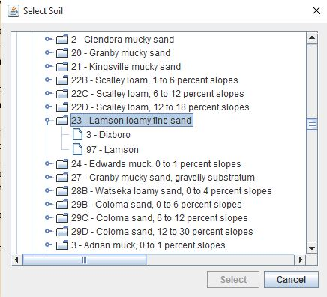
Figure Error! No text of specified style in document..2 The "Select SSURGO Soil" window.

Clicking on the ‘Template’ folder opens a window titled ‘Select SSURGO Soil’ (Figure Error! No text of specified style in document..2). Navigate through the database tree to find the soil survey area (or county) desired. Navigation is performed by clicking on the ‘key’ symbol to open the display to the next level of the tree. To close a level of the tree, click the ‘key’ symbol to close. The soil files are listed according to the soil map unit symbol, map unit name, surface texture, and local phase. Selecting a soil then displays its components and the percentage that each component contributes to the map unit. Click a soil component to highlight it and click the ‘Select’ button at the bottom of the screen (or double click the component with the left mouse button). This action converts the soil from the SSURGO database to a WEPS soil file format (with an ‘ifc’ file extension), places a copy in the current “Project” folder and returns the user to the main screen. The loaded soil file name will appear in the soil box window. Clicking the ‘Cancel’ button in the ‘Select SSURGO Soil’ window aborts the selection of a new soil.

Soils that have been previously selected or modified and saved to another name (and stored in the current “Project” folder) can be opened by clicking on the ‘ Project’ folder . This will open a window in which the user can select the desired soil or type in the soil file name.

Users have the option to view the parameters for the soil file displayed in the soil box by clicking on the button labeled ‘Soil’, on the left side of the soil box. This will open the WEPS Soil User Interface screen (Figure Error! No text of specified style in document..3).

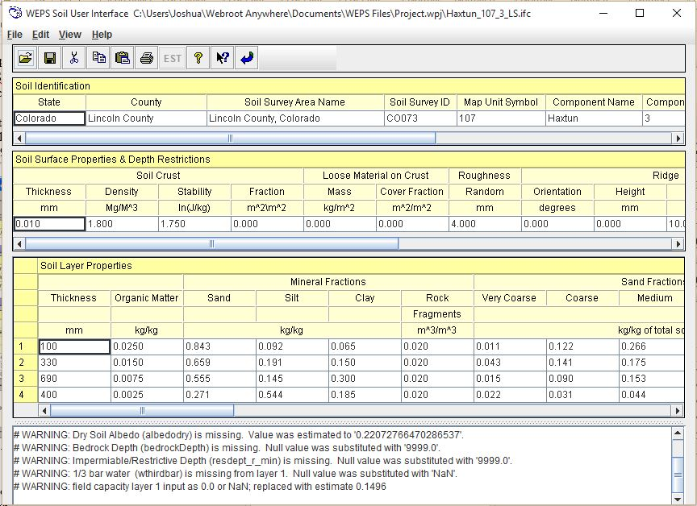
Figure Error! No text of specified style in document..3 WEPS Soil User Interface screen.

Many soil properties that affect soil wind erodibility vary with time as a result of weather and management. The parameters displayed in the Soil User Interface only represent the initial soil conditions and properties that exist prior to the first day of simulation. Beginning with the first day of simulation, the soil parameters change in response to weather and management conditions.

Soil properties greatly affect the erodibility of a field surface directly through their effects on such things as roughness and aggregate size distribution. The soil properties also affect erodibility indirectly through their effects on soil hydrology and plant growth. The Soil User Interface allows the user to view, edit (disabled for NRCS), and save the initial soil information under a new file name for the project. Users typically are discouraged from editing parameters derived from a SSURGO database file unless the user has specific knowledge of the parameter and more suitable values. A more detailed description of the soil parameters required by WEPS, as well as directions for obtaining a SSURGO database file for WEPS use, are found in Appendix 2 of the WEPS User Manual.

Users whose soils are not contained in a SSURGO database can create their own soil file by opening a new file and entering the appropriate parameters. It is recommended that in this case, the user enter the minimum set of parameters and let the Soil User Interface generate all parameter fields. The generation function is described under the Menu Bar function “View”, later in this chapter. Again, if the user has specific knowledge of the parameter and more suitable values, they may edit that value. As an alternative, the user may wish to find an existing soil file within a SSURGO database with properties similar to the soil they want to simulate with WEPS and edit any parameters that may differ.

The various functions of the WEPS Soil User Interface are described next. More detailed definitions of soil parameters and a description of how to download a SSURGO database and import it into WEPS are available in Appendix 2 of the WEPS User Manual.

Menu Bar Functions

The menu bar provides the following options:

File
This displays a drop-down list of various file options.

New Ctrl-N
Opens an empty, unnamed soil screen.

Open... Ctrl-O
Displays an “Open a Soil File” dialog box from which the user can select a soil (ifc) file from those in the current project.

Open Local BD Ctrl-L
Opens the “Select SSURGO Soil” window (Fig. 2.) to select a soil from a local database residing on your computer.

Open Remote DB Ctrl-R
Intended to access a remote database on the internet. This function is not currently working.

Save Ctrl- S
Saves the current file.
Save As... Ctrl-A
Saves the current soil file to a new name.

Print Ctrl-P
Opens a print dialog window to allow printing the soil file.

Exit Alt-F4
Exits the soil interface.

Edit
This menu displays a drop-down list of various layer editing functions.

Cut Layer Ctrl-X
Cuts a soil layer or layers and places it into the clipboard. The layer(s) (contiguous only) must be first selected by dragging the mouse while holding the left mouse button.

Copy Layer Ctrl-C
Copies a soil layer or layers and places it into the clipboard. The layer(s) (contiguous only) must be first selected by dragging the mouse while holding the left mouse button.

Paste Before Layer Ctrl-B
Pastes a soil layer or layers from the clipboard before the highlighted row.

Paste After Layer Ctrl-V
Pastes a soil layer f or layers from the clipboard after the highlighted row.

The edit functions for layers are also available by highlighting a row or set of contiguous rows then right clicking within the selected row(s) to display the edit functions.

View
This displays options for changing the parameters displayed in the Soil User Interface. Two exclusive options are available, of which only one can be chosen. Click ‘All fields’ to display on the Soil User Interface screen all the fields required by WEPS. Or, click ‘Minimum fields’ to display only the minimum input parameters required by the Soil User Interface. The minimum parameters displayed when the ‘Minimum fields’ box is checked are used by the soil interface as inputs to estimate or generate the parameters required by WEPS. These generated parameters are displayed when the ‘All fields’ box is checked. Any parameters that were adjusted because of out-of-range values, as well as the old and new values, are displayed in the Notes table at the bottom of the Soil User Interface screen.

Help
This menu displays a drop down list of help options.

Help Topics Ctrl-H
Opens a window containing the Soil User Interface online help system.

About Soil
Displays the current version of the Soil User Interface.

Button Bar Functions

The button bar provides a shortcut to some of the menu items.

Opens an existing soil file. This has the same function as selecting ‘Open’ under ‘File’ on the menu bar.

Saves the soil file being edited to the current project. This has the same function as selecting ‘Save’ under ‘File’ on the menu bar.

Cuts the row or rows of the soil file and places into the clipboard. This has the same function as selecting ‘Cut Layer’ under ‘Edit’ on the menu bar.

Copies a row or rows of the soil file and places into the clipboard. This has the same function as selecting ‘Copy Layer’ under ‘Edit’ on the menu bar.

Pastes a row or rows of the soil file from the clipboard to a row above the currently selected row. This has the same function as selecting ‘Paste Before Layer’ under ‘Edit’ on the menu bar.

Prints the soil properties currently displayed.

Opens the general help system for the Soil User Interface.

Enables context-sensitive help. Click on this button, then on any item of the screen, for help on that item.

Saves the currently displayed data and closes the Soil Users Interface.

The Soil User Interface displays data in four tables. The Soil Identification table provides information regarding the soil identification, location, and classification. The Soil Identification parameters are not critical to the operation of WEPS and are used for identification purposes only. The Soil Surface Properties & Depth Restrictions table provides information pertaining to the configuration of the soil surface in terms of crusts, roughness, albedo, slope, and rock cover. It also contains the depth to root and water restrictive layers. The Soil Layer Properties table contains soil properties by layer or horizon. At the bottom of the screen is the Soil Notes table. The user may enter any notes pertaining to the soil file. These notes are appended to the bottom of the Soil file. The Soil Notes may also contain notes generated by the interface. These generated notes specify parameters that were adjusted because of out-of-range values, and lists the old and new values. The notes are not critical to the operation of WEPS and are used for information purposes only.

Downloading Soil Data

This section describes how to download soil data from the NRCS Soil Data Mart and how to extract it for use within WEPS. A Microsoft Access database is available for importing the data in the export file. You must have Microsoft Access 97 or later installed on your PC.

Soil data for NRCS and most other users in the US, is currently available for download from the NRCS Soil Data Mart at: http://soildatamart.nrcs.usda.gov/ . Soil survey data that is exported from the Soil Data Mart is in what is referred to as “SSURGO” (Soil Survey Geographic) format. To obtain soil data for a Soil Survey Area of interest, go to the Soil Data Mart and click ‘Select State’ at the top of the Soil Data Mart screen. Select the desired state then click ‘Select Survey Area’ or ‘Select County’. Select the soil survey area, then click ‘Download Data’. On the download screen select ‘Tabular Data Only’, select the version of Microsoft Access on your computer, and enter your e-mail address, then click ‘Submit Request’. You will see a message stating “Your request has been logged. At a later time you will receive an e-mail with a link to download the export file. The format of an export file name is: soil_ssasymbol.zip, where ssasymbol is the soil survey symbol of the corresponding soil survey area.

After the export file has been copied to your PC, it must be unzipped by using either WinZip or a similar program. For additional information, please see the file named README.txt in the root directory that is created by unzipping the export file. For additional soil survey areas, each zip file should be copied and unzipped into individual directories. When an export file is unzipped, the following directory hierarchy is produced in the directory to which the export file was unzipped:

\spatial
\tabular

The top-level directory contains the following files:

soil_metadata_ssasymbol.txt - a Federal Geographic Data Committee (FGDC) metadata file in plain ASCII format.

soil_metadata_ssasymbol.xml - the same FGDC metadata file in XML format.

readme.txt - a text file containing additional information.

The root directory will also contain a zipped, empty MS Access SSURGO template database, if one was requested as part of the download. The non-extension part of the zipped template database file name varies, but if one was included, it will be the only file in the top-level directory with an extension of "zip". This file should be unzipped as well. For example, “soildb_US_2002.zip” unzips to “soildb_US_2002.mdb”.

The directory "tabular" contains any tabular data that was requested. The directory "spatial" contains any spatial data that was requested. Note that spatial data is not required nor recommended (due to large file sizes) for WEPS. It is possible to request tabular data from the Soil Data Mart without including the corresponding spatial data, and vice versa.

Tabular data is provided as a set of ASCII delimited files. Each file corresponds to a table in the SSURGO 2.1 data model. The tabular data isn't particularly useful until it has been imported into the MS Access SSURGO template database. Current Soil Data Mart downloads include a template database. The database is the “soildb_US_xxxx.zip” or the “soildb_US_xxxx.mdb” (unziped) file where “xxxx” varies depending on the version of database downloaded. If a template database was not included in the export file, you can download one from the following URL:

http://soildatamart.nrcs.usda.gov/templates.aspx

To import tabular data, load the template file into MS Access. A ‘SSURGO Import’ screen will display, asking for the full path to the tabular data directory (Figure Error! No text of specified style in document..4). Type (or cut and paste) the full path of the tabular directory and click ‘OK’. A list of database tables will appear and a folder will be created in the top level directory. The folder will have the base name (non-extension part) of the template name. At the same time, an MS Access database file (*.mdb), which contains the data required for WEPS, will be created in the template folder.

To import more than one soil survey area into a single MS Access database, run the Import macro specifying the full path to the directory the SSURGO data was unzipped into. Repeat the Import macro for each area desired. When done, save the template database with the imported data to a new name (*.mdb).
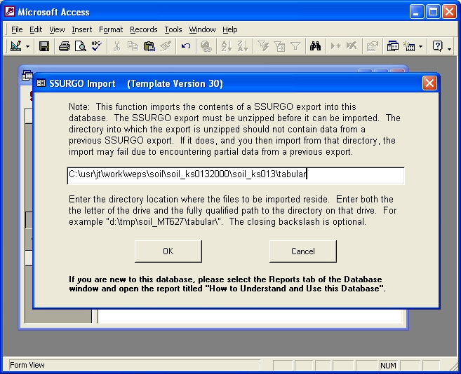
Figure Error! No text of specified style in document..4 WEPS SSURGO Import screen.

The WEPS 1.3.9 soil input file Version 1.0 extracts data from the following SSURGO data files located in the \tabular directory:

chfrags.txt
chorizon.txt
chtexgrp.txt
comp.txt
crstrcts.txt
legend.txt
mapunit.txt
muaggatt.txt
version.txt

If multiple soil survey areas are imported into a single MS Access database, the database may become very large. To reduce the size of the Access database file, one may run the Export macro and delete the SSURGO data (*.txt) files created in the tabular directory that are not listed above before importing into a template Access database.

Using SSURGO Data with WEPS

Within WEPS, open the "Configuration" window, then click the "Directories" tab. Fill out the full path and SSURGO soil database file name (*.mdb) for "Soil DB" and close the configuration window (click “Save” if you want to use that path in subsequent WEPS runs). Selecting the Soil Template folder at the bottom of the main WEPS screen will display the list of soil survey areas to choose from. Select the desired soil survey area and select the soil map unit and component for the simulation run. If the SSURGO database is not populated with data required by WEPS, you will get an error message when selecting that soil. More detailed information on selecting soils, see the “Interface Reference: Choosing a Soil” section of the WEPS User Manual.

Missing Data

In one mode of operation the Soil Interface estimates limited values if they are not populated in the SSURGO database. NRCS users must click the check box for “Do not estimate missing values from SSURGO database” under the “Miscellaneous” tab of the “Configuration” window so that these values are not estimated. If a soil database record generates an error listing missing data upon loading, contact your local NRCS office for assistance.

