Describing the Field and Barriers

One of the first tasks in beginning a new simulation is to describe the simulated field and any barriers that are present. This section describes the WEPS procedures for specifying the field geometries and barrier properties.

Simulation Run Information

Simulation information is entered in the Simulation panel on the WEPS main screen (Figure 2.3). The run-length mode determines the length and type of WEPS Run that will be simulated. There are three options for Run Mode: 1) An NRCS mode indicates that the number of simulation cycles is fixed to “50 cycles per rotation year in the selected management rotation”. This option is specified and locked (read-only) for official NRCS field use in the “NRCS configured” release of WEPS; 2) The Cycle mode indicates that the user can specify the number of simulation cycles to run (number of years to simulate for each rotation year in the selected management rotation). The larger the value specified, in general the more accurate (consistent) the simulation results will be. The default value of 50 cycles is generally considered a good compromise between accuracy and simulation runtime. The default length of run (number of cycles) is controlled through the “Run” tab in the “Configuration Settings” panel (see the discussion on “Configuration” for more details); 3) The Dates mode allows the user to specify the exact starting and ending dates for the simulation. This mode is only intended for researchers and developers for specific experimental scenarios are being evaluated. The “Dates” mode does not guarantee that the WEPS interface reports will display accurate information like the “NRCS” and “Cycle” modes do.
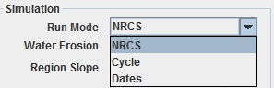
Figure 2-2 Simulation panel displaying the "Run Mode" input field.

There are additional fields in the Simulation panel besides Run Mode: a) Water Erosion; b) Region Slope with its Soil DB Value; and d) Rock Fragments with its Soil DB Value (Figure 2.4).

The Water Erosion value is required for true estimates of the Soil Quality Index, which uses both wind and water erosion estimates in its computation. The Soil Quality Index is used by NRCS as an indication of whether a particular set of management practices are improving or degrading the relative quality of the specified soil. Since the management practices are already specified as a part of the inputs required for a WEPS simulation run, NRCS requested that the index be computed as an ancillary byproduct of a wind erosion simulation. This field then, has no impact on wind erosion estimates and is not required to be properly populated for a non-NRCS WEPS simulation run.
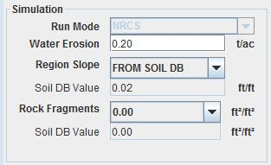
Figure 2-3 Full simulation panel display.

The Region Slope field (Figure 2.5) provides the user with the option to override the slope specified in the selected soil record (The Soil DB Value field displays the soil record value immediately below this field). The slope value is used within the WEPS model to determine the amount of rainfall and irrigation water applied that will runoff the site and not infiltrate into the soil under the surface conditions at the time. The reason this input is made available for user modification is because NRCS specifies a “typical” slope for all the soil components in their NASIS soil database. However, there is usually a range of slopes that a soil component may exist on. Providing the Region Slope field allows the user to specify a more representative slope value if the field site under simulation is significantly different than the soil record default value. The possible values are: Override Soil Slope (user specifies the specific slope value); Use Soil Slope from Soils Database; Level Basin, No Runoff (0 degree slope); Slope 0.001 (0.1%); Slope 0.01 (1%); Slope 0.02 (2%); Slope 0.03 (3%); Slope 0.04 (4%); Slope 0.05 (5%); and Slope 0.1 (10%).
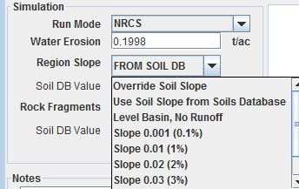
Figure 2-4 Region Slope field choices in the Simulation panel display.

The Rock Fragments field (Figure 2.6) provides the user with the option to override the surface rock fragments value specified in the selected soil record (The Soil DB Value field displays the soil record value immediately below this field). The rock fragments value is used within the WEPS model when determining the fraction of the surface considered non-erodible, which directly impacts the soil surface’s overall susceptibility to soil loss by wind erosion. The reason this input is made available for user modification is because of the known variability of the values within specific soil components listed in the NRCS NASIS soil database and the level of sensitivity to erosion estimates from this input parameter. The possible values are: Override Rock Fragments (user specifies the specific rock fragments ratio); or Use Rock Fragments from Soils Database.
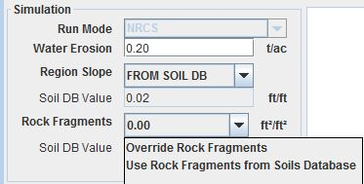
Figure 2-5 Rock Fragments field choices in the Simulation panel display.

WEPS Simulation Run Notes

If desired, each pending WEPS simulation run can be fully documented with specific user specified information into the Notes text panel on the main WEPS screen (Figure 2.7). The “Edit” button pops up a bigger display window for the user to type information into. The “Clear” button clears the Notes field of any previous run’s contents. (Note calibration values displayed in Figure 2.7 for various crops from a previous WEPS simulation run.) The WEPS simulation run Notes content is also available for post-editing after completion of the WEPS simulation run. The Notes content resides at the bottom of the last page of the WEPS Summary Report. That report provides editing functionality where the Notes content is displayed.
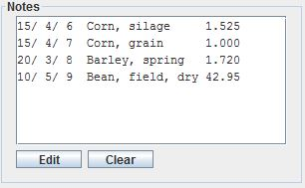
Figure 2-6 Notes panel for documenting pending WEPS simulation run information.

Client Information

Customer information for a simulation run is entered by using the upper left panel (Figure 2.8) of the WEPS main screen labeled Client Information. The Client Name as well as the Farm No, Tract No, and Field No for the simulation run can be entered by typing the information into the appropriate boxes in the panel. These four items (Client Name and Farm No, Tract No, and Field No) are for informational purposes only and are not required to conduct a WEPS simulation run. These fields and their names were provided primarily for NRCS business purposes, but any user can populate them with appropriate information to help them keep track of individual WEPS simulation runs.
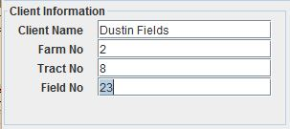
Figure 2-7 Client Information panel.

Simulation Region Information

The Simulation Region Information (Region panel) is shown in Figure 2.9. To describe the simulation region, the field dimensions are entered. For example, the X-Length and Y-Length are entered for a rectangle. Note that the area of the region will be displayed. To orient the field, simply type in the angle in degrees of deviation from north for the north/south field border and accept the value (tab or click outside the field). Note that the field will only rotate in a range of ±45 degrees. By rotating and adjusting the field length and width, the user should be able to obtain the desired size and orientation for any field.
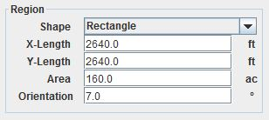
Figure 2-8 Simulation Region Information panel with rectangular field selected.

Other field shapes can be specified by clicking the down arrow to the right of the Shape box to display a list of valid field shapes. Figure 2.10 illustrates the panel entry for a circular field. To describe a circular field, either the radius or the area of the field can be specified and the other value is automatically computed. For simulation purposes within WEPS, fields that are circles or partial circles (i.e., half or quarter circle) are approximated as a square or rectangular field with an area equal to that specified in the Region panel. Field shapes that can be selected include Rectangle, Square, Circle, Half Circle VE (vertical east), Half Circle VW (vertical west), Half Circle HS (horizontal south), Half Circle HN (horizontal north), Quarter Circle NE (northeast), Quarter Circle SE (southeast), Quarter Circle SW (southwest), and quarter Circle NW (northeast). For a square, enter either the X-Length or the area. If area is entered, the field side length will be calculated and displayed. For rectangular fields enter either the X-Length and Y-Length or the area and one length. For circles or partial circles, enter the radius or the area and the other value is automatically calculated and displayed. The shape and orientation of the simulation region is displayed in the Field View and automatically updated when any of the field values are modified.
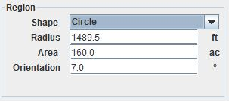
Figure 2-9 Simulation Region Information panel with circular field selected.

Special shapes or configurations such as circles and strip cropping are further discussed under the “Special Field Configurations” section of the chapter titled “Using WEPS for Conservation Planning” in the WEPS User Manual. Strip cropping is further discussed in detail in the “WEPS How To Guide” for Strip Cropping. The orientation of tillage direction is specified within the Management Crop Rotation Editor for WEPS (MCREW).

The Simulation Region must be considered carefully. The boundaries of this region are assumed to be non-erodible. This is assumed so that unknown quantities of material will not be entering from a neighboring area. Typically, stable boundaries do not allow creep and saltation sized material to pass through and include barriers or a surface at least 15 feet wide that has vegetation sufficient to stop erosion. However there are situations where one may want to simulate a field with erodible boundaries such as an area within an erodible field. In these situations the user should consult their agency’s policy for simulating such areas.

Field View

The Field View panel (Figure 2.11) is located in the center of the WEPS main screen. It is designed to give the user a view of the field size, shape, and orientation (green). The placement of any barriers present is also displayed in red. A yellow bar on the side of the field in the Field View panel indicates which side of the field has been selected for barrier placement using the radio button in the Barriers panel. This is useful for selecting field barrier placement when the field is oriented at angles close to 45 degrees. A red barrier shaded with yellow, as shown for the south barrier inFigure 2.12, indicates a selected barrier that has already been placed on the field border. Note that if the ratio of length to width of the field or barriers is too great to display to scale, this will be indicated within the panel, and an approximation of the field or barrier shape will be displayed. This panel is for viewing only and is not directly editable.
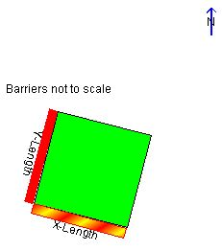
Figure 2-10 Field View panel for a rectangular field.
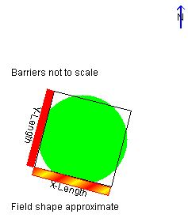
Figure 2-11 Field View panel for a circular field.

When a full, half, or quarter circle field is simulated (Figure 2.12), it is approximated within WEPS as a square or rectangular field with an area equal to that specified in the Region panel. The Field View panel displays an approximate inscribed circle (or half or quarter) within the simulated rectangular field. When a non-rectangular field is selected, the field described in the Region panel has an area equal to that of the simulated rectangular field.

Wind Barrier Information

The Wind Barrier Information (Barriers panel) (Figure 2.13) is used to add barriers to the field borders. Note that WEPS 1.5 only allows barriers on the borders of the field, not within the field. The barrier location is labeled for the side of the field on which the barrier is to be placed, such as ‘N’ for north, ‘S’ for south, ‘E’ for east, and ‘W’ for west. If the field is rotated, the location is labeled for the direction closest to one of the four cardinal directions. The barrier type can be selected from the drop-down list in the panel by clicking the down arrow to the right of the barrier type to bring up the list of available barriers and clicking on the appropriate barrier. Once a barrier type is selected, the barrier properties may be viewed and edited by clicking the Edit Selected Barrier button at the bottom of the panel. This displays a separate panel where one may enter the barrier width, height, and porosity in the appropriate fields. Note that the area of the barrier is displayed but cannot be edited. If barrier properties are modified, it will be noted in the type list with a <mod> designation before the type name. To remove a barrier from the field, click the radio button to select it (notice the barrier will be ‘highlighted’ when selected), then select the barrier type ‘None’ to remove it. To ‘deselect’ all barrier locations, click each enabled radio button to the off position. The Field View will automatically display the placement of selected barriers and highlight the currently selected barrier’s location. See the “WEPS How To Guide” for Barriers for further explanations on how to use barriers within WEPS and how to modify the barrier database. The Barriers panel is not the best way to simulate the effects of strip cropping, but it may be useful in strip cropping designs that include barriers along the strips. See the “WEPS How To Guide” for Strip Cropping for a detailed description of simulating strip cropping with WEPS 1.5.
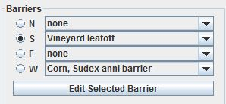
Figure 2-12 Wind Barrier Information panel.

