WEPS Interface Main Screen
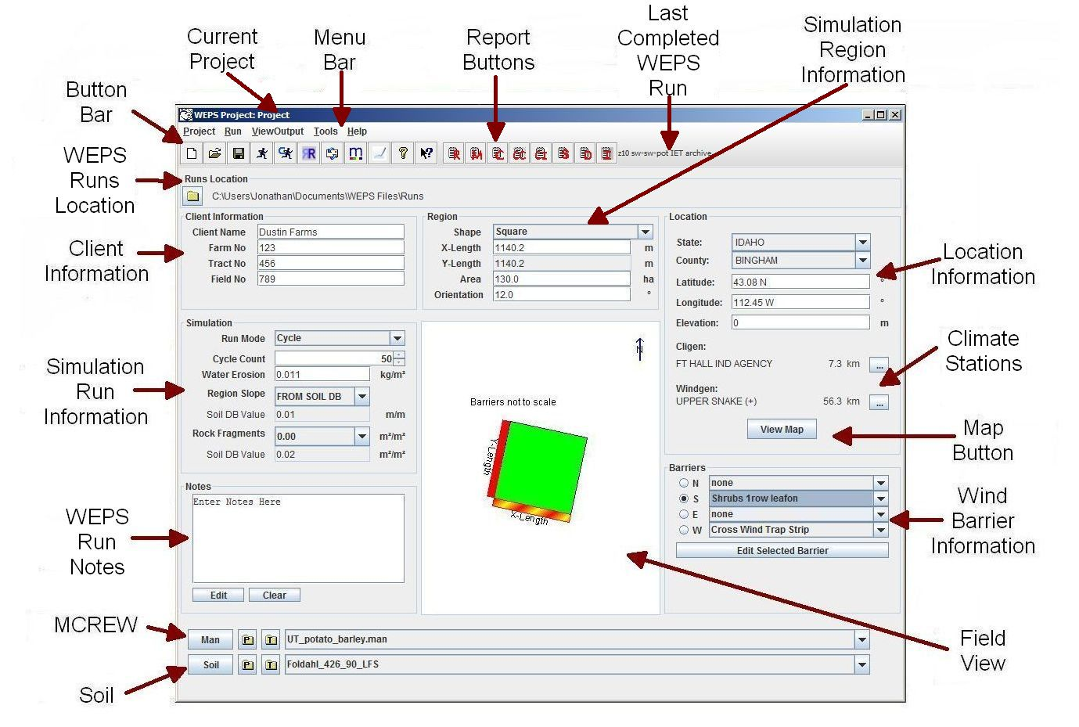
Figure 2-1 Main screen of the Wind Erosion Prediction System.

The WEPS main screen (Figure 2.1) should appear at model startup. Each part of the main screen is labeled in the Figure with regard to its function. A brief description of each part is given below. More detailed descriptions of their functions and use follow later in this chapter.

- The Button Bar and Menu Bar are collectively referred to as Toolbars. The Menu Bar provides the user with access to many of the operational functions of WEPS. The Button Bar provides a shortcut method of executing some of the Menu Bar functions.

- The Report Buttons are part of the Button Bar and provide quick access to the most commonly referred to WEPS reports. The Last Completed WEPS Run is also displayed just to the right of the last WEPS report button on the Button Bar.

- The current WEPS Runs Location (Runs Location panel) is displayed immediately below the Button Bar which lists the default directory where individual WEPS Runs are stored.

- The Client Information (Client Information panel) is used to enter customer information for a simulation run. The customer information is for information use only and is not required for the operation of WEPS.

- The Simulation Region Information (Region panel) provides the physical dimensions (i.e., shape, length and width or radius, and area) and the orientation with respect to north of the simulation field.

- The Simulation Run Information (Simulation panel) is used to enter specific information for a simulation run, as well as information regarding the run mode.

- WEPS Run Notes (Notes panel) in the lower left section of the screen is where the user can enter specific information regarding the upcoming WEPS simulation Run. These notes are retained as part of the upcoming WEPS simulation run and can also be further edited and printed from the Run Summary report after the conclusion of the WEPS simulation run.

- Access to MCREW (Management/Crop Rotation Editor for WEPS) is provided in the (Man panel) and allows for the selection, creation, and editing of management scenarios. Only one management rotation sequence is currently allowed for the WEPS simulation region.

- Access to the Soil viewer/editor is available from the (Soil panel) and is where the user can select and view the soil information for the upcoming WEPS simulation run. Only one soil is currently allowed for the WEPS simulation region.

- The Location Information (Location panel) is used to specify the location of the simulation field. This information is used to assist in determining the climate and wind stations (Climate Stations) selected for the upcoming WEPS simulation run. The Map Button (View Map button) is used to access a map viewer displaying weather and wind station locations as well as other GIS related information.

- Wind Barrier Information (Barriers panel) is where the selection and placement of wind barriers on the specified field borders is entered.

- The Field View (Field View panel) displays the physical dimensions and orientation of the field and location of wind barriers. This panel is for information only and is not directly editable. The Field View panel contents are updated automatically when information is changed in the Region and Barriers panels.

