Making a WEPS Run

WEPS Projects

A "WEPS project" is a directory that can be thought of as a working area where WEPS simulation runs are created and stored along with their outputs. A project stores all the parameters for the current simulation run being prepared within the WEPS interface, as well as any past WEPS simulation runs. For example, a particular project may represent a directory for an individual farm under which all the simulation runs for each field and management alternatives on that farm are stored. When a project is saved, all of the information contained on the current interface screen is stored in the project directory. Multiple WEPS projects can be created and given various names by the user. These directories can also be managed (i.e., renamed, deleted, or moved) with a file manager such as Windows Explorer (not provided with WEPS). One can also remove unnecessary WEPS project and WEPS run directories from within the WEPS interface via the pertinent options under the “Project” or “Run” menus. Note that known characters that are invalid in WEPS file names include: \ / < > | ? * & “ ~ ` ‘

All WEPS simulation run results are stored in subdirectories within a WEPS project directory. A WEPS run subdirectory is created every time a simulation run is made. A WEPS run subdirectory stores a copy of all input files used to make the simulation run, together with the output files generated from those inputs. Thus, one is able to reproduce the identical WEPS run at a later date (and presumably get the same outputs when using the same version of WEPS 1.3.9 and the weather generators/databases) because the original input files are still available. Typically, ‘re-running’ a previous run is not necessary since the outputs are stored in the run directory and can be reviewed via the ViewOutput menu. However, if additional outputs not generated with the original run are desired, it will be necessary to load the previous run and run using the desired output options. The run directories make it relatively easy to archive or remove WEPS runs as alternative erosion planning scenarios are tested for a field or farm. If, for example, a change is made to create a different management alternative, all the information pertaining to this new scenario will be saved to a new subdirectory under a new WEPS run name, when the simulation is made.

Working with Projects

Clicking the ‘Project’ menu item displays a list of various options pertaining to WEPS projects. These options are discussed below.

The ‘New’ menu item (same as on the button bar) allows the user to create a new project from scratch. Clicking on this menu item causes WEPS to check for any unsaved changes to the parameters displayed on the screen. If there are unsaved changes, the user is asked if they want to ‘Save current project?’. If the user clicks ‘Yes’, the current parameters are saved to the old (current) project. A file chooser then appears that allows the user to specify a name for the new WEPS project. The current WEPS interface screen is then cleared, and the newly created project becomes the current project. If the user clicks ‘No’, a file chooser opens immediately, allowing the user to name the new project to be created, and resets the parameters to the system defaults without saving any changes to the previous (current) project. In either case, the user can then proceed to build the new project by entering information on the interface screens. If the user clicks ‘Cancel’, the process of creating a new project is aborted and the screen returns to the previous project.

The ‘Open...’ menu item (same as on the button bar) opens an existing project. Clicking on this menu item causes WEPS to check for any unsaved changes to the displayed parameters. If there are unsaved changes, the user is asked if they want to ‘Save current project?’. If the user clicks ‘Yes’, the current parameters are saved to the old (current) project. A file chooser then appears that allows the user to specify the name of an existing project to open. The newly opened project becomes the current project. If the user clicks ‘No’, the old project is closed without saving any changes and a file chooser opens that allows the user to select an existing project to be re-opened. In either case, the user can then proceed to view the project information or modify the project by entering information on the interface screens. If the user clicks ‘Cancel’, the process of selecting a previous project is aborted and the screen returns to the old project. When leaving the project or WEPS, the user is asked if they want to save the current project.

The ‘Save’ menu item (same as on the button bar) saves the current WEPS project to the current project name.

‘Save As...’ allows the user to save a copy of the currently displayed WEPS project to a new name. The name must be new and cannot overwrite the name of an existing project. The user must enter a unique name. The copy then becomes the current project.

The ‘Delete Project’ and the ‘Delete Run’ menu item opens a file chooser to delete a WEPS project and run.

The ‘Delete Management Rotation File’ menu item opens a file chooser to delete a WEPS management file. The ‘Delete IFC Soil File’ item opens a file chooser to delete a WEPs soil file. ‘Exit’, exits the WEPS program.

The default project folder (i.e., directory) for these various project options, under which new projects will be created and existing projects will be opened, can be specified under the ‘Directories’ tab of the ‘Configuration’ window. Enter the default directory on the line labeled ‘Projects Dir’. By default, the last project that was open when WEPS was exited is the current project when WEPS is restarted.

Making a WEPS Run

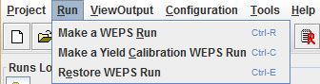
Once the desired information is entered through the interface screens, a simulation run can be started. Clicking on the ‘Run’ menu, then selecting ‘Make a WEPS Run’ (Figure 2.20), begins a WEPS simulation run. One can also click the run button on the button bar to begin a WEPS simulation run.
Figure 2.20 The Run menu of the main screen.

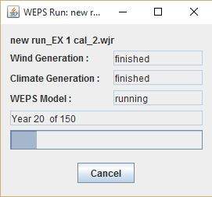
A box will appear, asking the user to “Enter a run name”. Note that some special characters are not allowed in file names. Known characters that are not allowed include ? ‘ ` & ~ / \ < > | : * ”. When a run name has been entered, the simulation begins and a window appears that shows the status and progress of the run (Figure 2.21). At the conclusion of the run, a window may appear, if warranted, displaying any warnings that have been generated. These warnings are for informational purposes and may or may not be of interest to the user. Upon completion of a run, a WEPS Run Summary report will appear for the user to review and print if desired. The Run Summary is saved in the run directory, along with more detailed output reports for later retrieval. The summary and detailed reports for a run can be viewed or created any time by the user. See the section of the WEPS User Manual titled ‘WEPS Output’ for more detailed descriptions of the WEPS output types and how to select them for viewing or printing.
Figure 2.21 WEPS run status window.

If a crop does not reach maturity, a warning will appear, indicating that the crop only reached the specified percent of the expected maturity for a given year. This warning can result from one of two causes. First, the crop variety chosen has a growing season too short for the climate being simulated. For example, a 120-day corn variety may be specified for a location that usually grows 110-day corn. In this case, a variety that matures over a longer period for that location should be chosen. If a variety of suitable length is not available in the crop drill-down list, a new variety can be created by following the method outlined in the WEPS How To Guide: Crop Database Record Development. Another cause of this warning may be that the growing season as specified by plant and harvest dates are too close together, not allowing the crop enough days to reach maturity. In this case, be sure the planting and harvest dates are correct, and adjust accordingly. If a crop is harvested before full maturity (e.g., for alfalfa or silage), a warning message will also appear.

Make a Yield Calibration WEPS Run

Differences in crop management by producers or local climate and soil variances may result in crop yields, generated by WEPS that do not reflect the actual yields observed by a producer. WEPS provides a method to “calibrate” yields and associated crop residue biomass from WEPS so that they more accurately reflect those of individual producers or a county as a whole. The following steps describe how, to make a yield calibration run.

a) Within MCREW, press the ‘Yield Calibrate’ button to display additional columns related to the crop-yield calibration function in WEPS.

b) Within MCREW, select the crop (or crops) that you want to calibrate by checking the box in the ‘Calib. Yield?’ column for the respective row the crop planting operation is in.

c) Fill in the desired ‘Target Yield’ for the selected crop(s). The yield units are displayed but not editable. The units may be changed in the Crop Drill-down window under the “Harvest” tab and the “Harvest yield conversion factor” must be adjusted to reflect the new units. Note that changing the water content requires changing the columns labeled “Yield Coef.” and “Residue Intercept” because all three parameters are interrelated. See the Crop How To Guide for more information on these parameters.

d) Save the rotation management file in MCREW. This currently can be done by: i) pressing the ‘Save’ icon , ii) via the ‘File > Save’ menu option, iii) using the ‘Ctrl-S’ keyboard shortcut, or iv) by clicking the Save and Close button , which saves the displayed data to the current file name and closes MCREW.

e) Exit MCREW. This can be done either by: i) clicking on the “Close Window” button 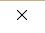 in the top right corner of the MCREW window frame or ii) via the ‘File > Exit’ menu option. Note that if one forgets to save the management file before attempting to exit MCREW, the user will be notified and given the opportunity to do so before exiting MCREW.

f) Click the ‘Make a Yield Calibration WEPS Run’ via the ‘Run’ menu bar option on the main screen (Figure 2.20) or the ‘Calibrate Run’ button on the main screen tool bar. The shortcut ‘Ctrl-C’ will also work if the main WEPS screen has focus.

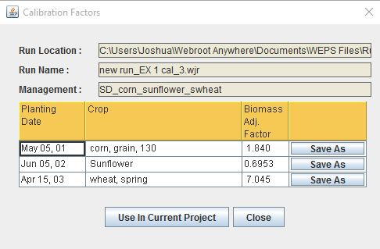
g) After the Calibration Run has completed, a popup dialog window will appear that displays the ‘Calibration Factors’ for each crop selected for calibration (see figure to the left). One may then save each crop record as a new crop by clicking the “Save As” button for each crop. The user may also use the Biomass Adjustment factor in the current project by clicking the “Use in Current Project” button at the bottom of the window. The biomass adjustment factor determined for each crop is also written into the ‘notes’ file for the calibration run.

Restore a WEPS Run

A previously created WEPS run can be restored by clicking on the ‘Run’ menu and selecting ‘Restore a WEPS Run’ (Figure 2.20). This will open a file chooser that allows the user to select a previously created WEPS run. One can also click the restore button
to restore a run. ‘Restoring a WEPS Run’ actually loads the inputs of the previous WEPS run into the WEPS interface. These inputs can be modified and a new simulation run again with a new WEPS run name. The new run will be saved into a new subdirectory; previous WEPS runs cannot be overwritten. Runs can be removed via the ‘Project>Delete Run’ menu option. It is recommended that the user remove unwanted runs regularly to prevent these runs from filling hard-disk space.

Viewing Previous Outputs

Output from either the current run or previous runs can be viewed by using the ‘ViewOutput’ menu. This menu allows the user to view output for the most recent (current) or previous runs. Clicking on the ‘Current Run’ menu item displays a list of output reports for the current (last completed WEPS simulation) run. Clicking on the ‘Previous Run’ menu item displays a list of output reports for previous runs. For previous runs, a file chooser opens to allow the user to pick the desired run for which to view the output. The “Multiple Run Manager” allows the user to open a list of previous WEPS runs. See the section of the WEPS User Manual titled ‘WEPS Output’ for more detailed description of WEPS outputs.

Errors

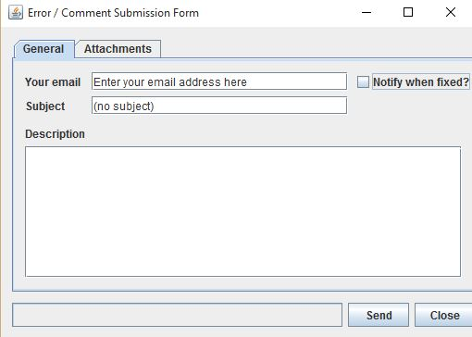
If an error occurs during a WEPS simulation run, an error message will appear. Once the error message is closed, an e-mail window opens that allows the user to report the error to USDA-ARS Wind Erosion Research Unit (Fig. 2.). The user should enter an e-mail address and a short message. Click the appropriate box at the bottom of the window to attach either the current project (with all associated run directories) or the current run files to your e-mail. One typically would only attach the run, unless there is a specific reason to attach the project and all its associated run directories. Because of the number of potential files within a project, attaching a project could create a large size attachment. Note that, by default, the project is attached to the e-mail message. If you are connected to the Internet, clicking ‘Send’ will e-mail the message to WERU, along with any attached files, so that your inquiry can be answered. Also note that the user cannot send e-mail from WEPS unless they have correctly configured the WEPS e-mail client within the ‘Configuration’ window.
Figure 2.22 E-mail error report window.

