WEPS Output

WEPS provides numerous outputs to aid the user in conservation planning. These outputs are accessed through the ‘ViewOutput’ menu on the main screen. Clicking on this menu displays two choices, ‘Current Run’ and ‘Previous Run’. Clicking on ‘Current Run’ displays a list of output options for the most recent WEPS run. The ‘Previous Run’ choice allows the user to view results of previous WEPS runs. A description of the choices under these two submenus follows.

Run Summary

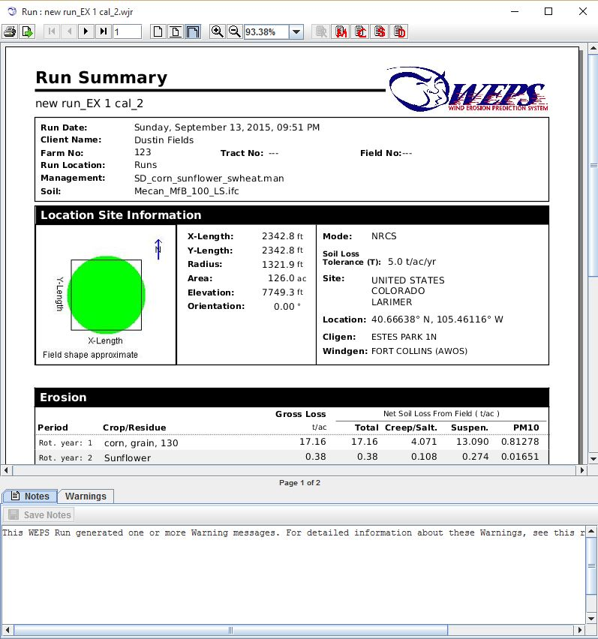
The Run Summary report screen (Figure 2.23) will automatically display at the conclusion of a simulation run. If the Run Summary screen has been closed, the user can display the Run Summary screen for the most recent WEPS run or previous runs by clicking the ‘ViewOutput’ menu on the WEPS main screen menu bar.

The Run Summary contains names of the input files, as well as other input parameters, basic soil loss information by rotation year, and the average annual for the total simulation.

Soil loss output in the Run Summary includes: Gross Loss, which is the average erosion within the field (i.e., removal of soil with no deposition taken into account); Net Total, the average total net loss from the field (net losses are gross losses minus deposition within the field); Net Creep/Salt, the average creep plus saltation net loss from the field; Net Suspension, the average suspension net loss from the field; and Net PM10, the average PM10 (particulate matter less than 10 microns) net loss from the field. Deposition occurs when the wind speed drops as it travels across the field or the surface conditions become less erodible in a downwind part of the field (i.e., transport capacity of the wind exceeds transport capacity for the surface conditions). In WEPS 1.3.9, deposition only occurs with a drop in wind speed across the field due to a barrier present on the downwind side of the field or surface conditions changing across the field because of the erosion process. In many simulations, however, it is not uncommon to have equal gross and net total loss.
Figure 2.23 The WEPS Run Summary screen.

If an erosion event occurred, but values generated by the model are too small to be displayed on the output table (i.e., <0.001 kg/m²), then the amount is listed as “ trace”. If amounts are too large to be accurately displayed, then the amount is listed simply as greater than a specified amount (i.e., > 300 kg/m²). In these cases, erosion amounts are so large that they are generally unacceptable. If any barriers were present on the field borders, a summary of their properties is also listed. Finally, any notes entered on the main screen for the run are reproduced, and they can be edited or added to, if desired, and saved via the appropriate button at the top of the form.

A button bar is included at the top of the Run Summary screen that allows the user to print the summary , export or save a pdf of the report , go to other pages in the report , and display the Management Summary screen , the Crop Summary screen , the Stir Energy report , and Detailed Reports screen . In the notes tab at the bottom of the report, the user may edit save the notes to the summary .

Crop Summary

The Crop Summary report screen (Figure 2.24) contains simulation run information, including the names of the input files. It also contains a Detailed Report table and a Summary Report table for each crop grown during the simulation run.
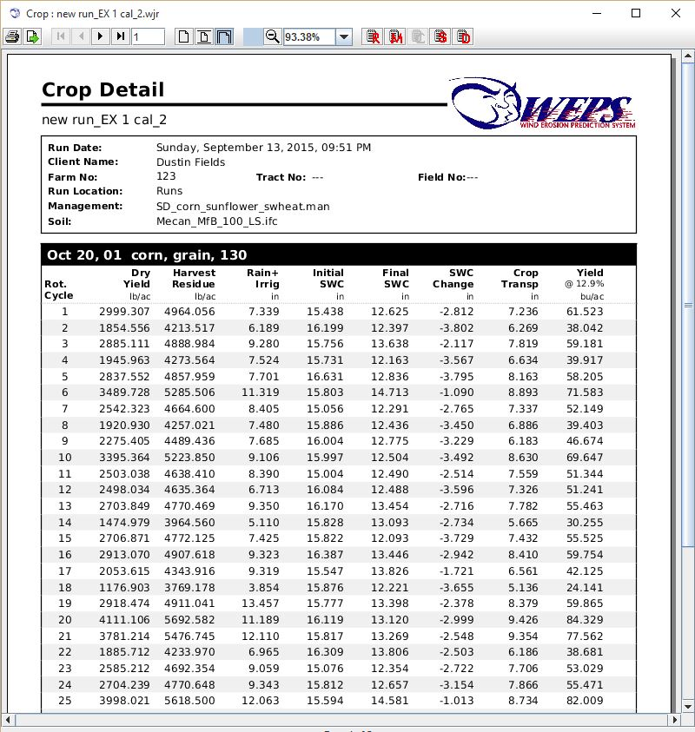
The Crop Summary table displays crop yield data for each crop year in the simulation. A table below the Crop Summary table provides statistical summary parameters for each rotation year. For example, it displays the mean yield for all the simulation years that an individual crop was grown.

A button bar is included at the top of the screen that allows the user to print the crop detail table export the crop detail report , go to other pages in the report , and display the Run Summary screen , the Management Summary screen , the Stir Energy report , and Detailed Reports screen . In the notes tab at the bottom of the report, the user may edit save the notes to the summary .
Figure 2.24 The WEPS Crop Summary Screen.

Management Summary

The Management Summary report screen (Figure 2.25) contains general run information as well as a summary of the management information for the run. The Management Summary table at the bottom of the screen displays the management operation date, operation, and crop for the run.

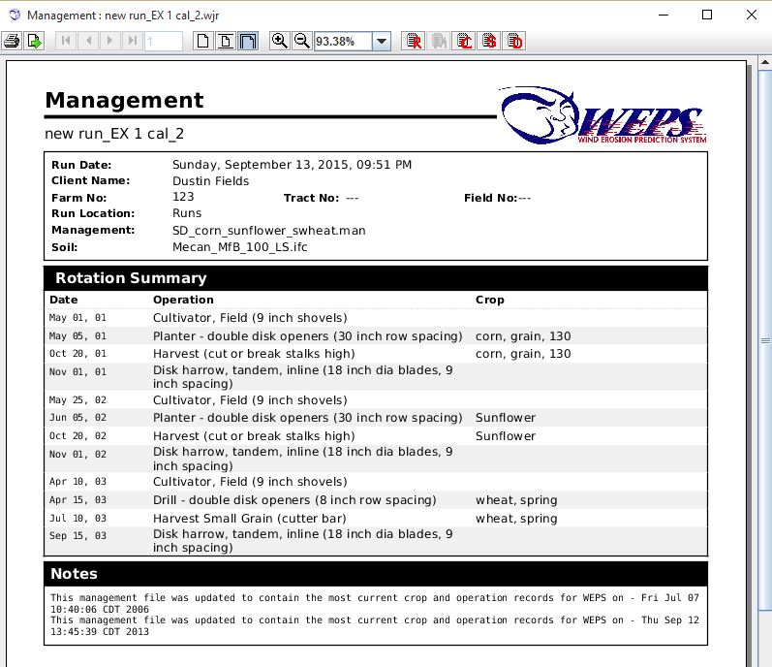
A button bar is included at the top of the screen that allows the user to print the management summary report export the management report , go to other pages in the report , and display the Run Summary screen , the Crop Detail report , the Stir Energy report , and Detailed Reports screen . In the notes tab at the bottom of the report, the user may edit save the notes to the summary .
Figure 2.25 The WEPS Management Summary Screen.

Detail Reports
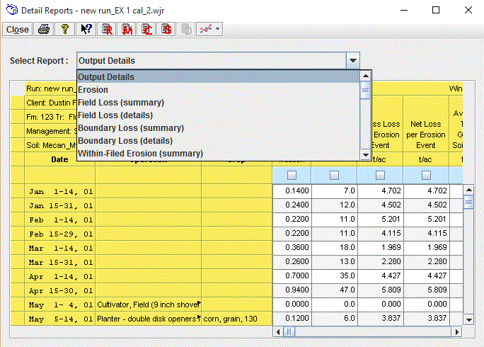

The Detail Reports screen (Figure 2.26) provides a choice list where the user can select various types of output.

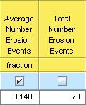
A button bar is included at the top of the Detail Reports screen that allows the user to close the window, print any detail report , open general help for WEPS , use the context help , and display the Run Summary screen , the Management Summary screen , , the Crop Summary screen and the Stir Energy Summary screen . The quickplots button plots data from user selected columns (see box to the left) The drop-down arrow allows the user to change plot style, restore default settings, and select or clear all columns. Below the button bar is a drop-down report list labeled ‘Select Report’. Clicking the down arrow to the right of ‘Select Report’ displays the list of outputs available. Click the desired list and it will be displayed in the window below. The following is a description of each report screen.
Figure 2.26 The WEPS Detailed Reports screen showing the drop-down report list.

Output Details
The Output Details report contains all of the erosion, weather, and surface information available by period, by rotation year, and for the entire simulation run.

The columns of the Output Details report have the following information.

Date - The start and end dates (day/month/rotation year) of the reporting period.

Operation - The management operation that occurred on the specified date (if multiple operations have been specified on the same date, only the last one listed on that date will be displayed).

Crop -The crop planted on the specified date.

Wind Erosion

Average Number Erosion Events - This column displays the average number of erosion events per period (fraction).

Total Number Erosion Events - The total number of erosion events during that period for the simulation.

Gross Loss per Erosion Event - The gross erosion within the field for each event, averaged across the field, as well as averaged over the number of simulation years in each rotation year (kg/m² or tons/acre).

Net Loss per Erosion Event - The net erosion within the field for each event, averaged across the field, as well as averaged over the number of simulation years in each rotation year (kg/m² or tons/acre). Some deposition within a field can occur, especially when barriers are present downwind. Net soil loss is the amount of gross loss minus deposition.

Average Total Gross Soil Loss - The average erosion (soil loss) within the field, averaged across the field, as well as averaged over the number of simulation years in each rotation year (kg/m² or tons/acre). This value is the total amount of soil being removed from the surface of the field. It does not take into consideration the amount of that entrained soil that may be re-deposited downwind within the field due to wind barriers, etc. The “gross” soil loss values are most important when evaluating the “onsite” effects of wind erosion.

Net Soil Loss from Field

The ‘Net Soil Loss from Field’ columns display the “actual” soil loss from the field (net losses are gross losses minus deposition within the field). Specific areas within the field may experience: 1) a net soil loss, 2) a net soil gain (deposition), 3) no soil movement, or 4) soil movement, but the soil loss is equal to the deposition within the specified area. Under some scenarios, a portion of soil entrained upwind can get deposited within the field borders, due to a reduction in wind speed (and thus its soil-carrying capacity) caused by downwind barriers, changes in surface roughness across the field, etc. Therefore, the “net” soil loss reported will be less than the “gross” soil loss in these situations. The “net” soil loss values are most important when evaluating “offsite” effects of wind erosion.
Average Total - The average total net soil loss from the field (kg/m² or tons/acre). This value represents the average amount of soil actually leaving the field boundaries. If there are any downwind barriers, this value will be somewhat less than the ‘Average Total Gross Soil Loss’ value due to deposition occurring within the field.

Average Creep & Saltation - The quantity of creep plus saltation-size material leaving the field for the period, averaged across the field grid areas, as well as averaged over the number of simulation years in each year of the crop rotation (kg/m² or tons/acre).

Average Suspension - The quantity of suspension-size material leaving the field for the period, averaged across the field grid areas, as well as averaged over the number of simulation years in each rotation year (kg/m² or tons/acre).

Average PM10 - The quantity of PM10 (particulate matter less than 10 microns) material leaving the field for the period, averaged across the field grid areas, as well as averaged over the number of simulation years in each rotation year (kg/m² or tons/acre).

Mass of Soil Passing Indicated Field Boundary
These columns display the average soil loss across the indicated field boundary, per unit length of field border, for the specified size range of eroding material.

Creep+Saltation - Average mass of creep plus saltation-size material passing each field boundary (kg/m or tons/1000 ft of field border length) in the direction indicated .

Suspension - Average mass of suspension-size material passing each field boundary (kg/m or tons/1000 ft of field border length) in the direction indicated .

PM10 - Average mass of PM10 size material passing each field boundary (kg/m or tons/1000 ft of field border length) in the direction indicated .

Within-Field Wind Erosion Activity
The information in this section is useful in determining how much of the field is actively eroding and how much is not, which may impact what control measures, if any, should be applied and where. This information is also useful in understanding how much of the field is actively eroding, and thus may be causing plant or soil damage, or how much is subject to burial. Finally, this information is useful in understanding how much of the field is contributing to overall (net) field loss.

Saltating Emission Region
Soil Loss - The amount of soil loss from that area of the field that had significant saltation emission (kg/m² or tons/acre).

Field Area - Both the area (acres or hectares) and fraction of the field area that had saltation emission.

Deposition Region
Soil Deposition - The amount of soil deposited in that area of the field where deposition is the primary activity (kg/m² or tons/acre).

Field Area - Both the area (acres or hectares) and fraction of the field area that had deposition.

High Flux Region
Field Area - Both the area (acres or hectares) and fraction of the field area that was near transport capacity.

Sheltered Region
Field Area - Both the area (acres or hectares) and fraction of the field area that had no saltation or suspension material being emitted. Sheltered areas are typically those immediately downwind of barriers.

Weather Info
Average Total Period Precip - The total precipitation for the period averaged over the simulation years in each year of the crop rotation (mm or inches).

Average Wind Energy >8 m/s - The average daily wind energy for the period for winds greater than 8 m/s (18 mi/h), averaged over the simulation years in each year of the crop rotation (KJ/m²/day).

Snow Depth > 20 mm - The total average fraction of time that snow cover on the field which is greater than 20 mm (0.787 in) in depth (mm or inches).

Average Biomass Surface Conditions on Date
Crop Vegetation (Live)
Canopy Cover - The fraction of live crop biomass cover (vertical view) at the period end, averaged over the simulation years for the period listed (fraction).

Effective Standing Silhouette - The standing silhouette area index of live plants, expressed on a fraction basis. If the plants are planted in the furrow, as opposed to the ridge top, the index is adjusted (down) to have less of an effect on the wind. These are values at the period end, averaged over the simulation years in each rotation year.

Leaf and Stem Mass - The total live crop biomass, above ground, at the period end, averaged over the simulation years for the period listed (kg/m² or lbs/acre).

Root Mass - The total live crop biomass, below ground, at the period end, averaged over the simulation years for the period listed (kg/m² or lbs/acre).

Crop Height - The height of the crop above the soil surface (mm or inches).

Crop Residue (Dead)
Surface Cover - The amount of flat residue cover (dead) on the soil surface, expressed as a fraction. These are values at the period end, averaged over the simulation years in each rotation year (fraction).

Effective Standing Silhouette - The standing silhouette area index of plant residues, expressed on a fraction basis. These are values at the period end, averaged over the simulation years in each rotation year.

Flat Mass - The amount of flat residue mass on the soil surface. These are values at the period end, averaged over the simulation years in each rotation year (kg/m² or lbs/acre).

Standing Mass - The amount of standing residue mass on the soil surface. These are values at the period end, averaged over the simulation years in each rotation year (kg/m² or lbs/acre).

Buried Mass - The amount of buried residue mass including roots, below the soil surface. These are values at the period end, averaged over the simulation years in each rotation year (kg/m² or lbs/acre).

Buried Root Mass - The amount of root mass, below the soil surface. These are values at the period end, averaged over the simulation years in each rotation year (kg/m² or lbs/acre).

Weighted Residue Height - The height of residue weighted by residue pool (residue is various stages of decomposition) (mm or inches).

Number of Residue Stems - The number of standing residue stems per hectare or acre.

Live and Dead Biomass
Surface Cover - The amount of flat surface cover from live vegetation and dead plant residue (flat cover) biomass on the soil surface, expressed on a fraction basis. These are values at the period end, averaged over the simulation years in each rotation year (fraction).

Effective Standing Silhouette - The standing silhouette area index of live vegetation plus dead plant residue. If the plants are planted in the furrow, as opposed to the ridge top, the index is adjusted (down) to have less of an effect on the wind. These are values at the period end, averaged over the simulation years in each rotation year (fraction).

Flat Mass - The amount of flat live vegetation (air dried) and dead plant residue biomass on the soil surface. These are values at the period end, averaged over the simulation years in each rotation year (kg/m² or lbs/acre).

Effective Standing Mass - The amount of standing live vegetation and plant residue biomass. If the plants are planted in the furrow, as opposed to the ridge top, the index is adjusted (down) to have less of an effect on the wind. These are values at the period end, averaged over the simulation years in each rotation year (kg/m² or lbs/acre).

All Buried Mass - The amount of vegetative material, both live and dead below the soil surface. These are values at the period end, averaged over the simulation years in each rotation year (kg/m² or lbs/acre).

Average Soil Surface Conditions on Date
Oriented Roughness
Ridge Orientation - The orientation of soil ridges, with zero degrees (0̊) representing north/south ridges.

Ridge Height - The height of ridges. This is the value, at the period end, averaged over the simulation years in each rotation year (mm or inches).

Ridge Spacing - The spacing between ridges. This is the value at the period end, averaged over the simulation years in each rotation year (mm or inches).

Random Roughness - The standard deviation of the soil surface random roughness. This is the value at the period end, averaged over the simulation years in each rotation year (mm or inches).

Aggregation
Aggregates < 0.84 mm - The fraction of aggregates less than 0.84 mm (0.033 inches). Aggregates < 0.84 mm are generally considered to be erodible. This is the value at the period end, averaged over the simulation years in each rotation year.

Dry Aggregate Stability - The dry aggregate stability is the log of crushing energy of dry soil aggregates (ln(J/kg)), which is related to abrasion resistance. This is the value at the period end, averaged over the simulation years in each rotation year.

Crust Cover - The fraction of the soil surface that is crusted. This is the value at the period end, averaged over the simulation years in each rotation year.

The rows in the Output Details table differ, depending on the number of cropping years in the rotation and the number of management operations in each year of the rotation.

Each year of the rotation has output displayed for the two week periods, as well as for each management operation date. This output allows the user to view the erosion and other output for each year of the rotation. At the end of each year in the rotation is a row that contains the average annual value for that rotation year.

The last row in the output form contains the average annual values for the complete crop rotation.

The remaining menu list items on the Detail Reports screen are generally a subset of the Output Details menu option just described.

Erosion
The Erosion report displays soil loss parameters for each rotation year and the average annual for all rotation years.

Field Loss (summary)
The Field Loss summary report displays average soil loss by rotation year and for the entire simulation run. The values displayed include: Average Total Gross Soil Loss, the average erosion within the field; Net Average Total, the average total net loss from the field; Net Average Creep/Salt, the average creep plus saltation net loss from the field; Net Average Suspension, the average suspension net loss from the field; and Net Average PM10, the average PM10 net loss from the field.

Field Loss (details)
The Field Loss detailed report displays average soil loss by period, by rotation year, and for the entire simulation run. The values displayed include: Average Total Gross Soil Loss, the average erosion within the field; Net Average Total, average total net loss from the field; Net Average Creep/Salt, the average creep plus saltation net loss from the field; Net Average Suspension, the average suspension net loss from the field; and Net Average PM10, the average PM10 net loss from the field.

Boundary Loss (summary)
The Boundary Loss summary report displays the average mass passing each field boundary (kg/m or tons/1000 ft of field border length) in the direction indicated . These parameters are reported for each rotation year and for the simulation run. The columns labeled ‘Creep + Saltation’ contain the mass per unit boundary length of creep plus saltation-size material that passed the field boundary for each direction. The Suspension columns contain the mass per unit boundary length of suspension-size material that passed the field boundary for each direction. The PM10 columns contain the mass per unit boundary length of PM10-size material that passed the field boundary for each direction.

Boundary Loss (details)
The Boundary Loss detailed report displays the average (by period, rotation year, and simulation run) mass passing each field boundary (kg/m or tons/1000 ft of field border length) in the direction indicated . These parameters are reported by period, for each rotation year, and for the simulation run. The columns labeled ‘Creep + Saltation’ contain the mass per unit boundary length of creep plus saltation-size material that passed the field boundary for each direction. The Suspension columns contain the mass per unit boundary length of suspension-size material that passed the field boundary for each direction. The PM10 columns contain the mass per unit boundary length of PM10-size material that passed the field boundary for each direction.

Within-field Erosion (summary)
The Within-field Erosion summary report displays information for various types of erosion activity by rotation year and for the simulation run. These activities include amounts, as well as area and fraction of the field that had significant saltation emission and deposition. In addition, high flux and sheltered areas and fraction of the field are given. The high flux region is that area that is near transport capacity. A sheltered area is one that had no saltation or suspension material being emitted. Sheltered areas are typically those immediately downwind of barriers. This information is useful in determining how much of the field is actively eroding and how much is not, which may impact what control measures, if any, should be applied and where. This information is also useful in understanding how much of the field is actively causing plant or soil damage or how much is subject to burial. Finally, this information is useful in understanding how much of the field is contributing to overall (net) field loss.

Within-Field Erosion (details)
The Within-Field Erosion detailed report displays information for various types of erosion activity by period, by rotation year, and for the simulation run. These activities include amounts, as well as areas and fraction of the field that had significant saltation emission and deposition. In addition, high flux and sheltered area and fraction of the field are given. The high flux region is that area that is near transport capacity. A sheltered area is one that had no saltation or suspension material being emitted. Sheltered areas are typically those immediately downwind of barriers. This information is useful in determining how much of the field is actively eroding and how much is not, which may impact what control measures, if any, should be applied and where. This information is also useful in understanding how much of the field is actively causing plant or soil damage, or how much is subject to burial. Finally, this information is useful in understanding how much of the field is contributing to overall (net) field loss.

Erosion (summary)
The erosion summary report displays all of the information available on erosion contained in the Field Loss (summary), Boundary Loss (summary), and Within-field Loss (summary) reports.

Erosion (details)
The erosion detailed report displays all of the information available on erosion contained in the Field Loss (details), Boundary Loss (details), and Within-field Loss (details) reports.

Erosion (monthly details)
The erosion monthly detailed report displays all of the information available on erosion contained in the Erosion (summary) report, but includes monthly average values (averaged across rotation years).

Erosion (yearly details)
The erosion yearly detailed report displays all of the information available on erosion contained in the Erosion (summary) report, but includes individual simulation-year values.

Weather (summary)
The weather summary report displays average total precipitation, the average wind energy for winds greater than 8 m/s (erosive winds), and average fraction of time that snow cover on the field is greater than 20 mm. These parameters are reported for each rotation year and for the simulation run.

Weather (details)
The weather detailed report displays average total precipitation, the average wind energy for winds greater than 8 m/s (erosive winds), and average fraction of time that snow cover on the field is greater than 20 mm. These parameters are reported by period, for each rotation year, and for the simulation run.

Weather (monthly details)
The weather monthly detailed report displays average total precipitation, the average wind energy for winds greater than 8 m/s (erosive winds), and average fraction of time that snow cover on the field is greater than 20 mm. These parameters are reported for each rotation year, by month and for the simulation run.

Weather (yearly details)
The weather yearly detailed report displays average total precipitation, the average wind energy for winds greater than 8 m/s (erosive winds), and average fraction of time that snow cover on the field is greater than 20 mm. These parameters are reported for each rotation year, each individual simulation year and for the simulation run.

Crop Vegetation (details)
The crop vegetation detailed report displays average live above-ground biomass conditions that existed on the end date for the period reported. The conditions displayed include canopy cover, effective standing silhouette, and above ground mass. Canopy cover is the fraction of live crop biomass cover from a vertical view. Effective standing silhouette is the standing silhouette area index of live plants. These values are standing silhouette area per area of soil surface, expressed as a fraction. If the plants are planted in the furrow, as opposed to the ridge top, the index is adjusted (down) to have less of an effect on the wind. Above-ground mass is the total above-ground biomass.

Crop Residue (details)
The crop residue detailed report displays average dead above-ground biomass conditions that existed on the end date for the period reported. The conditions displayed include flat cover, effective standing silhouette, flat mass, and standing mass. Flat cover is the fraction of dead crop biomass cover from a vertical view. Effective standing silhouette is the standing silhouette area index of dead plants. These values are standing silhouette area per area of soil surface, expressed as a fraction. If the plants are planted in the furrow as opposed to the ridge top, the index is adjusted (down) to have less of an effect on the wind. Flat mass is the above-ground biomass that is lying flat on the soil surface. Standing mass is the above-ground biomass that is in a standing or upright position on the soil surface.

Crop Biomass (details)
The crop biomass detailed report displays the average live plus dead above-ground biomass conditions that existed on the end date for the period reported. The conditions displayed include flat cover, effective standing silhouette, flat mass, and standing mass. Flat cover is the fraction of live plus dead crop biomass cover from a vertical view. Effective standing silhouette is the standing silhouette area index of live plus dead plants. These values are standing silhouette area per area of soil surface, expressed as a fraction. If the plants are planted in the furrow as opposed to the ridge top, the index is adjusted (down) to have less of an effect on the wind. Flat mass is the above-ground biomass that is lying flat on the soil surface. Standing mass is the above-ground biomass that is in a standing or upright position on the soil surface.

Crop Veg, Res & Biomass (details)
The crop vegetation, residue and biomass detailed report displays the all information on vegetative material contained in the Crop reports as described above.

Soil Surface (details)
The soil surface detailed report displays average soil conditions at the surface that existed on the end date for the period reported. The conditions displayed includes ridge orientation, ridge height, ridge spacing, random roughness, aggregates greater than 0.84 mm, aggregate stability, and crust cover. Ridge orientation is the orientation of the ridges, with zero degrees (0̊) representing north/south ridges. Random roughness is the standard deviation of the soil surface roughness height. Aggregates greater than 0.84 mm are expressed as a fraction and are those aggregates generally considered to be non-erodible. Aggregate stability is the log of crushing energy of dry soil aggregates (ln(J/kg)).

Surface Conditions (details)
The surface conditions detailed report displays all of the information available on the field surface contained in the Crop, Residue, Biomass, and Soil Surface reports.

Erosion and Crop (details)
These reports contain a combination of the erosion and crop reports as described above.

Debugging Reports
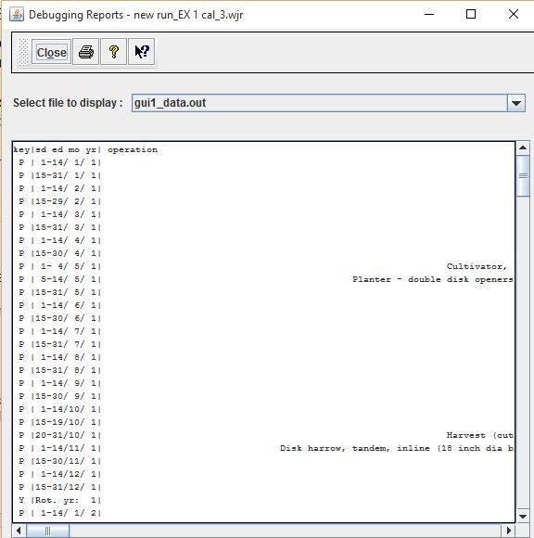
The Debugging Reports screen (Figure 2.27), located within the ViewOutput menu from the WEPS main screen, provides a means of directly accessing all output files generated by the WEPS science model, including those that are used by the WEPS user interface to generate reports. A list of selectable output files are available on a drop-down list. Clicking the down arrow to the right of ‘Select file to display’ displays the list of output available. Click the desired list and it will be displayed in the window below. These files are generally for advanced users and model developers. For more information on accessing and interpreting the WEPS science model output files, contact WEPS support.
Figure 2.27 Debugging Reports screen.

