Exercise 1 - A Basic Simulation

Skill Building: This example introduces some basic skills needed to perform simple wind erosion simulations with WEPS. It uses the rotations saved in the NRCS CMZ (Crop Management Zone) Management Files. It also demonstrates Target Yield adjustment.

Getting Started: Double-click the WEPS short-cut on the desktop to open the main WEPS interface. The user’s name and email address are required to help track any comment or error messages sent by the user. Note in Figure 3.19 the default run location: C:\Users\user.name\Documents\My WEPS Files\Runs. Red boxes are added for instruction purposes throughout these exercises and are not seen in the actual WEPS windows.

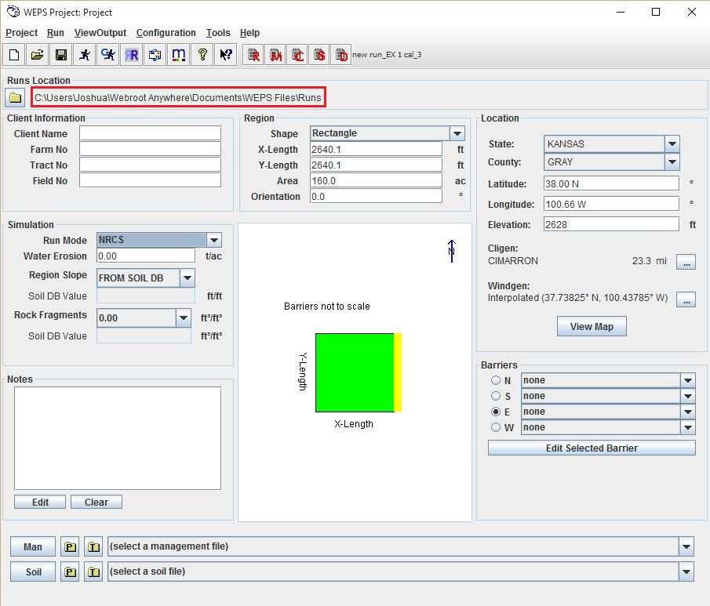
Figure 3.19 The WEPS main interface with default settings.

Scenario
- The farm is located near Stevens Point, Wisconsin, in Portage County.
- Use a Climate station within the county.
- The Soil Map Unit for this evaluation is Mecan_MfB_100_LS.
- The grower’s two-year cropping system is Peas, green, drilled and Bean, green snap.
- The harvest machines are viners that remove the beans and peas, returning all residue to the field.
- The field is circular with a size of about 126 acres and is fully irrigated with a circle system.
- The WEPS evaluation of the cropping system will be run for 50 rotation cycles (NRCS mode).

Fill in the following interface sections:

Step 1: Under the Client Information panel, enter Exercise 1 for Client Name.

Step 2: Under the Region panel, for Shape select Circle by clicking the drop-down arrow next to ‘Shape.’ For ‘Area’ enter 126 acres. The circle radius automatically synchronizes with acreage values when ‘Area’ is deselected.

Step 3: Under the Location panel, for the ‘State,’ select Wisconsin; for the ‘County,’ select Portage. This inputs the correct weather stations, so that the interface reads “Cligen: STEVENS POINT; Windgen: Interpolated (with coordinates).” The Central and Eastern regions of the United States use wind station interpolation, where the three surrounding wind stations’ data are combined to make a unique weather record for each run. At this point, WEPS has selected the center of Portage County. To confirm that the location is nearest to Stevens Point, click the View Map button for an overhead view of the station placement (Figure 3.20). The red cross denotes the current location. Now click the check box by Cligen Station in the Layer column in the lower left corner of the screen to display the Cligen station locations. See that the current location is near Stevens Point. Close the Map Viewer to return to the main interface screen.

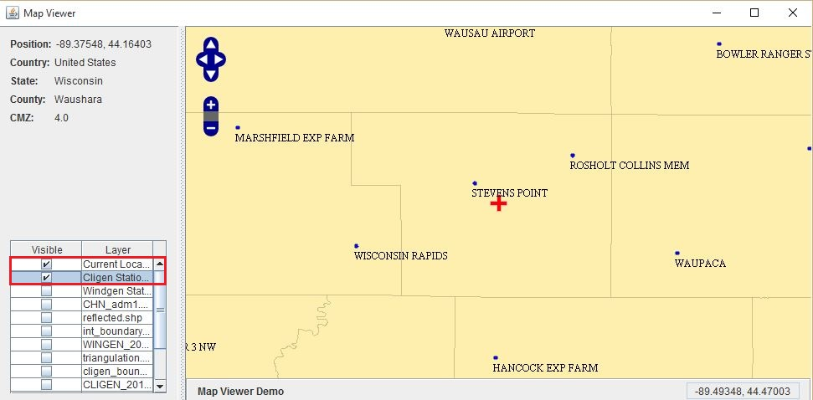
Figure 3.20 Map Viewer with Cligen Stations Layer turned on.

Step 4: Click the drop-down arrow opposite the Man button 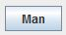 near the bottom of the WEPS screen (Figure 3.21). To open or close a folder on the list, click the key symbol beside it . To select a management file, click the desired file. From the list, select Templates, then NRCS, then Example Mgt. files, then Peas, green, drilled, st pt, disk, fcult,-Bean, green snap, st pt, disk, fcult, CMZ4.man. Note: the management files are displayed with .man file extension. The crop management file name will be displayed in the Man bar near the bottom of the WEPS interface when selected.

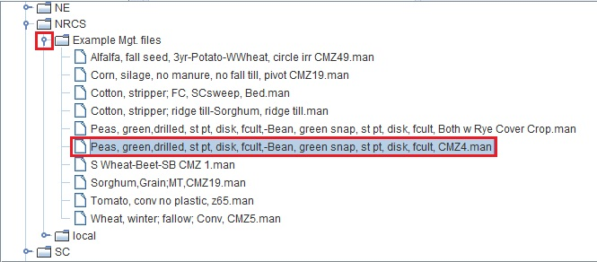
Figure 3.21 Selecting a template management file.

Step 5: Click the drop-down arrow opposite the Soil button near the bottom of the WEPS screen (Figure 3.22). Select Soil Templates, then Exercise Soils, then the Mecan_MfB_100_LS.ifc soil. Note: the soil files have an .ifc extension. When selected, the soil name is displayed near the bottom of the WEPS interface. You will normally use the drop-down arrow to select a soil from the SSURGO survey database in this directory or other locations determined by the configuration settings. SSURGO files have an .mdb extension. With internet connection, you can load the soil files directly from the NRCS Soil Data Mart by clicking the NRCS Soil Data Mart folder. Last on the drop-down list is a set of generic soil files to use when there is no soil survey or when the soil in the field is different than mapped. They can also be used for disturbed sites, such as landfill, mining reclamation, and construction sites.

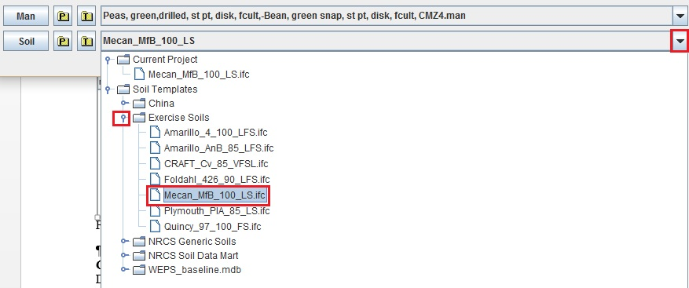
Figure 3.22 The soil selection drop-down box showing available templates.

Configuration Note:
Default WEPS directory locations are found in the Configuration window (Figure 3.23) To check the WEPS configuration on the main interface menu bar, click Configuration, then Edit Configuration, then Directories.
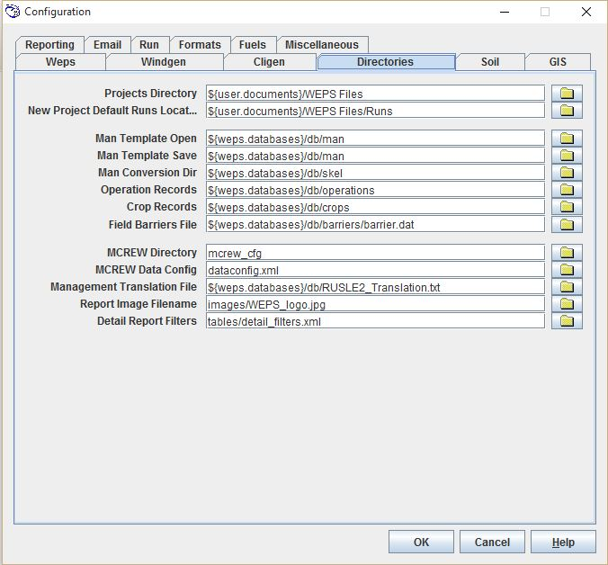
Figure 3.23 WEPS Configuration window opened to the Directories tab, showing directory locations which the user may change.

The location or locations shown in the boxes indicate to the user where the WEPS run will be saved and how to find the correct settings required to make a run. The bright yellow folders indicate those which the user can change, while the shaded folders show those the user cannot change. The user can change only highlighted folders. To change a location, click the yellow folder, select the directory or file, and click OK to save the configuration settings and close the window.

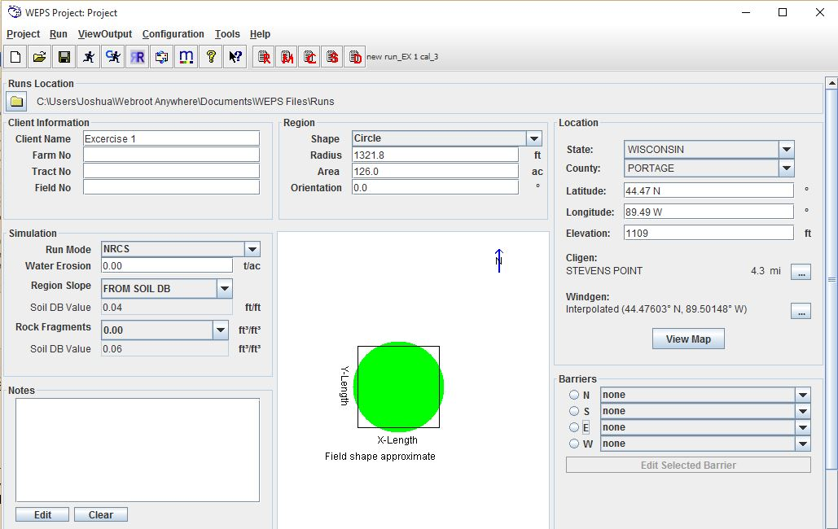
Figure 3.24 The WEPS interface with the correct information for the initial scenario of Exercise 1.

Simulation Run:
All required information has now been entered (Figure 3.24). To begin the simulation run, click the Run button . WEPS will prompt you to name the run. Enter Peas, green-Beans, green, irr, CMZ4 and click OK (Figure 3.25).

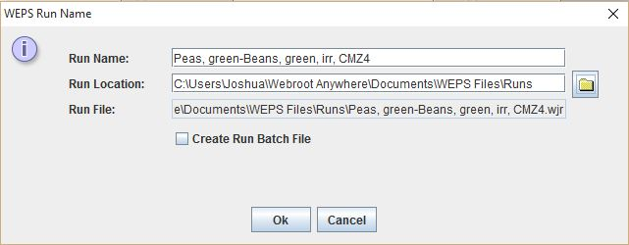
Figure 3.25 The WEPS Run Name box, showing the run name, location, and file.

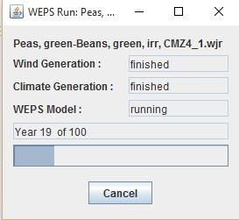

During a simulation run, a window (shown left) will appear, showing the simulation progress. Upon completion, the WEPS Run Summary report window appears (Figure 3.26). The simulation reports an Average Annual Soil Loss of 26.4 tons per acre; several times the acceptable soil loss of 5 t/ac/yr. Since crop yields determine the amount of residue, which affects erosion, the user should check to see if yields are as expected.
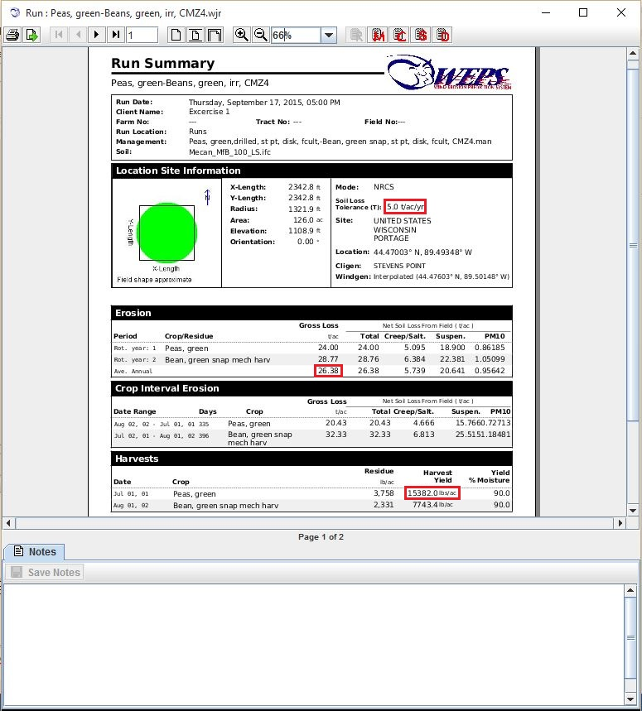
Figure 3.26 WEPS Run Summary showing Average Annual Soil Loss and Harvest Yield for each crop.

The expected yields for this area are 3400 pounds per acre for green peas and 8100 lbs/ac for the green beans. For this example, however, WEPS calculated 15382 lbs/acre for the peas (Figure 3.26). The pea yield is far too high and should be calibrated.

Calibration:
The calibration function allows WEPS to recalculate the crop growth based on the actual yield history of the field evaluated. It adjusts the Harvested Yield simulated to within 5% of the expected or historic yield entered. To calibrate the example run, first close the Run Summary. The main interface should remain.

Step 1: On the main screen, click the Man button to open the Management Crop Rotation Editor for WEPS (MCREW). The MCREW displays a calendar year date-ordered list of all management operations and crops for the rotation (Figure 3.27Figure 3.27). A more detailed explanation of MCREW use will be covered in later exercises. For now, click the Yield Calibrate button on the tool bar. This displays eight additional columns. The first three pertain to the target yield and calibration. The target yields can be edited on this screen. Remember, the target yield is 3400 lbs/ac for peas and 8100 lbs/ac for beans. Change the peas from 2860 to the 3400 lbs/ac desired. Then make sure box in the ‘Calib. Yield?’ column is checked.

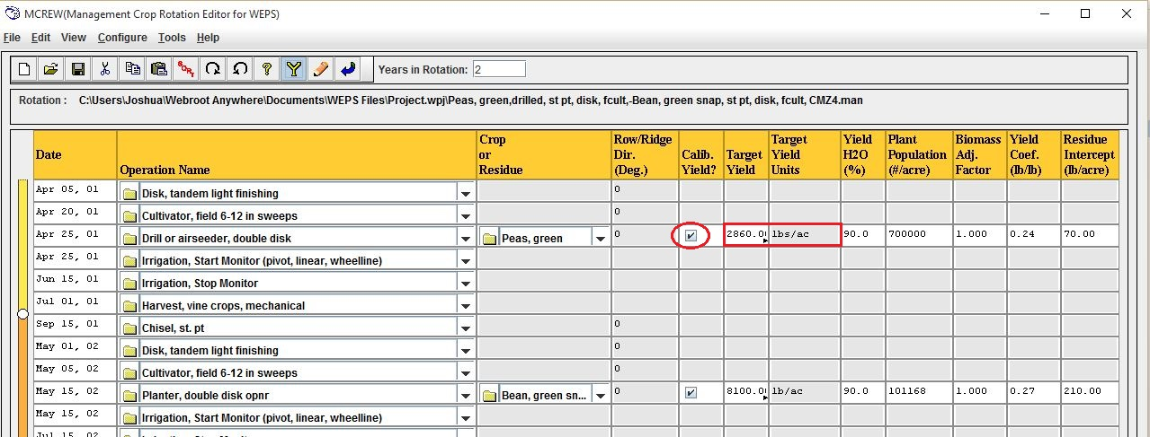
Figure 3.27 The Management Crop Rotation Editor for WEPS (MCREW).

Click the Return button and save the changes by clicking ‘Yes’ to save. This closes MCREW for the user to view the remaining WEPS interface.

Step 2: On the main interface screen, click Run, then Make a Yield Calibration WEPS Run. Another way to do this is to click the Yield Calibration Run button on the main toolbar. You will be prompted to enter a Run Name. The default Run Name is the last run name plus an incremented number appended to the name (in this example ‘_1’ is appended). This time, replace the _1 with cal, then click OK (Figure 3.28). A calibration run will take several minutes.

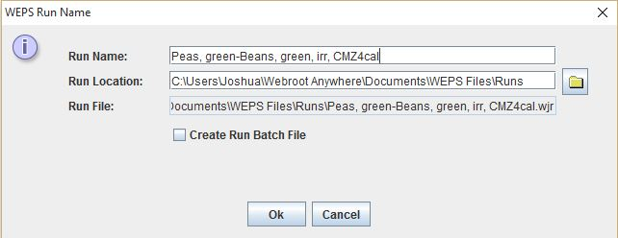
Figure 3.28 WEPS Run Name window showing 'cal' added at the end of the run name.
WEPS now displays a table showing two Calibration Factors; one for peas and one for beans (Figure 3.29). For WEPS to produce the expected pea residue for this farm, yields must be reduced from 15382 lbs/ac to 3400 lbs/ac. Therefore, we should expect the factor to be less than 1.0 and the Biomass Adjustment Factor is 0.3174. The beans did not need adjustment, so the factor remained at 1.0. The Biomass Adjustment Factor is a number assigned to each crop and used as a multiplier to adjust how much the crop grows. Numbers greater than 1 increase the final yield, whereas numbers less than 1 decrease the final yield of the crop.
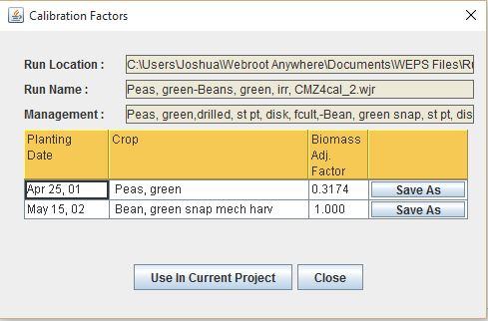
Figure 3.29 The Calibration Factors window displaying the Biomass Adjustment Factor for each crop.

The user has three options at the Calibration Factors screen: 1) Clicking Use in Current Project to apply these factors to all peas and beans being run in this project. 2) Clicking Save As to save a localized version of the crop file to the local subdirectory in the crop database for use with another local field. Since each run takes some time to complete, it is helpful to save a copy for the next time you run the model. The full path to the storage location is: C:\Documents and Settings\All Users\Application Data\USDA\WEPS\Databases\nrcs\crops\local. 3) Clicking Close to use the factors only in the current run.

For this exercise, click Use In Current Project to change the .mgt file in the project directory and not in any template file. WEPS will then display a message informing the user that “The current project is now using the calibrated management file.”

Upon completion, the WEPS Run Summary report window 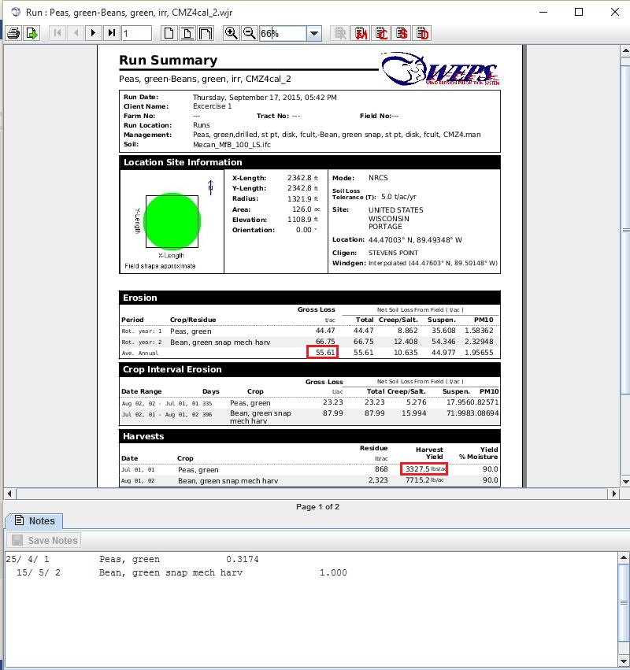
Figure 3.30 The Run Summary showing new results from the calibrated yield.
will appear (Figure 3.30). The simulation reports an Average Annual Gross Soil Loss of 55.6 tons/acre. This greatly exceeds the T-value (Soil Loss Tolerance) of 5 t/ac/yr. Note, the Biomass Adjustment Factors appear in the ‘Notes’ box near the bottom of the Run Summary report.

Is the yield within the 5% needed now? Yes, 3327.5 lbs/ac of peas is close enough to 3400, and 7715.3 lbs/ac is close enough to 8100.

Is the percent ground cover and mass of flat residue after seeding adequate to protect both seedling stages of both crops?

Hint: Click the Detailed Report button in the Summary Report toolbar. Near the top of the Detailed Report there is a window that allows the user to ‘Select Report.’ This should display Erosion & Crop Veg, Res & Biomass (details) as default. If not, click the drop-down arrow and select it from the list.

The Detailed Report includes a date-ordered list of output parameters by periods (every 15 days or the period between management operations). This detailed report shows the viewer the amount of cover and flat residue after seeding each crop (Figure 3.31).

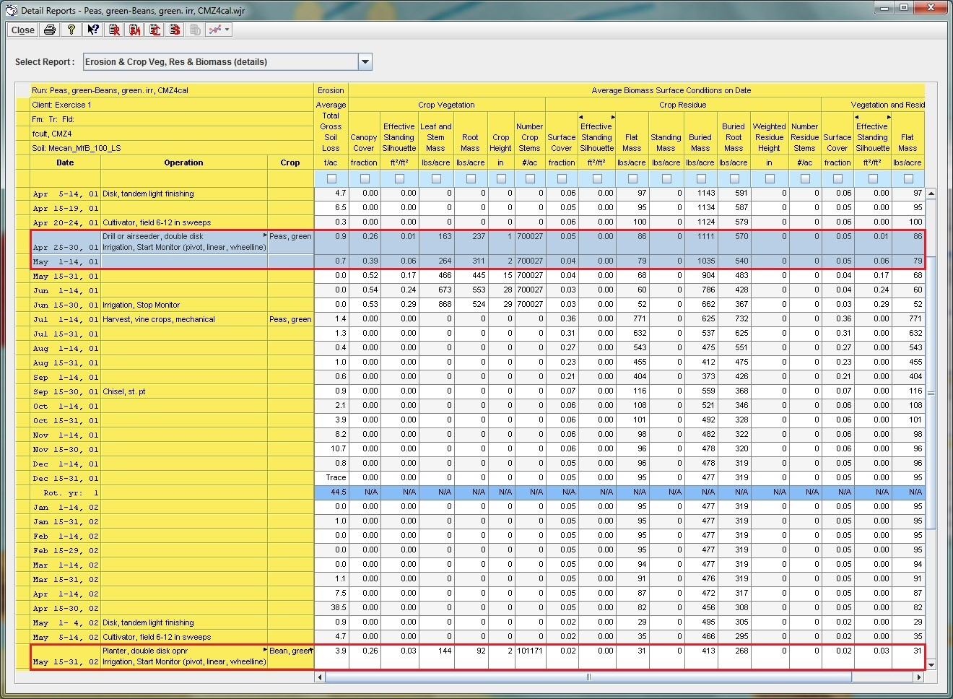
Figure 3.31 The Detailed Report showing soil loss and residue amounts after planting Peas and Beans.

By examining the Detailed Report table, you will see that bean residue after planting peas during April 25-30, 01 was 5% (0.05) Surface Cover and 86 lbs/ac flat mass.
Answer: These amounts provide enough protection for WEPS to estimate an Average Total Gross Soil Loss after planting the peas to be 1.6 t/ac (sum of gross losses for the period April 25- May 14, 01). There is yet some probability of damage to the peas by blowing soil.

The pea residue after planting beans (May 15-31, 02) was 2% surface cover and about 31 lbs/ac flat mass (Figure 3.31). For these residue amounts, WEPS estimates an Average Total Gross Soil Loss after planting of 3.9 tons/acre. The NRCS National Agronomy Manual has a Crop Tolerance to Blowing Soil table that lists Green/snap beans in the ‘no more than 1 ton/ac’ low tolerance column (see Table 3.2 in the Exercises Introduction). There is an issue with both crops in this case.

The annual erosion rate for the two low-residue crops is too high at 55.6 ton/ac. Since most of the erosion occurs after the peas, and there is good rainfall in that time period, a winter annual such as winter wheat or a rye cover crop could be the solution for conserving the soil.

Selecting New Templates
Return to the interface and use the management drop-down arrow to select Peas, green, drilled, st pt, disk, fcult,-Bean, green snap, st pt, disk, fcult, Both w Rye Cover Crop.man file for a run in the exercise management directory. Be sure the pea yield is set to 3400 lbs/ac, and the bean yield is set to 8100 lbs/ac. Click the Run Calibration button to make another calibrated run with the cover crop. The estimated Average Annual Soil Loss is now 0.5 t/ac; well within the Soil Loss Tolerance of 5 tons/acre (Figure 3.32).
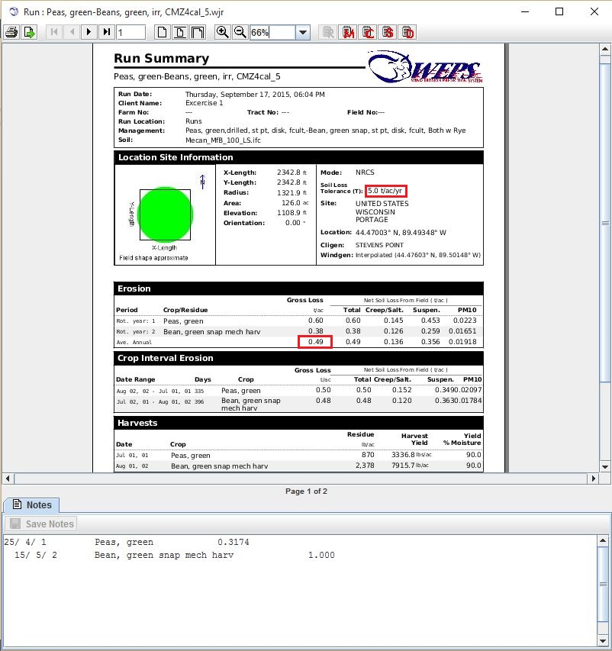
Figure 3.32 The third Summary Report, predicting that the Rye cover crop would reduce Gross Loss to below Soil Loss Tolerance.

