Exercise 2 - Adding a Crop to a Rotation

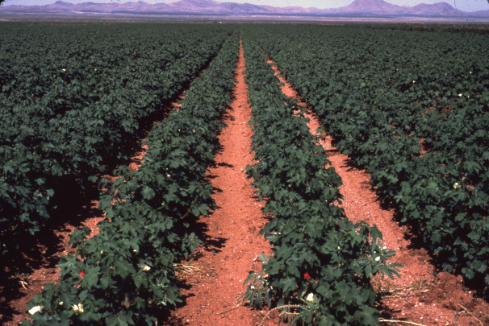
Skill Building: In this exercise, we begin with a pre-built management file and make a run. Then we add another crop to the rotation in the management editor and make a second run. We will also consider a strip tillage system and reduced tillage to address the erosion problem.

Scenario
- The farm is located in Lubbock County, Texas, south of the airport (use the default location for Lubbock Co.).
- The soil in the field is Amarillo Loamy Fine Sand.
- The crop rotation is continuous Cotton, stripper. It may be helpful to add Milo or Sorghum to the rotation.
- There is also some new technology from Texas A&M, using Strip Tillage and Ridge Till Planters that we would like to model for an alternative.
- The field is a half section of land (320 acres) and is oriented east and west.
- Normal yield for the Cotton is ¾ bale or 375 lbs lint/ac. Sorghum should yield an average 25 bu/ac.

Getting Started
Step 1: Start up the WEPS interface and add the information shown in Figure 3.33. Be sure to show the field as a rectangle (simulation area as 5280 by 2640 feet) with the short side (Y-length = 2640 ft) on the east and west, as shown in Figure 3.33.

Step 2: Click the ‘Man’ pull down black arrow (lower right side) to display the managements in the project folder. Load the pre-built file called Cotton, stripper; FC, SCsweep, Bed.man by clicking the name of the file on the list. Make a standard run as shown in Exercise 1 (Figure 3.19) by clicking the Run button . Type in the run name of: Cotton, stripper, Conv, TX. Upon completion, the Run Summary will appear as seen in Figure 3.34.
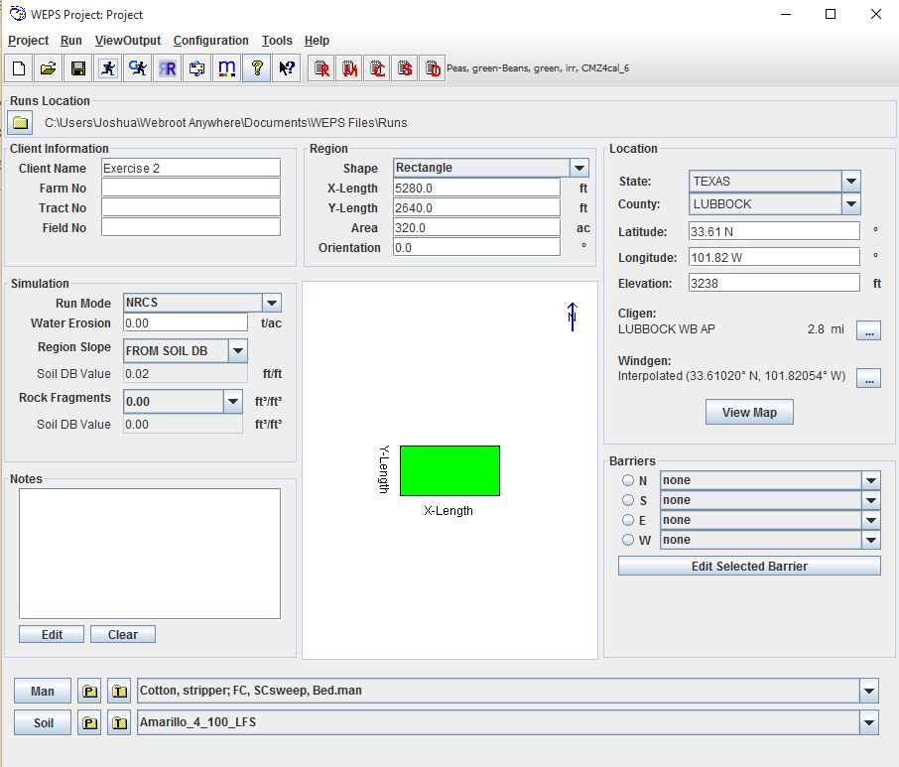
Figure 3.33 The WEPS interface loaded for Exercise 2 initial sequence.

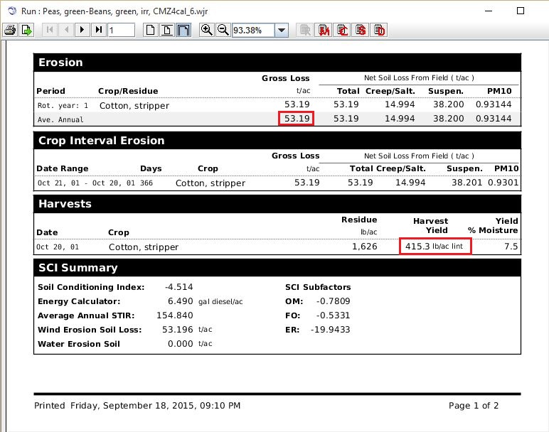
Figure 3.34 Summary Report showing average annual soil loss and the yield of lint.

The continuous Cotton run gave a 53.2 t/ac/yr soil loss. How much cotton lint is listed? Answer: 415.3 lbs/ac/yr. The inventory states that we should have 375 lbs/ac lint. Is this different enough to calibrate the cotton yield? Yes, because the predicted Harvest Yield exceeds the Expected Yield by greater than 5%. Following what was learned in Exercise 1, calibrate the yield to 375 lbs lint/ac. After the calibration run has completed, a Biomass Adjustment Factor of 0.9531 is displayed. Select Use in Current Project. The new harvest yield estimate is realistic at 386.0 lbs/ac lint, but soil loss is even more excessive at 58.6 t/ac/yr.

What can be done when the soil loss is too high? Let’s consider some options for lowering soil loss.

What is the total residue (flat mass) at planting time? Hint: Open the Detailed Report and check the total flat mass of residue at that time on the Erosion & Crop Veg Res & Biomass (details) report.
Answer: About 49 lbs/ac and 2% surface cover (Figure 3.35) are present at planting.

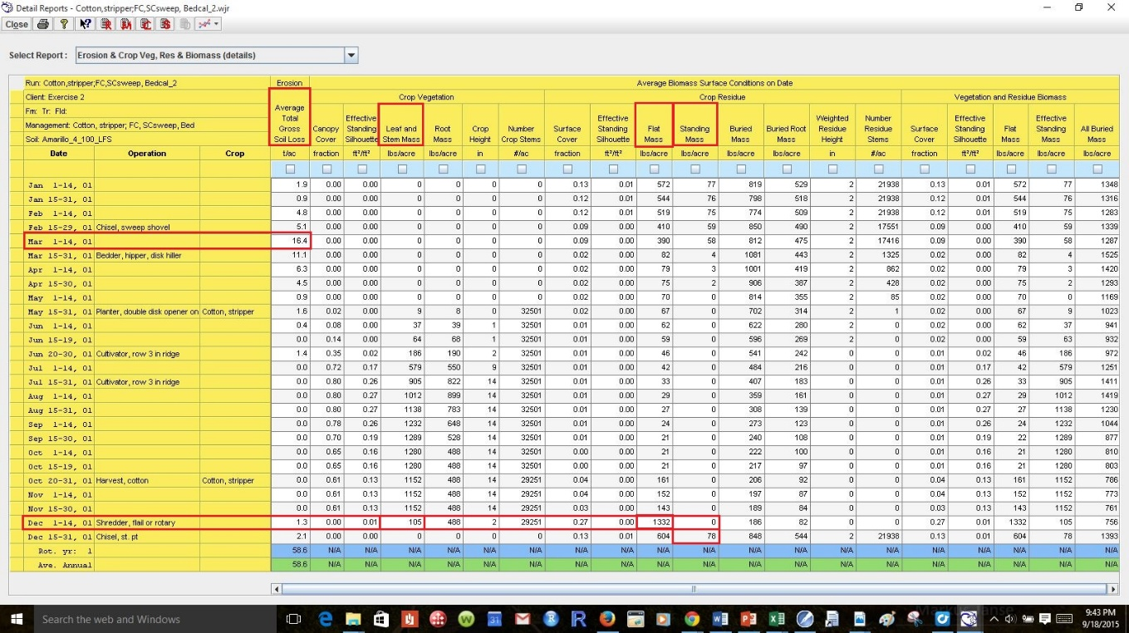
Figure 3.35 Detailed Report showing loss and residue at the planting and vegetative material at harvest.

What management period has the highest erosion loss?
Answer: After the Chisel, sweep, shovel operation (Mar 1-14, 01), 16.4 tons/ac (Figure 3.35).

How much total residue do we have after the Shredder, flail or rotary operation?
Answer: The residue after shredding is 1437 lbs/ac (105 leaf and stem + 1332 lbs/ac flat mass + 0 lbs/ac standing mass) (Figure 3.35). Notice: Cotton in this case was not killed by the stripper harvest. Cotton is a perennial so the harvest and the shredding does not kill the crop. However, frost or tillage would kill the crop. If a defoliant was used before harvest, the leaf residue would have shown up at that time. Cotton does not produce enough residue by itself to control the erosion. After the Chisel, st. pt the crop is killed, Dec 1; there are 78 lbs/ac standing residue.

We will add sorghum to the rotation to see how it affects the residue and erosion rates.

Adding a Crop to a Rotation
Close all the report windows, leaving only the main interface window open. Click the ‘Man’ button 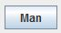 to open the MCREW management editor.

Step 1: Right-click the last row in the Operation Name column of the cotton file. Select Insert Management and double-click the Example Mgt. files directory. Choose Sorghum,Grain;MT,CMZ19.man and click the Select button .

Note: The sorghum crop comes into the rotation in the second year, yet the dates are correct, because both single management files have all their tillage in one year, (not 0 and 1 as with some RUSLE files) with fall tillage. The dates seem reasonable. Be sure to click the Yield Calibration button and enter 25 bu/ac yield as expected for the new sorghum crop. Check that you have 375 lbs/ac yield for the cotton and that both “Calib. Yield?” boxes are checked.

Step 2: The file must be saved with a new name. The rotation name in the Rotation box has turned blue, showing that it has been modified (Figure 3.36).

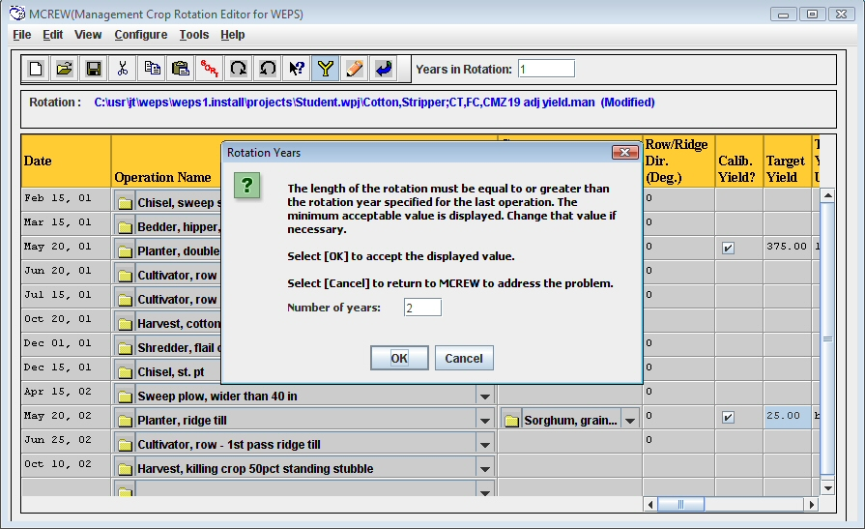
Figure 3.36 MCREW will ask for a number of rotation years if a crop was added with dates that increase the number of years.

Click File then Save as.... Notice MCREW has detected that we only have “1” in the year box (Figure 3.36). We must either change the value in the box to a number other than 1 or accept 2. Click OK to accept the change to a 2 year rotation.

MCREW then asks for a new name for the 2 year rotation. Enter Cotton, Stripper; FC, SCsweep-Sorghum, MT.man, and click ‘Save’. Note that it saved the new 2 year rotation to the C:\Users\your.name\Documents\My WEPS Files\ Project.wpj. This is a temporary working directory. To save this as a local template management file, you must (in MCREW) click ‘file,’ ‘save as Template…’, and ‘save.’ You have the option to either change the name or leave it as it was. It will be stored in the C:\Documents and Settings\All Users\Application Data\USDA\WEPS\Databases\nrcs\man\local folder. You may wish to post it to a shared server site if others in your work group can use the same management.

Step 3: Make the new run. This time let’s see if WEPS will give us an appropriate yield for the sorghum in this rotation. Return to the main interface by clicking the Close button . Click the Run button and call the run Cotton, stripper, Conv-Sorghum, MT, TX.

What is the soil loss?
Answer: The Run Summary shows an unacceptable predicted average loss of 55.46 t/ac/yr (Figure 3.37). The yields for both crops are also too high at 435.2 lb/ac of Cotton lint and 52.9 bu/ac for Sorghum grain.

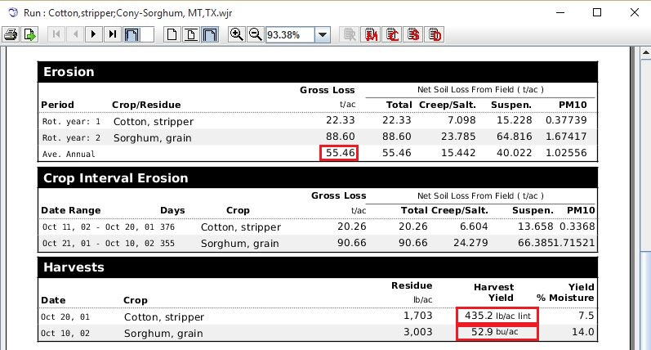
Figure 3.37 Run Summary showing the soil loss and the yields without calibration.

Close the run summary and make a calibrated run by clicking the Calibrate Run button . Name this run Cotton, stripper, Conv-Sorghum, MT, TX cal. Click Use in the Current Project (Figure 3.38).

Figure 3.38 Calibration window showing Biomass Adjustment Factors for each crop.

Predicted yields for the calibration run are reasonable at 379.2 lb/ac cotton lint and 25.0 bu/ac sorghum. The problem of yield overestimation is resolved, but soil loss is even higher now at 84.84 t/ac (Figure 3.38)

How much flat mass do we have now after planting Cotton on the detailed report?
Answer: Remember to click the Detailed Report and select the Erosion and Crop Veg, Res & Biomass (details) screen (default). On May 15-31, there is about 172 lbs/ac flat mass, and the erosion rate is 1.6 tons/ac at cotton planting (Figure 3.39).

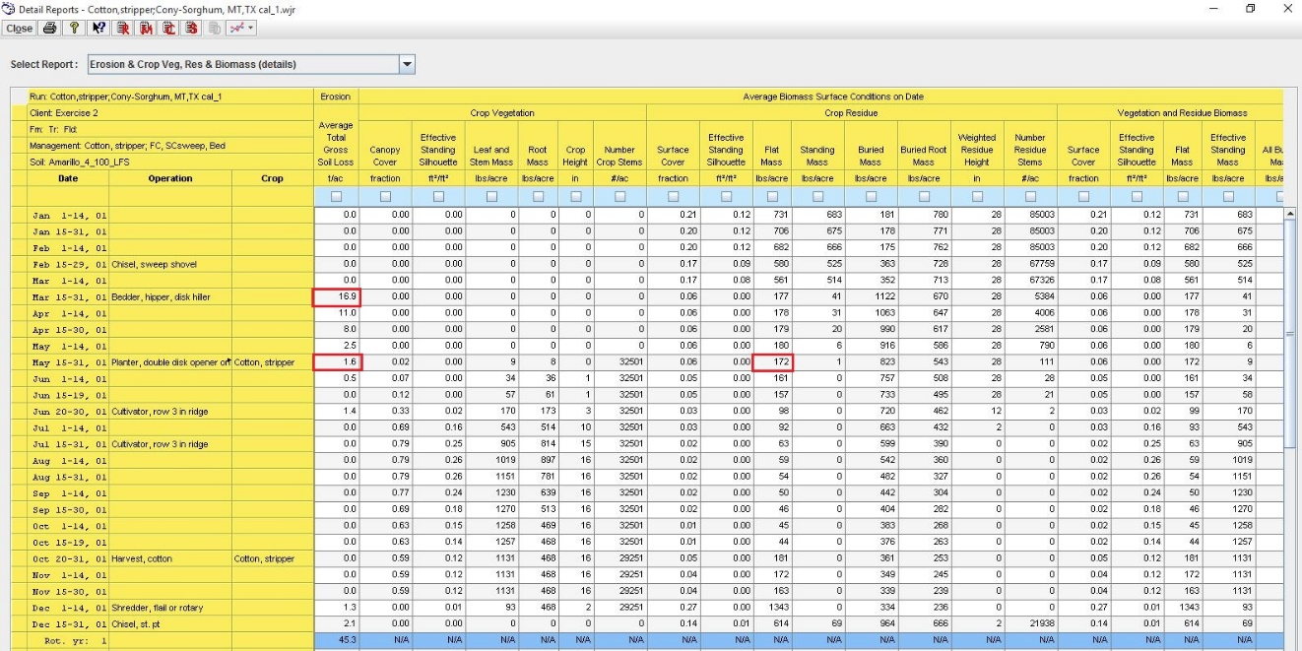
Figure 3.39 Detailed Report showing soil loss and flat mass.

What is the date of the first erosion period after harvest of the sorghum?
Answer: After the Bedder, hipper, disk hiller, ‘Mar 15-31, 01’ at 16.9 tons/ac/yr (Figure 3.39).

The average annual wind erosion of 84.84 tons/ac is still too high. Reduced tillage may save a considerable amount of soil.

Reduced Tillage
Let’s try one last set of adjustments to our set of runs. We know cotton is glyphosate ready for weed control, and strip-till works for cotton. We also know that standing residue is much more effective than flat residue at controlling erosion. We will start with the last run and reduce some of the tillage. Close the report windows, leaving only the main interface window open.

Step 1: Click the ‘Man’ button on the main interface. Be sure that you have the Cotton,Stripper; FC,SCsweep-Sorghum, MT.man file loaded. We are going to change, remove, or replace most of the tillage operations. Pressing and holding the Control Key on your keyboard while clicking enables you to select nonconsecutive operations. When all unnecessary operations are highlighted, right-click under the Operation Name column to select “Delete row(s)” as shown in Figure 3.40.
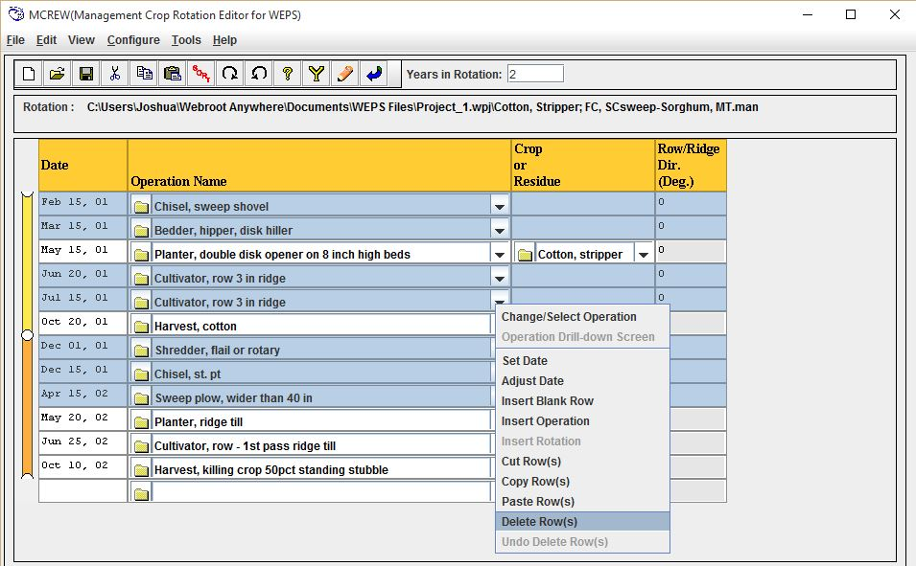
Figure 3.40 Removing excess tillage operations.
Step 2: Change the standard planter for the cotton from Planter, double disk, oprn to Planter, ridge till by clicking the drop-down arrow on the Planter double disk, oprn row and selecting the Planter, ridge till operation (Figure 3.41). In the same way, change Cultivator, row – 1st pass ridge till on June 25 to Sprayer, post emergence.
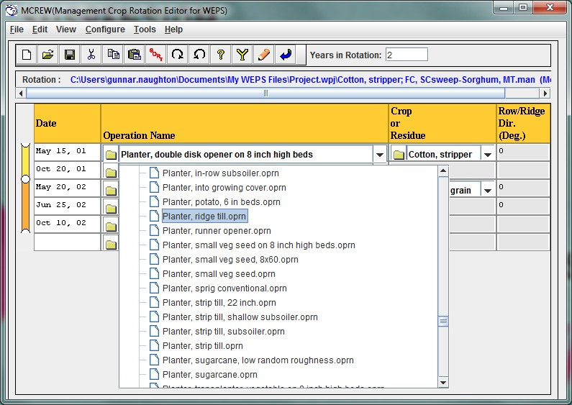
Figure 3.41 Illustration of changing operations.

Step 3: Add alternative operations. Right-click the May 15 operation Planter, ridge till and select Insert Operation. Double-click the NRCS Operations folder and scroll to find Strip till bed conditioner oprn (Figure 3.42). Once selected, this operation will be placed above the operation name you clicked to insert it. They will also share the same date as the operation above it (or below it if it is the one at the top) until modified appropriately. Continue to delete, change or add operations until the MCREW matches Figure 3.43.

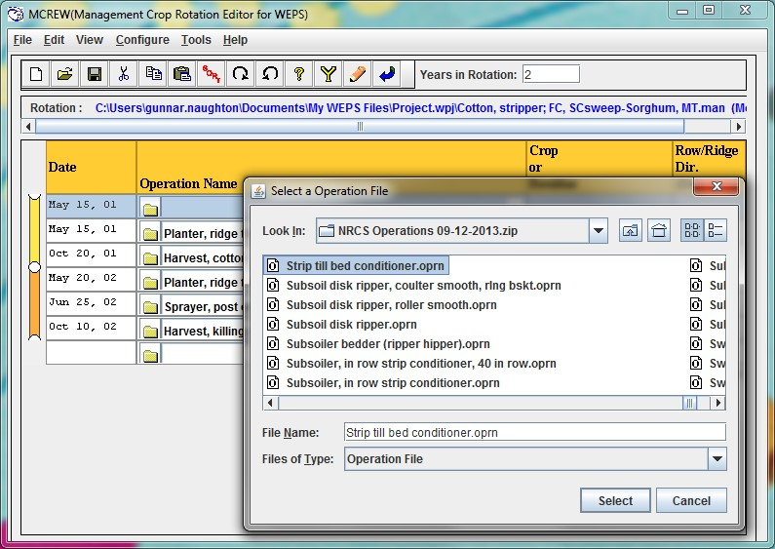
Figure 3.42 MCREW window showing all dates and operations needed to make the ridge till alternative.

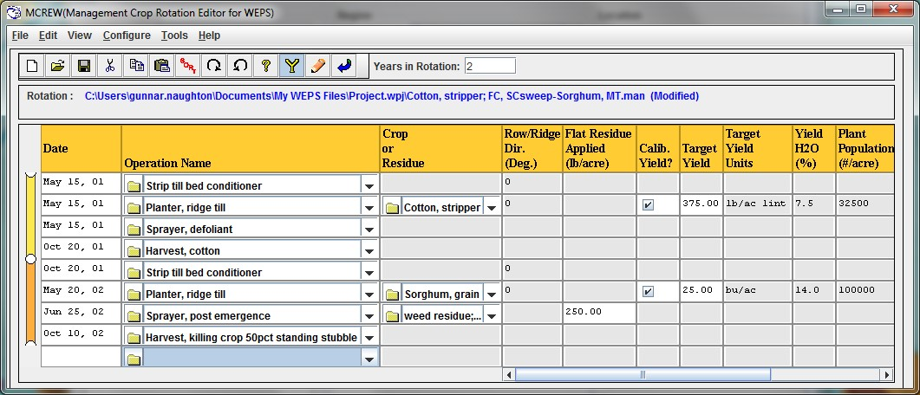
Figure 3.43 Operations prepared for the reduced tillage calibration run.

Be sure the yields are set to 375 lbs/ac for cotton and 25 bu/ac for sorghum. Save the new file as Cotton, stripper, striptill-Sorghum, striptill CMZ19, and close MCREW to return to the interface.

Note: In the future you may decide that a new management file is worthy of addition to what is known as the Local Management subdirectory. To do this, follow these steps: 1) Start with the edited and tested management file loaded in MCREW. It must have any Biomass Adjustment Factors to make the run for that locality where it will be used. 2) The location to save a Template Management Local file is C:\Documents and Settings\All Users\Application Data\USDA\WEPS\Databases\db\man\NRCS\local. 3) Save the file by clicking ‘File,’ then ‘Save as Template’, and navigate to the above directory. Use the name you have given it or one consistent with any naming conventions the FO has chosen to use. 4) Click ‘Save’.

Note: NRCS field offices are able to save templates to a networked server drive. The user must create a subdirectory in order to store runs for an individual farm or customer. This allows the local work group to have access to any locally made records.

Step 4: Make the calibrated run, since there were major revisions to the tillage. Call it Cotton, stripper, striptill-Sorghum, striptill CMZ19 cal. When the run is complete and the factors are displayed, click ‘Use in Current Project’ in the Calibration Factors window.
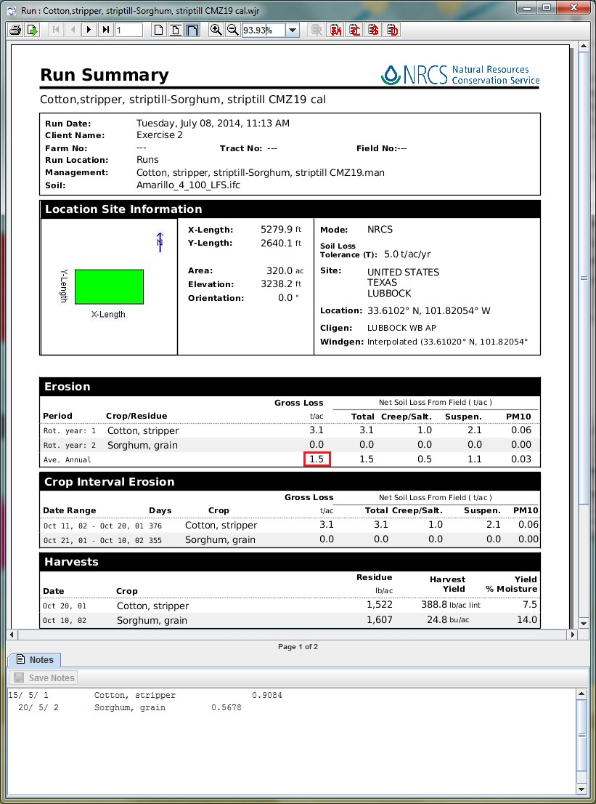
Figure 3.44 Run summary showing Average Annual Soil Loss of 1.5 tons/acre.

Average Annual Soil Loss is now predicted to be only 1.5 tons per acre (Figure 3.44). This run shows that it is possible to effectively control erosion using a cotton-sorghum rotation as designed in Figure 3.43. Leaving the cotton stalks standing is very effective at controlling wind erosion. The Detailed Report shows there is 939 lbs/ac Flat Mass and 25% Surface Cover of sorghum residue after planting cotton, and 706 lbs/ac Flat Mass, 17% Surface Cover of cotton residue after planting sorghum (Figure 3.45).

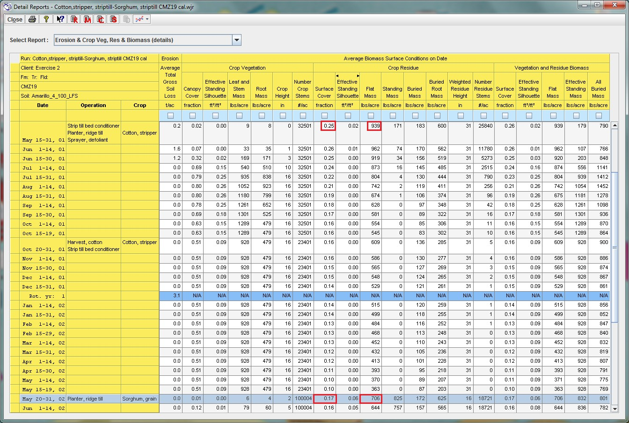
Figure 3.45 Detailed Report showing surface cover needed to meet the Soil Loss Tolerance.

