Exercise 3 – Management Templates and Adding Irrigation

Skill Building: This exercise begins with a template management run of winter wheat and fallow. The user will make a run, calibrate the run with an alternative crop, some added operations, and finally, supplemental irrigation.

Scenario
- The field is located in Haakon County, South Dakota.
- The Cligen station is Milesville.
- The Windgen station is Interpolated.
- The critical dominant Soil Map Unit is CRAFT_Cv_85_VFSL.
- The existing cropping system is Winter Wheat-fallow.
- The field is a 160 acre square, oriented 45 degrees from North.
- Management includes fall chisel at a 45º angle to the field borders after the winter wheat harvest, producing about 40 bu/ac/yr.
- The dry land yield for sudangrass added later should be 1.5 ton/ac/yr.

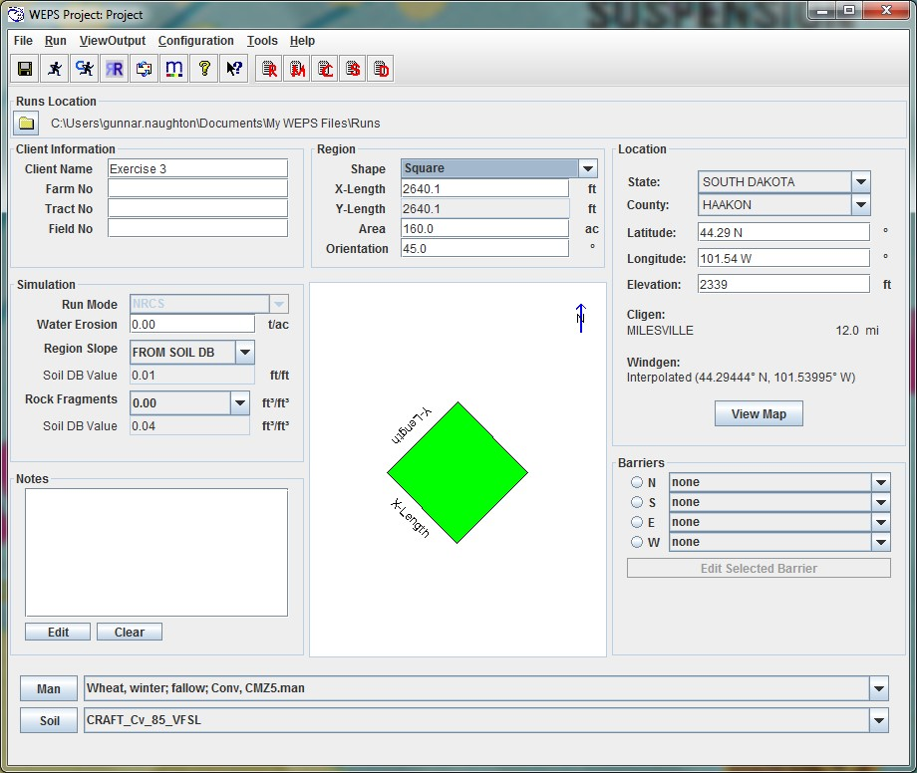
Figure 3.46 The WEPS interface set with the basic information for Exercise 3.

Getting Started
Step 1: Enter all the data shown in Figure 3.46. Be sure to change the field Orientation to 45.0º in the Simulation Region information panel. You will see the field orientation rotate in the Field View panel.
Open a template file by clicking the ‘Man’ dropdown button to the lower right of the screen. Scroll down to ‘Templates’, then ‘NRCS’, then click ‘Example Mgt. Files’, then select WWheat-fallow, Conv, CMZ5.man. Open MCREW and see that the operations are set to 45º as well. If they are not already oriented, click and drag to highlight all the operations, right-click in the Row/Ridge Dir. (Deg.) column, and select Set to 45 deg. The fall chisel (Oct 20, 02) direction should be 0º or North because the field angle is 45º. If you do not make these changes, there will be a different result that what is presented in this exercise. Figure 3.47 displays the correct MCREW setup for this run.

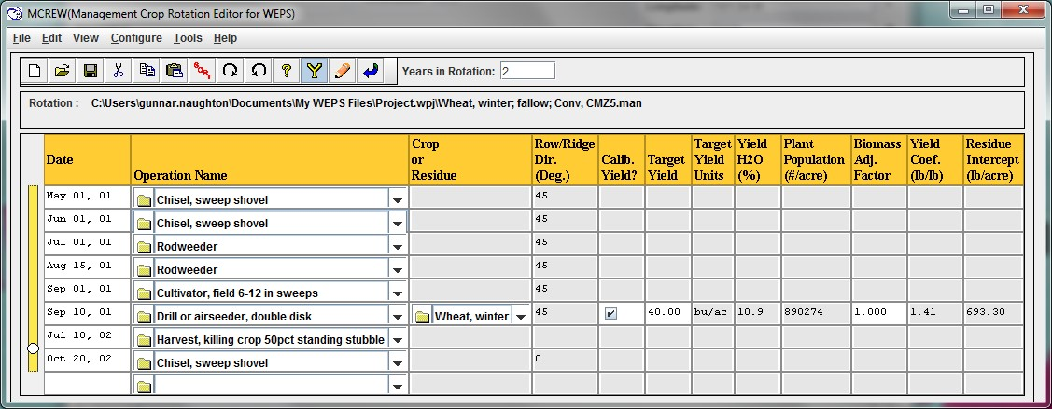
Figure 3.47 Management Crop Rotation Editor showing correct Row/Ridge direction.

Click the Yield Calibrate button to turn on the yield function and ensure Target Yield is set to 40 bu/ac. Click the Return button to close MCREW and return to the WEPS interface.

Step 2: Make a Yield Calibration WEPS Run and name the run WWheat-Fallow, Conv, CMZ5 cal. On completion, the Biomass Adjustment Factor of 0.7656 is displayed. Click Use in Current Project.
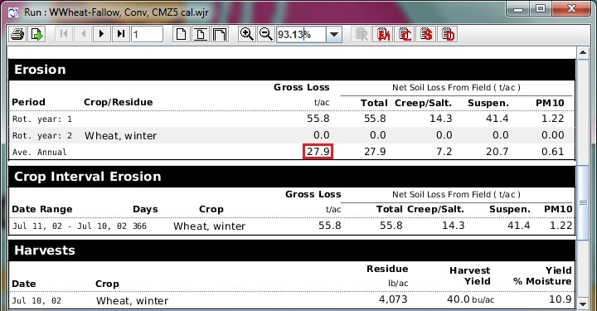
Figure 3.48 Calibration Run Summary

The Average Annual Soil Loss is 27.9 ton/ac (Figure 3.48).

Adding Sudangrass
It may be beneficial to replace the fallow with a short sudangrass forage crop. Note that forage crops are not calibrated. WEPS will simulate the crop growth without calibration.

Step 1: Reopen MCREW. Make a new management file called Wheat, winter-Sudangrass, forage, Conv, CMZ5.man, by clicking ‘File’, ‘Save as...’, and type the new name before saving.

Planting time for sudangrass is April 15, so we need to add a chisel and a field cultivator to the file before planting. These operations must be scheduled with two-day intervals, beginning in the spring time of the second year. Change the date of the spring chisel from ‘May 01, 01’ to ‘Apr 11, 01’.

Right-click the date on the next line (June 1), and change the date to ‘Apr 13, 01’. Then change the operation to Cultivator, field 6-12 in sweeps.

On the next line, change the date to Apr 15, 01 and the operation to Drill or airseeder, double disk. A drop-down box appears to the right, in the Crop or Residue column, saying “no crop”. Click the drop-down arrow and scroll to find Sorghum, forage. Sudangrass is a type of sorghum.

Next, change the ‘Aug 15, 01’ line to a hay harvest line (Harvest, hay, no regrowth operation) with a ‘Sep 01, 01’ harvest date.

Now we shall add another Chisel, sweep shovel before the Cultivator, field 6-12 in sweeps. Right-click the Chisel, sweep shovel operation on the top row and select ‘Copy Row(s)’. Right-click the Sep 01, 01 Cultivator, field 6-12 in sweeps and select ‘Paste Row(s)’. Now change the date of the pasted operation to Sep 03, 01 and the following cultivator to Sep 05, 01.

Next, correct the information in the Row/Ridge Dir. (Deg.) column so that the direction of all the tillage operations is 45º, except for the Oct 20, 02 chisel, which must remain at 0º. The updated management file should look as in Figure 3.49. Finally, click the Save button to save the management. Return to the WEPS interface.

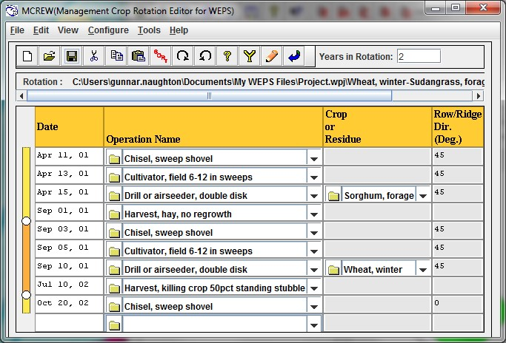
Figure 3.49 Management file with Sudangrass added.

Step 2: Since the Sudangrass uses soil moisture where it had been saved in the previous fallow period, the winter wheat will need recalibrated. Make the calibration run and call it Winter Wheat-Sudangrass, forage, conv, CMZ5 cal.

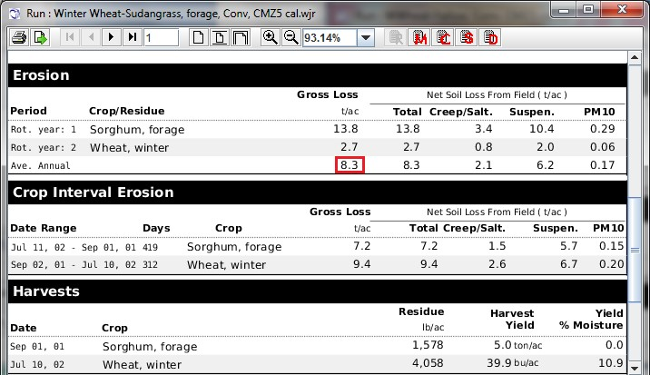
Figure 3.50 Run Summary showing reduced soil loss after growing the Sudangrass forage crop.

The Calibration Factors window appears on completion of the calibration run, showing that the Biomass Adjustment Factor of the winter wheat is 1.592. The Run Summary shows a soil loss prediction of 8.3 ton/ac (Figure 3.50Figure 3.50). This is a substantial reduction of the erosion rate from the previous annual average of 27.9 t/ac, but further protection is still necessary.

Adding Supplemental Irrigation
The producer can apply about 12 inches of water per year to the crops and would like to see what the effect would be on the yield and erosion loss. This question is rather easy to answer.

Step 1: Click the Man button 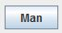 to open up the last management we ran: Wheat, winter-Sudangrass, forage, Conv, CMZ5.man. Save a new version of this rotation by clicking File, Save as... and adding irrigation to the name: Wheat, winter-Sudangrass, forage, Conv, irr supplemental, CMZ5.man.

The producer wants to add supplemental irrigation to see the effect on yields. Right-click the first line in the Operation Name column and click ‘Insert Operation’. Select Irrigation (2 inch, Pivot, Linear, Wheelline), and change the date to Apr 01, 01. Now use the copy-paste function by right-clicking on the irrigation operation just created and click ‘Copy Row(s)’. Now right-click in the Harvest, hay, no regrowth row and click ‘Paste Row(s)’. Repeat until there are six irrigation operations, then change the dates to Apr 01, Apr 20, May 15, Jun 15, Jul 15, and Aug 15, all with year of 01. The wheat also needs the two-inch irrigations on Sep 15, of year 01, and Mar 01, Apr 01, May 01, Jun 01, and Jun 15 of year 02. You can copy the six lines of irrigation for the sudangrass by left-clicking and dragging the mouse over the five consecutive sudangrass irrigations to highlight them, then holding down the ‘Ctrl” key while clicking the separate Apr 01, 01 irrigation operation (Figure 3.51).
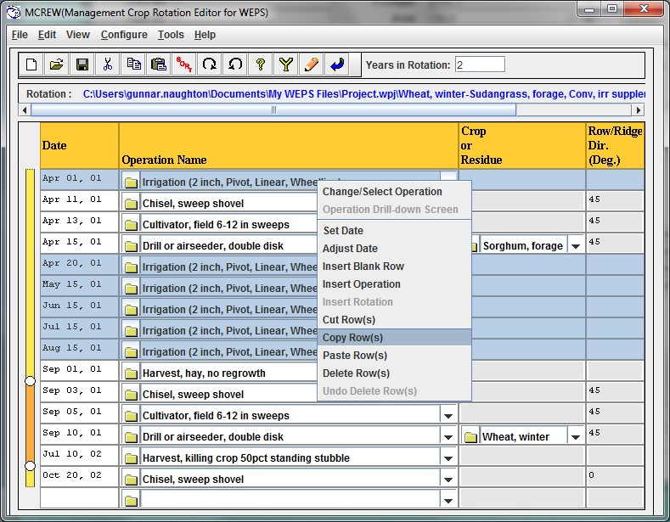
Figure 3.51 Clicking, dragging, and using the ‘Ctrl’ key to highlight all six irrigation operations for copying.

With all six irrigations highlighted, right-click, copy, and paste in the blank row at the bottom of the file. When all the correct dates have been entered, the file must be sorted by clicking the Sort button in the tool bar. Click the Yield Calibration button and set the Biomass Adjustment Factor for wheat to 1.000. This management file will be run without calibration in order to show how much the irrigation might increase the yield. The completed MCREW file should match Figure 3.52. Click Save .

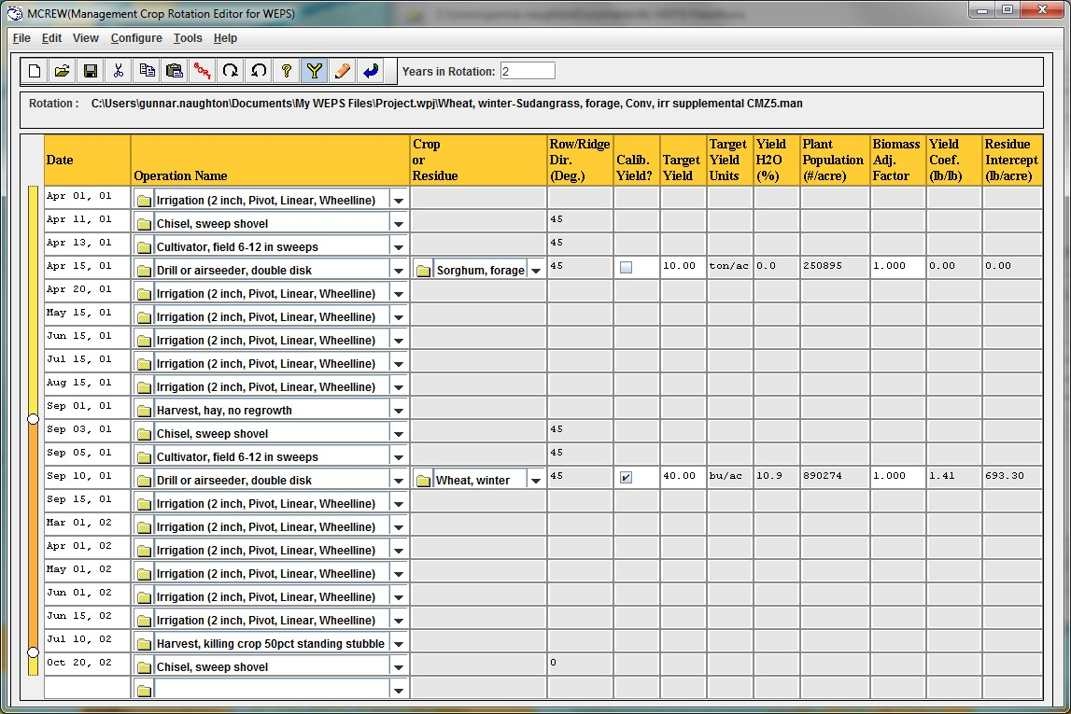
Figure 3.52 MCREW with the irrigation operations.

Step 2: Return to the main interface. Change the Simulation Region Shape to Circle, then type 120 ac in the area box. Click the Run button and name this run Wheat, winter-Sudangrass, forage, Conv, irr supplemental, CMZ5.

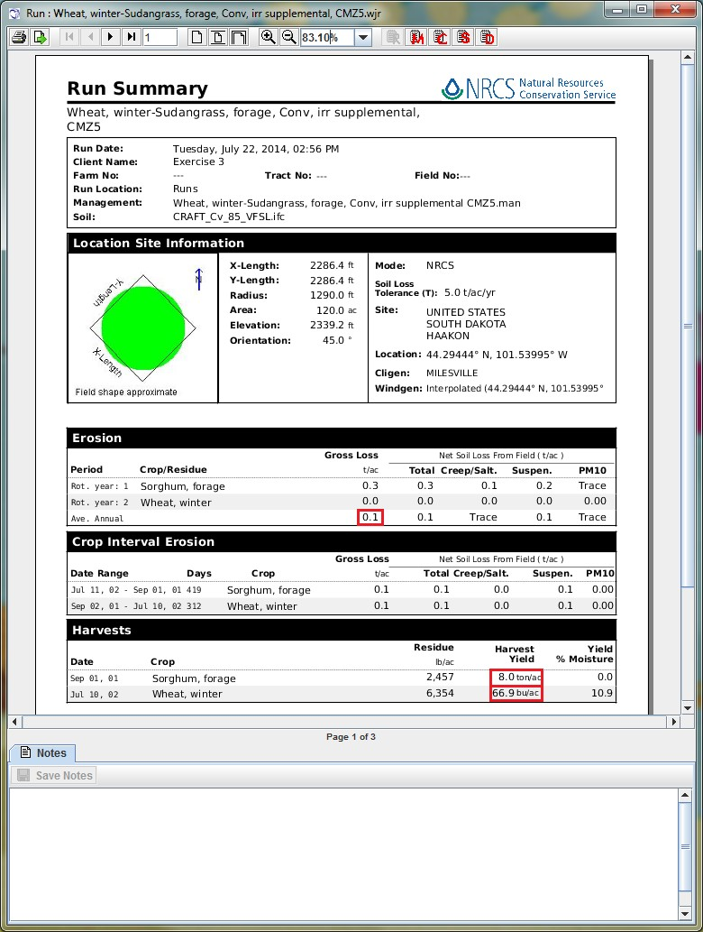
Figure 3.53 Run Summary showing Gross Loss of soil and Harvest Yields after supplemental irrigation.

The wind erosion problem has been resolved, with the estimated average annual soil loss having decreased to 0.1 t/ac/yr. The wheat yield increased to 66.9 bu/ac and the sudangrass hay yield increased to 8.0 t/ac (Figure 3.53). This may not be a good investment to add the full 12 inches of water per year.

Note: This example shows how to use supplemental irrigation. If you want to use full irrigation to meet crop consumptive use, put a Start Monitor (Pivot, Linear, Wheelline) operation just after planting and an Irritation, Stop Monitor operation 15 days before harvest. This will auto-irrigate the crop during the growing season similarly to the way Exercise 1 was run.

