Exercise 8 – DRAFT: Critical Dominant Soil

Skill Building: WEPS currently estimates only one soil map unit in a field at a time. Therefore, it is recommended that the user select the most erodible soil of a “manageable size”. This is called the “Critical Dominant Soil.” The Critical Dominant Soil is that which typically is the first to blow on the field and dominate the wind erosion process and is therefore critical for conservation planning.

The most erodible soil can be considered to be the one with the highest percentage of sand. For example, a fine sandy loam will be more susceptible to erosion than a loam. It is important to pay attention to the soils within the field when setting up a WEPS run. The WEQ (Wind Erosion Equation Error! Reference source not found.) I factor may be used to get some idea of the erodibility of the soils.

Example: Consider the soil map of a field in Grant County, Washington (Figure Error! No text of specified style in document..1). There are three map units in the semicircle. When determining the Critical Dominant Soil, the general guideline is to use the most erodible soil composing greater than 10% of the field or greater than 10 acres in size (i.e., a manageable size).
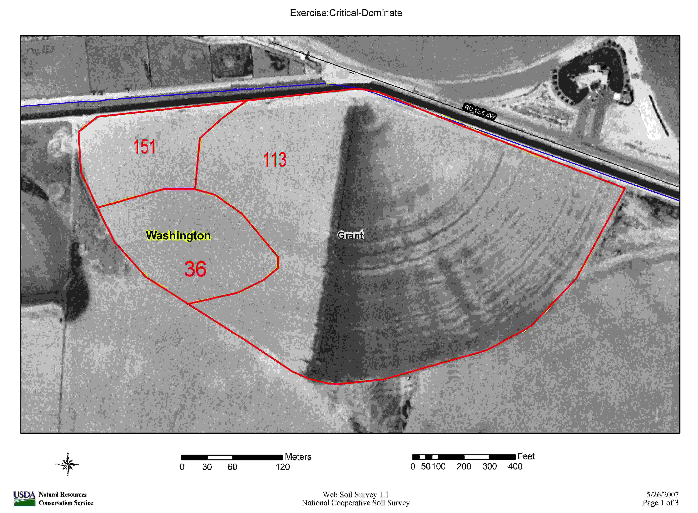
Figure Error! No text of specified style in document..1 Map showing the soil map units of a field.

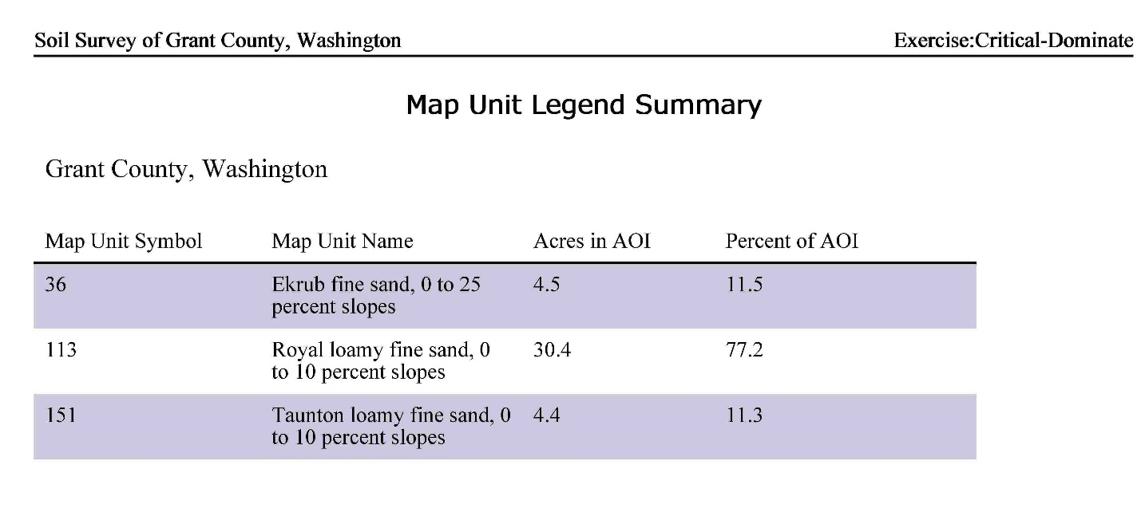
Figure Error! No text of specified style in document..2 Map Unit Legend Summary for Error! Reference source not found..

The total of the field is 39.3 acres.

Question: What soil should be used to estimate the soil loss?

Answer: From the figures we see that the Royal loamy fine sand (map unit 113) and Taunton loamy fine sand (map unit 151), comprise the majority of the field with 88.5% of the area. The Ekrub fine sand (map unit 36) makes up 11.5% of the area (Figure Error! No text of specified style in document..2). However, the Ekrub fine sand should be used since it is the Critical Dominant Soil. It was selected because 1) it is the most erodible soil in the field; 2) it comprises more than 10% of the field; and 3) it is upwind of the damaging westerly spring winds.

By using the Critical Dominant Soil within the field, we can ensure that we are considering the most erodible part of the field. By controlling wind erosion on that portion, it is highly likely that erosion will controlled on the entire field.

