INTRODUCTION


How To Use This Document

The Wind Erosion Prediction System or ‘WEPS’ is a process-based, daily time-step, wind erosion simulation model. It represents the latest in wind erosion prediction technology and is designed to provide wind erosion soil loss estimates from cultivated, agricultural fields. WEPS 1.5 consists of the computer implementation of the WEPS science model with a graphical user interface designed to provide easy to use methods of entering inputs to the model and obtaining useful user output reports. WEPS was developed by the former Wind Erosion Research Unit (WERU), now Agricultural Systems Research Unit (ASRU) of the United States Department of Agriculture, Agricultural Research Service.

The WEPS 1.4 User Manual is designed to provide information to different levels of users. Those users who are completely new to WEPS should start by reading all of this chapter to get an introduction to WEPS. It is recommended that, as a minimum preparation to use WEPS, the user should read the “Overview of the Wind Erosion Prediction System.”

The minimum computer requirements and the steps to install WEPS onto your computer are described in this chapter. Once WEPS has been installed on your computer, you should learn how to make a simple simulation run using the “Quick Start for WEPS 1.5." More experienced users should become familiar with the “Interface Reference - How to Operate WEPS”, which goes into detail of how to use all of the capabilities of WEPS 1.5. These details are also available in the ‘Online Help,’ accessible through the toolbars on the WEPS 1.5 interface screen.

“Using WEPS in Conservation Planning” contains sections on ‘Interpreting Outputs’, ‘Special Field Configurations’, and ‘Using Barriers for Erosion Control in WEPS.’ This section also has ‘Exercises,’ which guide the user through scenarios that describe how to use WEPS to design conservation systems.

The “Science Overview” contains information for more advanced users. For users interested in more detail on the interface and science behind WEPS, ‘Interface Implementation and Science Model’ is recommended. An even more detailed description of the science of the WEPS model is available in the “WEPS Technical Description,” which can be obtained from ASRU.

The Science Overview also contains information for more advanced users, such as the WEPS ‘Databases’ and a listing of ‘Submodel Report Flags and Command Line Options.’ Databases are described for the Weather, Soil, Management, Crop, Operation and Barrier sections of WEPS. Submodel Report Flags and Command Line Options are set under the ‘Configurations’ tabs available through the “Tools” menu on the Main Screen of the interface. Certain permissions may be required to alter some of these flags and options. There is a section on “Using WEPS with Measured Data” that will be useful to researchers and other users, such as those outside the United States who do not have their soils data in the SSURGO database format.

Finally this manual contains a series of “How To” Guides which provide the user with in-depth detail of simulating barriers and strip cropping. There are also “How To” Guides that guide the user in developing additional crop and operation database records.
Throughout this manual, the term “user” refers to the person(s) using WEPS 1.5 to set up and make a simulation run. The term “operator” refers to the producer or land manager whose actual field is being simulated with WEPS. This manual contains many graphics that are examples of what can be seen on the computer screen using WEPS. In addition, WEPS will continually be improved and the screens may change. Therefore, the user may or may not see the exact same screens as those illustrated in this manual.

WEPS is a model developed primarily for use by the USDA, Natural Resources Conservation Service (NRCS). As such, many of the capabilities of WEPS reflect the needs of NRCS for use in cultivated agricultural systems. But, WEPS has capabilities to be used in many other situations where wind affected soil movement is a problem. Contact ASRU if you wish to use WEPS to predict erosion for situations other than traditional cultivated agricultural systems.

Minimum Computer Requirements

The minimum recommended requirements to install and operate WEPS 1.5 are: an Intel Pentium class processor, or equivalent, personal computer (PC); Windows 7 or newer Microsoft operating system; 1 Gb RAM; 2 Gb free disk space; internet web access to download for installation; and a VGA color monitor with a minimum screen resolution of 800 x 600 pixels. WEPS also requires Java 1.8 or later (must be installed prior to installing WEPS). WEPS has been run in the past on older releases of Windows, but is no longer tested on them. Configurations for Linux and Unix are also available. Contact ASRU if you need versions for Linux/Unix assistance.

The recommended requirements to install and operate WEPS 1.5 effectively are: an equivalent of an Intel Core I-3 processor, or better, personal computer; Windows 7 or newer Microsoft operating system; greater than 2 Gb RAM; greater than 20 Gb of free disk space, internet web access to download WEPS for installation; and a color monitor with 1024 x 800 or better pixel resolution. Java 1.8 or later must be installed prior to installing WEPS.

Installation

To install the packaged version of WEPS, one must be logged in as “Administrator” or as a user with sufficient “privileges” to install Windows programs. To initiate the installation process, just double click with the left mouse button on the “WEPS” msi file package, which will at least contain the name “weps”, the version number and the build date, for example: weps_1.5.10_(2016-03-04).msi Simply follow the installation prompts and provide the requested information.

Again, note that on Windows 7 and newer machines (and possibly XP and Vista, depending on how they are configured), the user must either be logged in as “Administrator” or have sufficient privileges to successfully install WEPS. The WEPS installation program will inform the user attempting installation if they do not have sufficient privileges to perform the installation.

WEPS 1.5 is available for download on the ARS web site at:
https://www.ars.usda.gov/services/software/download.htm?softwareid=415#downloadForm. Fill in the required form fields and click on the “Take me to the download”. If you fill out the registration form, ASRU will provide email notices of updates to the model. The download file consists of an executable “msi” file that will install WEPS onto your Windows computer. Contact ASRU if you need assistance at:

USDA-ARS Agricultural Systems Research Unit
2150 Centre Ave., Bldg. D Suite 200
Fort Collins, CO 80526

Phone: 970-492-7382
E-mail: weps@ars.usda.gov

NOTE: NRCS users must obtain official copies of WEPS through their agency’s official channels. The release of WEPS provided by NRCS is pre-configured to their specifications. Contact Joel Poore, Wind Erosion Specialist, for the NRCS specific release of WEPS at:

Joel Poore, NRCS
Phone: 817-509-3213
E-mail: Joel.Poore@ftc.usda.gov

WEPS Installation Steps

Installation

To install the packaged version of WEPS, one must be logged in as “Administrator” or as a user with sufficient “privileges” to install Windows programs. On Windows 7 and newer machines (and possibly XP and Vista, depending on how they are configured), the user must either be logged in as “Administrator” or have sufficient privileges to successfully install WEPS. The WEPS installation program will inform the user attempting installation if they do not have sufficient privileges to perform the installation.

To initiate the installation process, just double click with the left mouse button on the “WEPS” msi file package, which will at least contain the name “weps”, the version number and the build date, for example: weps_1.5.10_(2016-03-04).msi Simply follow the installation prompts and provide the requested information. Screenshots of the process are shown below.

In some instances, the first window that will display is the Open File – Security Warning message (Figure 1-1). Simply click on the “Run” button in that window if it appears.

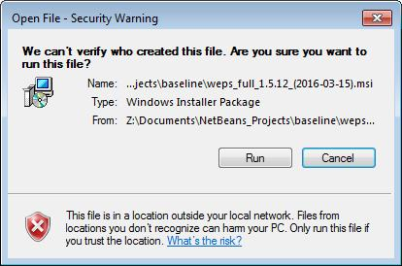
Figure 1-1 Security warning message that may appear when attempting to install WEPS.
The first WEPS window to appear is the setup welcome screen (Figure 1-2).

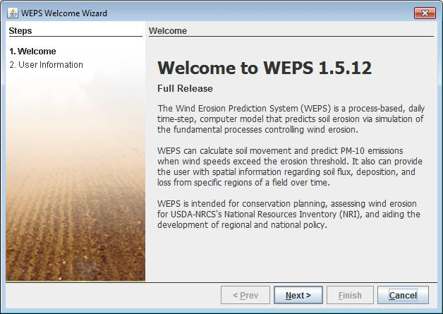
Figure 1-2 WEPS initial setup window.
The next window that will appear is the WEPS Setup Destination Folder (Figure 1-3). It will display the default WEPS installation folder and allow the user to change that location if desired. Once the desired location is specified, click on the “Next” button at the bottom of the screen.

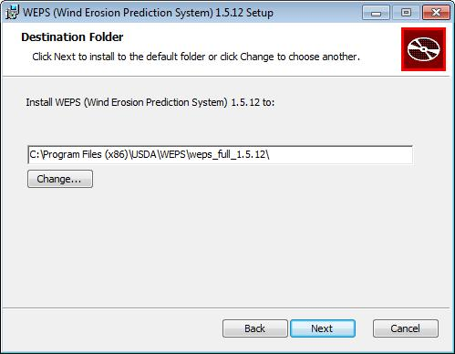
Figure 1-3 WEPS Setup Destination Folder Screen.
A Ready to install WEPS screen will now display (Figure 1-4).

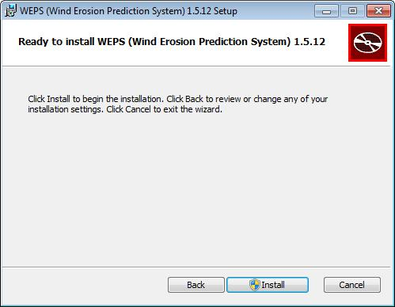
Figure 1-4 Ready to Install WEPS screen.
A WEPS Installation Progression screen will now display (Figure 1-5). When installation finishes, click on the “Next” button at the bottom of the screen. If installing under Windows 7 or later, usually the user will be presented with a security screen that they will have to select “Yes” to continue the installation.

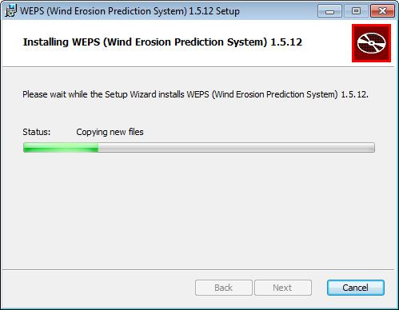
Figure 1-5 WEPS installation progression window.
A WEPS Installation Complete screen will now display (Figure 1-6). Click on the “Finish” button to close the window. WEPS has now been installed.

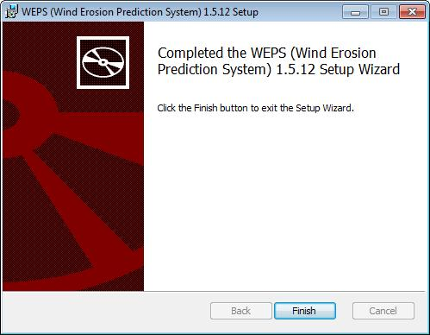
Figure 1-6 WEPS installation complete window.

Running the WEPS Wizard

The WEPS Wizard automatically runs the first time WEPS is initiated. The WEPS Wizard ensures that the user registers their contact information (name and email address) so that if they submit questions/comments/bug reports, we will know who sent the message.

Initiate WEPS from the Startup Menu (select “All Programs”, “USDA Applications”, “WEPS 1.5.x” and then the desired configuration of WEPS). Note that for the official NRCS WEPS release, the user will select “All Programs”, “USDA Applications”, then “WEPS”. The first window that will appear following the splash screen will be the WEPS Welcome Wizard screen (Figure 1-7). Select the “Next” button to proceed to the next Wizard screen.

Figure 1-7 WEPS Welcome Wizard Window.

The Welcome Wizard requests the user’s full name and email address (Figure 1-8). Fill in the appropriate information (the email address field will not accept text that does not contain an “@” character), select the “Next” button at the bottom of the screen.
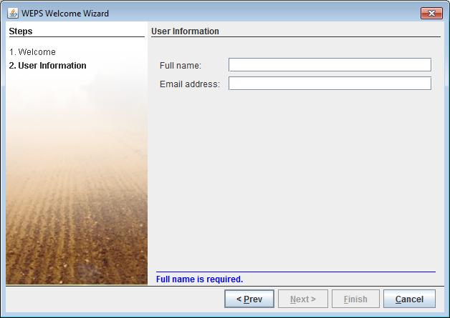
Figure 1-8 WEPS Welcome Wizard Window requesting name and email address.

The final WEPS Welcome Wizard screen will now display showing the absolute path and filename containing the user’s local WEPS configuration file (Figure 1-9). Select the “Close” button to finish the Welcome Wizard and close the window to begin work with WEPS.

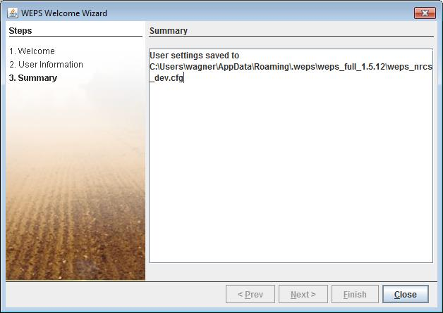
Figure 1-9 WEPS Welcome Wizard summary window.

Quick Start for WEPS 1.5

WEPS is a comprehensive wind erosion model with many options for inputs and outputs. For basic simulations however, WEPS is simple to operate. The following quick start guide will describe how to make a simple simulation run. To learn the more detailed features of WEPS, see the WEPS User Manual. For NRCS users, see the “Quick Start for NRCS Users of WEPS 1.5” for NRCS specific instructions related to your agency’s use of WEPS.

For Windows 7 users, to start WEPS, go to the circular colored globe “Start” menu at the bottom left corner of the display and select “All Programs”. Navigate to the “USDA Applications” menu, select the “WEPS ver. no.” menu (where “ver. no.” is the WEPS version) and then click the left mouse button on the “WEPS ver. no.” menu option. It will contain the following WEPS icon  to the left of potentially several menu options. Select the desired menu option (“WEPS” in this case). The WEPS main screen will then appear. In summary:
“Start>All Programs>USDA Applications>WEPS ver. no. >WEPS”

Note that the user may see variations on the naming scheme mentioned here, depending upon which release the user has installed and what options they selected during installation. Also, the user may also be able to start WEPS from desktop shortcuts, if selected for inclusion during the installation process.

A Simple Simulation
For a simple simulation, only four types of information are entered on the main WEPS screen.

- Describe the simulation field geometry by selecting the field shape, dimensions and orientation in the panel labeled “Region”.

Type in the specific coordinate and/or area information (dependent upon the “shape” selected), e.g.: X-Length and Y-Length field dimensions for a “Rectangle” shape, as well as specific field orientation (±45º max) relative to true north, in the “Orientation” box.

- Select a field location (for weather file selections).

In the panel labeled “Location”, use the mouse to select a Country (if enabled), State (or other country specific designation) and County (or other local designation) from the drop down menu . Coordinates for a location will be automatically selected near the center of the County. The weather stations, both “Cligen and Windgen”, for the selected location will be automatically determined and displayed immediately below the elevation field. The “elevation field” itself will be automatically populated with the value from the currently selected “Cligen” station, which can overridden by the user, if desired.

- Select a soil.

In the bottom panel of the window, to the far right of the button labeled ‘Soil’, use the mouse to select a soil from the drop down menu or via the filechooser “Template” button (if enabled) next to the labeled “Soil” button.

- Select a management scenario.

In the bottom panel of the window, to the far right of the button labeled ‘Man’, use the mouse to select a crop rotation from the drop down menu or via the filechooser “Template” button (if enabled) next to the labeled “Man” button.

Once these items are complete, click the ‘Run’ button on the tool bar at the top of the screen. You will be asked to enter a name for the simulation run and click ‘OK’. Once a run name is entered, you will then see indicators that WEPS is running. When the simulation run is finished, the “Run Summary” report screen will automatically appear on the computer screen .

Run Summary
The Run Summary displays user information, input parameter files, and basic soil loss information by rotation year, crop interval and the average annual soil loss for the total simulation. Soil loss (erosion) output in the Run Summary includes: Gross Loss, the average erosion within the field; Total, the average total net soil loss from the field; Creep/Salt, the average creep plus saltation (≥100 µm dia. particles) net erosion from the field; Suspension, the average net suspension size (<100 µm dia. particles) soil loss from the field; and PM10, the average net loss of particulate matter less than 10 microns in size from the field.

Exiting WEPS
To exit WEPS click the “Project” (or “File”) menu option on the far left of the menu bar at the top right corner of the main screen, then click “Exit”. You will be asked if you want to save your current WEPS Project (state of selections made on the interface screen). You will also be asked to confirm if you really want to exit WEPS. Select “Yes” to exit WEPS.

Additional Information
WEPS has the capability for many simulation input options, including adding barriers and specifying numerous management options. WEPS also can optionally produce very detailed output to provide the user with a better understanding of what field conditions and management situations cause soil loss by wind and when. Consult the WEPS User Manual for complete details. For further information regarding WEPS, users should contact:

USDA-ARS Agricultural Systems Research Unit
2150 Centre Ave., Bldg. D Suite 200
Fort Collins, CO 80526

Phone: 970-492-7382
E-mail: weps@ars.usda.gov

Quick Start for NRCS Users of WEPS 1.5

WEPS is a comprehensive wind erosion model with many options for inputs and outputs. For basic simulations however, WEPS is simple to operate. The following NRCS Users quick start guide will describe how to make a simple simulation run. To learn the more detailed features of WEPS, see the WEPS User Manual. For non-NRCS users, see the “Quick Start for WEPS 1.5” for specific instructions related to the use of the public release of WEPS.

For Windows 7 NRCS users, to start WEPS, go to the circular colored globe “Start” menu at the bottom left corner of the display and select “All Programs”. Navigate to the “USDA Applications” menu, select the “WEPS” menu by clicking the left mouse button on that menu option. It will contain the following WEPS icon to the left of potentially several menu options. Select the desired menu option (“WEPS Wind Erosion Prediction” in this case). The WEPS main screen will then appear. In summary:
“Start>All Programs>USDA Applications>WEPS >WEPS Wind Erosion Prediction”

A Simple Simulation
For a simple simulation, only four types of information are entered on the main WEPS screen.

  - Describe the simulation field geometry by selecting the field shape, dimensions and orientation in the panel labeled “Region”.

Type in the specific coordinate and/or area information (dependent upon the “shape” selected), e.g.: X-Length and Y-Length field dimensions for a “Rectangle” shape, as well as specific field orientation (±45º max) relative to true north, in the “Orientation” box.

  - Select a field location (for weather file selections).

In the panel labeled “Location”, use the mouse to select a Country (if enabled), State (or other country specific designation) and County (or other local designation) from the drop down menu . Coordinates for a location will be automatically selected near the center of the County. The weather stations, both “Cligen and Windgen”, for the selected location will be automatically determined and displayed immediately below the elevation field. The “elevation field” itself will be automatically populated with the value from the currently selected “Cligen” station, which can overridden by the user, if desired.

  - Select a soil.

In the bottom panel of the window, to the far right of the button labeled ‘Soil’, use the mouse to select a soil from the drop down menu .

  - Select a management scenario.

In the bottom panel of the window, to the far right of the button labeled ‘Man’, use the mouse to select a crop rotation from the drop down menu .

Once these items are complete, click the ‘Run’ button on the tool bar at the top of the screen. You will be asked to enter a name for the simulation run and click ‘OK’. Once a run name is entered, you will then see indicators that WEPS is running. When the simulation run is finished, the “Run Summary” report screen will automatically appear on the computer screen.

Run Summary
The Run Summary displays user information, input parameter files, and basic soil loss information by rotation year, crop interval and the average annual soil loss for the total simulation. Soil loss (erosion) output in the Run Summary includes: Gross Loss, the average erosion within the field; Total, the average total net soil loss from the field; Creep/Salt, the average creep plus saltation (≥100 µm dia. particles) net erosion from the field; Suspension, the average net suspension size (<100 µm dia. particles) soil loss from the field; and PM10, the average net loss of particulate matter less than 10 microns in size from the field.

Exiting WEPS
To exit WEPS click the “File” menu option on the far left of the menu bar at the top right corner of the main screen, then click “Exit”. You will be asked if you want to save your current WEPS Project (state of selections made on the interface screen). You will also be asked to confirm if you really want to exit WEPS. Select “Yes” to exit WEPS.

Additional Information
WEPS has the capability for many simulation input options, including adding barriers and specifying numerous management options. WEPS also can optionally produce very detailed output to provide the user with a better understanding of what field conditions and management situations cause soil loss by wind and when. Consult the WEPS User Manual for complete details. For further information regarding WEPS, NRCS users should first contact:

Joel Poore, NRCS
Phone: 817-509-3213
E-mail: Joel.Poore@ftc.usda.gov

Overview: Wind Erosion Prediction System

Introduction

Soil erosion by wind is a serious problem in the United States and the world. Wind erosion is a threat to agriculture and the earth’s natural resources. It renders soil less productive by removing the most fertile part of the soil, namely, the clays and organic matter. This removal of clays and organic matter also damages soil structure. In addition to the soil, wind erosion can damage plants, primarily by the abrasive action of saltating particles on seedlings and fruits. Eroded soil can also be deposited into waterways where it impacts water quality and emitted into the air where it degrades the air resources. By affecting these resources, wind erosion can also become a health hazard to humans and other animals. The ability to accurately simulate soil loss by wind is essential for, among other things, environmental and conservation planning, natural resource inventories, and reducing air and water pollution from wind blown sources.

The Wind Erosion Equation (WEQ) was published in 1965 by Woodruff and Siddoway (1965). For many years, WEQ has represented the most comprehensive and widely used model in the world for estimating soil loss by wind from agricultural fields. The functional form of WEQ is:

 | $$E=f(I,C,K,L,V)$$ | 1.1

where, E is the average soil loss (tons/acre/year), I is the soil erodibility, K is the soil ridge roughness, C is the climatic factor, L is the field length along the prevailing wind erosion direction, and V is the vegetative factor. WEQ is largely empirical in nature and was derived from nearly 20 years of field and laboratory studies by scientists at the USDA-Agricultural Research Service (ARS), Wind Erosion Research Unit (Chepil, 1958, 1959, 1960; Chepil and Woodruff, 1959). Many improvements were made to WEQ over the next 30 years (Tatarko, et al. 2013). Because of the limitations of adapting WEQ to many problems and environments, as well as advancements in wind erosion science and computer technology, the USDA Natural Resources Conservation Service requested that ARS develop a replacement for WEQ (Hagen, 1991).

Development of WEPS

Research in the 1980’s (Cole et. al., 1983; Cole, 1984; and Lyles, et. al., 1985) provided the initial attempt to outline a processed based approach to simulating wind erosion that would replace WEQ. Following this initial work, the initial modular structure used in the current WEPS model was developed (Hagen, 1991), which was later revised (Wagner, 1996) and the experimental research needed to support that structure was outlined. Numerous field and laboratory studies were conducted to develop relationships for surface conditions and erosion. Experimental data were collected for weather (Skidmore and Tatarko, 1990), hydrology (Durar and Skidmore, 1995), crop growth (Retta and Armbrust, 1995), residue decomposition (Steiner et. al., 1995), soil (Hagen, et. al., 1995; Potter, 1990, Zobeck and Popham, 1990, 1992), management (Wagner and Ding, 1995), and erosion (Hagen, 1995). Experiments were also conducted to validate that the erosion routines were producing accurate and precise erosion estimates (Fryrear, et. al, 1991). A brief history of WEPS development has been documented (Wagner, 2013).

A multi-disciplinary team was assembled to develop WEPS that included climate modelers, agronomists, agricultural engineers, soil scientists, and crop modelers. The WEPS development project had a multi-agency commitment consisting of the Agricultural Research Service, Natural Resources Conservation Service, and the Forest Service from the U.S. Department of Agriculture, along with the Environmental Protection Agency, the Army Corps of Engineers, and the Bureau of Land Management. In 2005, WEPS was released to the NRCS for testing and further development for field office conservation planning. In 2008, WEPS was released to NRCS for field office implementation. In 2010 NRCS officially adopted WEPS and is now their primary tool for wind erosion assessments on cropland agricultural fields.

WEPS User Requirements

Early in the WEPS development process, input was requested from potential users on the needed capabilities of a new wind erosion simulation model. These user requirements were summarized by Hagen (1991). Based on these requirements, WEPS was designed to:

- Provide more accurate and detailed estimates of soil loss by wind from agricultural fields. Results for WEQ were an annual average soil loss based essentially on average weather and field conditions. Since erosion is often the result of extreme weather events (e.g., high wind or dry soil conditions), an approach that accounts for such extreme conditions was needed to simulate the extreme soil loss for these situations. In addition, WEPS is capable of outputting erosion loss and surface conditions on a relatively fine temporal scale (e.g., hourly). However, for practical purposes, the default time step for WEPS output is two weeks. Such detail allows the user to observe the periods when excessive erosion occurs and the wind or surface conditions which caused the soil loss (e.g., low vegetative cover, etc.). These conditions can then be addressed by altering management or other control measures.
- Develop more cost-effective erosion control methods. Because of the detail in the soil loss and field conditions provided by WEPS, it is a valuable tool for testing various management scenarios or control methods through simulation. Each scenario can be evaluated before a change in farming practices is made in the field. Surface conditions and management can be observed during periods of excessive loss and adjusted to minimize erosion.
- Simulate the amount of soil loss by direction. With increasing concern of the offsite impacts of wind erosion on soil, water, and air quality, the capability of WEPS to provide the direction of soil loss is useful. For example, creep and saltation loss to a roadside ditch or waterway will impact water quality, so attention can be focused in these scenarios to controlling loss in that direction. Similarly, suspension loss in the direction of highly populated areas or nearby heavily trafficked roadways can be simulated with WEPS and specific control strategies simulated.
- Separate soil loss into creep/saltation, suspension, and PM10 components. Each of these components have specific characteristics and effects. Creep/saltation are typically deposited locally where they can affect soil and water quality, bury crops, roads, and irrigation ditches, or be deposited as dunes in fences or windbreaks. Suspension, by definition, can be lifted into the air and carried great distances. As such, it can be a detriment to air quality, become a health hazard, and reduce visibility along transportation systems. PM10 has been determined by the U.S. Environmental Protection Agency to be a hazard to air quality and a respiratory hazard in particular (U.S. EPA, 1996). Estimating soil loss of each of these components can aid in environmental assessments.
Taking all user requirements into consideration, WEPS is designed to be an aid in: 1) soil conservation planning, 2) environmental assessment and planning; and 3) determining off-site impacts of wind erosion.

WEPS Modeling Approach

WEPS is a process-based, daily time-step model that simulates weather, field conditions, and erosion. As such, it simulates not only the basic wind erosion processes, but also the field management and weathering processes that modify a soil's susceptibility to wind erosion. The current model release is WEPS 1.5 and is designed to provide the user with a simple tool for inputting initial field conditions, calculating soil loss, and displaying either simple or detailed outputs for conservation planning and design of erosion control systems.

WEPS 1.5 Geometries

To simplify inputs, WEPS 1.5 is designed with specific geometric constraints when specifying the simulation region or field (Figure 1-10). The simulation region is limited to a rectangular area. However other field shapes such as circles or half circles can also be simulated by defining a rectangle of the same length, width, or area of the desired field shape. The simulation area may be rotated to orient the field correctly on the landscape to account for the effects of varying tillage, planting, and wind directions.

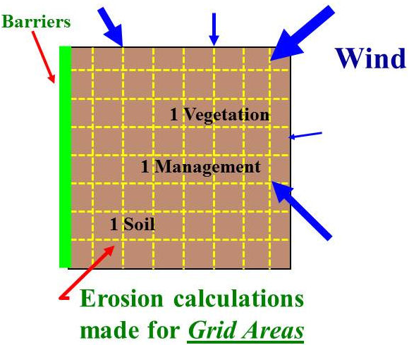
Figure 1-10 WEPS simulation geometries
A uniform simulation region surface is assumed in that only one soil type (uniform soil properties), crop type (biomass properties), and management are uniformly distributed over the field. In reality, fields are often not uniform so the user may select the dominant-critical (i.e., most erodible) soil or crop condition for a simulation. Barriers may be placed on any or all field boundaries. When barriers are present, the wind speed is reduced in the sheltered area on both the upwind and downwind sides of the barriers. Thus, WEPS can simulate deposition in front of downwind barriers. The erosion submodel determines the threshold friction velocity at which erosion can begin for each day’s surface condition. When wind speeds exceed the threshold, the submodel calculates the loss/deposition over a series of individual grid cells representing the field. The soil loss and deposition is divided into components of saltation/creep and suspension, because each has unique transport modes, as well as off-site impacts. The field surface is periodically updated during erosion events to simulate the surface changes caused by erosion. Surface updating during an erosion event includes changes to aggregate size distribution of the surface as fine particles are removed and surface aggregates breakdown into smaller sizes due to impacts from moving particles, smoothing of ridge roughness as ridges are eroded and furrows fill with eroded materials, etc.

WEPS 1.5 Model Implementation

The structure of WEPS 1.5 is modular and consists of the science model, coded in FORTRAN 95 coupled with a graphical user interface, which is coded in JAVA. The model also includes five databases, two weather simulation generators, and six submodels (Figure 1-11).

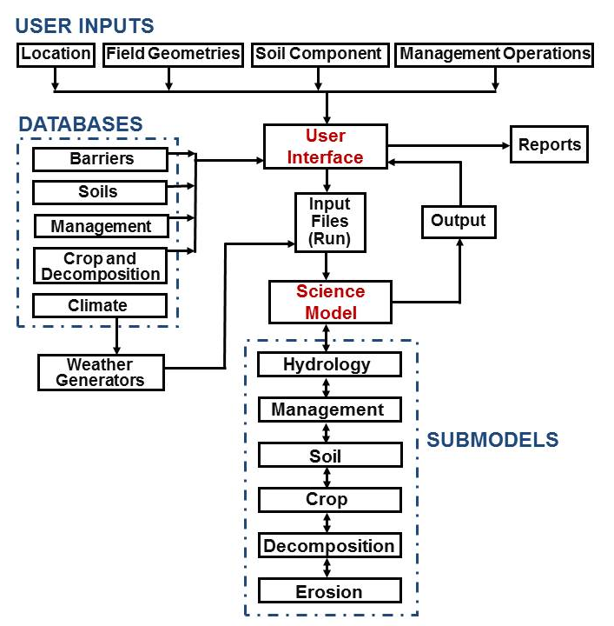
Figure 1-11 Structure of the WEPS model.
The user interface provides a means for the user to enter initial conditions such as the field dimensions, orientation, barriers, location, management operations, and soil component desired for the simulation region. Field dimensions are entered as a length and width and orientation as an angle deviation from north. The user selects the barrier type from a list accessed through the interface. For location, the user can either select the country (if configured for non-U.S. usage), state and county or enter a latitude and longitude directly for simulation. Based upon the latitude and longitude of the location, the interface then selects the weather stations for which statistical weather parameters based upon historical measured meteorological data are used to simulate daily (and hourly for wind) weather parameters. The soil component is selected from a list of soils supplied by the NRCS Soil Survey Geographic (SSURGO) database for the Soil Survey Area of the simulation region or, when online, directly from the NRCS Soil Data Mart website (http://soildatamart.nrcs.usda.gov). Management operation and dates are compiled in the Management/Crop Rotation Editor for WEPS (MCREW) in a spreadsheet style table editor.

Given the user supplied inputs, the interface accesses five databases for climate, soils, management, barriers, and crop growth and residue decomposition for the simulation. These databases provide needed parameters for location and conditions simulated as specified by the user. The interface writes the information needed for a WEPS simulation, obtained from the user and the databases, into WEPS input files. The interface also executes the weather generators which create weather files containing daily precipitation, maximum and minimum temperatures, solar radiation, and dew-point temperature as well as daily wind direction and subdaily (e.g., hourly) wind speeds. These input files for a given simulation are collectively known in WEPS as a “WEPS Run”. To reduce computation time, a daily time step is used in WEPS, except for selected subroutines in the Hydrology and Erosion submodels, which may use hourly or sub-hourly time steps (e.g., 15 minutes). The science model reads the input run files and calls the Hydrology, Soil, Crop, and Decomposition submodels daily which account for changes in the soil surface erodibility as influenced by management and weather. If surface conditions for a given day are such that erosion can occur for the maximum wind speed for that day, Erosion submodel routines are called to calculate soil loss and deposition. Soil erosion by wind is initiated when the wind speed exceeds the saltation threshold speed for a given soil and biomass condition. After initiation, the duration and severity of an erosion event depend on the wind speeds and the evolution of the surface conditions.

WEPS Model Use

WEPS is a comprehensive wind erosion model with many options for inputs and outputs. For basic simulations however, WEPS 1.5 is simple to operate. Only four types of information are entered on the main screen: 1) description of the simulation region geometry by defining the field dimensions and field orientation; 2) select the field location for which to generate simulated weather; 3) select the soil; and 4) select a management scenario. For U.S. simulations, the last three may be selected from lists provided with the WEPS model or from NRCS. New input files will usually be created using previous input files as templates modified within the user-interface. By varying inputs, particularly the field management, users can compare various alternatives to control soil loss by wind. Interpreting the outputs of WEPS is an integral part of using WEPS as a tool to develop conservation plans for controlling wind erosion. WEPS provides options for viewing very detailed outputs by periods (default is two weeks) including soil loss as saltation/creep, suspension, and PM10. Period output is also available for weather parameters such as wind energy, as well as surface conditions such as soil erodibility and biomass amounts. Such information is useful in determining which period is resulting in severe erosion and the conditions that are contributing to the loss. WEPS outputs also include amount of loss for each direction which aid the user in the placement of barriers, strip cropping, or other directional erosion control methods. More detailed features of WEPS and information on use of WEPS outside the U.S. are covered later in this manual. WEPS also has a Multiple Run Management View option to allow easier comparisons of alternative outputs.

Conclusion

The Wind Erosion Prediction System is a process-based, daily time-step model that simulates weather, field conditions, and erosion. WEPS development was in response to customer requests for improved wind erosion technology. It was intended to replace the predominately empirical Wind Erosion Equation as a prediction tool for those who plan soil conservation systems, conduct environmental planning, or assess offsite impacts caused by wind erosion. The WEPS model is continually being improved with periodic updates. Plans are in place to develop the following enhancements to WEPS for future upgrades: i) provide plant damage estimates, ii) integration with the Water Erosion Prediction Project (WEPP) model, iii) add capabilities for other, non-cropped lands such as range lands, iv) predict visibility effects of dust storms, v) dust prediction via weather forecasting, vi) prediction of PM2.5 and PM-coarse (PM10 minus PM2.5), and vii) include capabilities for complex fields in terms of relief (terrain elevation), multiple soils, crops, and management on one simulated field.

References

Chepil, W.S. 1958. Soil conditions that influence wind erosion. USDA Tech. Bul. No. 1185.

Chepil, W.S. 1959. Wind erodibility of farm fields. J. Soil and Water Conserv. 14(5):214-219.

Chepil, W.S. 1960. Conversion of relative field erodibility to annual soil loss by wind. Soil Sci. Soc. Am. Proc. 24(2):143-145.

Chepil, W.S. and N.P. Woodruff. 1959. Estimations of wind erodibility of farm fields. USDA, ARS Prod. Res. Rpt. No. 25.
Cole, G.W. 1984. A stochastic formulation of soil erosion caused by wind. Trans. Am. Soc. Agric. Engin. 27(5):1405-1410.

Cole, G. W., L. Lyles, and L. J. Hagen. 1983. A simulation model of daily wind erosion soil loss. Transactions, Am. Soc. Agric. Engin. 26:1758-1765.

Durar, A.A. and E.L. Skidmore. 1995. WEPS technical documentation: Hydrology submodel. SWCS WEPP/WEPS Symposium. Ankeny, IA.

Fryrear, D.W., J.E. Stout, L.J. Hagen, and E.D. Vories. 1991. Wind erosion: field measurement and analysis. Trans. Am. Soc. Agric. Engin. 34(1):155-160.

Hagen, L.J. 1991. A wind erosion prediction system to meet user needs. J. Soil and Water Conservation. 46:106-111.

Hagen, L.J. 1995. WEPS technical documentation: Erosion submodel. SWCS WEPP/WEPS Symposium. Ankeny, IA.

Hagen, L.J., T.M. Zobeck, E.L. Skidmore, and I. Elminyawi. 1995. WEPS technical documentation: Soil submodel. SWCS WEPP/WEPS Symposium. Ankeny, IA.

Lyles, L., G.W. Cole, and L.J. Hagen. 1985. Wind erosion: Processes and prediction. In: Soil Erosion and Crop Productivity. R.F. Follett and B.A. Stewart (eds.), Chap. 10, pp. 163-172, Madison, WI.
Potter, K.N. 1990. Estimating wind-erodible materials on newly crusted soils. Soil Sci. 150(5):771-776.

Retta, A. and D.V. Armbrust. 1995. WEPS technical documentation: Crop submodel. SWCS WEPP/WEPS Symposium. Ankeny, IA.

Skidmore, E.L. and J. Tatarko. 1990. Stochastic wind simulation for erosion modeling. Trans. ASAE 33:1893-1899.

Steiner, J.L., H.H. Schomberg, and P.W. Unger. 1995. WEPS technical documentation: Residue decomposition submodel. SWCS WEPP/WEPS Symposium. Ankeny, IA.

Tatarko, J., M.A. Sporcic, and E.L. Skidmore. 2013. A history of wind erosion prediction models in the United States Department of Agriculture prior to the Wind Erosion Prediction System. Aeolian Research. 10:3-8.

U.S. EPA. 1996. National ambient air quality standards for particulate matter: Proposed decision. 40 CFR 50 61(241). Federal Register 6 1 (24 1).

Wagner, L.E. An overview of the wind erosion prediction system. Proc. of International Conference on air Pollution from Agricultural Operations, sponsored by MidWest Plan Service, February 7-9, 1996. Kansas City, MO, pp.73-78.

Wagner, L.E. 2013. A history of wind erosion prediction models in the United States Department of Agriculture: The Wind Erosion Prediction System (WEPS). Aeolian Research. 10:9-24.

Wagner, L.E., and D. Ding. 1995. WEPS technical documentation: Management submodel. SWCS WEPP/WEPS Symposium. Ankeny, IA.

Woodruff, N.P. and F.H. Siddoway. 1965. A wind erosion equation. Soil Sci. Soc. Am. Proc. 29(5):602-608.

Zobeck, T.M. and T.W. Popham. 1990. Dry aggregate size distribution of sandy soils influenced by tillage and precipitation. Soil Sci. Soc. Am. J. 54(1):197-204.

Zobeck, T.M. and T.W. Popham. 1992. Influence of microrelief, aggregate size, and precipitation on soil crust properties. Trans. ASAE. 35(2):487-492.

