WEPS 1.5 Installation

The Wind Erosion Prediction System or ‘WEPS’ is a process-based, daily time-step, wind erosion simulation model. It represents the latest in wind erosion prediction technology and is designed to provide wind erosion soil loss estimates from cultivated, agricultural fields. WEPS 1.5 consists of the computer implementation of the WEPS science model with a graphical user interface designed to provide easy to use methods of entering inputs to the model and obtaining useful user output reports. WEPS was developed by the former Wind Erosion Research Unit (WERU), now Agricultural Systems Research Unit (ASRU) of the United States Department of Agriculture, Agricultural Research Service.

The WEPS 1.4 User Manual is designed to provide information to different levels of users. Those users who are completely new to WEPS should start by reading all of this chapter to get an introduction to WEPS. It is recommended that, as a minimum preparation to use WEPS, the user should read the “Overview of the Wind Erosion Prediction System.”

The minimum computer requirements and the steps to install WEPS onto your computer are described in this chapter. Once WEPS has been installed on your computer, you should learn how to make a simple simulation run using the “Quick Start for WEPS 1.5." More experienced users should become familiar with the “Interface Reference - How to Operate WEPS”, which goes into detail of how to use all of the capabilities of WEPS 1.5. These details are also available in the ‘Online Help,’ accessible through the toolbars on the WEPS 1.5 interface screen.

“Using WEPS in Conservation Planning” contains sections on ‘Interpreting Outputs’, ‘Special Field Configurations’, and ‘Using Barriers for Erosion Control in WEPS.’ This section also has ‘Exercises,’ which guide the user through scenarios that describe how to use WEPS to design conservation systems.

The “Science Overview” contains information for more advanced users. For users interested in more detail on the interface and science behind WEPS, ‘Interface Implementation and Science Model’ is recommended. An even more detailed description of the science of the WEPS model is available in the “WEPS Technical Description,” which can be obtained from ASRU.

The Science Overview also contains information for more advanced users, such as the WEPS ‘Databases’ and a listing of ‘Submodel Report Flags and Command Line Options.’ Databases are described for the Weather, Soil, Management, Crop, Operation and Barrier sections of WEPS. Submodel Report Flags and Command Line Options are set under the ‘Configurations’ tabs available through the “Tools” menu on the Main Screen of the interface. Certain permissions may be required to alter some of these flags and options. There is a section on “Using WEPS with Measured Data” that will be useful to researchers and other users, such as those outside the United States who do not have their soils data in the SSURGO database format.

Finally this manual contains a series of “How To” Guides which provide the user with in-depth detail of simulating barriers and strip cropping. There are also “How To” Guides that guide the user in developing additional crop and operation database records.
Throughout this manual, the term “user” refers to the person(s) using WEPS 1.5 to set up and make a simulation run. The term “operator” refers to the producer or land manager whose actual field is being simulated with WEPS. This manual contains many graphics that are examples of what can be seen on the computer screen using WEPS. In addition, WEPS will continually be improved and the screens may change. Therefore, the user may or may not see the exact same screens as those illustrated in this manual.

WEPS is a model developed primarily for use by the USDA, Natural Resources Conservation Service (NRCS). As such, many of the capabilities of WEPS reflect the needs of NRCS for use in cultivated agricultural systems. But, WEPS has capabilities to be used in many other situations where wind affected soil movement is a problem. Contact ASRU if you wish to use WEPS to predict erosion for situations other than traditional cultivated agricultural systems.

Minimum Computer Requirements

The minimum recommended requirements to install and operate WEPS 1.5 are: an Intel Pentium class processor, or equivalent, personal computer (PC); Windows 7 or newer Microsoft operating system; 1 Gb RAM; 2 Gb free disk space; internet web access to download for installation; and a VGA color monitor with a minimum screen resolution of 800 x 600 pixels. WEPS also requires Java 1.8 or later (must be installed prior to installing WEPS). WEPS has been run in the past on older releases of Windows, but is no longer tested on them. Configurations for Linux and Unix are also available. Contact ASRU if you need versions for Linux/Unix assistance.

The recommended requirements to install and operate WEPS 1.5 effectively are: an equivalent of an Intel Core I-3 processor, or better, personal computer; Windows 7 or newer Microsoft operating system; greater than 2 Gb RAM; greater than 20 Gb of free disk space, internet web access to download WEPS for installation; and a color monitor with 1024 x 800 or better pixel resolution. Java 1.8 or later must be installed prior to installing WEPS.

Installation

To install the packaged version of WEPS, one must be logged in as “Administrator” or as a user with sufficient “privileges” to install Windows programs. To initiate the installation process, just double click with the left mouse button on the “WEPS” msi file package, which will at least contain the name “weps”, the version number and the build date, for example: weps_1.5.10_(2016-03-04).msi Simply follow the installation prompts and provide the requested information.

Again, note that on Windows 7 and newer machines (and possibly XP and Vista, depending on how they are configured), the user must either be logged in as “Administrator” or have sufficient privileges to successfully install WEPS. The WEPS installation program will inform the user attempting installation if they do not have sufficient privileges to perform the installation.

WEPS 1.5 is available for download on the ARS web site at:
https://www.ars.usda.gov/services/software/download.htm?softwareid=415#downloadForm. Fill in the required form fields and click on the “Take me to the download”. If you fill out the registration form, ASRU will provide email notices of updates to the model. The download file consists of an executable “msi” file that will install WEPS onto your Windows computer. Contact ASRU if you need assistance at:

USDA-ARS Agricultural Systems Research Unit
2150 Centre Ave., Bldg. D Suite 200
Fort Collins, CO 80526

Phone: 970-492-7382
E-mail: weps@ars.usda.gov

NOTE: NRCS users must obtain official copies of WEPS through their agency’s official channels. The release of WEPS provided by NRCS is pre-configured to their specifications. Contact Joel Poore, Wind Erosion Specialist, for the NRCS specific release of WEPS at:

Joel Poore, NRCS
Phone: 817-509-3213
E-mail: Joel.Poore@ftc.usda.gov

WEPS Installation Steps

Installation

To install the packaged version of WEPS, one must be logged in as “Administrator” or as a user with sufficient “privileges” to install Windows programs. On Windows 7 and newer machines (and possibly XP and Vista, depending on how they are configured), the user must either be logged in as “Administrator” or have sufficient privileges to successfully install WEPS. The WEPS installation program will inform the user attempting installation if they do not have sufficient privileges to perform the installation.

To initiate the installation process, just double click with the left mouse button on the “WEPS” msi file package, which will at least contain the name “weps”, the version number and the build date, for example: weps_1.5.10_(2016-03-04).msi Simply follow the installation prompts and provide the requested information. Screenshots of the process are shown below.

In some instances, the first window that will display is the Open File – Security Warning message (Figure 1-1). Simply click on the “Run” button in that window if it appears.

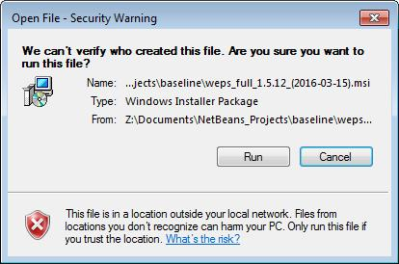
Figure 1-1 Security warning message that may appear when attempting to install WEPS.
The first WEPS window to appear is the setup welcome screen (Figure 1-2).

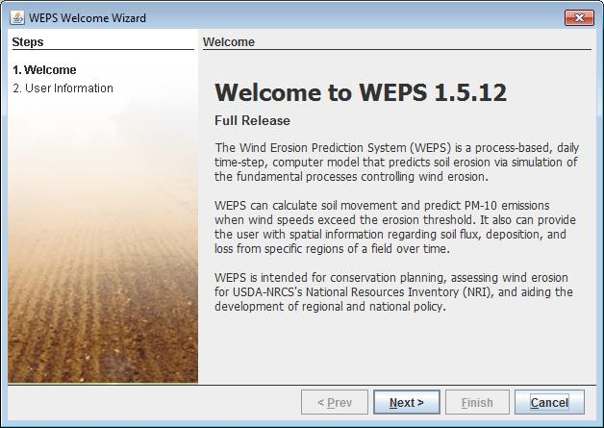
Figure 1-2 WEPS initial setup window.
The next window that will appear is the WEPS Setup Destination Folder (Figure 1-3). It will display the default WEPS installation folder and allow the user to change that location if desired. Once the desired location is specified, click on the “Next” button at the bottom of the screen.

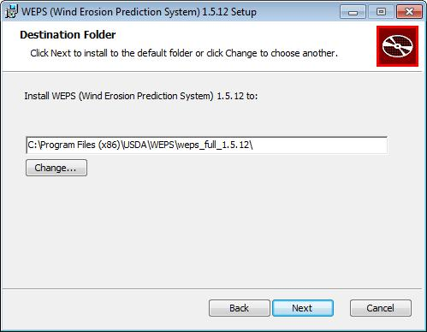
Figure 1-3 WEPS Setup Destination Folder Screen.
A Ready to install WEPS screen will now display (Figure 1-4).

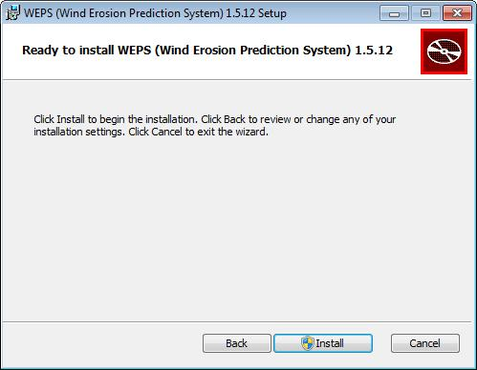
Figure 1-4 Ready to Install WEPS screen.
A WEPS Installation Progression screen will now display (Figure 1-5). When installation finishes, click on the “Next” button at the bottom of the screen. If installing under Windows 7 or later, usually the user will be presented with a security screen that they will have to select “Yes” to continue the installation.

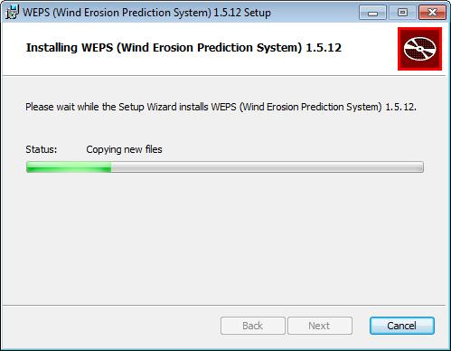
Figure 1-5 WEPS installation progression window.
A WEPS Installation Complete screen will now display (Figure 1-6). Click on the “Finish” button to close the window. WEPS has now been installed.

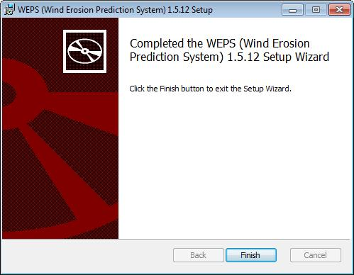
Figure 1-6 WEPS installation complete window.

Running the WEPS Wizard

The WEPS Wizard automatically runs the first time WEPS is initiated. The WEPS Wizard ensures that the user registers their contact information (name and email address) so that if they submit questions/comments/bug reports, we will know who sent the message.

Initiate WEPS from the Startup Menu (select “All Programs”, “USDA Applications”, “WEPS 1.5.x” and then the desired configuration of WEPS). Note that for the official NRCS WEPS release, the user will select “All Programs”, “USDA Applications”, then “WEPS”. The first window that will appear following the splash screen will be the WEPS Welcome Wizard screen (Figure 1-7). Select the “Next” button to proceed to the next Wizard screen.

Figure 1-7 WEPS Welcome Wizard Window.

The Welcome Wizard requests the user’s full name and email address (Figure 1-8). Fill in the appropriate information (the email address field will not accept text that does not contain an “@” character), select the “Next” button at the bottom of the screen.
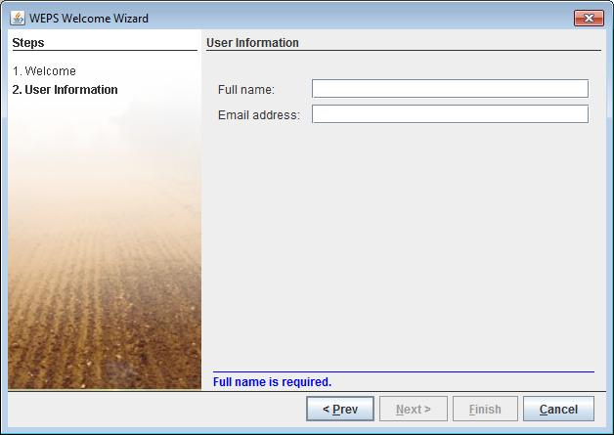
Figure 1-8 WEPS Welcome Wizard Window requesting name and email address.

The final WEPS Welcome Wizard screen will now display showing the absolute path and filename containing the user’s local WEPS configuration file (Figure 1-9). Select the “Close” button to finish the Welcome Wizard and close the window to begin work with WEPS.

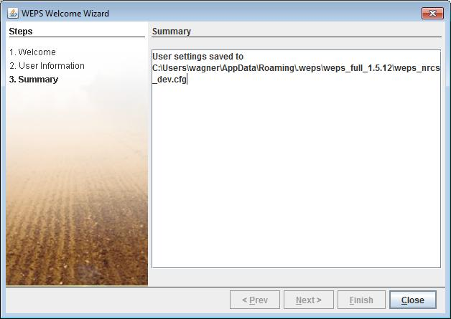
Figure 1-9 WEPS Welcome Wizard summary window.

