WEPS INTERFACE REFERENCE


WEPS Interface Main Screen Components

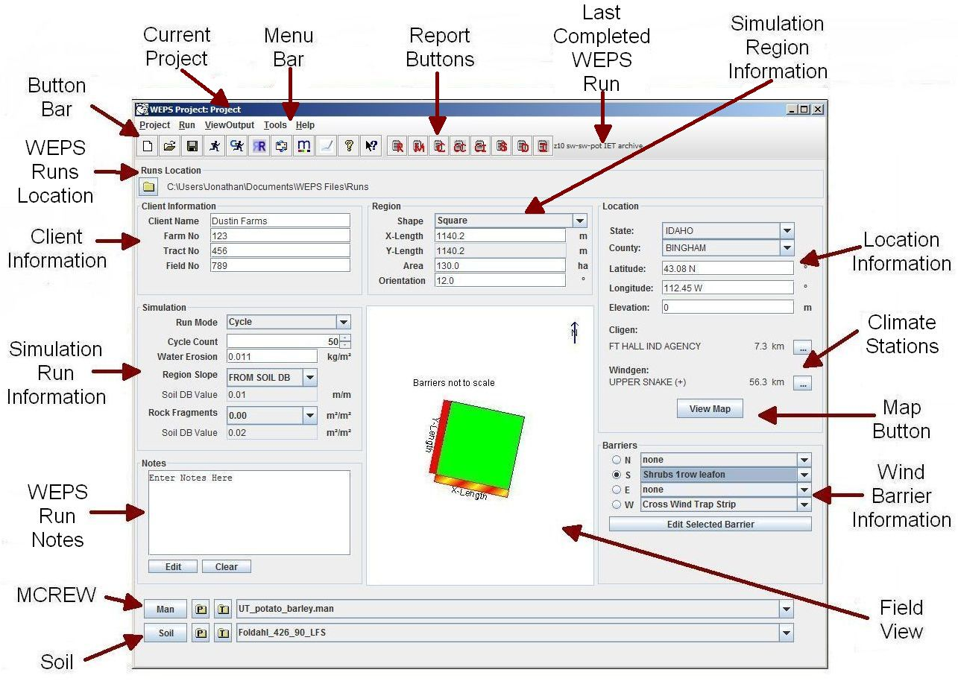
Figure 2-1 Main screen of the Wind Erosion Prediction System.
The WEPS main screen (Figure 2-1) should appear at model startup. Each part of the main screen is labeled in the Figure with regard to its function. A brief description of each part is given below. More detailed descriptions of their functions and use follow later in this chapter.

- The Button Bar and Menu Bar are collectively referred to as Toolbars. The Menu Bar provides the user with access to many of the operational functions of WEPS. The Button Bar provides a shortcut method of executing some of the Menu Bar functions.

- The Report Buttons are part of the Button Bar and provide quick access to the most commonly referred to WEPS reports. The Last Completed WEPS Run is also displayed just to the right of the last WEPS report button on the Button Bar.

- The current WEPS Runs Location (Runs Location panel) is displayed immediately below the Button Bar which lists the default directory where individual WEPS Runs are stored.
- The Client Information (Client Information panel) is used to enter customer information for a simulation run. The customer information is for information use only and is not required for the operation of WEPS.

- The Simulation Region Information (Region panel) provides the physical dimensions (i.e., shape, length and width or radius, and area) and the orientation with respect to north of the simulation field.

- The Simulation Run Information (Simulation panel) is used to enter specific information for a simulation run, as well as information regarding the run mode.

- WEPS Run Notes (Notes panel) in the lower left section of the screen is where the user can enter specific information regarding the upcoming WEPS simulation Run. These notes are retained as part of the upcoming WEPS simulation run and can also be further edited and printed from the Run Summary report after the conclusion of the WEPS simulation run.

- Access to MCREW (Management/Crop Rotation Editor for WEPS) is provided in the (Man panel) and allows for the selection, creation, and editing of management scenarios. Only one management rotation sequence is currently allowed for the WEPS simulation region.

- Access to the Soil viewer/editor is available from the (Soil panel) and is where the user can select and view the soil information for the upcoming WEPS simulation run. Only one soil is currently allowed for the WEPS simulation region.

- The Location Information (Location panel) is used to specify the location of the simulation field. This information is used to assist in determining the climate and wind stations (Climate Stations) selected for the upcoming WEPS simulation run. The Map Button (View Map button) is used to access a map viewer displaying weather and wind station locations as well as other GIS related information.

- Wind Barrier Information (Barriers panel) is where the selection and placement of wind barriers on the specified field borders is entered.

- The Field View (Field View panel) displays the physical dimensions and orientation of the field and location of wind barriers. This panel is for information only and is not directly editable. The Field View panel contents are updated automatically when information is changed in the Region and Barriers panels.

WEPS Toolbars

WEPS Menu Bar

The menu bar is the top line of the WEPS main screen. A description of each item on the menu bar is given below. Note that the NRCS configured WEPS release contains a slightly modified version of the menu bar. The Project menu option is replace with the File menu option. The specific differences between the two menu options’ sub-options are highlighted below.

  - Project (or File) menu options
The “Project” menu is a drop down list of various computer operations pertaining to WEPS Projects, Runs and files. The Project menu contains the following options:

- New (Ctrl-N) - Allows user to create a new “Project” folder. Note that the NRCS configured WEPS release does not contain this submenu option since it is configured to only use a single “Project” folder.
- Open... (Ctrl-O) - Allows user to open a different pre-existing “Project“ folder. Note that the NRCS configured WEPS release does not contain this submenu option since it is configured to only use a single “Project” folder.
- Save (Ctrl-S) - Saves currently displayed information on the main WEPS screen to the current “Project” folder.
- Save As... (Ctrl-A) - Saves the currently displayed information under a different “Project” folder. Note that the NRCS configured WEPS release does not contain this submenu option since it is configured to only use a single “Project” folder.
- Set Run Location (Ctrl-U) - Allows the user to change the default WEPS Run Directory.
- Reset – Resets the main WEPS screen to the default values. Note that the NRCS configured WEPS release does not provide this option.
- Delete Project (Ctrl-P) - Opens a file chooser in the folder containing the current “Project” to allow the user to select WEPS Projects for deletion. Note that the NRCS configured WEPS release does not contain this submenu option since it is configured to only use a single non-removable “Project” folder.
- Export Run - Allows the user to move or copy (user specified toggle in the popup screen determines if the original WEPS Run is deleted or not) previous WEPS Runs into other folder locations.
- Delete Run (Ctrl-D) - Opens a file chooser in the folder containing WEPS Runs to delete user selected WEPS runs.
- Delete Management Rotation File (Ctrl-M) - opens a file chooser in the current “Project” folder to delete user selected WEPS management files.
- Delete IFC Soil File (Ctrl-L) - Opens a file chooser in the current “Project” folder to delete user selected WEPS soil files.
- Browse Database Folder… - Opens up a copy of the computer system’s file manager (Windows Explorer in Windows). The starting location is the folder specified in the WEPS configuration settings where the WEPS database files reside
- Exit (Ctrl-X) - Exit the WEPS program.

Run menu options
This allows the user to run WEPS using the current inputs specified on the WES main screen or to restore inputs from previous WEPS Runs. Details of each of these options are provided in detail here (Making a WEPS Run) and here (Restore a WEPS Run). The Run menu on the WEPS Main Screen displays the following options:

- Make a WEPS Run (Ctrl-R) - Begin a WEPS simulation using the currently selected inputs specified on the main WEPS screen.
- Make a Yield Calibration WEPS Run (Ctrl-C) - Begins a WEPS simulation running WEPS in “yield calibration mode” using the currently selected inputs specified on the main WEPS screen. See section titled “Making a WEPS Run” for more information on yield calibration runs.
- Restore WEPS Run (Ctrl-E) - Opens a file viewer listing previous WEPS Runs from which the user can select one from and load that previous WEPS Run inputs into the WEPS interface screen.

ViewOutput menu options
This menu allows the user to view output for the most recent (i.e., last completed) WEPS run or any other previous WEPS runs. Discussion of the specific contents of all the reports are provided here (Viewing WEPS Output).
- Most Recent Run – Clicking on this menu item opens a list of output options.
  - Crop (Ctrl+Shift-C) - Displays a summary of crop yields and water usage statistics for the most recent WEPS simulation run.
  - Cover Crop (Ctrl+Shift-V) - Displays a summary of all cover crops (non-harvested crops) biomass production parameters and water usage statistics for the most recent WEPS run.
  - Crop Interval (Ctrl+Shift-I) - Displays a summary of each crop interval’s biomass production parameters and water usage statistics for the most recent WEPS run.
  - Management (Ctrl+Shift-M) - Displays a summary of management operations, operation dates and crops associated with the planting and harvesting operations for the most recent WEPS run.
  - STIR Energy (Ctrl+Shift-E) - Displays an SCI (Soil Quality Index) summary and both Rotation STIR Energy and Crop Interval Stir Energy reports.
  - Crop Detail - Displays a detail year by year report of all crop yields and water usage statistics for the most recent WEPS run.
  - Cover Crop Detail - Displays a detail year by year report for all cover crops (non-harvested crops) biomass production parameters and water usage statistics for the most recent WEPS run.
  - Crop Interval Detail - Displays a detail of each crop interval and breaks each crop interval into its component “Crop Periods” and reports their biomass production parameters and water usage statistics for the most recent WEPS run.
  - Confidence Interval - Displays the “Confidence Interval” information on the wind erosion soil loss in a yearly plot and a quartile distribution plot, which includes outliers.
  - Tabular Detailed Report (Ctrl+Shift-T) - Displays a detailed output in a spreadsheet format for the most recent WEPS run.
  - Science Model Reports (Ctrl+Shift-D) - Displays a window to view additional science model text-based output files from the most recent WEPS run.

- Previous Run - Clicking on this menu item opens the following list of output options. Selecting any of these options will bring up a file chooser where the user can select the desired previous WEPS Run folder, which will then display the selected report.
  - Run (Ctrl+Alt-R) - Displays a brief output summary for the selected WEPS run.
  - Crop (Ctrl+Alt-C) - Displays a summary of crop yields and water usage statistics for the selected WEPS run.
  - Cover Crop (Ctrl+Alt-V) - Displays a summary of all cover crops (non-harvested crops) biomass production parameters and water usage statistics for the selected WEPS run.
  - Crop Interval (Ctrl+Alt-I) - Displays a summary of each crop interval’s biomass production parameters and water usage statistics for the selected WEPS run.
  - Management (Ctrl+Alt-M) - Displays a summary of management operations, operation dates and crops associated with the planting and harvesting operations for the selected WEPS run.
  - STIR Energy (Ctrl+Alt-E) - Displays an SCI (Soil Quality Index) summary and both Rotation STIR Energy and Crop Interval Stir Energy reports.
  - Crop Detail - Displays a detail year by year report of all crop yields and water usage statistics for the selected WEPS run.
  - Cover Crop Detail - Displays a detail year by year report for all cover crops (non-harvested crops) biomass production parameters and water usage statistics for the selected WEPS run.
  - Crop Interval Detail - Displays a detail of each crop interval and breaks each crop interval into its component “Crop Periods” and reports their biomass production parameters and water usage statistics for the selected WEPS run.
  - Confidence Interval - Displays the “Confidence Interval” information on the wind erosion soil loss in a yearly plot and a quartile distribution plot, which includes outliers.
  - Tabular Detailed Report (Ctrl+Alt-T) - Displays a detailed output in a spreadsheet format for the selected WEPS run.
  - Science Model Reports (Ctrl+Alt-D) - Displays a window to view additional science model text-based output files from the selected WEPS run.
- Multiple Run Manager - Opens a window displaying output information from multiple WEPS Runs for “side-by-side” comparisons of the results. The “Run” menu at the top of the screen contains items that allow the user to add a directory of runs, or a single run. The user can also restore a selected run in WEPS so that its results can be viewed in more detail or modified for another run. The “Help” menu item allows the user to display version information about the Multiple Run Manager. Additional information regarding this screen is provided later. The Multiple Run Manager is discussed in more detail here ( WEPS Multiple Run Manager (WMRM)).

Tools menu options
This menu contain various tools available for use with WEPS, including:
- Database Reports - Display reports of the “user notes” for the following WEPS crop, operation and management database records:
  - Crops - Prints out the “user notes” for each crop record in the crops database folder(s), if available, else only the name of the crop record is printed.
  - Operations - Prints out the “user notes” for each operation record in the operations database folder(s), if available, else only the name of the operation record is printed.
  - Managements - Prints out the “user notes” for each management/crop rotation file in the management database template folder(s), if available, else only the name of the management/crop rotation file is printed.
- Send Email (Alt-E) - Send email comments to ARS, providing the computer is connected to the Internet and the email configuration options are properly configured. The “Send Bug/Comment Report” (the next menu option and mentioned next) is now the preferred communication method.
- Send Bug/Comment Report (Alt-B) - Send comments and bug reports directly to ARS, provided the computer is connected to the internet. Selecting this option brings up an “Error/Comment Submission Form” (Figure 2-2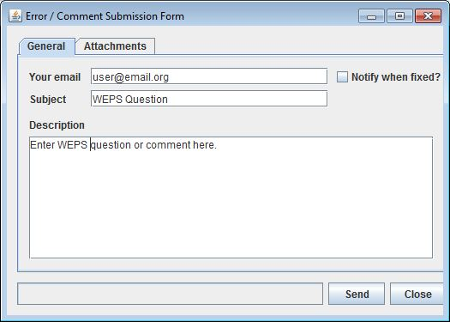) that requests the user’s email address and name. It also provides a “Description” field to allow the user to enter a message. In addition, the user can also attach individual files, the most current WEPS run and also an entire WEPS Project directory to the message, if desired (Figure 2-3). The WEPS log file is automatically zipped and attached to the message by default. This is the preferred communication method to use.
Figure 2-2 Error/Comment Submission form displaying the “General” tab.

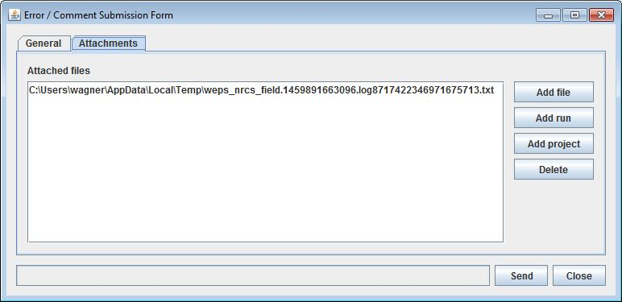
Figure 2-3 Error/Comment Submission form displaying the "Attachments" tab.
- Display Wind Station Info (Ctrl+Alt-W) - Displays wind information for the selected Windgen station including wind parameters by month in a popup window. For the selected Windgen wind station and the specified wind speed threshold (m/s), the average wind energy for the year (kJ/m²/day), the percent of winds greater than the specified threshold, the monthly percent of the annual erosive wind energy, the preponderance (maximum ratio of parallel to perpendicular erosive winds) and prevalence of prevailing erosive wind direction for each month). The parameters are displayed for each month. Additional information regarding the Wind Station Data information popup window is fully described here ( Displaying Wind Station Data Information).
- Diff WEPS Files - Opens a window that allows a comparison of differences in two WEPS files. Additional information regarding the WEPS Diff tool is provided here ( Comparing WEPS Files for Differences).
Edit Configuration (Alt-C) - Opens up the tabbed configuration window allowing the user to view/set various configuration options for WEPS. Details on the Configuration panel and all options, etc. are provided here ( WEPS Configuration Options and Settings).

Help Menu Option
This menu contains various help related and miscellaneous options for WEPS.

- Help Topics (Ctrl+Alt-T) - Displays a window containing the WEPS online help system.
- User Guide - Displays a copy of the PDF formatted WEPS User’s Guide (a PDF viewer must be installed on the computer for this function to work.
- Welcome Wizard - Runs the initial configuration wizard which requests the user’s name and email address and sets them in the local WEPS configuration file.
- About WEPS (Ctrl+Alt-A) - Displays the Build Date, Release Number, and Java Runtime Version used for WEPS, etc.

WEPS Button Bar

At the top of the main WEPS window (below the menu bar) is a series of buttons with icons. They provide shortcuts to some of the menu option functions to assist the user in the operation of WEPS.
Some buttons may or may not be visible because WEPS can be configured to not display some of them or disable specific features that these button bar icons are use with. Note that the NRCS configured version of WEPS also does not display all of the icons shown here. The specific NRCS differences are highlighted below.

WEPS Project Buttons
This button allows user to create a new WEPS Project from scratch. This has the same function as selecting New under Project on the menu bar. If multiple WEPS Project functionality is not enabled, this button is not available, such as on NRCS configured versions of WEPS.

  - This button opens an existing WEPS Project. This has the same function as selecting Open under Project on the menu bar. If multiple WEPS Project functionality is not enabled, this button is not available, such as on NRCS configured versions of WEPS.
  - This button saves the currently displayed WEPS Project to its current file name (the current WEPS Project filename is displayed in the upper left corner of the main WEPS screen). This has the same function as selecting Save under Project on the menu bar. If multiple WEPS Project functionality is not enabled, this button is equivalent to Save under File on the menu bar.

WEPS Run Buttons
The Run button begins a; WEPS simulation run. This has the same function as Make a WEPS Run under Run on the menu bar.
The Run Calibration button begins a WEPS yield calibration simulation run. This has the same function as Make a Yield Calibration WEPS Run under Run on the menu bar.
The Reload button allows the user to “restore the inputs from a previous WEPS run” into the main WEPS interface window. This has the same function as Restore a WEPS Run under Run on the menu bar.

WEPS Communication and Help Buttons
The Email button allows the user to email comments to ARS. Clicking the Email button brings up the user’s email window, if appropriately configured. This has the same function as Send Email under Tools on the menu bar.
The Mantis button allows the user to send comments and/or bug reports to ARS, along with the contents of a WEPS Project, WEPS run or individual files, if desired. Clicking this button brings up a separate window. That windows functions are described fully here (Reporting Errors and Submitting Questions/Comments). This has the same function as Send Bug/Comment Report under Tools on the menu bar.
The Question button opens the general online help system for WEPS.
The Context Help button provides help for a particular item on the WEPS screen. Clicking the Context Help button on the tool bar and then clicking on the item on the screen for which help is desired brings up a help screen for that specific item.

WEPS Report Buttons
These buttons display the last (current) WEPS Run results, e.g. Run Summary, Management/Crop Rotation, Crop Summary, Cover Crop Summary, Crop Interval Summary, Stir Energy, Detailed Report and Confidence Interval reports respectively. All of these reports are also accessible under the ViewOutput menu option along with additional, more detailed reports for both current and previous WEPS Runs. Full explanations of each report and their contents are described here (Viewing WEPS Output).
- Following the report icon buttons, the last (current) WEPS Run name is displayed. If the run name is too long to fit on the button bar row, it will be truncated. The main WEPS interface screen can be resized though, so it is usually possible for one to widen the screen to see the complete WEPS Run name if desired.

Specifying WEPS Run Information

There are several items that a user needs to address prior to using WEPS. Most of these items are not critical for most WEPS Runs, but are beneficial for keeping track of previous runs, documenting what was done for each run, listing who the client is and why the WEPS Run(s) were being made, etc. Other items are purely useful for better organization of previous WEPS Runs, clean up of temporary results and deletion of old temporary simulation runs, etc.

WEPS Runs Location

The first item is determining where one wants to store WEPS runs and setting the default location for them. This can be configured within the “Configuration” panel, but was added to the WEPS main screen to allow the user the ability to easily override the default configuration setting, if desired. The WEPS Runs Location panel (Figure 2-4) is located immediately below the “Button Bar” on the Main WEPS screen (see Figure 2-1).

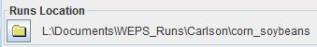
Figure 2-4 WEPS Runs Location panel on Main WEPS Screen.
This Set Run Location button allows the user to change the default WEPS Run Directory by popping up a modified file chooser window (Figure 2-5). The field immediately to the right (Figure 2-4) lists the currently selected WEPS Runs Location folder. The user can also revert back to the configuration default setting by clicking on the button in the right side panel of the file chooser window.
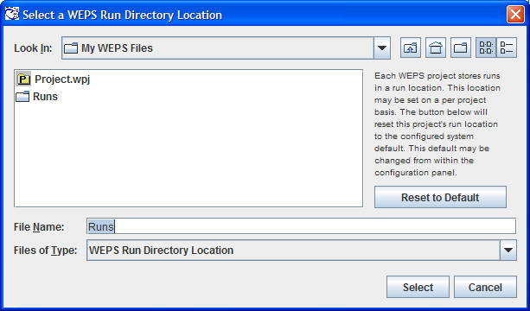
Figure 2-5 File chooser window to select/set the desired WEPS Run Directory Location.

Simulation Run Information

Simulation information is entered in the Simulation panel on the WEPS main screen (Figure 2-6 and Figure 2-7). The run-length mode determines the length and type of WEPS Run that will be simulated. There are three options for Run Mode: 1) An NRCS mode indicates that the number of simulation cycles is fixed to “50 cycles per rotation year in the selected management rotation”. This option is specified and locked (read-only) for official NRCS field use in the “NRCS configured” release of WEPS; 2) The Cycle mode indicates that the user can specify the number of simulation cycles to run (number of years to simulate for each rotation year in the selected management rotation). The larger the value specified, in general the more accurate (consistent) the simulation results will be. The default value of 50 cycles is generally considered a good compromise between accuracy and simulation runtime. The default length of run (number of cycles) is controlled through the “Run” tab in the “Configuration Settings” panel (see the discussion on “Configuration” for more details); 3) The Dates mode allows the user to specify the exact starting and ending dates for the simulation. This mode is only intended for researchers and developers for specific experimental scenarios are being evaluated. The “Dates” mode does not guarantee that the WEPS interface reports will display accurate information like the “NRCS” and “Cycle” modes do.

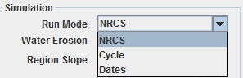
Figure 2-6 Simulation panel displaying the "Run Mode" input field.
There are additional fields in the Simulation panel besides Run Mode: a) Water Erosion; b) Region Slope with its Soil DB Value; and d) Rock Fragments with its Soil DB Value (Figure 1-7).

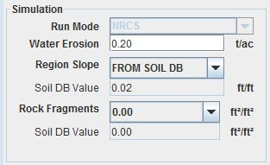
Figure 2-7 Full simulation panel display.
The Water Erosion value is required for true estimates of the Soil Quality Index, which uses both wind and water erosion estimates in its computation. The Soil Quality Index is used by NRCS as an indicator of whether a particular set of management practices are improving or degrading the relative quality of the soil based upon the management practices specified for a WEPS simulation run. NRCS requested that the index be computed as an ancillary byproduct of each WEPS wind erosion simulation. This input field therefore has no impact on wind erosion estimates and is not required to be properly populated for a non-NRCS WEPS simulation run.

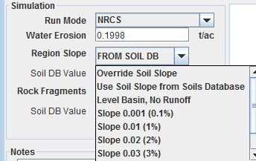
Figure 2-8 Region Slope field choices in the Simulation panel display.
The Region Slope field (Figure 2-8) provides the user with the option to override the slope specified in the selected soil record (The Soil DB Value field displays the soil record value immediately below this field). The slope value is used within the WEPS model to determine the amount of rainfall and applied irrigation water that will runoff the site and not infiltrate into the soil under the surface conditions present at the time the water is received. The reason this input is made available for user modification is because NRCS specifies a “typical” slope for all the soil components in their NASIS soil database. However, there is usually a range of slopes that a soil component may exist on. Providing the Region Slope field allows the user to specify a more representative slope value for a particular field site if it is significantly different than the soil record default value. The possible values are: Override Soil Slope (user specifies the specific slope value); Use Soil Slope from Soils Database; Level Basin, No Runoff (0 degree slope); Slope 0.001 (0.1%); Slope 0.01 (1%); Slope 0.02 (2%); Slope 0.03 (3%); Slope 0.04 (4%); Slope 0.05 (5%); and Slope 0.1 (10%).

The Rock Fragments field (Figure 2-9) provides the user with the option to override the surface rock fragments value specified in the selected soil record (The Soil DB Value field displays the soil record value immediately below this field). The rock fragments value is used within the WEPS model when determining the fraction of the surface considered non-erodible, which directly impacts the soil surface’s overall susceptibility to soil loss by wind erosion. The reason this input is made available for user modification is because of the known variability of the values within specific soil components listed in the NRCS NASIS soil database and the level of sensitivity to erosion estimates from this input parameter. The possible values are: Override Rock Fragments (user specifies the specific rock fragments ratio); or Use Rock Fragments from Soils Database.

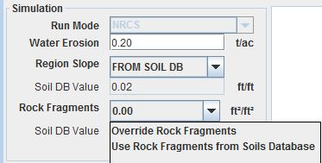
Figure 2-9 Rock Fragments field choices in the Simulation panel display.

WEPS Simulation Run Notes

If desired, each pending WEPS simulation run can be fully documented with specific user specified information into the Notes text panel on the main WEPS screen (Figure 2-10). The “Edit” button pops up a bigger display window for the user to type information into. The “Clear” button clears the Notes field of any previous run’s contents. (Note calibration values displayed in Figure 2-10 for various crops from a previous WEPS simulation run.) The WEPS simulation run Notes content is also available for post-editing after completion of the WEPS simulation run. The Notes content resides at the bottom of the last page of the WEPS Summary Report. That report provides editing functionality where the Notes content is displayed.

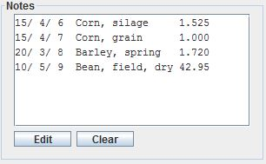
Figure 2-10 Notes panel for documenting pending WEPS simulation run information.

Client Information

Customer information for a simulation run is entered by using the upper left panel Figure 2-11) of the WEPS main screen labeled Client Information. The Client Name as well as the Farm No, Tract No, and Field No for the simulation run can be entered by typing the information into the appropriate boxes in the panel. These four items (Client Name and Farm No, Tract No, and Field No) are for informational purposes only and are not required to conduct a WEPS simulation run. These fields and their names were provided primarily for NRCS business purposes, but any user can populate them with appropriate information to help them keep track of individual WEPS simulation runs.

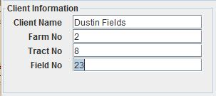
Figure 2-11 Client Information panel.

Simulation Region Information

The Simulation Region Information (Region panel) is shown in Figure 2-12. To describe the simulation region, the field dimensions are entered. For example, the X-Length and Y-Length are entered for a rectangle. Note that the area of the region will be displayed. To orient the field, simply type in the angle in degrees of deviation from north for the north/south field border and accept the value (tab or click outside the field). Note that the field will only rotate in a range of ±45 degrees. By rotating and adjusting the field length and width, the user should be able to obtain the desired size and orientation for any field.

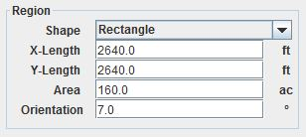
Figure 2-12 Simulation Region Information panel with rectangular field selected.
Other field shapes can be specified by clicking the down arrow to the right of the Shape box to display a list of valid field shapes. Figure 2-13 illustrates the panel entry for a circular field. To describe a circular field, either the radius or the area of the field can be specified and the other value is automatically computed. For simulation purposes within WEPS, fields that are circles or partial circles (i.e., half or quarter circle) are approximated as a square or rectangular field with an area equal to that specified in the Region panel. Field shapes that can be selected include Rectangle, Square, Circle, Half Circle VE (vertical east), Half Circle VW (vertical west), Half Circle HS (horizontal south), Half Circle HN (horizontal north), Quarter Circle NE (northeast), Quarter Circle SE (southeast), Quarter Circle SW (southwest), and quarter Circle NW (northeast). For a square, enter either the X-Length or the area. If area is entered, the field side length will be calculated and displayed. For rectangular fields enter either the X-Length and Y-Length or the area and one length. For circles or partial circles, enter the radius or the area and the other value is automatically calculated and displayed. The shape and orientation of the simulation region is displayed in the Field View and automatically updated when any of the field values are modified.

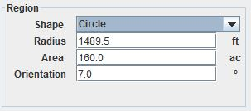
Figure 2-13 Simulation Region Information panel with circular field selected.
Special shapes or configurations such as circles and strip cropping are further discussed under the “Special Field Configurations” section of the chapter titled “Using WEPS for Conservation Planning” in the WEPS User Manual. Strip cropping is further discussed in detail in the “WEPS How To Guide” for Strip Cropping. The orientation of tillage direction is specified within the Management Crop Rotation Editor for WEPS (MCREW).

The Simulation Region must be considered carefully. The boundaries of this region are assumed to be non-erodible. This is assumed so that unknown quantities of material will not be entering from a neighboring area. Typically, stable boundaries do not allow creep and saltation sized material to pass through and include barriers or a surface at least 15 feet wide that has vegetation sufficient to stop erosion. However there are situations where one may want to simulate a field with erodible boundaries such as an area within an erodible field. In these situations the user should consult their agency’s policy for simulating such areas.

Field View

The Field View panel (Figure 2-14) is located in the center of the WEPS main screen. It is designed to give the user a view of the field size, shape, and orientation (green). The placement of any barriers present is also displayed in red. A yellow bar on the side of the field in the Field View panel indicates which side of the field has been selected for barrier placement using the radio buttons in the Barriers panel. This is useful for selecting field barrier placement when the field is oriented at angles close to 45 degrees. A red barrier shaded with yellow, as shown for the south barrier in Figure 1-10, indicates a selected barrier that has already been placed on the field border. Note that if the ratio of length to width of the field or barriers is too great to display to scale, this will be indicated within the panel, and an approximation of the field or barrier shape will be displayed. This panel is for viewing only and is not directly editable.
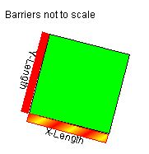
Figure 2-14 Field View panel for a rectangular field.
When a full, half, or quarter circle field is simulated (Figure 2-15), it is approximated within WEPS as a square or rectangular field with an area equal to that specified in the Region panel. The Field View panel displays an approximate inscribed circle (or half or quarter) within the simulated rectangular field. When a non-rectangular field is selected, the field described in the Region panel has an area equal to that of the simulated rectangular field.

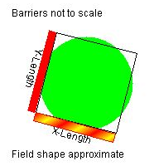
Figure 2-15 Field View panel for a circular field.

Choosing a Location

Choosing a location within WEPS defines the physical location of the field to be simulated. This location information is then normally used within WEPS to automatically select the weather stations (Cligen and Windgen) to be used for the simulation.

State/County Selection Method

Location information is entered through the rightmost panel of the main interface screen, labeled Location (Figure 2-16). Select the country, if configured to display that input field (Note that the NRCS configured version of WEPS does not display this field and assumes the country is the United States), state (or province) and county (or parish) of interest from their respective drop-down lists by clicking the down arrow to the right of the individual fields. The centroid latitude and longitude coordinates of the county will automatically be displayed. By default, the Cligen and Windgen stations nearest to the latitude and longitude coordinates will automatically be determined, and made available in a sorted list. The nearest stations are selected and displayed by default. The Elevation field will automatically be populated with the elevation of the selected Cligen station.

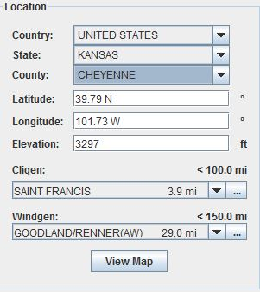
Figure 2-16 Location information panel.
Notice that the Cligen and Windgen fields display not only the station name, but also the distance from the specified lat/lon location above. By clicking on the down arrow to the right of the individual station fields, the user can override the default nearest station selection if desired. The radius range distance used for populating the nearest station lists is displayed immediately above weather station fields. There are other options available that can be used to determine the stations selected. They are accessible via the button left of the weather station fields (This button does not display if only one weather station selection option has been specified in the WEPS configuration settings). These options are discussed later in this section. Note that the default weather station selection behavior can be modified and is in fact configured differently for various WEPS versions, such as the NRCS WEPS releases. Likewise, there are configuration options that control whether the “Country”, “State” and “County” fields are displayed, or the “lat/lon” fields and even the “View Map” button. Thus, the Location panel will often appear somewhat differently than the one shown in Figure 1-16 for those alternatively configured WEPS versions.

Lat/Lon Selection Method

As an alternative, the Latitude and Longitude of the location can also be directly entered, which will automatically display the country (if configured for display), state and county in which the coordinates reside and then select the nearest Cligen and Windgen stations to that latitude and longitude coordinates. Note that the hemisphere is displayed in the lat/lon fields. The “N” (northern) and “E” (eastern) hemispheres are represented as positive values and the “S” (southern) and “W” (western) hemispheres are represented as negative values when a user clicks in those fields to edit them.

Note that the default hemispheres are the Northern and Western hemispheres for the United States. If the Southern hemisphere is desired, the user should select Cligen stations and management files with appropriate operation dates for this hemisphere. Once the stations are displayed, the user can click on the down arrow next to the stations to bring up a list of nearby stations from which to choose an alternative station if desired. The search radius for the list of stations (maximum distance to all stations on the list) is listed to the right of ‘Cligen Station’ and ‘Windgen Station.’ The State and County, as well as the Longitude and Latitude, fields are optional and can be added to or removed from the interface through the ‘Display’ tab of the ‘Configuration’ panel (see the discussion on ‘Configuration’ for more details).

Map Viewer Selection Method

Another alternative method to choosing a location is by using the Map Viewer, if configured to display the View Map button. Clicking on the View Map button (as shown in Figure 2-16) will bring up a window containing a map of the world zoomed into the region centered about the currently listed lat/lon coordinates, which is highlighted as a red cross (+ sign) on the map (Figure 2-17). The user can select any location on the map to change the lat/lon values in the Location panel on the main WEPS interface screen, by moving the mouse cursor to the desired lat/lon location (current mouse cursor lat/lon coordinates are displayed in the bottom right corner of the screen and are continuously updated when the mouse cursor is moved) on the map and double clicking the left mouse button. The Map Viewer window will automatically close and populate the Location panel lat/lon fields as well as update the Country, State and County fields as well as re- select the default Cligen and Windgen stations, if necessary.

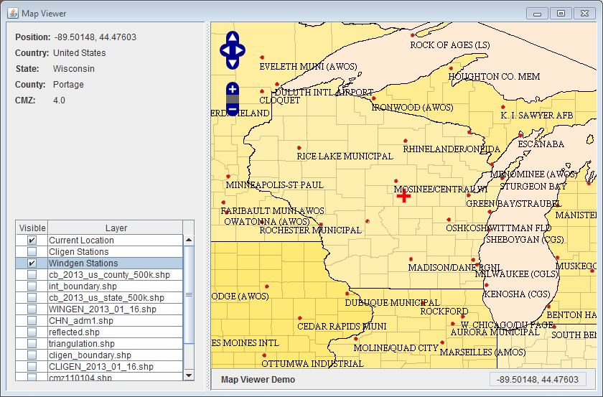
Figure 2-17 WEPS Map Viewer with wind stations displayed.
The user can move the map left, right, up and down by selecting the appropriate directional controls (4 white arrows surrounded by a blue background) at the top left of the screen. By clicking the appropriate arrows, the user can move the map in the specified direction in the window. Likewise, the user can zoom the map in or out by selecting the “+/-“ controls (+/- symbols surrounded by a blue background) that are located directly beneath the directional controls. The user may also perform these functions directly with the mouse and mouse cursor. By selecting a location within the map using the mouse cursor. By pressing and holding the right mouse button down, the user can move (drag) the map left, right, up or down within the window. By clicking the left mouse button with the cursor in the map and then scrolling the mouse wheel, the user can zoom the map in and out on the screen. The currently selected lat/lon coordinates are displayed in the upper left corner of the window and the Country, State and County, including the Crop Management Zone (CMZ) the lat/lon coordinates reside in are also displayed.

Clicking the check boxes at the left side of the Map Viewer window will enable (display) various GIS (Graphical Information System) layers on the map (Figure 2-17). Map layers currently enabled by default are: a) world (country) borders; b) U.S. State borders; c) U.S. County borders; and d) the current lat/lon coordinates (identified by a red cross (+ sign) on the map) as listed in the Location panel on the main WEPS screen. Additional map layers available include: a) Cligen station names and locations; b) Windgen station names and locations; c) nearest Cligen station boundaries; d) Cligen polygon regions; e) Windgen polygon regions; f) Windgen interpolation region; g) Windgen triangulation lines (used for displaying station interpolation regions); and f) reflected Windgen stations (identifies location of “reflected” stations outside the interpolation region for use in interpolation calculations near the interpolation region border).

Alternative Weather Station Selection Methods

As mentioned previously, WEPS can be configured to automatically select both Cligen and Windgen stations differently than the default method specified above. All methods will be described here, including the NRCS method (last method listed), which employs several of the other methods, depending upon where the lat/lon location resides.

- Station Choice List
  - This is the default method and has been explained above. Briefly, a list of stations within a specified radius of the lat/lon location is determined and sorted by distance from the lat/lon location. The nearest station in the list is displayed as the default choice, but the user has the option of overriding that selection, if desired.
- Nearest Station
  - This method selects and displays the nearest station to the lat/lon location specified. No option is available to override this selection.
- File
  - This method allows the user to specify a previously generated weather file (in the Cligen or Windgen format) to use rather than having the weather generators create them automatically prior to the WEPS simulation being run. This option is useful for developers and researchers if they need to use field weather data for research needs, etc. This option is not normally selected for use in typical WEPS usage.
- GIS
  - This option allows GIS (Graphical Information System) map (shape) files consisting of polygon maps with stations assigned to the polygons to be used. If the lat/lon location resides within a polygon, the assigned station is selected and displayed. If the lat/lon location does not reside within a polygon region, then the weather station field will display “None Selected”. The user will not be allowed to make a WEPS run until both weather stations, Cligen and Windgen, are selected.
- Interpolated
  - This option only applies to Windgen stations at this time. Based upon a specific Windgen interpolation polygon map and a corresponding “reflected” Windgen stations map, if the lat/lon location falls within an “interpolated region” polygon, then the Windgen record is interpolated from data within three nearby Windgen stations. The lat/lon location is used for the “interpolated” station’s location. Note that since Windgen generated data is dependent upon the statistical parameters in the station record, having an interpolated station that is even slightly different, e.g. even a few feet from another location will give a completely different sequence of weather (wind) data, even though, statistically, the two interpolated stations would be essentially the same. Thus, care must be taken when selecting the use of the “interpolated” mode alone. (See NRCS mode for how this issue is addressed there)
- NRCS
  - This option was developed for use by NRCS and is the default, and only option, configured for “NRCS configured specific versions of WEPS. It is also the recommended mode for most other WEPS users to use in the United States as well. The NRCS mode uniquely combines several of the above listed options. Note that this mode uses the list of NRCS Windgen stations for interpolation purposes, even if the entire list of available Windgen stations has been selected for use, e.g. like most alternative WEPS configurations available in the public release are configured. Here is the decision tree that defines the “NRCS” Windgen station selection mode:
- For Windgen only, if the lat/lon location is within an “interpolated” polygon, then an “interpolated” Windgen station is created and used. In this case, the lat/lon used for interpolation is always the “centroid” lat/lon for the specified county, which may or may not be the lat/lon specified on the main WEPS Location panel. This guarantees that the NRCS user will always get the same sequence of generated wind data in that county because it will produce the same “interpolated” Windgen record for all locations within the county.
  - Due to sometimes big differences in Windgen station data and the relatively large distances between stations (at least compared to Cligen stations), it was deemed beneficial to use interpolation rather than the “nearest station” approach and have potentially very large differences in generated wind data occur across those nearest station boundaries. Most of the eastern half of the U.S. is currently contained in the “interpolated” polygon region. These Windgen interpolated polygon region(s) are selectable for viewing within the Map Viewer.
- If the lat/lon falls within a Cligen or Windgen polygon region, it will use the assigned station for that polygon.
  - Most of the Cligen and Windgen polygons have been created by NRCS for use in the western U.S. due to mountains separating neighboring valleys, large elevation differences between nearby weather stations, etc. not being conducive to allowing the nearest station or interpolation selection methods to work well in these regions. These polygon regions are selectable for viewing within the Map Viewer.
- If the lat/lon location does not fall within either an “interpolated” polygon region (Windgen only) or a Windgen/Cligen polygon region, then the nearest station is automatically selected with the user having the option to override that selection from a sorted list of other nearby weather stations.

Selecting a Management Rotation

The selected management scenario can be selected and accessed for editing from the bottom “man/soil” panel on the main WEPS screen (Figure 2-1) and is shown here (Figure 2-18.

Figure 2-18 Bottom panel of the WEPS main screen with the MCREW box at the top.
A management rotation scenario for a WEPS simulation run can be selected from pre-generated management (template) files. Management rotation scenarios can be selected from a dropdown choice list (Figure 2-19) by using the “Man” down arrow box on the far right side of the bottom panel of the WEPS 1.5 main screen (Figure 2-19). Navigation is performed by clicking on the ‘closed key’ symbolor select the folder and press the right arrow key to open the folder to display its contents. To close a folder, click the ‘open key’ symbolor press the left arrow key to quit displaying the folder contents.

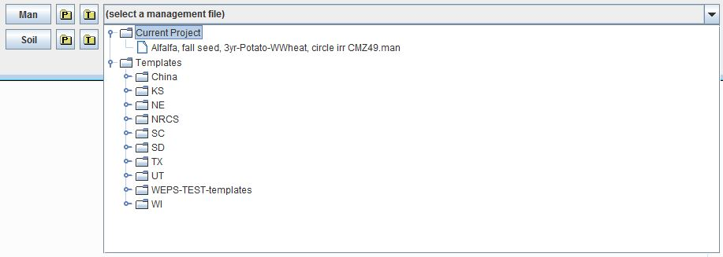
Figure 2-19 Management scenario drop down choice list.
The user can also select a management rotation by clicking on the “Template” folder button to the left of the management rotation name, which will bring up a standard file chooser. The user may also select previously used management files stored in the current WEPS Project directory by clicking on the Project folder button. Management rotation files in a WEPS Project directory are usually derivatives of those selected previously from the “Template” directory with local “Project-specific” modifications. Note that the and buttons are not displayed by default for the official NRCS configured releases of WEPS. Therefore, these users can only use the down arrow box to access the dropdown choice list for selecting management rotation scenarios from the main WEPS screen. Management rotation scenarios for a simulation run can also be created/selected within the rotation editor which can be opened by using the ‘Man’ button on the left side of the bottom panel of the WEPS main screen (Figure 2-20).

To open the Management/Crop Rotation Editor for WEPS ( MCREW), double click on the ‘Man’ button 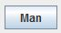, on the left side of the management box. This will open the MCREW window Figure 2-20), which allows the user to view, edit, and save management rotation information. Details on editing a management rotation file are discussed here: Editing with the Management/Crop Rotation Editor for WEPS (MCREW).

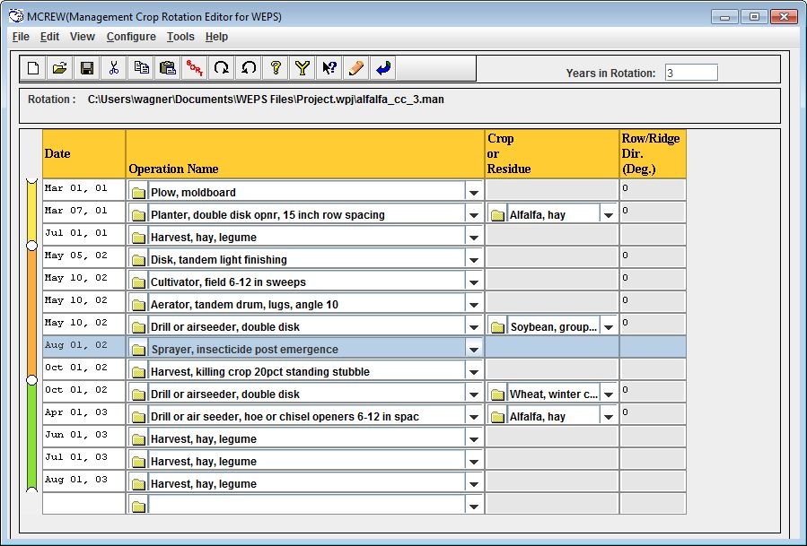
Figure 2-20 Management/Crop Rotation Editor for WEPS (MCREW) window.

Choosing a Soil
A soil for a WEPS simulation run is usually selected by using the ‘ Soil’ down arrow box on the far right side of the bottom panel of the WEPS 1.5 main screen (Figure 2-21) or by clicking on the ‘ Template’ folder button to the left of the soil name. The user may also select previously used soil files stored in the current WEPS Project directory by clicking on the Project folder button. Note that the and buttons are not displayed by default for the official NRCS configured releases of WEPS. Therefore, these users can only use the down arrow box to access the dropdown choice list for selecting soils from the main WEPS screen.

Figure 2-21 Bottom panel of the WEPS main screen with the Soil box on the bottom.
A soil for a WEPS simulation run is typically selected from a list of soils contained in the NRCS Soil Survey Geographic (SSURGO) database via a live “NRCS Soil Data Mart” internet connection option. There are other options available though, through the “Soil Templates” subfolder with “Exercise Soils”, “NRCS Generic Soils” and optionally Microsoft Access NRCS SURRGO “.mdb” files. Note that NRCS and other users can also provide MS Access SSURGO files for use in offline (no internet access) conditions. In addition, the current WEPS “Project” folder containing previously selected “.ifc” soil files is also available.

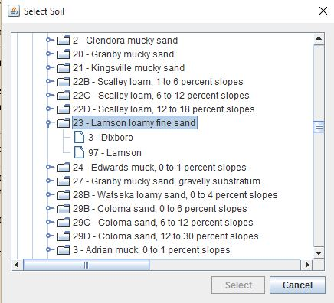
Figure 2-22 The "Select Soil" window.
Clicking on the ‘Template’ folder opens a window titled ‘Select Soil’ (Figure 2-22). Navigate through the database tree to find the soil survey area (or county) desired. Navigation is performed by clicking on the ‘closed key’ symbol to open the folder to display its contents. To close a folder, click the ‘open key’ symbol to quit displaying the folder contents. The soil files are listed according to the soil map unit symbol, map unit name, surface texture, and local phase. Selecting a soil then displays its components and the percentage that each component contributes to the map unit. Click a soil component to highlight it and click the ‘Select’ button at the bottom of the screen (or double click the component with the left mouse button). This action converts the soil from the SSURGO database to a WEPS soil file format (with an ‘ifc’ file extension), places a copy in the current “Project” folder and returns the user to the main screen. The loaded soil file name will appear in the soil box window. Clicking the ‘Cancel’ button in the ‘Select Soil’ window aborts the selection of a new soil.

Soils that have been previously selected or modified and saved to another name (and stored in the current “Project” folder) can be opened by clicking on the ‘ Project’ folder button. This will open a window in which the user can select the desired soil or type in the soil file name.

Users have the option to view the parameters for the soil file displayed in the soil box by clicking on the button labeled ‘Soil’, on the left side of the soil box. This will open the WEPS Soil User Interface screen (Figure 2-23). The details of the soil screen contents and the functionality are provided here.

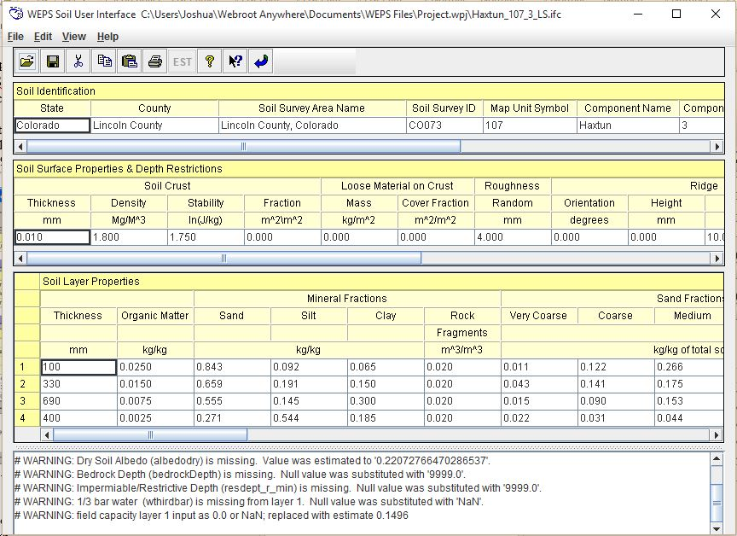
Figure 2-23 WEPS Soil User Interface screen.

Selecting a Wind Barrier

The Wind Barrier Information (Barriers panel) (Figure 2-24) is used to add barriers to the field borders. Note that WEPS 1.5 only allows barriers on the borders of the field, not within the field. The barrier location is labeled for the side of the field on which the barrier is to be placed, such as ‘N’ for north, ‘S’ for south, ‘E’ for east, and ‘W’ for west. If the field is rotated, the location is labeled for the direction closest to one of the four cardinal directions. The barrier type can be selected from the drop-down list in the panel by clicking the down arrow box to the right of the barrier type to bring up the list of available barriers and clicking on the appropriate barrier. Once a barrier type is selected, the barrier properties may be viewed and edited by clicking the button at the bottom of the panel. This displays a separate panel where one may enter the barrier width, height, and porosity in the appropriate fields. Note that the area of the barrier is displayed but cannot be edited. If barrier properties are modified, it will be noted in the type list with a <mod> designation before the type name (Figure 2-24). To remove a barrier from the field, click the radio button to select it (notice the barrier will be ‘highlighted’ when selected), then select the barrier type ‘None’ to remove it. To ‘deselect’ all barrier locations, click the enabled radio button to the off position. The Field View will automatically display the placement of selected barriers in red and highlight the currently selected location in yellow if no barrier exists there. If there is already a barrier for the selected location, it will display with a mixture of both red and yellow stripes. See the “WEPS How To Guide” for Barriers for further explanations on how to use barriers within WEPS and how to modify the barrier database.

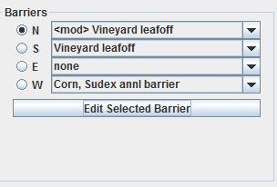
Figure 2-24 Wind Barrier Information panel.
Note that the Barriers panel is not the best way to simulate the effects of strip cropping, but it may be useful in strip cropping designs that include barriers along the edge of the strips. See the “WEPS How To Guide” for Strip Cropping for a detailed description of simulating strip cropping with WEPS 1.5.

WEPS Projects

A “WEPS Project” is a directory that can be thought of as a working area where WEPS simulation run files are created, edited and stored. A WEPS Project stores all the parameters for the current simulation run being prepared within the WEPS interface, as well as any past WEPS simulation runs. For example, a particular WEPS Project may represent a directory for an individual farm under which all the simulation runs for each field and management alternatives on that farm can stored. When a WEPS Project is saved, all of the information contained on the current interface screen is stored in the project directory along with the currently selected management and crop files. Multiple WEPS Projects can be created and given various names by the user. These directories can also be managed (i.e., renamed, deleted, or moved) with a file manager such as Windows Explorer (not provided with WEPS). One can also remove unnecessary WEPS Project and WEPS Run directories from within the WEPS interface via the pertinent options under the “Project” or “Run” menus. Note that the following characters cannot be used in WEPS file names: \ / < > | ? * & “ ~ ` ‘

Working with WEPS Projects
Clicking the ‘Project’ menu item displays a list of various options pertaining to WEPS Projects. These options are discussed below. Note: Multiple WEPS Projects functionality is not available for the NRCS configured version of WEPS.

The ‘New’ menu item (same as on the button bar) allows the user to create a new Project from scratch. Clicking on this menu item causes WEPS to check for any unsaved changes to the parameters displayed on the screen. If there are unsaved changes, the user is asked if they want to ‘Save current project?. If the user clicks ‘Yes’, the current parameters are saved to the old (current) Project. A file chooser then appears that allows the user to specify a name for the new WEPS Project. The current WEPS interface screen is then cleared, and the newly created WEPS Project becomes the current WEPS Project. If the user clicks ‘No’, a file chooser opens immediately, allowing the user to name the new WEPS Project to be created, and resets the parameters to the system defaults without saving any changes to the previous (current) WEPS Project. In either case, the user can then proceed to build the new WEPS Project by entering information on the interface screens. If the user clicks ‘Cancel’, the process of creating a new WEPS Project is aborted and the screen returns to the previous Project.

The ‘Open...’ menu item (same as on the button bar) opens an existing WEPS Project. Clicking on this menu item causes WEPS to check for any unsaved changes to the displayed parameters. If there are unsaved changes, the user is asked if they want to ‘Save current project?’. If the user clicks ‘Yes’, the current parameters are saved to the old (current) WEPS Project. A file chooser then appears that allows the user to specify the name of an existing WEPS Project to open. The newly opened Project becomes the current WEPS Project. If the user clicks ‘No’, the old WEPS Project is closed without saving any changes and a file chooser opens that allows the user to select an existing WEPS Project to be re-opened. In either case, the user can then proceed to view the WEPS Project information or modify the WEPS Project by entering information on the interface screens. If the user clicks ‘Cancel’, the process of selecting a previous WEPS Project is aborted and the screen returns to the old WEPS Project. When leaving the WEPS Project or WEPS, the user is asked if they want to save the current WEPS Project.

The ‘Save’ menu item (same as on the button bar) saves the current WEPS Project to the current Project name.

‘Save As...’ allows the user to save a copy of the currently displayed WEPS Project to a new name. The name must be new and cannot overwrite the name of an existing WEPS Project. The user must enter a unique name. The copy then becomes the current WEPS Project.

The ‘Delete Project’ and the ‘Delete Run’ menu item opens a file chooser to delete a WEPS Project and run.

The ‘Delete Management Rotation File’ menu item opens a file chooser to delete a WEPS management file. The ‘Delete IFC Soil File’ item opens a file chooser to delete a WEPs soil file. ‘Exit’, exits the WEPS program.

The default WEPS Project folder (i.e., directory) for these various WEPS Project options, under which new WEPS Projects will be created and existing WEPS Projects will be opened, can be specified under the ‘Directories’ tab of the ‘Configuration’ window. Enter the default directory on the line labeled ‘Projects Dir’. By default, the last WEPS Project that was open when WEPS was exited is the current WEPS Project when WEPS is restarted.

“WEPS Run” Directories
All WEPS simulation run results can be stored in subdirectories within the current WEPS Project directory, if configured to do so. A WEPS Run directory is created every time a simulation run is made. A WEPS Run directory stores a copy of all input files used to make the simulation run, together with the output files generated from those inputs by the WEPS science model. Thus, one is able to reproduce the identical WEPS Run at a later date (and get the same output results assuming they are using the same version of WEPS and weather generators/databases used when making the original simulation) because the original input files are still available. Typically, ‘re-running’ a previous WEPS Run is not necessary since the outputs are stored in the WEPS Run directory and can be reviewed via the “ViewOutput” menu options. However, a user may want to “restore” a previous WEPS Run and use it as a template to for editing prior to making a subsequent simulation run. This functionality is available via the button or the “Restore WEPS Run” option under the “Run” menu. Storing the input and output files for each WEPS Run in individually named directories makes it relatively easy to manage, archive and remove selected WEPS Runs as necessary.

Making a WEPS Run

Making a Standard WEPS Run

Once the desired information is entered through the interface screens, a simulation run can be initiated. Clicking on the ‘Run’ menu, then selecting ‘Make a WEPS Run’ (Figure 2-25), begins a WEPS simulation run. One can also click the run button on the button bar or press the Ctrl-R keys simultaneously to begin a WEPS simulation run. WEPS run status window.

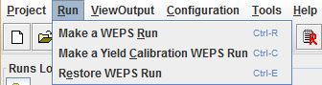
Figure 2-25 The Run menu on the main WEPS screen.
A “WEPS Run Name” window will appear (Figure 2-26), allowing the user to edit the default WEPS Run name displayed in the first (top) field labeled “Run Name”. Note that some special characters are not allowed in file names. Known characters that are not allowed include: ? ‘ ` & ~ / \ < > | : * ”. The user also also has the option to change the default “WEPS Run” location in the middle field labeled “Run Location”. If the user does not remember the exact path they desire the WEPS Run to be placed in, they can use the folder icon to bring up a file chooser to select the WEPS Run directory location. The complete WEPS “Run File” name and path are displayed in the third (bottom) read-only field.

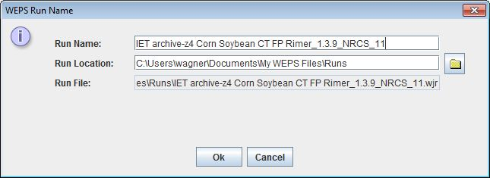
Figure 2-26 WEPS Run Name window.
When a run name has been entered, the simulation begins and a window appears that shows the status and progress of the run (Figure 2-27). At the conclusion of the run, a window may appear, if warranted, displaying any warnings that have been generated. These warnings are for informational purposes and may or may not be of interest to the user.

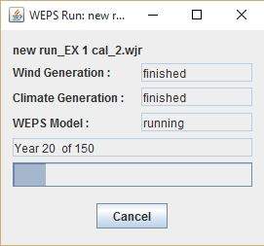
Figure 2-27 WEPS Run status window.
Upon completion of a run, a WEPS Run Summary report will appear for the user to review and print if desired. The Run Summary is saved in the run directory, along with more detailed output reports for later retrieval. The summary and detailed reports for a run can be viewed or created any time by the user. See the section of the WEPS User Manual titled “Viewing WEPS Output” for more detailed descriptions of the WEPS output types and how to select them for viewing or printing.

If a crop does not reach maturity, a warning will appear (Figure 2-28), indicating that the crop only reached the specified percent of the expected maturity for a given year. This warning can result from one of two causes. First, the crop variety chosen has a growing season too short for the climate being simulated. For example, a 120-day corn variety may be specified for a location that usually grows 110-day corn. In this case, a variety that matures over a longer period for that location should be chosen. If a variety of suitable length is not available in the crop drill-down list, a new variety can be created by following the method outlined in the WEPS How To Guide: Crop Database Record Development. Another cause of this warning may be that the growing season as specified by plant and harvest dates are too close together, not allowing the crop enough days to reach maturity. In this case, be sure the planting and harvest dates are correct, and adjust accordingly. If a crop is harvested before full maturity (e.g., for alfalfa or silage), a warning message will also appear.

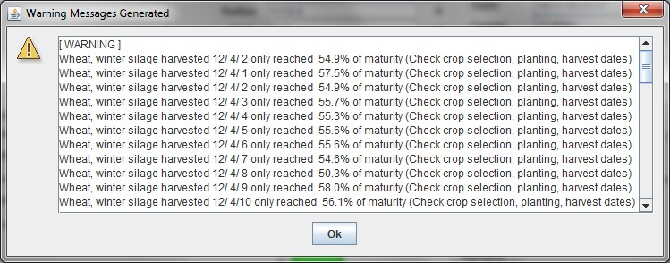
Figure 2-28 Crop growth/maturity warning message popup window.

Make a Yield Calibration WEPS Run

Differences in crop management by producers or local climate and soil variances may result in crop yields, generated by WEPS that do not reflect the actual yields observed by a producer. WEPS provides a method to “calibrate” yields and associated crop residue biomass from WEPS so that they more accurately reflect those of individual producers or a county as a whole. The following steps describe how, to make a yield calibration run.

a) Within MCREW, press the ‘Yield Calibrate’ button to display additional columns related to the crop-yield calibration function in WEPS.

b) Within MCREW, select the crop (or crops) that you want to calibrate by checking the box in the ‘Calib. Yield?’ column for the respective row the crop planting operation is in.

c) Fill in the desired ‘Target Yield’ for the selected crop(s). The yield units are displayed but not editable. The units may be changed in the Crop Drill-down window under the “Harvest” tab and the “Harvest yield conversion factor” must be adjusted to reflect the new units. Note that changing the water content requires changing the columns labeled “Yield Coef.” and “Residue Intercept” because all three parameters are interrelated. See the Crop How To Guide for more information on these parameters.

d) Save the rotation management file in MCREW. This currently can be done by: i) pressing the ‘Save’ icon , ii) via the ‘File > Save’ menu option, iii) using the ‘Ctrl-S’ keyboard shortcut, or iv) by clicking the Save and Close button , which saves the displayed data to the current file name and closes MCREW.

e) Exit MCREW. This can be done either by: i) clicking on the operating system’s “Close Window” button in the top right corner of the MCREW window frame or ii) via the ‘File > Exit’ menu option. Note that if one forgets to save the management file before attempting to exit MCREW, the user will be notified and given the opportunity to do so before exiting MCREW.

f) Click the ‘Make a Yield Calibration WEPS Run’ via the ‘Run’ menu bar option on the main screen (Figure 2-29) or the ‘Calibrate Run’ button on the main screen button bar. The shortcut ‘Ctrl-C’ will also work if the main WEPS screen has focus.

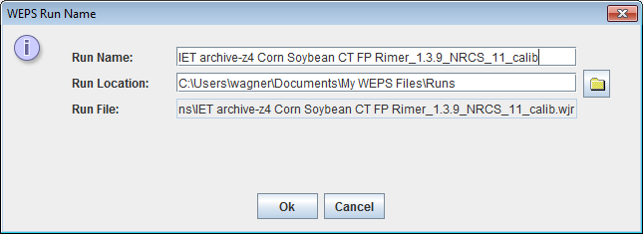
Figure 2-29 WEPS Yield Calibration Run Name window.
g) After the Calibration Run has completed, a popup dialog window (Figure 2-30) will appear that displays the ‘Calibration Factors’ for each crop selected for calibration (see figure to the left). One may then save each crop record as a new crop by clicking the “Save As” button for each crop. The user may also use the Biomass Adjustment factor in the current Project by clicking the “Use in Current Project” button at the bottom of the window. The biomass adjustment factor determined for each crop is also written into the ‘notes’ file for the calibration run.

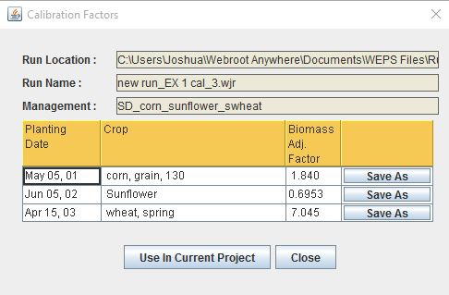
Figure 2-30 WEPS Run Calibration Factors window.

Restore a WEPS Run

A previously created WEPS run can be restored by clicking on the Run menu and selecting Restore a WEPS Run. This will open a file chooser that allows the user to select a previously created WEPS run. One can also click the restore button to restore a WEPS Run. “Restoring a WEPS Run” actually loads the inputs of the previous WEPS Run into the WEPS interface. These inputs can be modified and a new simulation run again with a new WEPS Run name. The new Run will be saved into a new subdirectory; previous WEPS Runs cannot be overwritten. Runs can be removed via the “Project>Delete Run” menu option. It is recommended that the user remove unwanted WEPS Runs regularly to prevent these directories and their contents from using too much storage space.

Viewing WEPS Output Reports

WEPS provides numerous outputs to aid the user in conservation planning. These outputs are accessed through the ViewOutput menu on the main screen with some reports also being accessible via the button bar. Clicking on this menu displays two choices, Current Run and Previous Run. Clicking on Current Run displays a list of output options for the most recent WEPS run. The Previous Run choice allows the user to view results of previous WEPS Runs. A description of the choices under these two submenus follows. All of the report options, except the Tabular Detail Report and the Science Model Reports contain a header that lists:

- Name of WEPS Run
- WEPS Run Date
- Client Name
- Farm No, Tract No and Field No
- WEPS Run folder location
- Management scenario file name
- Soil file name

For each of those same reports there is a button bar included at the top of the display screen (Figure 2-31).

Figure 2-31WEPS output reports button bar.
The following button bar functions are provided:

  - This button allows the user to print the report.

  - This button allows the user to create a file of the report in any of the following formats: a) PDF (Adobe Postscript), b) RTF (Rich Text Format), c) ODT (Open Document Format), d) HTML (Hypertext Markup Language), e) CSV (Comma Separated Values), f) XML (Extensible Markup Language) and g) Embedded Images XML.

  - This button allows the user to view the report using the operating system’s default PDF viewer to display the PDF generated version of the report. If the selected report does not have a PDF version available, a popup message will alert the user to that fact. However, the user can use the previous button bar button to generate the PDF file themselves, if desired.

  - This button allow the user to jump back to the 1st page of the report.

  - This button allows the user to go to the previous page of the report.

  - This button allows the user to go to the next page of the report.

  - This button allow the user to go to the last page of the report.

  - This button allows the user to go to the specified page number entered into the field.

  - This button allows the user to resize the report to the default (100%) size.

  - This button allows the user to shrink the report size.

  - This button allows the user to magnify the report size.

  - This button allows the user to magnify the report by 25% increments.

  - This button allows the user to shrink the report by 25% increments.

  - This button allows the user to specify the exact size of the report or to select a specified size through the dropdown arrow button which provides a choice list menu of pre-selected sizes ranging from 50% to 800%.

  - The remaining buttons provide quick access to a subset of the “current WEPS Run” reports:

  - This button allows the user to access the current WEPS Run Summary Report.

  - This button allows the user to access the current WEPS Run Crop Summary Report.

  - This button allows the user to access the current WEPS Run Cover Crop Summary Report.

  - This button allows the user to access the current WEPS Run Crop Interval Summary Report.

  - This button allows the user to access the current WEPS Run Soil Report.

  - This button allows the user to access the current WEPS Run Tabular Detail Report.

Run Summary Report

The Run Summary report screen (Figure 2-32) will automatically display at the conclusion of a WEPS simulation run. If the Run Summary screen has been closed, the user can re-display the Run Summary screen for the most recent WEPS Run by selecting the button on the main WEPS screen button bar or a previous WEPS Run by clicking the “ViewOutput” menu and selecting the “Previous Run” and then the “Run” option from the WEPS main screen menu bar.

The Run Summary contains the header information mentioned above along with the following additional information:

- Graphical representation of the field site
- Dimensions, orientation, area and elevation of the field site
- What “simulation mode” and number of “cycles” were used for the WEPS Run
- Site location, e.g. country, state and county, latitude and longitude coordinates, etc.
- Name of Cligen station used in WEPS Run
- Name of Windgen station, or if interpolated, the “lat/lon” coordinates, used in WEPS Run

The Run Summary WEPS report has the following sections which provide:

- Summarized rotation year and average annual soil loss by wind erosion
- Crop Interval period erosion rates
- Summarized harvested crop information
- SCI (Soil Conditioning Index) summarization
- Rotation Stir Energy summary for the management rotation
- Crop Interval period Stir Energy summary
- Management user notes

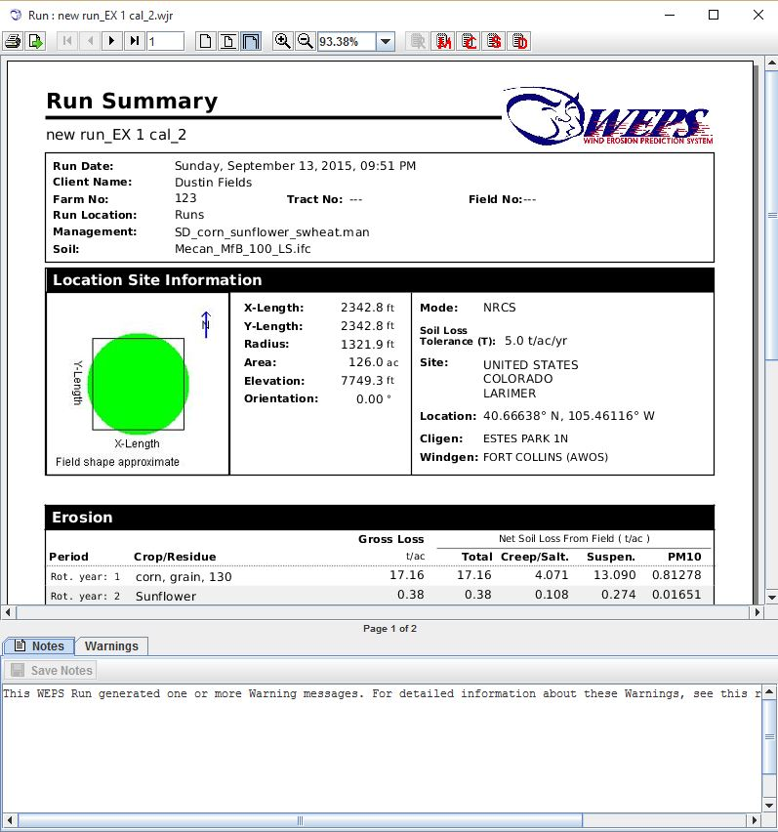
Figure 2-32 First page of WEPS Run Summary Report.

Erosion
This section of the Run Summary reports the wind erosion results from the simulation by specific periods in a tabular report (Figure 2-33). The values are reported in units of mass per area, e.g. for SI (kg/m²) and English (t/ac). The columns of this report section consist of:

Column 1, labeled Period, consists of the individual rotation years within the management/crop rotation cycle (Rot. Year: #) and the complete management/crop rotation cycle (Ave. Annual).

Column 2, labeled Crop/Residue, consists of the crops harvested during the specified rotation years.

Column 3, labeled Gross Loss, which is the average erosion within the field (i.e., removal of soil with no deposition taken into account).

Column 4-7, labeled “Net Soil Loss From Field”, which is the average total net soil losses from the field (net losses are gross losses minus deposition within the field. These values are broken down and reported by the size class of the particulates.

Column 4, labeled Total, which is total average net soil loss from the field for all size classes.

Column 5, labeled Creep/Salt., which is the average net soil loss from the field for creep and saltation size particles (≥100µ).

Column 6, labeled Suspen., which is the average net soil loss from the field for suspension size particles (<100µ).

Column 7, labeled PM10, which is the average net soil loss from the field for the fraction of suspension size particles less than 10µ in size.

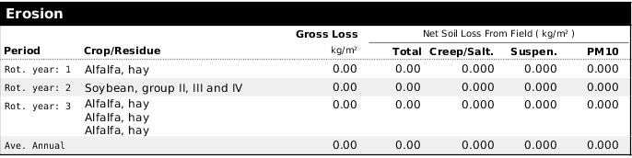
Figure 2-33 WEPS Run Summary Erosion report.

Deposition occurs when the wind speed drops as it travels across the field or the surface conditions become less erodible in a downwind part of the field (i.e., transport capacity of the wind exceeds transport capacity for the surface conditions). In WEPS 1.5, deposition only occurs with a drop in wind speed across the field due to a barrier present on the downwind side of the field or surface conditions changing across the field because of the erosion process. In many simulations, however, it is not uncommon to have equal gross and net total loss.

If an erosion event occurred, but values generated by the model are too small to be displayed on the output table (i.e., <0.001 kg/m²), then the amount is listed as “trace”. If amounts are too large to be accurately displayed, then the amount is listed simply as greater than a specified amount (i.e., > 300 kg/m²). In these cases, erosion amounts are so large that they are generally unacceptable. If any barriers were present on the field borders, a summary of their properties is also listed.

Crop Interval Erosion

This section of the Run Summary (Figure 2-34) reports the wind erosion results from the simulation by crop interval, which is defined as the time from the previous crop’s termination (final harvest or crop kill process) until the termination of this crop (final harvest or crop kill process). The soil loss values (last 5 columns) are reported exactly as they are for the Erosion sub-report previously described. The first three columns consist of:

Column 1, labeled Date Range, consists of the start and ending dates for each crop interval.

Column 2, labeled Days, consists of the crop interval period length in days.

Column 3, labeled Crop, consists of the crops defining each “crop interval”.

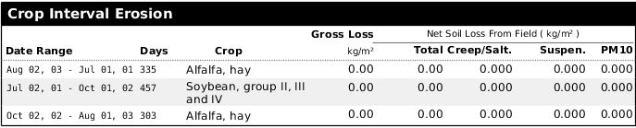
Figure 2-34 WEPS Run Summary Crop Interval report.

Harvests
This section of the Run Summary (Figure 2-35) provides a summarization of the average yield and after-harvest residue amounts for each harvested crop grown in the management/crop rotation scenario. The information is presented in tabular form where the columns consist of:

Column 1, labeled Date, consists of the harvest date for the specified crop.

Column 2, labeled Crop, consists of the crops that are harvested.

Column 3, labeled Residue, consists of the average after harvest crop residue left on the field and is reported in kg/m² when SI units are specified and lbs/ac when English units are used.

Column 4, labeled Harvest Yield, consists of the average yield produced by the crop and is reported in kg/m² when SI units are specified. When English units are used, the units displayed are obtained from the crop record, e.g. ton/ac, bu/ac, etc.

Column 5, labeled Yield % Moisture, consists of the percent water content value specified in the crop record and is used for reporting the yield.

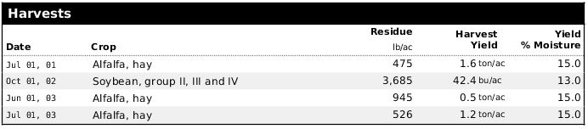
Figure 2-35 WEPS Run Summary Harvests report.

SCI Summary

This section of the Run Summary (Figure 2-36) provides a summary of the SCI (Soil Condition Index), Energy Calculator, Average STIR, and other inputs required for computing the SCI, including the SCI subfactors. The SCI is an index developed by NRCS to reflect trends in soil organic matter, which are assumed to be an indicator of soil quality trends. A negative value generally implies that the soil organic matter is decreasing and thus soil quality would be degrading over time. A positive value implies that soil organic matter is increasing and thus soil quality is generally improving over time. A value of zero or near zero implies that soil organic matter is not changing over time and thus the soil quality is sustainable. The values presented in this summary are:

- Soil Condition Index - Index developed and used by NRCS to reflect the relative quality of a soil due to the management/crop rotation practices being applied.
- Energy Calculator - Average annual energy per acre expended for operations specified in the management/crop rotation.
- Average Annual STIR - Computed for the management/crop rotation sequence from the listed operations.
- Wind Erosion Soil Loss - An input required for SCI calculation. Obtained from the WEP simulation run.
- Water Erosion Loss - An input required for SCI calculation. User is expected to specify the value on the main WEPS screen prior to the WEPS simulation being executed.

SCI Subfactors
- OM - It is the organic material or biomass subfactor. This component accounts for the effect of biomass returned to the soil, including material from plant or animal sources, and material either imported to the site or grown and retained on the site.
- FO - It is the field operations subfactor. This component accounts for the effect of field operations that stimulate organic matter breakdown. Tillage, planting, fertilizer application, spraying, harvesting, and other operations crush and shatter plant residues and aerate or compact the soil. These effects increase the rate of residue decomposition and affect the placement of organic material in the soil profile.
- ER - It is the erosion subfactor. This component accounts for the effect of removal and sorting of surface soil organic matter by sheet, rill, or wind erosion processes as predicted by water and wind erosion models. It does not account for the effects of concentrated flow erosion, such as ephemeral or classic gullies.

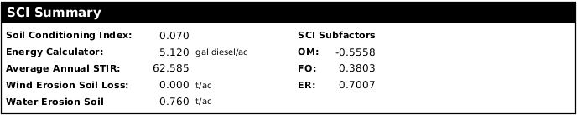
Figure 2-36 WEPS Run Summary SCI report.

Rotation Stir Energy

This section of the Run Summary (Figure 2-37) provides a summarization of the STIR (Soil Tillage Intensity Rating) for the operations listed in the management/crop rotation file. The STIR value is an indication of the overall “intensity” of the tillage applied for each specific operation in a given management/crop rotation scenario.

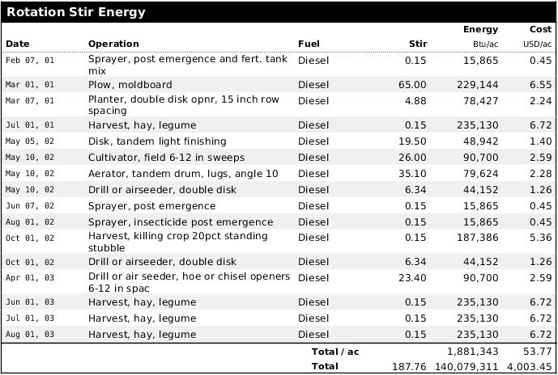
Figure 2-37 WEPS Run Summary Rotation Stir Energy report.
The Rotation Stir Energy table columns are:

Column 1, labeled Date, consists of operation date for the specified operation.

Column 2, labeled Operation, consists of the operation used on the specified date.

Column 3, labeled Fuel, consists of type of fuel used for energy estimates for the specified operation.

Column 4, labeled Stir, consists of the computed Stir value for the specified operation.

Column 5, labeled Energy, consists of the total computed energy consumed per unit area (kJ/ha for SI units and Btu/ac for English units) for the specified operation.

Column 6, labeled Cost, consists of the total computed cost in dollars per unit area (US dollars/ha for SI units and US dollars/ac for English units) for the specified operation.

The last row displays the rotation’s Total/unit area values for the Energy and Cost columns as well as the management rotation’s Total values for the entire field for the Stir, Energy and Cost columns.

Crop Interval Stir Energy

This section of the Run Summary (Figure 2-38) provides a summarization of the STIR (Soil Tillage Intnesity Rating), Energy and Energy Costs associated with each specific crop interval. The STIR value is an indication of the overall “intensity” of the tillage applied during each specific crop interval in a given management/crop rotation scenario.

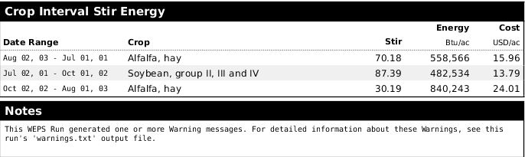
Figure 2-38 WEPS Run Summary Crop Interval Stir Energy report.
The Crop Interval Stir Energy table columns are:

Column 1, labeled Date Range, consists of the beginning and ending dates for the specified crop interval.

Column 2, labeled Crop, consists of the crop grown during the specified crop interval.

Column 4, labeled Stir, consists of the computed Stir value for the specified crop interval.

Column 5, labeled Energy, consists of the total computed energy consumed per unit area (kJ/ha for SI units and Btu/ac for English units) for the specified crop interval.

Column 6, labeled Cost, consists of the total computed cost in dollars per unit area (US dollars/ha for SI units and US dollars/ac for English units) for the specified crop interval.

Notes

The Notes section consists of two parts, the “Notest tab and the “Warnings” tab (Figure 2-39). The Notes section consists of any text entered prior to the simulation on the main WEPS screen’s Notes section (Figure 2-1 and Figure 2-10). Any notes entered on the main WEPS screen for this run are reproduced here. They can be edited or added to, if desired, and saved via the appropriate button at the top of the Notes form. Any warnings generated during the simulation are listed under the “Warnings” tab.

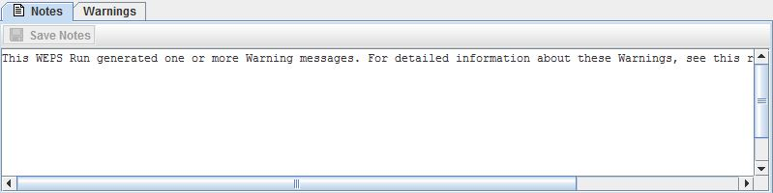
Figure 2-39 WEPS Run Notes listed in Run Summary.

Management Rotation Summary Report

The Management Summary Report screen (Figure 2-40) contains general run information as well as a summary of the management information for the WEPS run. The Management Summary Report displays the management operation date, operation name and crop name for the run with the management notes content listed at the bottom of the screen.
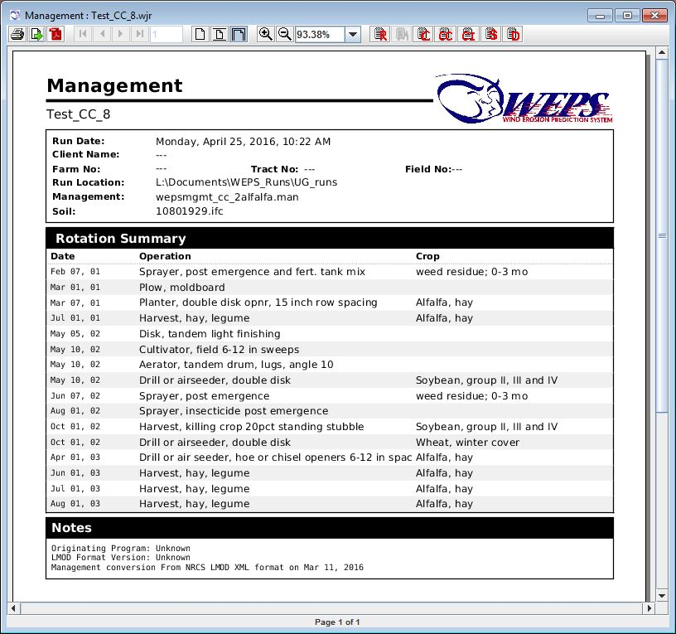
Figure 2-40 WEPS Management Rotation Summary Report.

Crop Reports

There are two crop reports, a Crop Summary Report (Figure 2-41), which only contains a statistical summarization of the individual management rotation year crop data consisting of the mean, standard deviation, minimum and maximum values and a Crop Detail Report (Figure 2-42), which also contains the individual management rotation year-by-year crop data results along with the statistical summarization data. Both reports contain the standard simulation run information in its initial header section, including the names of the input files. All crops that are harvested are reported here. This includes any multiply harvested crops like alfalfa, which are reported for each cropping period harvest individually.

The table heading lists the beginning (usually planting date) and the end (harvest date) of the cropping period, the total numbers of days for the period and the name of the crop being harvested. The individual column labels are:

Column 1, labeled Dry Yield, consists of the crop yield reported on a dry matter basis in lbs/ac (English units) or kg/m² (SI units).

Column 2, labeled Harvest Residue, consists of the remaining above ground residue reported on a dry matter basis in lbs/ac (English units) or kg/m² (SI units) after the harvest operation.

Column 4, labeled Rain, consists of the total precipitation received in inches (English units) or mm (SI units) during the crop growing period specified.

Column 5, labeled Irrig, consists of the total irrigation water applied in inches (English units) or mm (SI units) during the crop growing period specified.

Column 6, labeled Initial SWC, consists of the initial soil water content in the soil profile reported in inches (English units) or mm (SI units) of water.

Column 7, labeled Final SWC, consists of the final soil water content in the soil profile reported in inches (English units) or mm (SI units) of water.

Column 8, labeled SWC Change, consists of the change in soil water content in the soil profile reported in inches (English units) or mm (SI units) of water for the crop growing period specified. A negative value means that the stored soil water amount has decreased during the period. A positive value means that the stored water increased during the period.

Column 9, labeled Crop Transp, consists of the water transpired through the crop reported in inches (English units) or mm (SI units) of water during the growing period specified.

Column 10, labeled Yield, consists of the crop yield reported at the water content specified (obtained from the value provided in the crop record) in the units specified (also obtained from the crop record) when English units are used and kg/m² for SI units.

Crop Summary

The Crop Summary Report screen only contains a statistical summarization of the individual management rotation year crop data consisting of the mean, standard deviation, minimum and maximum values for each harvested crop as shown in (Figure 2-41).

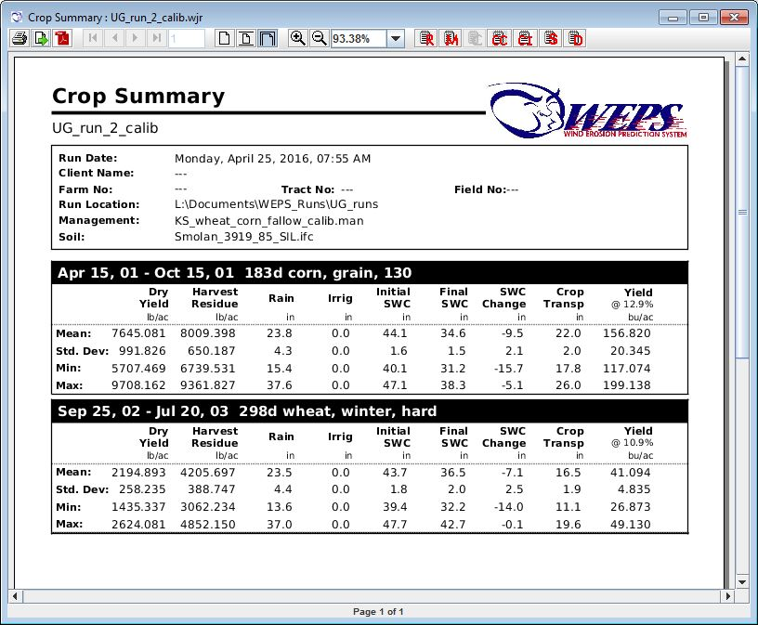
Figure 2-41 WEPS Crop Summary Report.

Crop Detail Report

The Crop Detail Report screen (Figure 2-42), consists of the individual management rotation year-by-year crop data results along with the statistical summarization data provided in the Crop Summary Report. The individual management rotation crop years are listed with a column heading of Rot. Cycle to indicate which management rotation cycle is being reported for each row.

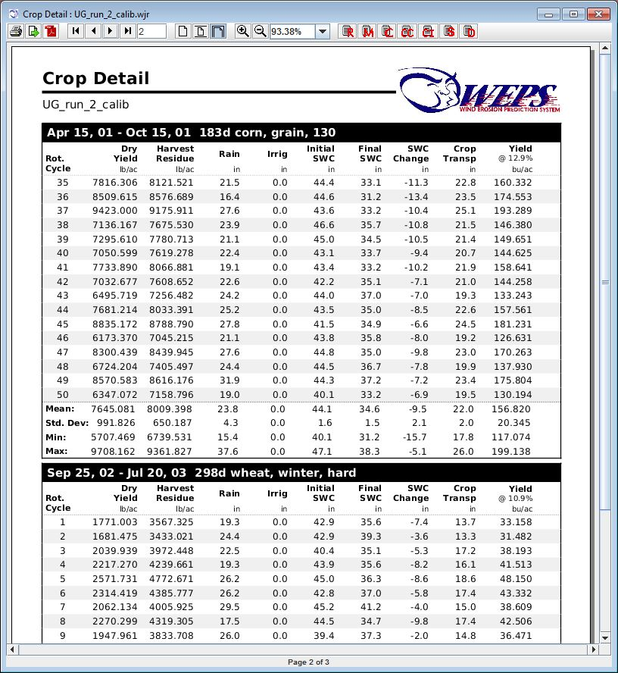
Figure 2-42 WEPS Crop Detail Report.

Cover Crop Reports
There are two cover crop reports, a Cover Crop Summary Report (Figure 2-43), which only contains a statistical summarization of the individual management rotation year cover crop data consisting of the mean, standard deviation, minimum and maximum values and a Cover Crop Detail Report (Figure 2-46), which also contains the individual management rotation year-by-year cover crop data results along with the statistical summarization data. Both reports contain the standard simulation run information in its initial header section, including the names of the input files. Crops that are not being harvested are considered cover crops. In addition, any multiply-harvested crop like alfalfa that is terminated on a later date than the last harvest operation will have that last “crop period” following the last reported harvest as a cover crop.

The table heading lists the beginning (usually planting date) and the end (cover crop termination date) of the cover crop period, the total numbers of days for the period and the name of the cover crop. The individual column labels are:

Column 1, labeled Standing Stem, consists of the cover crop standing stem mass reported on a dry matter basis in lbs/ac (English units) or kg/m² (SI units) on the cover crop termination date.

Column 2, labeled Standing Leaf, consists of the cover crop standing leaf mass reported on a dry matter basis in lbs/ac (English units) or kg/m² (SI units) on the cover crop termination date.

Column 3, labeled Avg Height, consists of the average cover crop height reported in inches (English units) or mm (SI units) on the cover crop termination date.

Column 4, labeled Stem Count, consists of the number of standing stems reported in number stems per in² (English units) or number stems per m² (SI units) on the cover crop termination date.

Column 5, labeled Rain, consists of the total precipitation received in inches (English units) or mm (SI units) during the cover crop growing period specified.

Column 6, labeled Irrig, consists of the total irrigation water applied in inches (English units) or mm (SI units) during the cover crop growing period specified.

Column 7, labeled Initial SWC, consists of the initial soil water content in the soil profile reported in inches (English units) or mm (SI units) of water.

Column 8, labeled Final SWC, consists of the final soil water content in the soil profile reported in inches (English units) or mm (SI units) of water.

Column 9, labeled SWC Change, consists of the change in soil water content in the soil profile reported in inches (English units) or mm (SI units) of water for the cover crop growing period specified. A negative value means that the stored soil water amount has decreased during the period. A positive value means that the stored water increased during the period.

Column 10, labeled Crop Transp, consists of the water transpired through the cover crop reported in inches (English units) or mm (SI units) of water during the growing period specified.

Cover Crop Summary

The WEPS Cover Crop Summary Report screen only contains a statistical summarization of the individual management rotation year cover crop data consisting of the mean, standard deviation, minimum and maximum values for each harvested crop as shown in (Figure 2-43).

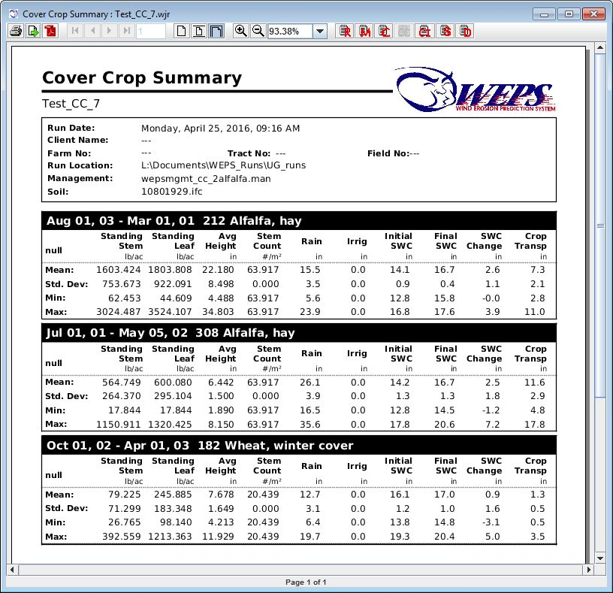
Figure 2-43 WEPS Cover Crop Summary Report.

Cover Crop Detail Report

The Cover Crop Detail Report screen (Figure 2-44), consists of the individual management rotation year-by-year crop data results along with the statistical summarization data provided in the Cover Crop Summary Report. The individual management rotation cover crop years are listed with a column heading of Rot. Cycle to indicate which management rotation cycle is being reported for each row.

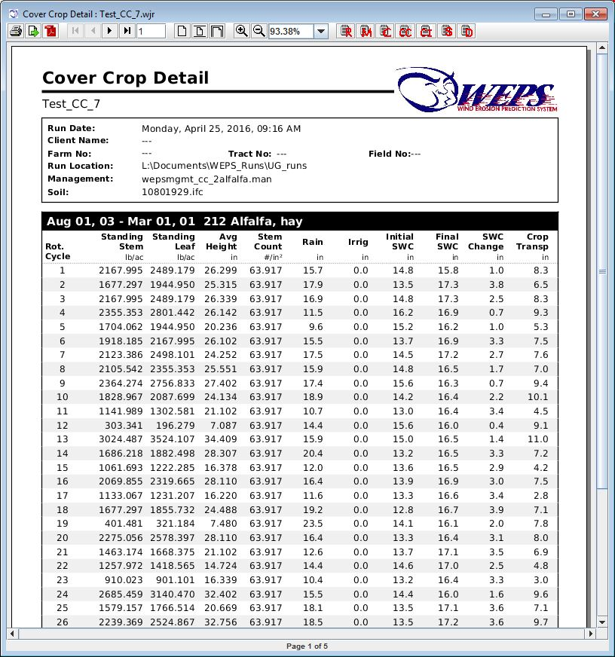
Figure 2-44 WEPS Cover Crop Detail Report.

Crop Interval Reports

There are three crop interval reports, a Crop Interval Summary Report, Crop Interval Detail Report and a Crop Interval Period Detail Report. The Crop Interval Summary Report (Figure 2-45) only contains a statistical summarization of the individual management rotation year crop interval data consisting of the mean, standard deviation, minimum and maximum values. The Crop Interval Detail Report (Figure 2-46) contains the summarized crop period data results along with the statistical summarization data. The Crop Interval Period Detail Report (Figure 2-47) contains the individual management rotation year-by-year crop period and crop interval data results along with the statistical summarization data for the crop periods and crop intervals. All three reports contain the standard simulation run information in its initial header section, including the names of the input files.

Crops intervals consist of the period following the previous crop’s termination until the termination of that crop. For typical row crops, these dates usually correspond to the previous crop’s harvest date to this crop’s harvest date, assuming the harvest dates. Cropping periods are defined as the period between the previous crops’ termination and the planting of the current crop, if this period exists, and is identified as CP_0 in the crop interval reports. The cropping (crop growth) period that refers to crop planting until harvest is identified as CP_1 in the crop interval reports. For multiply harvested crops, such as alfalfa, the additional crop growth/harvest periods are referred to as CP_2, CP_3, etc. If a crop can continue to grow (re-grow) after the final harvest and is not explicitly terminated by that harvest operation, a final cover crop period is defined for that period.

The table heading lists the beginning and the end dates for the periods indicated, the total numbers of days for the period and the name of the crop (for crop intervals) or the operation that concludes the crop period. The individual column labels are:

Column 1, labeled Biomass, consists of the above ground biomass grown during the period indicated and reported on a dry matter basis in lbs/ac (English units) or kg/m² (SI units).

Column 2, labeled Rain, consists of the total precipitation received in inches (English units) or mm (SI units) during the period specified.

Column 3, labeled Irrig, consists of the total irrigation water applied in inches (English units) or mm (SI units) during the period specified.

Column 4, labeled Runoff, consists of the total surface runoff of water in inches (English units) or mm (SI units) during the period specified.

Column 5, labeled Drainage, consists of the total drainage of water through the soil profile in inches (English units) or mm (SI units) during the period specified.

Column 6, labeled Evap, consists of the total soil surface evaporation of water in inches (English units) or mm (SI units) during the period specified.

Column 7, labeled Crop Transp, consists of the total water transpired through the growing crop reported in inches (English units) or mm (SI units) of water during the specified.

Column 8, labeled Initial SWC, consists of the initial soil water content in the soil profile reported in inches (English units) or mm (SI units) of water.

Column 9, labeled Final SWC, consists of the final soil water content in the soil profile reported in inches (English units) or mm (SI units) of water.

Column 10, labeled SWC Change, consists of the change in soil water content in the soil profile reported in inches (English units) or mm (SI units) of water for the period specified. A negative value means that the stored soil water amount has decreased during the period. A positive value means that the stored water increased during the period.

Column 11, labeled Runoff Loss, consists of the percent of surface water runoff lost during the period specified.

Column 12, labeled Drainage Loss, consists of the percent of total water lost through the soil during the period specified.

Column 13, labeled Evap Loss, consists of the percent of total water lost to surface evaporation during the period specified.

Column 14, labeled Water use Eff., consists of the percent of total water transpired through the growing crop during the period specified. Note that not all periods contain a growing crop (CP_0), thus not all report sections will display this column.

Column, 14, labeled Water Storage Ratio, consists of the fraction of water stored during a non-crop period (CP_0). It is not displayed for periods consisting of a growing crop and the Water use Eff. value is displayed instead.

Column 15, labeled Fallow Eff., consists of the total water gained or lost during the period specified and is expressed as a fraction. This term is only useful for periods where there is no crop growing, e.g. a “fallow period” or CP_0 labeled periods in the Crop Interval Detail Report and the Crop Interval Period Detail Report.

Crop Interval Summary

The WEPS Crop Interval Summary Report screen only contains a statistical summarization of the individual management rotation year crop interval data consisting of the mean, standard deviation, minimum and maximum values for each crop interval as shown in (Figure 2-45).

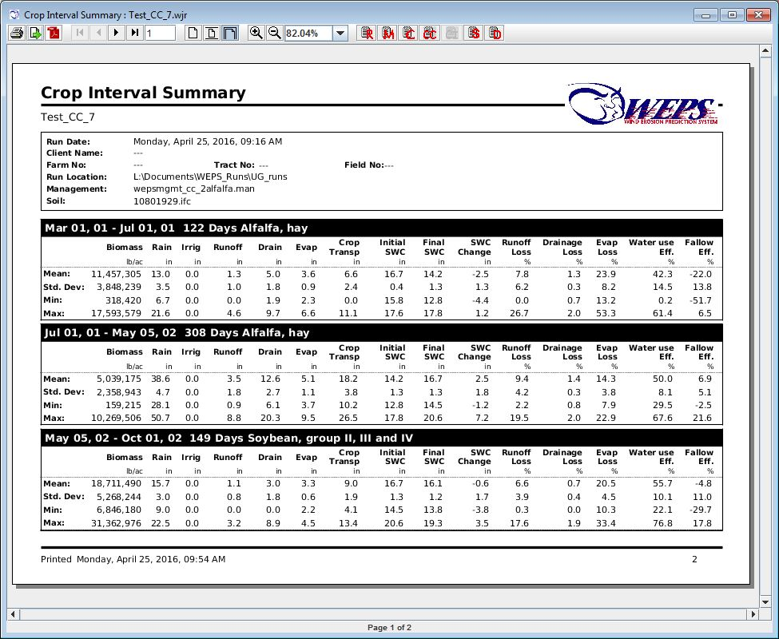
Figure 2-45 WEPS Crop Interval Summary Report.

Crop Interval Detail Report

The Crop Interval Detail Report screen (Figure 2-46) consists of the individual crop periods (CP_0, CP_1, CP_2, etc.) results along with the statistical summarization of the crop interval data provided in the Crop Interval Summary Report.

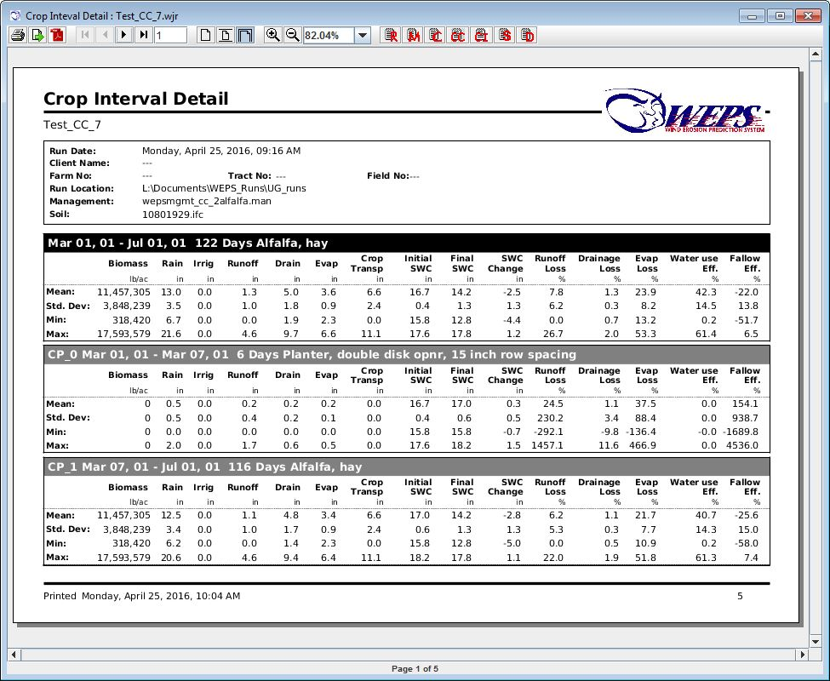
Figure 2-46 WEPS Crop Interval Detail Report.

Crop Interval Period Detail Report

The Crop Interval Period Detail Report screen (Figure 2-47) consists of the individual management rotation year-by-year crop interval and crop period data results along with the statistical summarization of the crop interval and crop period data provided in the Crop Interval Detail Report. The individual management rotation crop period and crop interval years are listed with a column heading of Rot. Cycle to indicate which management rotation cycle is being reported for each row.

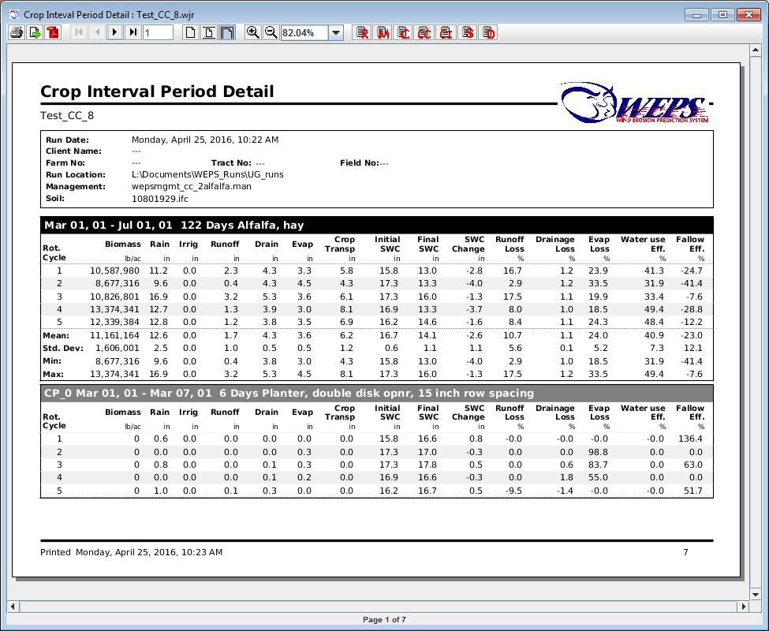
Figure 2-47 WEPS Crop Interval Period Detail Report.

STIR Energy Report

The STIR Energy Report screen (Figure 2-48) contains general run information as well as a summary of the STIR energy and SCI (Soil Conditioning Index) information for the WEPS run. The STIR Energy Report displays the three sections (SCI Summary, Rotation STIR Energy and Crop Interval STIR Energy).
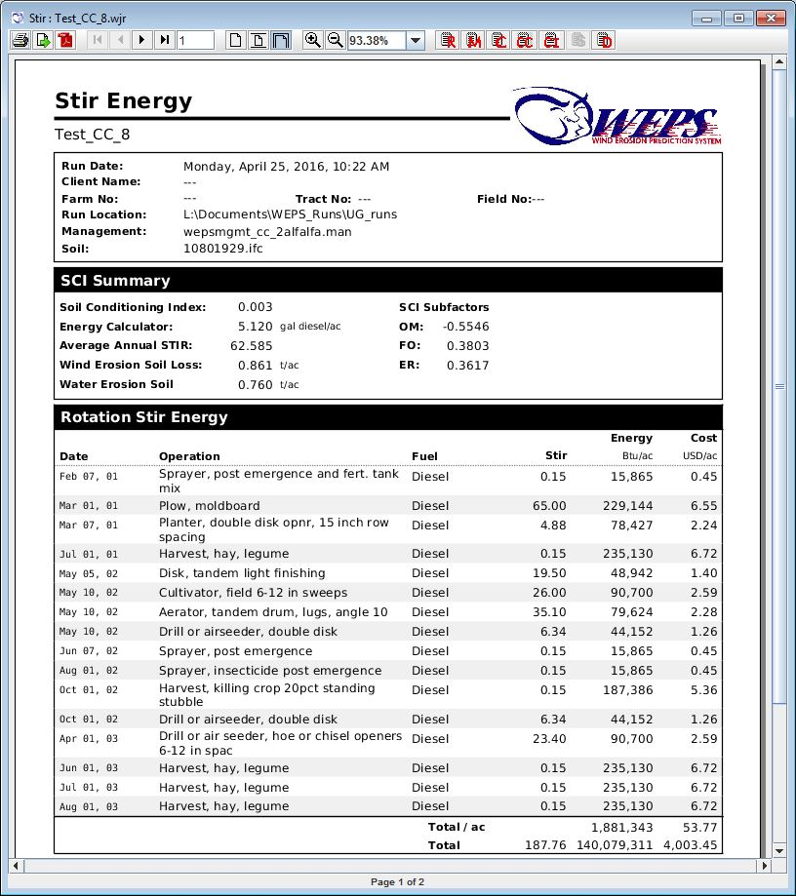
Figure 2-48 WEPS STIR Energy Report displaying the “SCI Summary” and “Rotation STIR Energy” sections.
This SCI Summary section consists of the SCI (Soil Conditioning Index) value, the Energy Calculator (fuel/ac for English units and fuel/ha for SI units), average annual STIR value, wind and water erosion values (t/ac for English units and kg/m² for SI units) and the SCI subfactors: OM, FO and ER.

The SCI is an index developed by NRCS to reflect trends in soil organic matter, which are assumed to be an indicator of soil quality trends. A negative value generally implies that the soil organic matter is decreasing and thus soil quality would be degrading over time. A positive value implies that soil organic matter is increasing and thus soil quality is generally improving over time. A value of zero or near zero implies that soil organic matter is not changing over time and thus the soil quality is sustainable. The values presented in this summary are:

- Soil Condition Index - Index developed and used by NRCS to reflect the relative quality of a soil due to the management/crop rotation practices being applied.
- Energy Calculator - Average annual energy per acre expended for operations specified in the management/crop rotation.
- Average Annual STIR – STIR stands for Soil Tillage Intensity Rating and is computed for the entire management/crop rotation sequence from the listed operations.
- Wind Erosion Soil Loss - An input required for SCI calculation. Obtained from the WEPS simulation run.
- Water Erosion Loss - An input required for SCI calculation. User is expected to specify the value on the main WEPS screen prior to the WEPS simulation being executed.

SCI Subfactors
- OM - It is the organic material or biomass subfactor. This component is an indicator of organic matter preservation and accounts for the effect of biomass returned to the soil, including material from plant or animal sources, and material either imported to the site or grown and retained on the site.
- FO - It is the field operations subfactor. This component accounts for the effect of field operations that stimulate organic matter breakdown. Tillage, planting, fertilizer application, spraying, harvesting, and other operations crush and shatter plant residues and aerate or compact the soil. These effects increase the rate of residue decomposition and affect the placement of organic material in the soil profile.
- ER - It is the erosion subfactor. This component accounts for the effect of removal and sorting of surface soil organic matter by sheet, rill, or wind erosion processes as predicted by water and wind erosion models. It does not account for the effects of concentrated flow erosion, such as ephemeral or classic gullies.

The Rotation STIR Energy section (Figure 2-48) summarizes the effect of the management/crop rotation operations on the health of the soil and the energy required to perform them. It consists of the individual operation names, date of use, STIR values along with their Fuel type, estimated Energy use (Btu/ac for English units and kJ/ha for SI units) and Costs ($/ac for English units and $/ha for SI units). The total STIR energy value (But/ac if English units are used and kJ/ha if SI units are specified) and Cost ($/ac for English units and $/ha if SI units are specified) are also tallied and reported at the bottom of this section.

The Crop Interval STIR Energy section (Figure 2-49) summarizes the effect of the management/crop rotation operations used over the specified crop interval dates (from termination of the last crop to the harvest or termination of this crop) values for STIR, Energy and Cost are displayed.

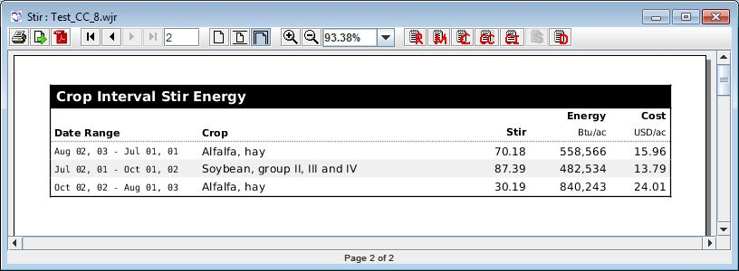
Figure 2-49 WEPS STIR Energy Report displaying the “Crop Interval STIR Energy” section.

Confidence Interval Report

The WEPS Confidence Interval Report screen (Figure 2-50) contains a statistical summarization of the estimated erosion loss from the field in terms of a “confidence interval” and reports the nonlinearity of the erosion data in terms of quartiles. A Final Cycle Gross Loss Confidence Interval box and whisker graph is shown in the first section. In the middle section, a Cycle Gross Loss Confidence Interval graph of the gross average soil for each rotation cycle, the gross soil loss upper and lower 90% confidence intervals and the running average soil loss are plotted against the rotation cycles. There is also an Annual Gross Loss Quartile Distribution box and whisker graph that plots the “Mean”, Median” and “Extreme-Outlier annual soil loss data against erosion loss. In addition, there is a table starting on page 2 displaying the individual rotation cycle values reporting the annual soil loss for the individual cycle, a running average annual soil loss, and the upper and lower 90% confidence interval values through each rotation cycle.

Final Cycle Gross Loss Confidence Interval: A box and whisker graph providing a statistical picture of the final minimum, maximum and median annual erosion values, the annual average (mean) erosion total and 90% confidence interval values are shown. Each data point is the average of the individual year values for each rotation cycle, e.g. a 3-year cycle would be the average of the 3 individual yearly average values. The whiskers show the maximum and minimum values for the cycles. The box ends indicate the upper and lower values of the 90% confidence interval and the box itself representing the confidence interval range. The black dot is placed at the mean value and the black vertical bar at the median value.

Cycle Gross Loss Confidence Interval Plot: Each value of the annual erosion total is averaged over each rotation cycle (blue line), and the running average mean (red line) and confidence interval (green line/fill region) values are calculated as each cycle is added. When fewer cycles have been simulated, the mean and confidence interval values can change dramatically when a large cycle erosion value is included in the calculation. As more years are simulated, the mean and confidence interval become more stable, even when large cycle erosion values occur. The final results at the end of the plot are presented more clearly in the previous box and whisker graph. Note that the auto-scaling is based upon the maximum average annual erosion value, so the upper 90% CI values are truncated if they exceed that maximum Y-axis plot limit.

Annual Gross Loss Quartile Distribution: A box and whisker graph providing a statistical picture of total erosion for each year, irrespective of the cycles, is shown. The lower quartile is the 25% of values which are below the lower end of the red bar. When at least 25% of the years have no erosion, then the lower end of the red bar would be at zero, signifying a zero erosion amount. The second quartile is the 25% of values which are between the lower end of the red bar and the median (as shown by the black vertical bar). The third quartile are the 25% of values which are between the median and the upper end of the red bar. The fourth quartile is all values above the upper end of the red bar. The inter-quartile range is the distance between the lower and upper ends of the red bar (represented by the red box). The lower and upper “fences” are shown by the lower and upper whiskers, which are the values which are 1.5 times the inter-quartile range below the lower end of the red bar, or 1.5 times the interquartile range above the upper end of the red bar. All values below the lower whisker or above the upper whisker are considered to be extreme outliers and are plotted with a blue × symbol. Note that this graph is plotting the individual yearly erosion values and not the individual rotation cycle average values.
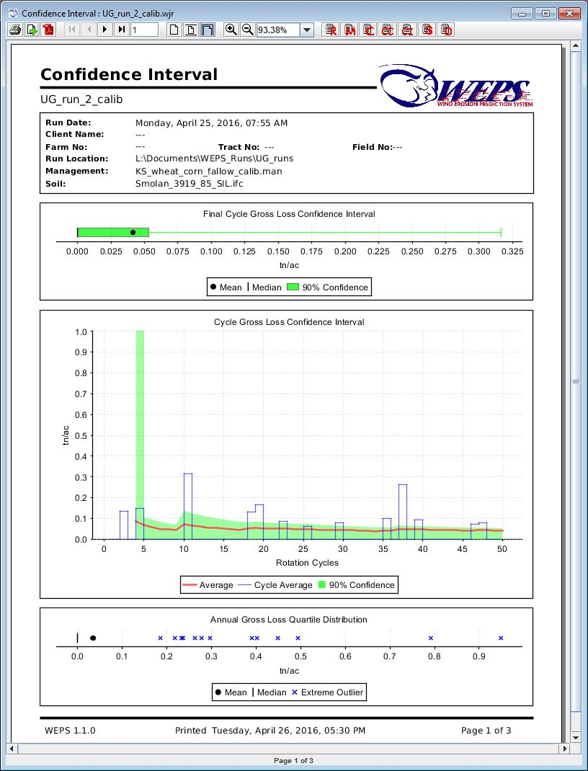
Figure 2-50 WEPS Confidence Interval Report.

Viewing Previous WEPS Output Reports

Output from either the current run or previous runs can be viewed by using the ‘ViewOutput’ menu. This menu allows the user to view output for the most recent (current) or previous runs. Clicking on the ‘Current Run’ menu item displays a list of output reports for the current (last completed WEPS simulation) run. Clicking on the ‘Previous Run’ menu item displays a list of output reports for previous runs. For this menu option, a file chooser opens to allow the user to pick the desired run for which to view the output. The “Multiple Run Manager” also allows the user to open a list of previous WEPS runs. See the section of the WEPS User Manual titled “Viewing WEPS Output Reports”, “Viewing Tabular Detail Reports” and “

Viewing Science Model Reports” for a more detailed description of the individual WEPS output reports available.

Viewing Science Model Reports

The Science Model Reports screen (Figure 2-51), accessible from the ViewOutput menu on the WEPS main screen, provides a means of directly accessing all output files generated by the WEPS science model, including those that are used by the WEPS user interface to generate reports.

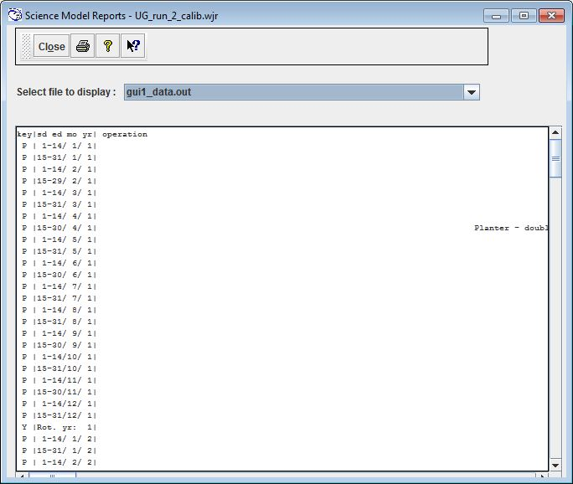
Figure 2-51WEPS science model report screen.
The Science Model Report contains a toolbar which consists of the following functions:

  - This button allows the user to close the Science Model Report window.

  - This button allows the user to print the Science Model Report.

  - This button allows the user to bring up the online help for the Science Model Report.

  - Selecting this button produces a question mark mouse pointer which allows the user to select a specific location on the Science Model Report to obtain specific context sensitive help regarding the selected location on the screen.
A list of selectable output files are available on a drop-down list. Clicking the down arrow to the right of ‘Select file to display’ will show a list of ASCII text output files available for viewing. Click the desired list entry and it will be displayed below in the view area of the window. These files are generally for advanced users and model developers. For more information on accessing and interpreting the WEPS science model output files, contact WEPS support.

Viewing Tabular Detail Reports

The Tabular Detail Reports screen (Figure 2-52) displays a multitude of data in a table (spreadsheet) format. The data is provided on a “period” basis with the “periods” being roughly biweekly in length (half of month) with these period intervals being spit into smaller sub-periods when an operation event is specified on a date within a “period”. In addition, the rotation year averages are also provided along with the entire rotation averages. Data that is cumulative through a period are reported as the average values for all rotation cycles. Data that has a fixed value for a given date have the “end of period” values reported as the average “end of period” values for all rotation cycles.

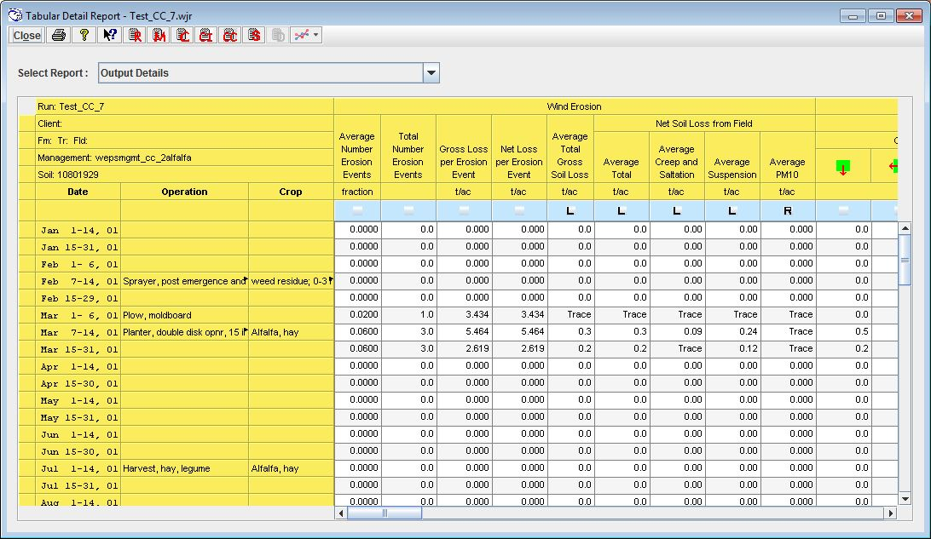
Figure 2-52 Tabular Detail Report.
The Tabular Detail Report contains a toolbar which consists of the following functions:

This button allows the user to close the Tabular Detail Report window.

This button allows the user to print the Tabular Detail Report.

This button allows the user to bring up the online help for the Tabular Detail Report.

Selecting this button produces a question mark mouse pointer which allows the user to select a specific location on the Tabular Detail Report to obtain specific context sensitive help regarding the selected location on the screen.

This button allows the user to access the current WEPS Run Summary Report.

This button allows the user to access the current WEPS Run Crop Summary Report.

This button allows the user to access the current WEPS Run Cover Crop Summary Report.

This button allows the user to access the current WEPS Run Crop Interval Summary Report.

This button allows the user to access the current WEPS Run Soil Report.

This button allows the user to graph the selected columns of data in a “Quick Plot”. Selecting the “down arrow” component on this button will present the user with a dropdown menu of choices:
- Plot Style (sets the default plot style to be graphed)
  - Line (default plot style)
  - Bar
  - Bar Stacked
  - Area
  - Scatter
- Restore Defaults (resets the selected columns to the defaults)
- Select All (selects all columns to be plotted)
- Clear All (clears all columns from being selected for plotting)

The Tabular Detail Report also includes some WEPS Run information consisting of:
- The WEPS Run name.
- The Client name.
- The Farm, Tract and Field numbers.
- The Management scenario file name.
- The Soil file name.

Tabular Report Column and Row Definitions
The columns of the Tabular Detail Report are defined as follows (Note that not all columns listed here are available for the NRCS configured version of WEPS):

Date - The start and end dates (day/month/rotation year) of the reporting period.

Operation - The management operation that occurred on the specified date (if multiple operations have been specified on the same date, only the last one listed on that date will be displayed).

Crop -The crop planted on the specified date.

Wind Erosion
Field erosion related data are presented here, e.g. the number of erosion event:, gross, net and average value per period specified as well as particulate size classification.

Average Number Erosion Events - This column displays the average number of erosion events per period (fraction).

Total Number Erosion Events - The total number of erosion events during that period for the simulation.

Gross Loss per Erosion Event - The gross erosion within the field for each event, averaged across the field, as well as averaged over the number of simulation years in each rotation year (kg/m² or tons/acre).

Net Loss per Erosion Event - The net erosion within the field for each event, averaged across the field, as well as averaged over the number of simulation years in each rotation year (kg/m² or tons/acre). Some deposition within a field can occur, especially when barriers are present downwind. Net soil loss is the amount of gross loss minus deposition.

Average Total Gross Soil Loss - The average erosion (soil loss) within the field, averaged across the field, as well as averaged over the number of simulation years in each rotation year (kg/m² or tons/acre). This value is the total amount of soil being removed from the surface of the field. It does not take into consideration the amount of that entrained soil that may be re-deposited downwind within the field due to wind barriers, etc. The “gross” soil loss values are most important when evaluating the “onsite” effects of wind erosion.

Net Soil Loss from Field
The ‘Net Soil Loss from Field’ columns display the “actual” soil loss from the field (net losses are gross losses minus deposition within the field). Specific areas within the field may experience: 1) a net soil loss, 2) a net soil gain (deposition), 3) no soil movement, or 4) soil movement, but the soil loss is equal to the deposition within the specified area. Under some scenarios, a portion of soil entrained upwind can get deposited within the field borders, due to a reduction in wind speed (and thus its soil-carrying capacity) caused by downwind barriers, changes in surface roughness across the field, etc. Therefore, the “net” soil loss reported will be less than the “gross” soil loss in these situations. The “net” soil loss values are most important when evaluating “offsite” effects of wind erosion.

Average Total - The average total net soil loss from the field (kg/m² or tons/acre). This value represents the average amount of soil actually leaving the field boundaries. If there are any downwind barriers, this value will be somewhat less than the ‘Average Total Gross Soil Loss’ value due to deposition occurring within the field.

Average Creep & Saltation - The quantity of creep plus saltation-size material leaving the field for the period, averaged across the field grid areas, as well as averaged over the number of simulation years in each year of the crop rotation (kg/m² or tons/acre).

Average Suspension - The quantity of suspension-size material leaving the field for the period, averaged across the field grid areas, as well as averaged over the number of simulation years in each rotation year (kg/m² or tons/acre).

Average PM10 - The quantity of PM10 (particulate matter less than 10 microns) material leaving the field for the period, averaged across the field grid areas, as well as averaged over the number of simulation years in each rotation year (kg/m² or tons/acre).

Mass of Soil Passing Indicated Field Boundary (per Unit Length of Field Border)
These columns display the average soil loss across the indicated field boundary, per unit length of field border, for the specified size range of eroding material.

Creep+Saltation - Average mass of creep plus saltation-size material passing each field boundary (kg/m or tons/1000 ft of field border length) in the direction indicated .
Suspension - Average mass of suspension-size material passing each field boundary (kg/m or tons/1000 ft of field border length) in the direction indicated .

PM10 - Average mass of PM10 size material passing each field boundary (kg/m or tons/1000 ft of field border length) in the direction indicated .

Within Field Wind Erosion Activity
The information in this section is useful in determining how much of the field is actively eroding and how much is not, which may impact what control measures, if any, should be applied and where. This information is also useful in understanding how much of the field is actively eroding, and thus may be causing plant or soil damage, or how much is subject to burial. Finally, this information is useful in understanding how much of the field is contributing to overall (net) field loss.

Saltating Emission Region
Soil Loss - The amount of soil loss from that area of the field that had significant saltation emission (kg/m² or tons/acre).

Field Area - Both the area (acres or hectares) and fraction of the field area that had saltation emission.

Deposition Region
Soil Deposition - The amount of soil deposited in that area of the field where deposition is the primary activity (kg/m² or tons/acre).

Deposition Field Area - Both the area (acres or hectares) and fraction of the field area that had deposition.

High Flux Region
High Flux Field Area - Both the area (acres or hectares) and fraction of the field area that was near transport capacity.

Sheltered Region
Sheltered Field Area - Both the area (acres or hectares) and fraction of the field area that had no saltation or suspension material being emitted. Sheltered areas are typically those immediately downwind of barriers.

Weather Information
Wind Energy >8 m/s - The average daily wind energy for the period for winds greater than 8 m/s (18 mi/h), averaged over the simulation years in each year of the crop rotation (KJ/m²/day).

Snow Depth > 20 mm - The total average fraction of time that snow cover on the field which is greater than 20 mm (0.787 in) in depth (mm or inches).

Total Period Precipitation - The total precipitation for the period averaged over the simulation years in each year of the crop rotation (mm or inches).

Crop/Soil Water Information
Irrigation - The total average irrigation water applied for the period (mm or inches).

Runoff - Quantity of water (precipitation and irrigation) for the period that does not infiltrate into the soil and leaves the field (mm or inches).

Drainage - Quantity of water in the soil that drains out of the bottom of the soil profile for the period (mm or inches).

Soil Water - Quantity of water stored in the soil profile at the end of the period (mm or inches).

Soil Surface Evaporation - Quantity of water lost to surface evaporation for the period (mm or inches).

Plant Transpiration - Quantity of water used by the crop (growing plants) for the period (mm or inches).

Average Biomass Surface Conditions on Date (at end of period)
Crop Vegetation (Live)
Canopy Cover - The fraction of live crop biomass cover (vertical view) at the period end, averaged over the simulation years for the period listed (fraction).

Effective Standing Silhouette - The standing silhouette area index of live plants, expressed on a fraction basis. If the plants are planted in the furrow, as opposed to the ridge top, the index is adjusted (down) to have less of an effect on the wind. These are values at the period end, averaged over the simulation years in each rotation year.

Leaf and Stem Mass - The total live crop biomass, above ground, at the period end, averaged over the simulation years for the period listed (kg/m² or lbs/acre).

Root Mass - The total live crop biomass, below ground, at the period end, averaged over the simulation years for the period listed (kg/m² or lbs/acre).

Crop Height - The height of the crop above the soil surface (mm or inches).

Number of Crop Stems - The number of live crop stems at the end of the period (number per m² or per acre).

Crop Residue (Dead)
Surface Cover - The amount of flat residue cover (dead) on the soil surface, expressed as a fraction. These are values at the period end, averaged over the simulation years in each rotation year (fraction).

Effective Standing Silhouette - The standing silhouette area index of plant residues, expressed on a fraction basis. These are values at the period end, averaged over the simulation years in each rotation year.

Flat Mass - The amount of flat residue mass on the soil surface. These are values at the period end, averaged over the simulation years in each rotation year (kg/m² or lbs/acre).
Standing Mass - The amount of standing residue mass on the soil surface. These are values at the period end, averaged over the simulation years in each rotation year (kg/m² or lbs/acre).

Buried Mass - The amount of buried residue mass including roots, below the soil surface. These are values at the period end, averaged over the simulation years in each rotation year (kg/m² or lbs/acre).

Buried Root Mass - The amount of root mass, below the soil surface. These are values at the period end, averaged over the simulation years in each rotation year (kg/m² or lbs/acre).

Weighted Residue Height - The height of residue weighted by residue pool (residue is various stages of decomposition) (mm or inches).

Number of Residue Stems - The number of standing residue stems per m² or per acre.

Live and Dead Biomass
Surface Cover - The amount of flat surface cover from live vegetation and dead plant residue (flat cover) biomass on the soil surface, expressed on a fraction basis. These are values at the period end, averaged over the simulation years in each rotation year (fraction).

Effective Standing Silhouette - The standing silhouette area index of live vegetation plus dead plant residue. If the plants are planted in the furrow, as opposed to the ridge top, the index is adjusted (down) to have less of an effect on the wind. These are values at the period end, averaged over the simulation years in each rotation year (fraction).

Flat Mass - The amount of flat live vegetation (air dried) and dead plant residue biomass on the soil surface. These are values at the period end, averaged over the simulation years in each rotation year (kg/m² or lbs/acre).

Effective Standing Mass - The amount of standing live vegetation and plant residue biomass. If the plants are planted in the furrow, as opposed to the ridge top, the index is adjusted (down) to have less of an effect on the wind. These are values at the period end, averaged over the simulation years in each rotation year (kg/m² or lbs/acre).

All Buried Mass - The amount of vegetative material, both live and dead below the soil surface. These are values at the period end, averaged over the simulation years in each rotation year (kg/m² or lbs/acre).

Average Soil Surface Conditions on Date (at end of period)
Oriented Roughness
Ridge Orientation - The orientation of soil ridges, with zero degrees (0̊) representing north/south ridges.

Ridge Height - The height of ridges. This is the value, at the period end, averaged over the simulation years in each rotation year (mm or inches).

Ridge Spacing - The spacing between ridges. This is the value at the period end, averaged over the simulation years in each rotation year (mm or inches).

Random Roughness
Random Roughness - The standard deviation of the soil surface random roughness. This is the value at the period end, averaged over the simulation years in each rotation year (mm or inches).

Aggregation
Aggregates < 0.84 mm - The fraction of aggregates less than 0.84 mm (0.033 inches). Aggregates < 0.84 mm are generally considered to be erodible. This is the value at the period end, averaged over the simulation years in each rotation year.

Dry Aggregate Stability - The dry aggregate stability is the log of crushing energy of dry soil aggregates (ln(J/kg)), which is related to abrasion resistance. This is the value at the period end, averaged over the simulation years in each rotation year.

Aggregate Density - The density of the surface aggregates (Mg/m² or lbs/in²).

Aggregate Coefficient - The wind erosion abrasion coefficient for the surface aggregates
of Abrasion (1/m or 1/ft).

Crust Properties
Crust Cover - The fraction of the soil surface that is crusted. This is the value at the period end, averaged over the simulation years in each rotation year.

Crust Stability - The stability is related to abrasion resistance. This is the value at the period end, averaged over the simulation years in each rotation year.

Loose Material on Crust - The quantity of loose material on the crusted surface (kg/m² or lbs/ac).

Crust Thickness - The thickness of the surface crust (mm or inches).

Crust Density - The density of the surface crust (Mg/m³ or lbs/ft³).

Crust Loose Fraction - Fraction of the crusted surface that contains loose, erodible material.

Crust Coefficient of Abrasion - The wind erosion abrasion coefficient for the crust (m⁻¹ or ft⁻¹).

The rows in the Tabular Details Report table differ, depending on the number of cropping years in the rotation and the number of management operations in each year of the rotation.

Each year of the rotation has output displayed for the two week periods, as well as for each management operation date. This output allows the user to view the erosion and other output for each year of the rotation. At the end of each year in the rotation is a row that contains the average annual value for that rotation year.

The last row in the complete table contains the average annual values for the complete crop rotation.

Tabular Detail Report Display Options

A dropdown choice list is available, “Select Report:” button, where the user can select various subsets of the tabular output data for display. Note that the default report option and the available reports may be different for various configured versions of WEPS, like the NRCS configured version. The specific view report options are listed here:

Output Details
The Output Details report option contains all of the erosion, weather, and surface information available by period, by rotation year, and for the entire simulation run. The remaining menu list items on the Tabular Detail Reports screen are essentially a subset of the Output Details report option.

Erosion
The Erosion report displays soil loss parameters for each rotation year and the average annual for all rotation years.

Field Loss (summary)
The Field Loss summary report displays average soil loss by rotation year and for the entire simulation run. The values displayed include: Average Total Gross Soil Loss, the average erosion within the field; Net Average Total, the average total net loss from the field; Net Average Creep/Salt, the average creep plus saltation net loss from the field; Net Average Suspension, the average suspension net loss from the field; and Net Average PM10, the average PM10 net loss from the field.

Field Loss (details)
The Field Loss detailed report displays average soil loss by period, by rotation year, and for the entire simulation run. The values displayed include: Average Total Gross Soil Loss, the average erosion within the field; Net Average Total, average total net loss from the field; Net Average Creep/Salt, the average creep plus saltation net loss from the field; Net Average Suspension, the average suspension net loss from the field; and Net Average PM10, the average PM10 net loss from the field.

Boundary Loss (summary)
The Boundary Loss summary report displays the average mass passing each field boundary (kg/m or tons/1000 ft of field border length) in the direction indicated . These parameters are reported for each rotation year and for the simulation run. The columns labeled ‘Creep + Saltation’ contain the mass per unit boundary length of creep plus saltation-size material that passed the field boundary for each direction. The Suspension columns contain the mass per unit boundary length of suspension-size material that passed the field boundary for each direction. The PM10 columns contain the mass per unit boundary length of PM10-size material that passed the field boundary for each direction.

Boundary Loss (details)
The Boundary Loss detailed report displays the average (by period, rotation year, and simulation run) mass passing each field boundary (kg/m or tons/1000 ft of field border length) in the direction indicated . These parameters are reported by period, for each rotation year, and for the simulation run. The columns labeled ‘Creep + Saltation’ contain the mass per unit boundary length of creep plus saltation-size material that passed the field boundary for each direction. The Suspension columns contain the mass per unit boundary length of suspension-size material that passed the field boundary for each direction. The PM10 columns contain the mass per unit boundary length of PM10-size material that passed the field boundary for each direction.

Within-field Erosion (summary)
The Within-field Erosion summary report displays information for various types of erosion activity by rotation year and for the simulation run. These activities include amounts, as well as area and fraction of the field that had significant saltation emission and deposition. In addition, high flux and sheltered areas and fraction of the field are given. The high flux region is that area that is near transport capacity. A sheltered area is one that had no saltation or suspension material being emitted. Sheltered areas are typically those immediately downwind of barriers. This information is useful in determining how much of the field is actively eroding and how much is not, which may impact what control measures, if any, should be applied and where. This information is also useful in understanding how much of the field is actively causing plant or soil damage or how much is subject to burial. Finally, this information is useful in understanding how much of the field is contributing to overall (net) field loss.

Within-Field Erosion (details)
The Within-Field Erosion detailed report displays information for various types of erosion activity by period, by rotation year, and for the simulation run. These activities include amounts, as well as areas and fraction of the field that had significant saltation emission and deposition. In addition, high flux and sheltered area and fraction of the field are given. The high flux region is that area that is near transport capacity. A sheltered area is one that had no saltation or suspension material being emitted. Sheltered areas are typically those immediately downwind of barriers. This information is useful in determining how much of the field is actively eroding and how much is not, which may impact what control measures, if any, should be applied and where. This information is also useful in understanding how much of the field is actively causing plant or soil damage, or how much is subject to burial. Finally, this information is useful in understanding how much of the field is contributing to overall (net) field loss.

Erosion (summary)
The erosion summary report displays all of the information available on erosion contained in the Field Loss (summary), Boundary Loss (summary), and Within-field Loss (summary) reports.

Erosion (details)
The erosion detailed report displays all of the information available on erosion contained in the Field Loss (details), Boundary Loss (details), and Within-field Loss (details) reports.

Erosion (monthly details)
The erosion monthly detailed report displays all of the information available on erosion contained in the Erosion (summary) report, but includes monthly average values (averaged across rotation years).

Erosion (yearly details)
The erosion yearly detailed report displays all of the information available on erosion contained in the Erosion (summary) report, but includes individual simulation-year values.

Weather (summary)
The weather summary report displays average total precipitation, the average wind energy for winds greater than 8 m/s (erosive winds), and average fraction of time that snow cover on the field is greater than 20 mm. These parameters are reported for each rotation year and for the simulation run.

Weather (details)
The weather detailed report displays average total precipitation, the average wind energy for winds greater than 8 m/s (erosive winds), and average fraction of time that snow cover on the field is greater than 20 mm. These parameters are reported by period, for each rotation year, and for the simulation run.

Weather (monthly details)
The weather monthly detailed report displays average total precipitation, the average wind energy for winds greater than 8 m/s (erosive winds), and average fraction of time that snow cover on the field is greater than 20 mm. These parameters are reported for each rotation year, by month and for the simulation run.

Weather (yearly details)
The weather yearly detailed report displays average total precipitation, the average wind energy for winds greater than 8 m/s (erosive winds), and average fraction of time that snow cover on the field is greater than 20 mm. These parameters are reported for each rotation year, each individual simulation year and for the simulation run.

Crop Vegetation (details)
The crop vegetation detailed report displays average live above-ground biomass conditions that existed on the end date for the period reported. The conditions displayed include canopy cover, effective standing silhouette, and above ground mass. Canopy cover is the fraction of live crop biomass cover from a vertical view. Effective standing silhouette is the standing silhouette area index of live plants. These values are standing silhouette area per area of soil surface, expressed as a fraction. If the plants are planted in the furrow, as opposed to the ridge top, the index is adjusted (down) to have less of an effect on the wind. Above-ground mass is the total above-ground biomass.

Crop Residue (details)
The crop residue detailed report displays average dead above-ground biomass conditions that existed on the end date for the period reported. The conditions displayed include flat cover, effective standing silhouette, flat mass, and standing mass. Flat cover is the fraction of dead crop biomass cover from a vertical view. Effective standing silhouette is the standing silhouette area index of dead plants. These values are standing silhouette area per area of soil surface, expressed as a fraction. If the plants are planted in the furrow as opposed to the ridge top, the index is adjusted (down) to have less of an effect on the wind. Flat mass is the above-ground biomass that is lying flat on the soil surface. Standing mass is the above-ground biomass that is in a standing or upright position on the soil surface.

Crop Biomass (details)
The crop biomass detailed report displays the average live plus dead above-ground biomass conditions that existed on the end date for the period reported. The conditions displayed include flat cover, effective standing silhouette, flat mass, and standing mass. Flat cover is the fraction of live plus dead crop biomass cover from a vertical view. Effective standing silhouette is the standing silhouette area index of live plus dead plants. These values are standing silhouette area per area of soil surface, expressed as a fraction. If the plants are planted in the furrow as opposed to the ridge top, the index is adjusted (down) to have less of an effect on the wind. Flat mass is the above-ground biomass that is lying flat on the soil surface. Standing mass is the above-ground biomass that is in a standing or upright position on the soil surface.

Crop Veg, Res & Biomass (details)
The crop vegetation, residue and biomass detailed report displays the all information on vegetative material contained in the Crop reports as described above.

Soil Surface (details)
The soil surface detailed report displays average soil conditions at the surface that existed on the end date for the period reported. The conditions displayed includes ridge orientation, ridge height, ridge spacing, random roughness, aggregates greater than 0.84 mm, aggregate stability, and crust cover. Ridge orientation is the orientation of the ridges, with zero degrees (0̊) representing north/south ridges. Random roughness is the standard deviation of the soil surface roughness height. Aggregates greater than 0.84 mm are expressed as a fraction and are those aggregates generally considered to be non-erodible. Aggregate stability is the log of crushing energy of dry soil aggregates (ln(J/kg)).

Surface Conditions (details)
The surface conditions detailed report displays all of the information available on the field surface contained in the Crop, Residue, Biomass, and Soil Surface reports.

Erosion and Crop (details)
These reports contain a combination of the erosion and crop reports as described above.

Reporting Errors and Submitting Questions/Comments

If an error happens to occur during a WEPS simulation run, an error message will appear. Once the error message is closed, an Error/Comment Submission Form window opens that allows the user to report the error to USDA-ARS Agricultural Systems Research Unit (Figure 2-53). Note that the user can also submit a report manually by clicking on the button on the button bar or via the “Send Bug/Comment Report” option under the “Tools” menu. The user should enter an e-mail address and a short message describing what happened and what one was doing immediately prior to the event that triggered this submission form to appear.
Figure 2-53. Error/Comment Submission Form.
Click the “Attachments” tab at the top of the window to attach either the current Project (with all associated WEPS Run directories), current WEPS Run, or any individual files deemed useful by the submitter as a part of your submission. If WEPS crashed, it will include both the current log file and the WEPS Run being simulated if that is when the problem occurred (Figure 2-54). If the problem occurred prior to making a WEPS run, the current management and soil files will automatically be included. One typically would only attach a WEPS Run, unless there is a specific reason to attach an entire Project directory that may contain all its associated WEPS Run directories, etc. Because of the number of potential files within a Project, attaching a WEPS Project directory could create an attachment too large to transmit to USDA-ARS. If you are connected to the Internet, clicking ‘Send’ will transmit the message to ASRU, along with any attached directories/files, so that your inquiry can be answered. The user cannot send a submission from WEPS unless they have provided an email address and are connected to the Internet.
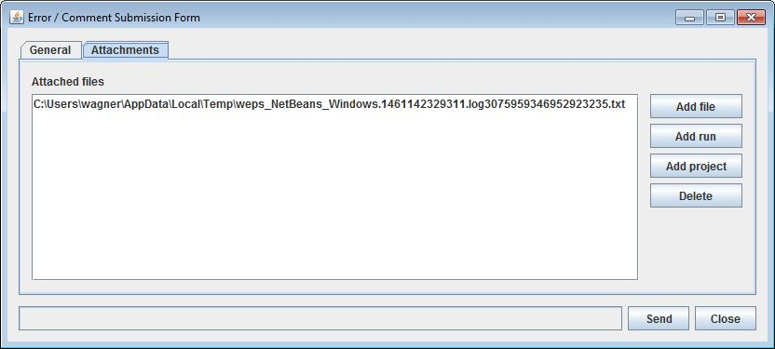
Figure 2-54. Error/Comment Submission Form displaying the Attachments tab.
Note that an individual can also send an email message as an alternative method of communication, but that method is deprecated and requires the user to have correctly configured the WEPS e-mail client in the WEPS ‘Configuration’ settings.

Editing with the Management/Crop Rotation Editor for WEPS (MCREW)

To open the Management/Crop Rotation Editor for WEPS ( MCREW), double click on the ‘Man’ button , on the left side of the management box as shown in Figure 2-1. This will open the MCREW window (Figure 2-55), which allows the user to view, edit, and save management rotation information.

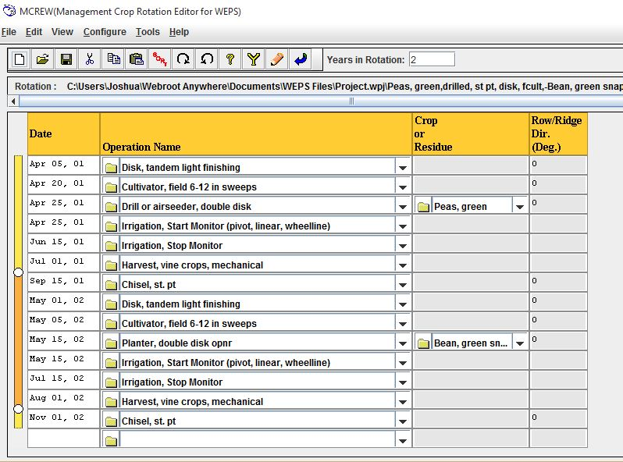
Figure 2-55 Management/Crop Rotation Editor for WEPS (MCREW) window.
MCREW's principle purpose is to create/modify/construct management rotation files required for making WEPS simulation runs. Although it is an integral component of the WEPS 1.5 interface, it can be used as a stand-alone program to edit management rotation files independent of the WEPS interface and was designed to be configurable for uses outside of WEPS. Much of MCREW's functionality, behavior, and visual appearance is controlled via ASCII XML-based configuration files. Changing the appropriate configuration files allows one to specify the structure and definition of the management/crop rotation file format and control the user's ability to view and edit specific operation, and/or crop properties, etc.

MCREW is fundamentally a date-ordered list of management operations. This release of MCREW provides the user with a tabular, row-oriented view of the operations and their associated dates. In WEPS, a management operation is defined as any human-initiated process, such as a tillage event, seeding, irrigation application, etc. If the operation triggers the WEPS model to start simulating the growth of a crop (or any other plant vegetation supported with a crop database record containing the necessary vegetation growth parameters), e.g., a planting/seeding/transplanting operation, then the name of that crop is listed in the same row in the column next to the name of the operation.

Since surface roughness (both random and oriented) affects a surface’s susceptibility to wind erosion, especially when little or no vegetation cover exists, it is important to represent not only the degree of roughness, but the direction it is oriented. Since many management operations have a direction associated with them, e.g., many tillage operations for example, these operations will create an oriented roughness with the direction of travel. Since this direction of travel is not known until it is associated with a particular site, the final column displayed by default in the table provides the user the option of setting that direction in the management file and is labeled Row/Ridge Dir. (Deg.).

Using MCREW

MCREW is designed to allow easy creation and editing of management rotation files for WEPS. The MCREW screen consists of 5 major components:

- Menu bar - The menu bar consists of assorted menu options that provide access to MCREW’s functions. Functions of the menu bar are discussed later in this document.

- Button bar - The button bar consists of an assortment of icons that provide quick access to special functions for MCREW. Those functions are discussed later in this document.

- Years in Rotation - On the right of the button bar, the user may view and edit the number of years in a rotation cycle.
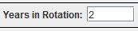

- Rotation - This window displays the name and full path of the management rotation file that is loaded. If the management rotation name is too large, a scroll bar is automatically provided so the user can view the entire rotation name.

- Table View - The Table View displays the sequence of operations, with their associated dates and any crops planted, in a tabular format. Spreadsheet-style editing functions are available to manipulate the order, selection, and removal of operations and/or crops, etc. More details of the editing functions of the Table View are given later in this section.

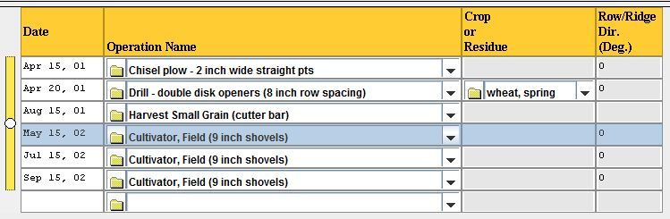

Opening and Saving MCREW files

In WEPS 1.5, there are two primary locations in which management rotation files exist:

- In the “ Management Templates” directory.
This is the location in which complete or partial (single or multi-crop year) management rotation files are kept. Files in this directory always show up on the management rotation selection choice lists. Management rotation files to be used in WEPS Projects can be selected and edited from previously built management rotation files, or they can be constructed and then edited from several partial management rotation template files located in this directory.

- Within a “WEPS Projects” directory.
Any edited or viewed management rotation file used in a WEPS Project simulation run is always located in that WEPS Project’s directory. There can be more than one management rotation file in a WEPS Project. The current management rotation file to be used when making a WEPS run is the one specified in the “weps.run” file (e.g., the one listed in the “management” input field on the WEPS main screen. Management rotation files in a WEPS Project usually are simply copies of those selected from the “Template” directory, with local “Project- or run-specific” modifications.

MCREW Menu Bar Functions

File Menu (Alt-F)

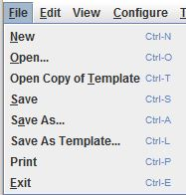
Once the MCREW window is open, rotation files can be created from scratch and saved in the desired location, and/or other rotation files may be opened for editing. The “ File” menu allows access to the file management functions for MCREW. It contains all of the options listed here, with the common functions (“New”, “Open”, and “Save”) also being available on the button bar:

  - New Ctrl-N
Opens an empty, unnamed rotation file.

  - Open... Ctrl-O
Displays an “Open File” file chooser window from which the user can select the desired rotation file from those in the current Project. This is not accessible if the “Enable full MCREW editing functionality in WEPS” option is not enabled in the “Display” tab of the WEPS interface Configuration panel.

  - Open Copy of Template Ctrl-T
Displays an “Open File” file chooser window from which the user can select the desired rotation file from the “Management Templates” directory. A copy of the selected file is then added to the current WEPS Project and made available for editing in MCREW. To edit a management file, the “Enable full MCREW editing functionality in WEPS” option must be enabled in the “Display” tab of the WEPS interface Configuration panel. If desired, the actual default location can be changed under the “Directories” tab in the WEPS interface Configuration panel as well.

  - Save Ctrl-S
Saves the current Project’s rotation file being edited (in the current WEPS Project directory). The “saved” filename will become the selected management file in the main WEPS interface screen upon exit of MCREW.

  - Save As... Ctrl-A
Displays a “Save File...” dialog box from which the user can specify the desired filename with which to save the rotation file for the current Project (the default location is in the current WEPS Project directory). The “saved” filename will become the selected management file in the main WEPS interface screen upon exit of MCREW.

  - Save As Template Ctrl-L
Displays a “Save File” dialog box from which the user can specify the desired filename with which to save a copy of the currently edited rotation file into the “Management Templates” directory. The original file is still the current file being edited within MCREW.

  - Print Ctrl-P
Displays a print dialog box through which the MCREW table view can be printed.

  - Exit Ctrl-E
Exits MCREW. If MCREW finds that the rotation file has been modified and not saved, it will display a popup message and ask if the user wants to save it before leaving.

Edit Menu (Alt-E)

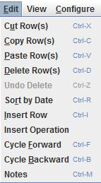
A WEPS 1.5 management rotation file is a date-ordered list of management operations. MCREW provides basic editing functionality to insert, delete, modify, and change dates for those operations. In WEPS, each operation is defined by a list of physical processes, such as residue burial, soil inversion, flattening standing residue, creation of ridges, planting a crop, etc., which are described to the model via one or more parameter values.

In its most basic form then, a WEPS management rotation file can be viewed within MCREW via the table view.

The primary editing functions available are accessible via the ‘ Edit’ menu option. The table view editing functions are:

Cut Row(s) Ctrl-X
Removes the currently selected operation row(s) from the rotation and stores in a temporary buffer for possible pasting back into the rotation table later. This function is also via the cut rows button available on the toolbar.

  - Copy Row(s) Ctrl-C
Copies the selected operation row(s) from the rotation and stores in a temporary buffer for possible future pasting back into the rotation table. This function is also via the copy rows button available on the toolbar.

  - Paste Row(s) Ctrl-V
Pastes the previously cut or copied operation row(s) above the selected operation row. This function is also via the paste rows button available on the toolbar.

  - Delete Row(s) Ctrl-D
Deletes the selected operation row(s).

  - Undo Delete Ctrl-Z
Restore a deleted item. Note, this item is not active for the current version.

  - Sort by Date Ctrl-R
Sorts the operations in ascending order by date. See “Management File Date Adjustment Functions” section later in this chapter for alternate methods of manipulating dates.

  - Insert Row Ctrl-I
Inserts a blank row above the selected row.

  - Insert Operation
Inserts a row, then opens a window that allows the selection of an operation to be placed in that new blank row.

  - Cycle Forward Ctrl-F
Causes the last year in the rotation to become the first year in the rotation, while the other rotation years are incremented by one year. See “Management File Date Adjustment Functions” section later in this chapter for alternate methods of manipulating dates.

  - Cycle Backward Ctrl-B
Causes the first year in the rotation to become the last year in the rotation, while the other rotation years are decremented by one year. See “Management File Date Adjustment Functions” section later in this chapter for alternate methods of manipulating dates.

  - Notes Ctrl-M
Displays the Management Field Notes, where the user may enter notes regarding the management file. These notes are saved with the management file and can also be accessed and viewed by clicking the Notes button on the toolbar.

View Menu

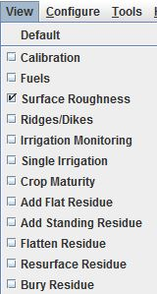
The View menu allows the user to select from a list of columns to display in the MCREW window. Select each item to display by clicking on that item and note that the item will be displayed in the table display and that item will also be checked in the View menu. To remove items from the display columns, similarly click the item on the View menu and those columns will be removed from the MCREW table and the item will be unchecked in this menu list.

Tools Menu (Alt-T)

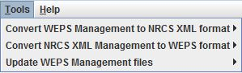
The ‘Tools’ menu item provides access to tools and utilities related to the use of MCREW.

  - Convert WEPS Management to NRCS XML Format (this item has two options)
▸ select individual files
Converts a single WEPS management file to the NRCS standardized summary management XML file format.
▸ select directory (recursively)
Converts multiple WEPS management files recursively in a single directory to the NRCS standardized summary management XML file format.

  - Convert NRCS XML Management to WEPS Format (this item has two options)
▸ select individual files
Converts single NRCS standardized summary management XML format files to the WEPS management file format.
▸ select directory (recursively)
Converts multiple NRCS standardized summary management XML format files recursively to the WEPS management file format.

  - Update WEPS Management Files (this item has two options)
▸ select individual files
Updates individual WEPS management files with the most current crop and operation database parameters.
▸ select directory (recursively)
Updates WEPS management files recursively with the most current crop and operation database parameters.

Help Menu (Alt-H)

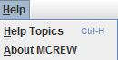
The ‘ Help’ menu item displays help options about MCREW and includes:

  - Help Topics Ctrl-H
Opens a window containing the MCREW online help system.

  - About MCREW
Displays the current version, build date, and other information about the current version of MCREW.

MCREW Button Bar Functions

Opens a blank MCREW screen. This has the same function as selecting New under File on the menu bar.

Opens an existing MCREW file. This has the same function as selecting Open under File on the menu bar.

Saves the rotation file being edited to the current Project. This has the same function as selecting Save under File on the menu bar.

Cuts a selected row or rows of the management file and places into the clipboard. This has the same function as selecting Cut Row(s) under Edit on the menu bar.

Copies a selected row or rows of the management file and places into the clipboard. This has the same function as selecting Copy Row(s) under Edit on the menu bar.

Pastes a row or rows of the management file from the clipboard above the selected row. This has the same function as selecting Paste Row(s) under Edit on the menu bar.

Sorts the rows of the management operations into date order. This has the same function as selecting Sort by Date under Edit on the menu bar.

Cycles the rotation year for the management operations forward. This has the same function as selecting Cycle Forward under Edit on the menu bar.

Cycles the rotation year for the management operations backward. This has the same function as selecting Cycle Backward under Edit on the menu bar.

Enables context-sensitive help. Click on this button, then click on any item on the screen for help on that item.

Toggles the display of extra columns in the table for yield calibration use. When this option is on (columns displayed), a red border surrounds the button.

Opens the Management File Notes display, where the user may enter notes regarding the management file. These notes are saved with the management file and can be viewed by clicking the Notes Button or the Edit menu item Notes.

Saves the displayed data to the current file name and closes MCREW.

MCREW Table View Editing

MCREW’s table view is where most of the editing occurs when working with management/crop rotation sequences.

MCREW Row and Cell Selection Functions
The mouse is currently the primary method used to "select" either a row and/or an individual table cell. If a particular table cell cannot be directly edited within the cell, this is indicated by a gray background, (e.g., Date, Operation Name, or Crop) and the row is selected (indicated by the blue background in all cells within the row). The following figure shows an example of a row selection after a left mouse click within the “Date” column.

One can select multiple rows at one time by depressing and holding down the left mouse button on the first row to be selected and dragging the mouse cursor over the additional contiguous rows to also be selected. Release the left mouse button on the last row to be selected. All selected rows will be highlighted with a blue background (see following figure for example of multiple row selection).

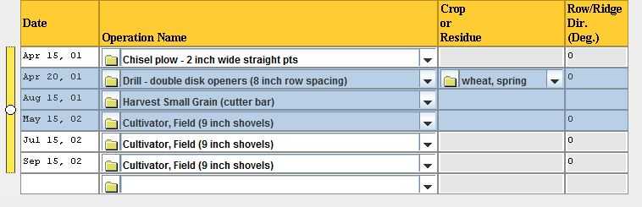

The user can append contiguous rows adjacent to a previously selected row or multi-row selection, by holding down the "shift" key and clicking the left mouse button on the last desired contiguous row to append to the selection. This is similar to how Microsoft Windows append selection works with the "shift" key depressed.

Similarly, one can append non-contiguous rows by holding down the "ctrl" key and making an additional multi-row (or single row) selection similar to the original row or multi-row selection (see following figure for example of non-contiguous row selection). As many non-contiguous rows can be selected, as desired, via this method. Again this is similar to how Microsoft Windows non-contiguous selection method works with the "ctrl" key depressed.

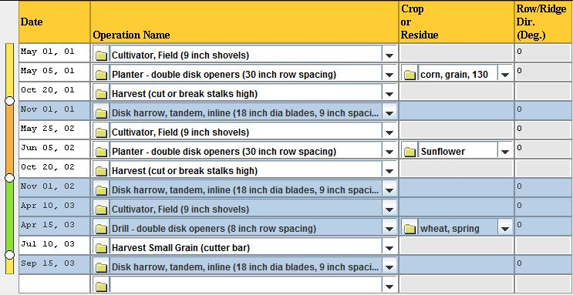

Any row or multi-row selection can be de-selected and replaced by simply clicking the left mouse button anywhere within the MCREW table display (with no keyboard keys pressed).

MCREW Row Editing Functions
Using the Edit menu, the user can cut, copy, paste, and delete rows. One can also insert a new blank row (Insert Row) immediately above the currently selected row. In addition, the user can press the right mouse menu button (when the mouse is in any row cell except in the date column) to display a popup menu that contains row editing functions. The Set Date and Adjust Date options will be described under “Management File Date Adjustment Functions”.

The contents of another (previously created) management file can also be inserted via the Insert Management File option immediately above the currently selected row. The "File Chooser" dialog will pop up, allowing the user to select the desired management file from which to include all the operations and their associated dates into the current management file being edited.

The Cut, Copy and Paste functions apply to the selected (both single and multiple) rows. These functions are accessible via the Edit menu, button bar and the dropdown operation and crop column menus. The Paste function should only be active if there has been a previous Cut or Copy function conducted previously. The Delete function applies to all selected rows. Only if a previous Delete function has been conducted will the Undelete function be accessible.
The Insert Row and Insert Operation functions insert a blank row or selected operation respectively above the currently selected row. The date for this new row will automatically be set to the date of the row above the previously selected (now the newly inserted) row.

MCREW Date Adjustment Functions
There are several date adjustment functions available in MCREW, in the Edit menu and the icon button bar. These operations are:

Sort by Date - The Sort by Date function sorts the management operations by ascending date order. Thus, the user can adjust/set the dates of management operations without having to worry about whether they are in the correct sequential order at that time. When the user wants to see the list of operations in the correct date-ordered format, they can simply select the Sort by Date function from the button bar icon or the Edit menu.

Cycle Forward - MCREW will not allow the user to save a WEPS management file without the operations being listed in date order. The user is given the options to automatically sort them, if they are not sorted during a management file save operation, or to go back to the editor and allow the user to correct the date order problem(s) manually.

Cycle Backward - The Cycle Forward and Cycle Backward functions will rotate the "rotation year" of the management operation dates forward or backward in increments of one year. For example, a three-year management file rotation ‘cycled forward’ would change the operation dates in the first year to the 2nd year, those in the 2nd year to the 3rd year and those in the 3rd year to the 1st year. Thus, the crops grown and harvested in the first year would now occur in the second year, etc. Likewise, a rotation ‘cycled backward’ would shift the rotation the opposite direction, making the 2nd year operations occur in the first year, etc.

MCREW Date Column Editing Functions
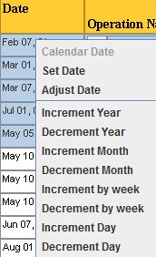
Limited date editing functions are available by right clicking on a cell in any column. Clicking the right mouse button while the cursor is on a date column cell causes a date editing popup menu to appear that has additional date editing functions (see figure to the left). These functions allow the user to adjust dates for one row or all operation rows selected (highlighted in blue) simultaneously (single-row date editing operations are made inaccessible and are greyed out if multiple rows are selected). Currently, the top item, Calendar Date, is the only function specific to single rows, and if multiple rows are selected, the Calendar Date item will be greyed out and inaccessible.

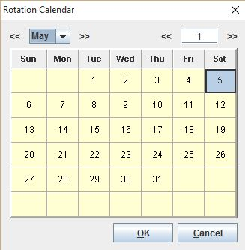
The Calendar Date option displays a popup calendar to aid in adjusting dates. A shortcut to accessing the Calendar Date is available by double left mouse clicking in a date cell, which will also display the popup calendar. This calendar window allows the user to select the desired date. The calendar allows the user to increment (>>) or decrement (<<) the month and year values if desired. Then the day of the operation within that month/year can be selected. The user can either double right mouse click on the day value or click on the "OK" button to accept the specified date (see the figure to the left). The Calendar Date function is only applicable when a single date cell is selected.

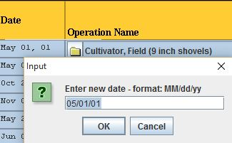
Selecting the Set Date option will display a dialog box that allows the user to type in a specific date (day/month/rotation year) for the selected operation row (highlighted in blue). The figure to the left shows an example of the Set Date popup window.

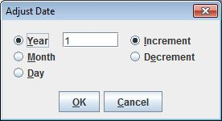
The Adjust Date function is available from this menu, with year, month, and day increment and decrement functions available. They apply to all dates in the rows that are selected. The user can adjust the operation dates on the selected rows. Selecting the Adjust Date option will display a dialog box allowing the user to adjust the operation dates in the selected rows by a specified ± number of days, months, or years (see left figure). Additional menu options are also available to increment (increase) or decrement (decrease) the dates of selected rows by a day, week, month, or year.

The remaining date menu options below the line are specific menu shortcuts to the Adjust Date function and are listed here:

Increment Year - Increments the selected rows by one rotation year.
Decrement Year - Decrements the selected rows by one rotation year.

Increment Month - Increments the selected rows by one month.
Decrement Month - Decrements the selected rows by one month.

Increment by week - Increments the selected rows by one week.
Decrement by week - Decrements the selected rows by one week.

Increment Day - Increments the selected rows by one day.
Decrement Day - Decrements the selected rows by one day.

MCREW General Editing Functions within the Column Menus
All left mouse click menus that come up when one has the cursor in any column cell other than the date column contain general functions that pertain to the row and are not necessarily specific to the column the user produced the menu from. These general functions are confined to the bottom of the column menus and are always located below the horizontal line in the menu. Some of these functions do not apply when multiple rows have been selected, in which case those functions will still display but be greyed out and inaccessible for use under those conditions. The complete list of “general editing functions are:

Set Date - Set the date of the selected row(s) to the specified date.

Adjust Date - Brings up the Adjust Date dialog box, which allows the user to increment or decrement the rotation year, month or day by the specified value.

Insert Blank Row - Inserts a blank row immediately above the selected row or cell. This function is inaccessible if multiple rows have been selected.

Insert Operation - Inserts a new row immediately above the selected row or cell and brings up a file chooser window allowing the user to select the desired operation to place in that new row. This function is inaccessible if multiple rows have been selected.

Insert Operation - Inserts a new row immediately above the selected row or cell and brings up a file chooser window allowing the user to select the desired operation to place in that new row. If the user aborts the operation selection process, the new row is removed from the table. This function is inaccessible if multiple rows have been selected.

Insert Rotation - Inserts a management rotation file (“.rot” extension filenames) only if the bottom row is selected, otherwise it will be greyed out and inaccessible. Note this function has not been completely implemented at this time. There are no “.rot” management rotation files available for WEPS yet.

Insert Management - Brings up a file chooser window allowing the user to select the desired management rotation file to be placed immediately above the selected row. The rotation year dates are automatically altered to make the first operation in the newly selected management rotation file to follow chronologically the operation immediately above the selected operation row. This function is inaccessible if multiple rows have been selected.

Insert Management Unadjusted - Brings up a file chooser window allowing the user to select the desired management rotation file to be placed immediately above the selected row, but does not modify the dates within the newly selected management rotation file. This function is inaccessible if multiple rows have been selected.

Cut Row(s) - Cut the selected row(s) and store them in a temporary buffer for possible re-insertion in the management rotation file with the Paste function later.

Copy Row(s) - Copy the selected row(s) and store them in a temporary buffer for possible re-insertion in the management rotation file with the Paste function later.

Paste Row(s) – Paste (insert) previously cut or copied row(s) immediately above the selected row in the management rotation file. This function is inaccessible if multiple rows have been selected.

Delete Row(s) - Delete the selected row(s) and store them in a temporary buffer for possible re-insertion into the management rotation file with the Undelete Row(s) function later.

Undelete Row(s) – Undoes a previous Delete Row(s) operation, if possible, and re-inserts the previously deleted rows into the management rotation file where they were prior to executing the delete function. If other editing functions have been conducted after deleting the row(s), then the undelete function may no longer be accessible (greyed out) because it cannot correctly perform the undelete function any more. One can best think of and use this function as an “immediate undelete” function to undo the previous delete action.

MCREW Operation Column Editing Functions
A new operation can be added to a blank line or a different operation can be selected to replace an existing operation by clicking the down arrow to the right of the Operation Name column and selecting the desired operation. An operation can also be replaced in the selected cell by double clicking the left mouse button with the mouse cursor in an operation cell (including the blank cell at the bottom of the table where it will insert a new operation). This action will display the operation file chooser window. It allows the user to select a management operation record and place it into the selected row. The user can also access this operation file chooser dialog from the Change/Select Operation menu option via the right mouse menu.

Additional editing functions for the Operation column are displayed by right clicking within the column (see figure below). Clicking on one of the menu options available will apply the function to the highlighted row(s). The top items above the line are specific to the operation column. The items below the line are the general editing functions described previously in the MCREW General Editing Functions within the Column Menus section.

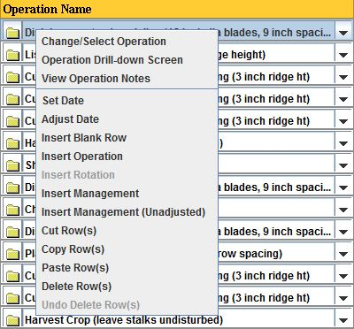
The Change/Select Operation menu option via the right mouse menu will also bring up the operation file chooser window. It allows the user to select a management operation record and place it into the selected row(s). This function works with multiple selected rows and replaces the specified operation in each of the selected rows.

The Operation Drill-down Screen option provides access to the operation’s process list and its parameters, which is discussed in more detail later in the MCREW Operation and Crop Dialog Drill-Down Screens section.

The View Operation Notes shows the user notes content in a popup screen for the selected operation. These two functions will be greyed out and not accessible if multiple rows are selected.

MCREW Crop or Residue Column Editing Functions
Operations that contain planting/seeding processes require a crop or residue to be specified. Those that have this process defined will either display the name of the crop to be planted in the Crop or Residue column or display the string "No crop", signifying that no crop is to be planted or it hasn't yet been selected by the user. A different crop or residue can be selected to replace or fill the existing crop or residue entry by clicking the down arrow to the right of the Crop or Residue column cell and selecting the desired crop or residue. A crop or residue can also be replaced in the selected cell by double clicking the left mouse button with the mouse cursor in a Crop or Residue cell. This action will display the crop or residue file chooser window for the user to select the desired crop or residue and place it into the selected cell. The user can also access this crop or residue file chooser dialog from the Change/Select Crop menu option via the right mouse menu.
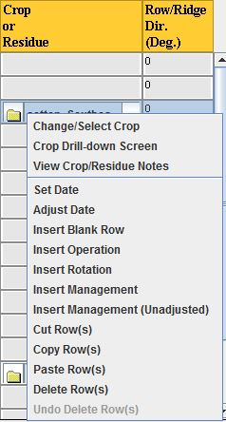
Additional editing functions for the Crop or Residue column are displayed by right clicking within the column (see figure below). Clicking on one of the menu options available will apply the function to the highlighted row(s). The top items above the line are specific to the Crop or Residue column. The items below the line are the general editing functions described previously in the MCREW General Editing Functions within the Column Menus section.

The Change/Select Crop menu option via the right mouse menu will also bring up the crop or residue file chooser window. It allows the user to select a crop or residue record and place it into the selected row(s). This function works with multiple selected rows and replaces the specified crop or residue in each of the selected rows.

The Crop Drill-down Screen option provides access to the crop or residue’s process list and its parameters, which is discussed in more detail later in the MCREW Operation and Crop Dialog Drill-Down Screens section.

The View Crop/Residue Notes shows the user notes content in a popup screen for the selected crop or residue. These two functions will be greyed out and not accessible if multiple rows are selected.

MCREW Operation and Crop Dialog Drill-Down Screens
Both the MCREW Operation and Crop or Residue columns have a "drill-down" function available that allows the user to display a popup screen that makes many of the specific operation or crop/residue parameter values viewable or editable. The operation parameters specify how WEPS operations simulate soil and biomass properties that influence wind erosion. Similarly, the crop parameters specify how WEPS simulates crop planting, growth, and harvest, as well as residue decomposition. The specific content of these screens depends upon both the type of crop or operation and specific configuration file settings. The configuration files describe which parameters are viewable or hidden to the user and, if viewable, whether or not they are editable by the user. In addition, for each parameter that is displayed, the prompt information for the parameter is described in these configuration files. Examples of Operation and Crop Dialog drill-down screens are shown in Figure 2-56 and Figure 2-57.

The drill-down functions are cell specific and are available only when a single operation or crop/reisdue cell is selected. The Operation drill-down screen is accessible if the selected cell is in the operation column and a Crop drill-down screen is accessible if the selected cell is in the crop column. To access the Operation or Crop drill-down screen, click the folder icon to the right of the Operation or Crop name in the MCREW table. An alternative method is to left click in the operation or crop/residue cell and selecting “Operation Drill-down Screen” or “Crop Drill-down Screen” respectively.

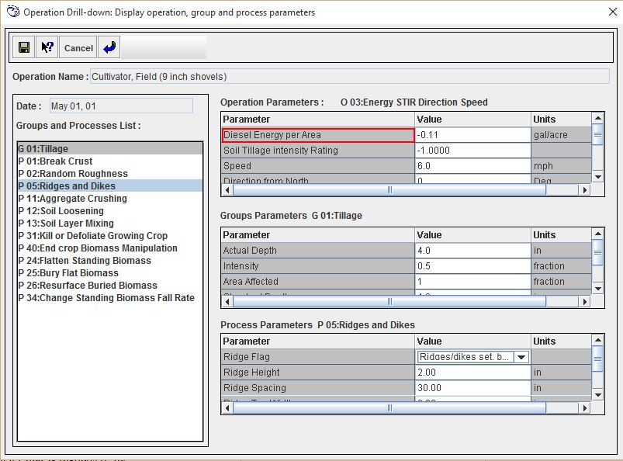
Figure 2-56 Example Operation Dialog drill-down screen.

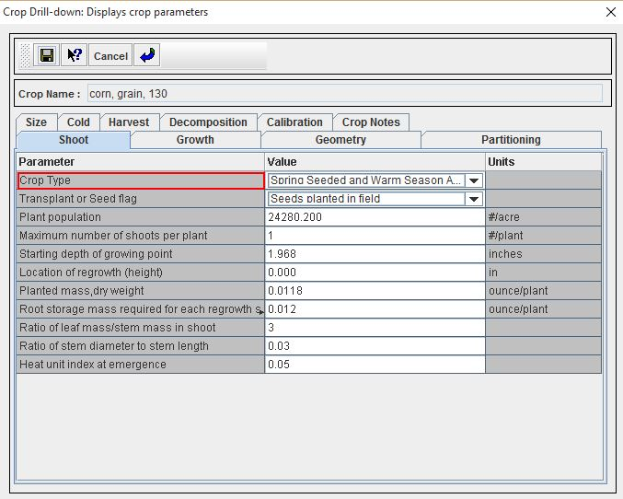
Figure 2-57 Example Crop Dialog drill-down screen.
Definitions and ranges for specific operation parameters are also available in the WEPS How To Guide, “Management Operation Database Record Development”. Definitions and ranges for specific crop/residue parameters are available in the WEPS How To Guide, “Crop Database Record Development”. These guides also provide guidelines for determining parameters for crops not listed in the operation or crop/residue databases.

Viewing and Editing a Soil Record

Users have the option to view and edit the parameters for the soil record displayed in the soil box by clicking on the button labeled ‘Soil’, on the left side of the soil box in the bottom left corner of the main WEPS screen (Figure 2-1). This will open the WEPS Soil User Interface screen (Figure 2-58).

Figure 2-58 WEPS Soil User Interface screen.
Many soil properties that affect soil wind erodibility vary with time as a result of weather and management. The parameters displayed in the Soil User Interface only represent the initial soil conditions and properties that exist prior to the first day of simulation. Beginning with the first day of simulation, the soil parameters change in response to weather and management conditions.

Soil properties greatly affect the erodibility of a field surface directly through their effects on such things as roughness and aggregate size distribution. The soil properties also affect erodibility indirectly through their effects on soil hydrology and plant growth. The Soil User Interface allows the user to view, edit (disabled for NRCS), and save the initial soil information under a new file name for the Project. Users typically are discouraged from editing parameters derived from a SSURGO database file unless the user has specific knowledge of the parameter and more suitable values. A more detailed description of the soil parameters required by WEPS, as well as directions for obtaining a SSURGO database file for WEPS use, are found in Chapter 6.5 of the WEPS User Manual.

Users whose soils are not contained in a SSURGO database can create their own soil file by opening a new file and entering the appropriate parameters. It is recommended that in this case, the user enter the minimum set of parameters and let the Soil User Interface generate all parameter fields. The generation function is described under the Menu Bar function View, later in this section. Again, if the user has specific knowledge of the parameter and more suitable values, they may then edit those values. As an alternative, the user may wish to find an existing soil file within a SSURGO database with properties similar to the soil they want to simulate with WEPS and edit any parameters that may differ.

The various functions of the WEPS Soil User Interface are described next. More detailed definitions of soil parameters are available in Chapter 6.5 of the WEPS User Manual.

Soil Menu Bar Functions

The menu bar provides the following options:

- File - This menu displays a drop-down list of various file options.
  - New (Ctrl-N) - Opens an empty, unnamed soil screen.
  - Open... (Ctrl-O) - Displays an “Open a Soil File” dialog box from which the user can select a soil (ifc) file from those in the current Project.
  - Open Database (Ctrl-L) - Opens the “Select Soil” window (Figure 2-22) to select a soil from a file, local database residing on your computer or from the NRCS SSURGO (NASIS) database.
  - Save (Ctrl-S) - Saves the current file.
  - Save As... (Ctrl-A) - Saves the current soil file to a new name in the current Project directory.
  - Save As Template… (Ctrl-T) - Save the current soil file to a new name in the default soil database directory location.
  - Print (Ctrl-P) - Opens a print dialog window to allow printing the soil file table display.
  - Exit (Alt-F4) - Exits the soil interface.

- Edit - This menu displays a drop-down list of various layer editing functions.

  - Estimate Values (Ctrl-E) - Estimates the values for all fields that can be estimated. Usually used when building a new soil record manually. Can only be used in conjunction with the Minimum Fields option under the View menu.
  - Cut Layer (Ctrl-X) - Cuts a soil layer or layers and places it into the clipboard. The layer(s) (contiguous only) must be first selected by dragging the mouse while holding the left mouse button down.
  - Copy Layer (Ctrl-C) - Copies a soil layer or layers and places it into the clipboard. The layer(s) (contiguous only) must be first selected by dragging the mouse while holding the left mouse button.
  - Paste Before Layer (Ctrl-B) - Pastes a soil layer or layers from the clipboard above the highlighted row.
  - Paste After Layer (Ctrl-V) - Pastes a soil layer f or layers from the clipboard after the highlighted row.
  - Insert Before Layer (Ctrl-Insert) - Inserts a blank soil layer before the highlighted row.
  - Insert After Layer (Insert) - Inserts a soil layer after the highlighted row.
  - Delete Layer (Delete) - Deletes the selected soil layer or layers that are highlighted.
The edit functions for layers are also available by highlighting a row or set of contiguous rows then right clicking within the selected row(s) to display the edit functions.

- View - This menu displays options for changing the parameters displayed in the Soil User Interface. Two exclusive options are available, of which only one can be chosen.
  - All fields - When selected, it displays all the fields required by WEPS in the Soil User Interface screen.
  - Minimum fields - When selected, it displays only the minimum input parameters required by the Soil User Interface. The minimum parameters displayed when the Minimum fields box is checked are used by the soil interface as inputs to estimate or generate the parameters required by WEPS. This functionality is accessible from the Edit menu with the Estimate Values menu option or using Ctrl-E. These generated parameters are displayed when the All fields box is checked. Any parameters that were adjusted because of out-of-range values, as well as the old and new values, are displayed in the Notes table at the bottom of the Soil User Interface screen.

- Help - This menu displays a drop down list of help options.
  - Help Topics (Ctrl-H) - Opens the Soil User Interface online help system.
  - About Soil - Displays the current version of the Soil User Interface.

Soil Button Bar Functions

The button bar provides a shortcut to some of the menu items.

Opens an existing soil file. This has the same function as selecting ‘Open’ under ‘File’ on the menu bar.

Saves the soil file being edited to the current Project. This has the same function as selecting ‘Save’ under ‘File’ on the menu bar.

Cuts the row or rows of the soil file and places into the clipboard. This has the same function as selecting ‘Cut Layer’ under ‘Edit’ on the menu bar.

Copies a row or rows of the soil file and places into the clipboard. This has the same function as selecting ‘Copy Layer’ under ‘Edit’ on the menu bar.

Pastes a row or rows of the soil file from the clipboard to a row above the currently selected row. This has the same function as selecting ‘Paste Before Layer’ under ‘Edit’ on the menu bar.

Prints the soil properties currently displayed.

Estimates the values for all fields that can be estimated. Active only when used in conjunction with the Minimum Fields option under the View menu.

Opens the general help system for the Soil User Interface.

Enables context-sensitive help. Click on this button, then on any item on the screen, for help on that item.

Saves the currently displayed data and closes the Soil User Interface.

The Soil User Interface displays data in four sections with three of them being parameter tables:

- The Soil Identification table provides information regarding the soil identification, location, and classification. The Soil Identification parameters are not critical to the operation of WEPS and are used for identification purposes only.

- The Soil Surface Properties & Depth Restrictions table provides information pertaining to the configuration of the soil surface in terms of crusts, roughness, albedo, slope, and rock cover. It also contains the depth to root and water restrictive layers.

- The Soil Layer Properties table contains soil properties by layer or horizon. At the bottom of the screen is the Soil Notes table. The user may enter any notes pertaining to the soil file. These notes are appended to the bottom of the Soil file.

- The Soil Notes may also contain notes generated by the interface. These generated notes specify parameters that were adjusted because of out-of-range values, and lists the old and new values. The notes are not critical to the operation of WEPS and are used for information purposes only.

Downloading Soil Data

This section describes how to download soil data from the NRCS Soil Data Mart and how to extract it for use within WEPS. A Microsoft Access database template is available for importing the data from the export file. You must have Microsoft Access 97 or later installed on your PC.

Soil data for NRCS and most other users in the US, is currently available for download from the NRCS Soil Data Access site’s URL at: http://sdmdataaccess.nrcs.usda.gov/ for specific soil data requests using custom scripts, etc. For simpler manual downloads, use the NRCS Web Soil Survey site at: http://websoilsurvey.sc.egov.usda.gov/App/WebSoilSurvey.aspx of required WEPS soil data elements. The soil survey data that is exported from the Soil Data Access and the Web Soil Survey sites are in what is referred to as “SSURGO” (Soil Survey Geographic) format. There are multiple ways to obtain WEPS soil data from these sites. The easiest method is to select the “Download Soils Data” tab on the NRCS Web Soil Survey site and follow the instructions provided to download the desired soil data. Note that there may be both “tabular” and “spatial” data available. Only the “tabular” data is required for this release of WEPS.

After the zipped file has been downloaded to your PC, it must be unzipped by using either WinZip or a similar program. For additional information, please see the file named README.txt in the root directory that is created by unzipping the zipped soil file. For additional soil survey areas, each zipped file should be copied and unzipped into individual directories. When a file is unzipped, the following directory hierarchy is produced in the directory to which the file was unzipped:

\spatial
\tabular

The top-level directory contains the following files:

soil_metadata_ssasymbol.txt - a Federal Geographic Data Committee (FGDC) metadata file in plain ASCII format.

soil_metadata_ssasymbol.xml - the same FGDC metadata file in XML format.

readme.txt - a text file containing additional information.

The root directory will also contain an empty MS Access SSURGO template database, if one was requested as part of the download. This file is currently named “soildb_US_2003.mdb”.

The directory "tabular" contains any tabular data that was requested. The directory "spatial" contains any spatial data that was requested. Note that spatial data is not required nor recommended (due to large file sizes) for WEPS. It should still be possible to request tabular data from the Soil Survey download site without including the corresponding spatial data, and vice versa.

Tabular data is provided as a set of ASCII delimited files. Each file corresponds to a table in the SSURGO 2.1 data model. The tabular data isn't particularly useful until it has been imported into the MS Access SSURGO template database. Current Web Soil Survey downloads include a template database, if requested. The database is the “soildb_US_2003.mdb”.

To import tabular data, load the template file into MS Access. A ‘SSURGO Import’ screen will display, asking for the full path to the tabular data directory (Figure 2.59). Type (or cut and paste) the full path of the tabular directory and click ‘OK’. A list of database tables will appear and a folder will be created in the top level directory. The folder will have the base name (non-extension part) of the template name. At the same time, an MS Access database file (*.mdb), which contains the data required for WEPS, will be created in the template folder.

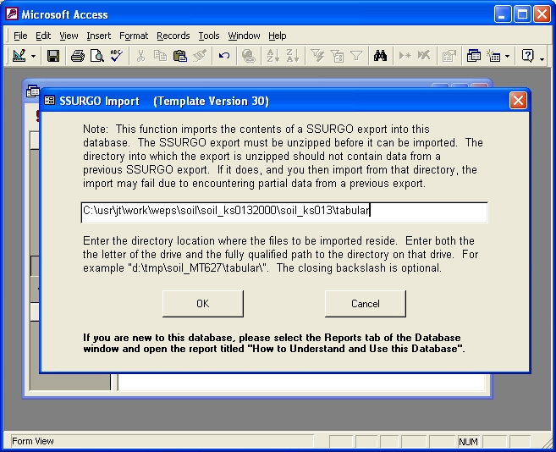
Figure 2.59 WEPS SSURGO Import screen.
To import more than one soil survey area into a single MS Access database, run the Import macro specifying the full path to the directory the SSURGO data was unzipped into. Repeat the Import macro for each area desired. When done, save the template database with the imported data to a new name (*.mdb).

The WEPS 1.5 soil selection process extracts data elements stored in the following SSURGO text data files located in the \tabular directory (tables in the MS Access database), when connected to a Microsoft Access SSURGO database file:

chfrags.txt
chorizon.txt
chtexgrp.txt
comp.txt
crstrcts.txt
legend.txt
mapunit.txt
muaggatt.txt
version.txt

If multiple soil survey areas are imported into a single MS Access database, the database may become very large. To reduce the size of the Access database file, one may run the Export macro and delete the SSURGO data (*.txt) files created in the tabular directory that are not listed above before importing into a template Access database.

Using SSURGO Data in Microsoft Access format with WEPS

Within WEPS, open the "Configuration" window, then click the "Soils" tab (Figure 2-60). Fill out the full path and SSURGO soil database file name (*.mdb) for "Soils Database” and close the configuration window (click “Save” if you want to use that path in subsequent WEPS runs). Selecting the Soil Template folder at the bottom of the main WEPS screen will display the list of soil survey areas to choose from. Select the desired soil survey area and select the soil map unit and component for the simulation run. If the SSURGO database is not populated with data required by WEPS, you will get an error message when selecting that soil. More detailed information on selecting soils, see the “Interface Reference: Choosing a Soil” section of the WEPS User Manual.

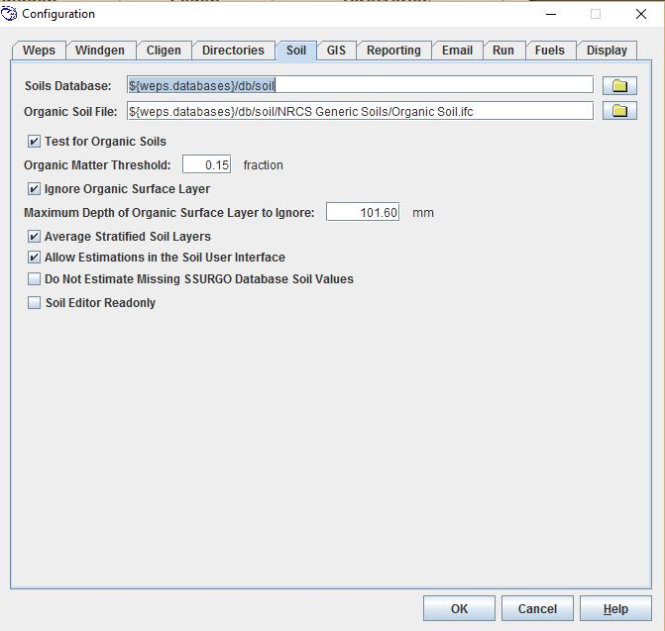
Figure 2-60 Soils Configuration Tab.

How to Handle Missing Soil Data

In one mode of operation the Soil User Interface estimates limited values if they are not populated in the SSURGO database. NRCS users must click the check box for “Do not estimate missing values from SSURGO database” under the “Miscellaneous” tab of the “Configuration” window so that these values are not estimated. If a soil database record generates an error listing missing data upon loading, contact your local NRCS office for assistance.

WEPS Multiple Run Manager (WMRM)

One can view erosion results from multiple WEPS Runs simultaneously from the WEPS Multiple Run Manager (WMRM) shown in Figure 2.61. It is accessible from the Main WEPS window (Figure 2-1) by selecting the Multiple Run Manager option under the ViewOutput menu.
The left side of the screen consists of a tree of directories that contain WEPS Runs that can be selected for display. A subset of the total available runs can be selected by clicking on the desired WEPS Runs to display. Use Ctrl-right mouse button to select multiple, non-contiguous WEPS Runs for display.
The table consists of the following columns (columns can be selectively displayed or hidden):

Run Name – The WEPS Run directory name.

Run Location – The path containing the WEPS Run directories.

Management Name – The name of the management/crop rotation file used in the WEPS Run.

Soil Name – The name of the soil ifc file used in the WEPS Run.

Field Size – The simulation field size used in the WEPS Run.

Gross – The gross annual soil loss on the field.

Net Total – The annual net soil loss leaving the field.

Net Creep/Salt – The annual net creep and saltation size particles leaving the field.

Net Suspension – The annual net suspension size particles leaving the field.

Net PM10 – The annual net PM10 (<10µ) particles leaving the field.

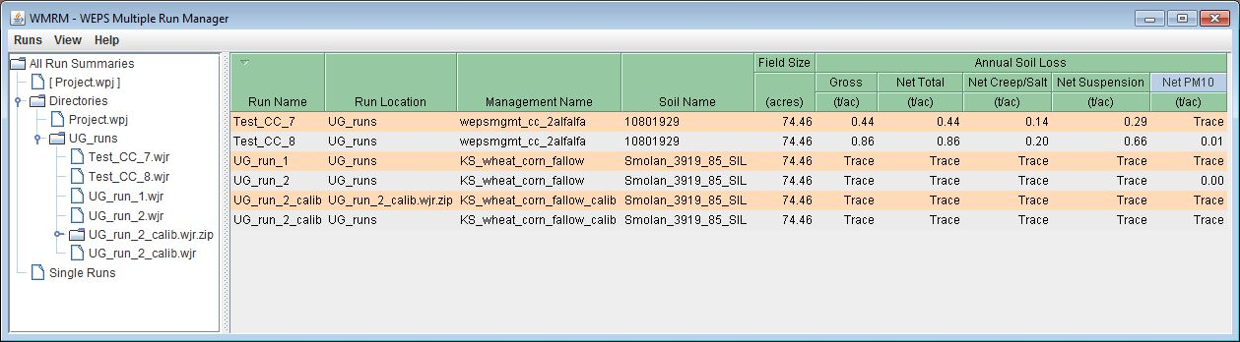
Figure 2.61 WEPS Multiple Run Manager (WMRM).

The WMRM Menus options are: Run, View and Help.
The Runs menu consists of:
Add Directory - Add a directory containing WEPS Runs for display in WMRM.
Add Single Run - Add a single WEPS Run for display in WMRM.
Restore Selected Run in WEPS - Restore the selected WEPS Run inputs into the main WEPS interface screen.
Export Selected Run - Export the selected WEPS Run into the user specified directory location in a popup window. The user has the option of deleting the original copy if desired from within that window.
Delete Selected Run - Delete the selected WEPS Run.
Refresh Table - Refresh the WMRM table so that it contains all the WEPS Runs in the specified locations. Useful if the WMRM window is open and additional WEPS Runs have been made since opening it.
Print… - Print the contents of the WMRM table.
Close - Close the WMRM window.
The View menu consists of:
Default - Resets the WMRM table to the default list of columns (currently all of them).
Run Name - Selects the WEPS Run name column to be displayed.
Run Location - Selects the WEPS Run location name column to be displayed.
Management Name - Selects the WEPS Run Management name column to be displayed.
Soil Name - Selects the WEPS Run Soil name column to be displayed.
Field Size - Selects the WEPS Run Field Size column to be displayed.
Gross - Selects the average annual Gross soil loss column to be displayed.
Net Total - Selects the average annual Net Total soil loss column to be displayed.
Net Creep/Salt - Selects the average annual Net Creep/Salt column to be displayed.
Net Suspension - Selects the average annual Net Suspension column to be displayed.
Net PM10 - Selects the average annual Net PM10 column to be displayed.
The Help menu consists of:
About WMRM - Displays a popup window that provides information about the WMRM window.

Displaying Wind Station Data Information

One can view wind information on selected Windgen records (even interpolated Windgen records) from the Main WEPS window (Figure 2-1) by selecting the Display Wind Station Info option under the Tools menu or by pressing the Alt+W keys simultaneously to bring up the “Wind Station Data” window (Figure 2-62). The wind information for the selected Windgen station, including wind parameters by month are displayed in a popup window. Clicking the down arrow to the right of the station name displays a list of available wind stations from which to choose. Multiple windows can be displayed simultaneously, so an individual can compare two or more station’s data if desired.

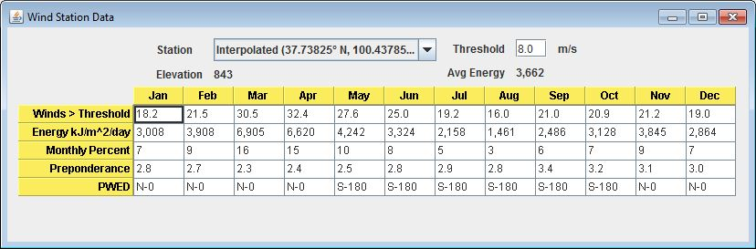
Figure 2-62. Wind Station Data information window.
The assumed wind speed threshold (see discussion below) for the calculations (m/s), the station elevation (m), and the average wind energy for the year (kJ/m^2/day) are displayed at the top of the window. The following parameters are displayed for each month in tabular form:

Winds > Threshold - the percentage of the time the wind is above the given threshold. This parameter will give the user an indication of the percentage of time winds are near or above erosive speeds and should only be used for general purposes. The actual threshold of wind erosion used in WEPS varies with the surface conditions. The default threshold value is 8.0 m/s.

Energy - the erosive wind energy greater than the given threshold (kJ/m²/day).

Monthly Percent - percentage of the annual erosive wind energy.

Preponderance - the prevalence of the prevailing wind erosion direction for the month (maximum ratio of parallel to perpendicular erosion forces). A preponderance value of 1.0 indicates no prevailing wind erosion direction. A value of 2.0 indicates a prevailing wind erosion direction, with wind erosion forces twice as great parallel as perpendicular to prevailing wind erosion direction.

Comparing WEPS Files for Differences

One can compare WEPS Runs, WEPS “weps.run” files, WEPS Management files and WEPS Soil files and determine what is different between them. The Diff WEPS Files menu option is accessible under the Tools menu on the main WEPS Screen. The differencing window is shown in Figure 2-63. This function is very useful to determine exactly what is different between to WEPS Runs or files when one is not sure what is different between them anymore.
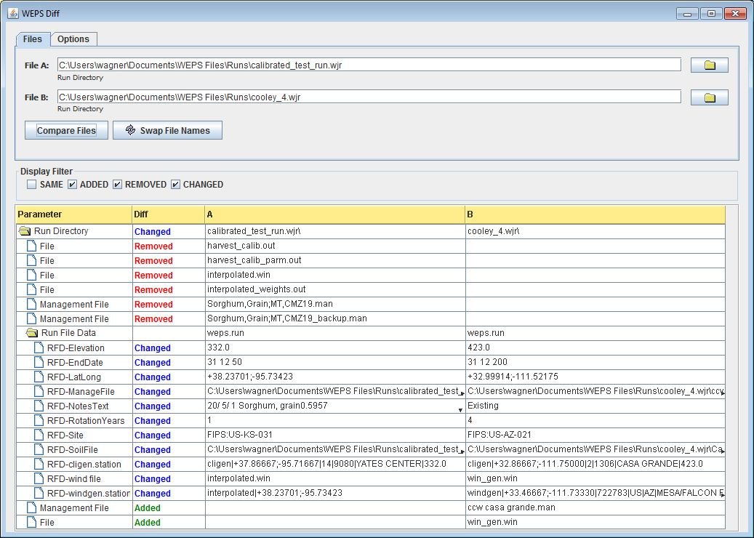
Figure 2-63 WEPS Differencing Window.
There are two tabs in the top section: Files and Options. The Files section, as shown in Figure 2-63, allows the user to select the two files or directories to compare. The comparison is made when the button is pressed. The button switches File A and File B positions. The Options tab (Figure 2-64) contains the options that WEPS operations are matched on: Operation Date, Operation Name and Crop Name and whether an AND or OR comparison is made.
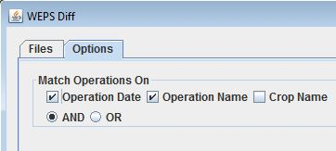
Figure 2-64 WEPS Differencing window Options tab.
The Display Filter section allows one to check what is to be displayed in the differencing window below. The options are: Same, Added, Removed and Changed.

The differencing window in the bottom section displays a table with the “differences” displayed. The column headings are:

Parameter - The specific parameter or object being compared on the line.

Diff - The type of difference between the two files/directories being compared.

A - The File A: file or directory being compared.

B - The File B: file or directory being compared.

WEPS Configuration Options and Settings

The Configuration Panel window is accessible from the main WEPS screen menu as Edit Configuration as the last option under the Tools menu. It can also be accessed with the Alt-C key combination when the main WEPS screen has focus. The configuration panel consists of several labeled tabs and three buttons at the bottom of the screen. Those buttons are:
OK - Saves the changes permanently to the WEPS configuration file and closes the configuration panel window.
Cancel - Cancels all changes and closes the WEPS configuration panel window.
Help - Opens the general help for the WEPS configuration panel window.

The WEPS Configuration Panel consists of the following tabs:
WEPS - Displays the commandline options for the WEPS science model.
Windgen - Displays the settings pertaining to the Windgen generator, interpolation functions available and settings on how the interface determines which Windgen record to use for a specified WEPS Run.
Cligen - Displays the settings pertaining to the Cligen generator and settings on how the interface determines which Cligen record to use for a specified WEPS Run.
Directories - A list of directories and configuration files used by the WEPS interface.
Soil - Specifies the location of the soil database directory, organic soil file and other options and settings specific to how WEPS treats the soil data provided.
GIS - Provides the location of the GIS files needed by the MAP tool in the WEPS interface.
Reporting - Provides setting options for specific detail and debug reports available from the WEPS science model.
Email - Provides settings for the built-in email function and the Mantis ticket system connectivity for the WEPS interface.
Run - Specifies the WEPS Run length settings and other related parameters.
Fuels - Provides access to the Fuels database and displays the current contents of that file.
Display - Provides numerous general settings and options for the WEPS interface.

Configuration Panel - WEPS Tab
The WEPS tab is shown here (Figure 2-65). It displays the command line options for the WEPS science model and its directory location, etc.
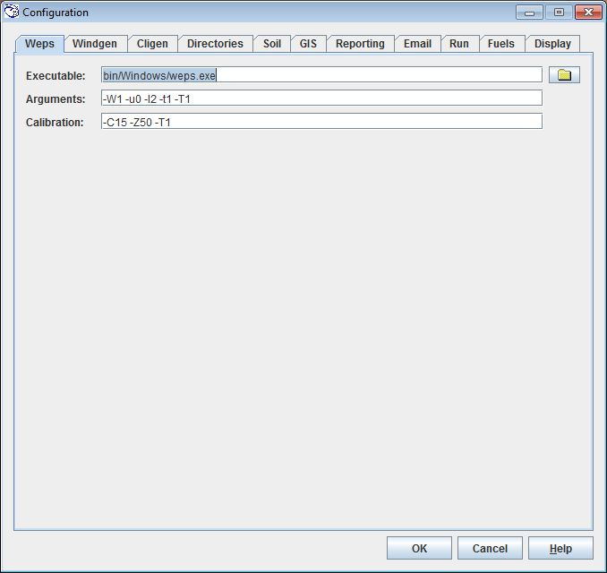
Figure 2-65 WEPS Configuration Panel displaying the WEPS tab.

Executable – Displays the path and file name of the WEPS science executable. The folder button allows the user to browse and select an alternate WEPS executable if desired.

Arguments – Displays the WEPS science model default command line arguments (see Chapter 5 for argument list).

Calibration – Display the WEPS science model default command line arguments to be used for a yield calibration run (see Chapter 5 for argument list).

Configuration Panel – Windgen Tab
Displays the settings pertaining to the Windgen generator, interpolation functions available and settings on how the interface determines which Windgen record to use for a specified WEPS Run (Figure 2-75).

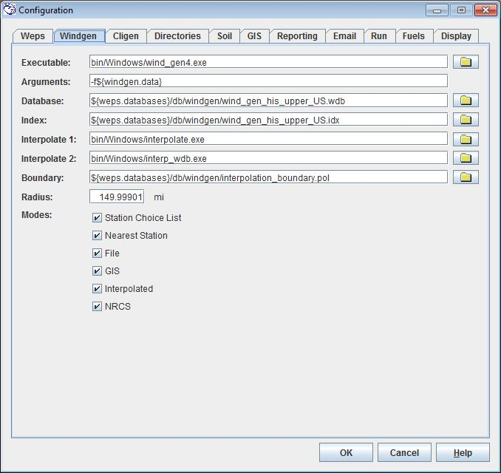
Figure 2-66 WEPS Configuration Panel displaying Windgen tab.
Executable – Displays the path and file name of the Windgen generator executable. The folder button allows the user to browse and select an alternate Windgen generator executable if desired.

Arguments – Displays the Windgen generator executable default command line arguments (see Appendix for argument list). The “${windgen.data}” argument option refers to the default location of the Windgen station database file, which is defined in the Database field on this form.

Database – Displays the path and file to the Windgen station database file. The folder button allows the user to browse and select an alternate Windgen database file if desired. The “${weps.databases}” property is set to the default location where the WEPS database file resides.

Index – Displays the path and file to the Windgen station database index file. This file contains a list of the Windgen stations in the corresponding database file to use in WEPS. The folder button allows the user to browse and select an alternate Windgen database index file if desired. This file must be kept in sync with the Windgen database file listed above, otherwise WEPS may not find the desired Windgen station for WEPS Runs.

Interpolate 1 – Displays the path and file to the spatial interpolation executable file which determines which three Windgen stations to use for station parameter interpolation at a given location. The folder button allows the user to browse and select an alternate interpolation executable file if desired.

Interpolate 2 - Displays the path and file to the interpolation executable file which interpolates the station parameters for the three Windgen stations obtained from the Interpolate 1 program listed above. The folder button allows the user to browse and select an alternate interpolation executable file if desired.

Boundary - Displays the path and file to the GIS polygon “interpolation boundary” file which specifies the spatial polygon boundary that defines the region where Windgen stations are interpolated. The folder button allows the user to browse and select an alternate GIS polygon boundary file if desired.

Radius- Displays the radius limit that is used in the Windgen station selection field on the main WEPS screen when the Station Choice List option is active. It constrains the number of stations to be displayed in the dropdown choice list

Modes – Lists the modes that can be enabled for Windgen station selection on the main WEPS screen. There are several Windgen station selection methods described here: Alternative Weather Station Selection Methods that employ these modes, when set. The mode options are:

Station Choice List – Provides a dropdown list of stations sorted by distance from the specified lat/lon on the main WEPS screen, with the nearest station the default option.

Nearest Station – Provides the nearest Windgen station to the specified lat/lon coordinates on the main WEPS screen.

File – Allows the user to select a file that is in the format of a Windgen generator created Windgen hourly wind data file for use in WEPS.

GIS – Allows the user to use the GIS polygon map for selecting Windgen stations.

Interpolated – Allows Windgen station records to be interpolated if they fall within the polygon boundary specified in the GIS polygon Boundary file listed above.

NRCS – A special mode that employs several other modes in a prescribed sequence for determining the Windgen station, based upon the selected lat/lon coordinates specified in the WEPS main screen. The sequence is defined in the Alternative Weather Station Selection Methods section.

Configuration Panel – Cligen Tab

Displays the settings pertaining to the Cligen generator, interpolation functions available and settings on how the interface determines which Cligen record to use for a specified WEPS Run (Figure 2-67).

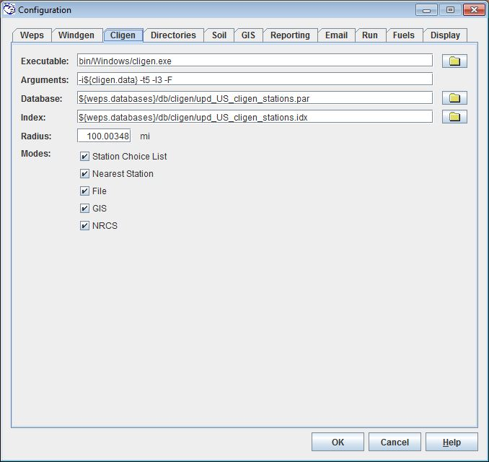
Figure 2-67 WEPS Configuration Panel displaying Cligen tab.
Executable – Displays the path and file name of the Cligen generator executable. The folder button allows the user to browse and select an alternate Cligen generator executable if desired.

Arguments – Displays the Cligen generator executable default command line arguments (see Appendix for argument list). The “${cligen.data}” argument option refers to the default location of the Cligen station database file, which is defined in the Database field on this form.

Database – Displays the path and file to the Cligen station database file. The folder button allows the user to browse and select an alternate Cligen database file if desired. The “${weps.databases}” property is set to the default location where the WEPS database file resides.

Index – Displays the path and file to the Cligen station database index file. This file contains a list of the Cligen stations in the corresponding database file to use in WEPS. The folder button allows the user to browse and select an alternate Cligen database index file if desired. This file must be kept in sync with the Cligen database file listed above, otherwise WEPS may not find the desired Cligen station for WEPS Runs.

Radius- Displays the radius limit that is used in the Cligen station selection field on the main WEPS screen when the Station Choice List option is active. It constrains the number of stations to be displayed in the dropdown choice list

Modes – Lists the modes that can be enabled for Cligen station selection on the main WEPS screen. There are several Cligen station selection methods described here: Alternative Weather Station Selection Methods that employ these modes, when set. The mode options are:

Station Choice List – Provides a dropdown list of stations sorted by distance from the specified lat/lon on the main WEPS screen, with the nearest station the default option.

Nearest Station – Provides the nearest Cligen station to the specified lat/lon coordinates on the main WEPS screen.

File – Allows the user to select a file that is in the format of a Cligen generator created Cligen daily weather data file for use in WEPS.

GIS – Allows the user to use the GIS polygon map for selecting Cligen stations.

NRCS – A special mode that employs several other modes in a prescribed sequence for determining the Cligen station, based upon the selected lat/lon coordinates specified in the WEPS main screen. The sequence is defined in the Alternative Weather Station Selection Methods section.

Configuration Panel – Directories Tab
The Directories tab allows the user to select the directories used for templates, skeleton files, databases, and Projects as well as other WEPS related configuration files, etc. by entering the path/file name or clicking the folder icon to display a file chooser to select the files or locations (Figure 2-68).

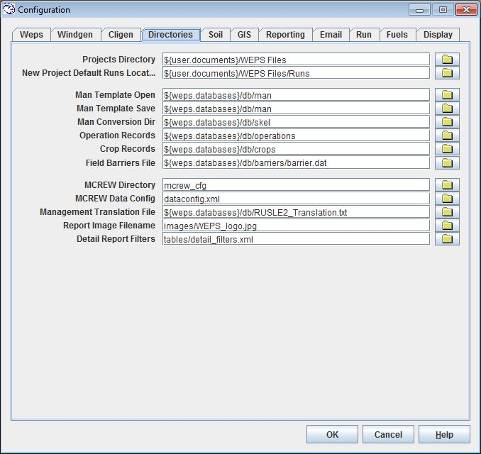
Figure 2-68 WEPS Configuration Panel displaying the Directories tab.
Projects Directory - The default directory for WEPS Projects. ${user.documents} is an operating system variable that defines the user’s documents directory (typically the My Documents folder in Microsoft Windows).

New Project Default Runs Locat… - The default WEPS Runs location that is used when a new Project directory is specified from within the WEPS main screen Projects menu.

Man Template Open - The default directory location for storing management template files.

Man Template Save - The default directory for saving management template files.

Man Conversion Dir – The directory specified for use when converting management files between the intermediate RUSLE2/WEPS “skel” format and the WEPS format.

Operation Records - The default directory location for the management operation database files.

Crop Records - The default directory location for the management crop database files.

Field Barriers – The default directory location and filename for the WEPS wind barrier data file.

MCREW Directory - The default directory location for MCREW configuration files.

MCREW Data Config - The default directory and filename for the MCREW data configuration file.

Management Translation File - The translation file used for converting NRCS RUSLE2 "skel" format management files to WEPS format management files.

Report Image Filename - The file name of the image to be displayed on the WEPS report files such as an Agency logo.

Detail Report Filters – The default directory location and filename for the WEPS Tabular Detail Report filters.

Configuration Panel – Soil Tab

The Soil tab allows the user to select the directories and specify specific options related to WEPS soil data (Figure 2-69). One can click on the folder icon to display a file chooser to select the files or locations for those type of configuration fields.

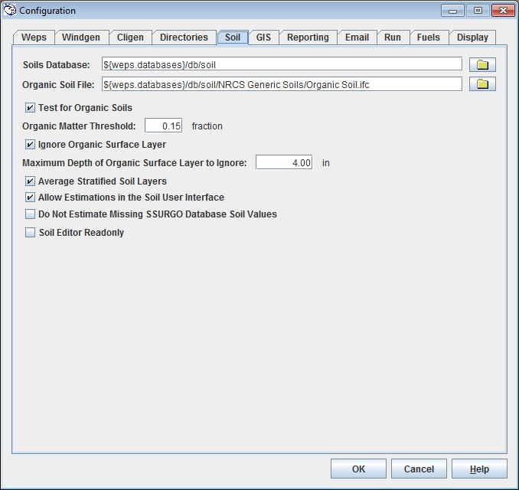
Figure 2-69 WEPS Configuration Panel displaying the Soil tab.

Soil Database - The default directory for local “ifc” and NRCS SSURGO Microsoft Access “mdb” soil database files. It is also where the “SDMDataAccess.nrc.usda.gov.db” file resides containing the link information to the NRCS online SSURGO soil database.

Organic Soil File – The default directory location and filename of the WEPS soil file used as a surrogate for organic soils by NRCS.

Test for Organic Soils – Enables the check for organic soils that is used by NRCS.

Organic Matter Threshold – Sets the threshold value for organic matter that the NRCS Organic Soils test uses.

Ignore Organic Surface Layer – Enables the feature to ignore a surface layer that is high in organic matter when reading in a soil file within WEPS.

Maximum Depth of Organic Surface Layer to Ignore – Sets the maximum depth for the Ignore Organic Surface Layer feature.

Average Stratified Soil Layers – Enables the feature to average “stratified” soil layers specified in an NRCS soil data record.

Allow Estimations in the Soil User Interface – Enables the manually triggered soil property estimation functions in the Soil User Interface to work if specific soil properties are missing in the displayed soil record.

Do Not Estimate Missing SSURGO Database Soil Values – Disables the automated soil property estimation functions in WEPS if specific soil properties are missing in the selected soil record.

Soil Editor Readonly – Configures the Soil User Interface editor to not allow editing.

Configuration Panel – GIS tab

The GIS tab (Figure 2-70) allows the user to specify the GIS directory containing GIS files used in the MAP component that is accessible from the main WEPS interface screen.

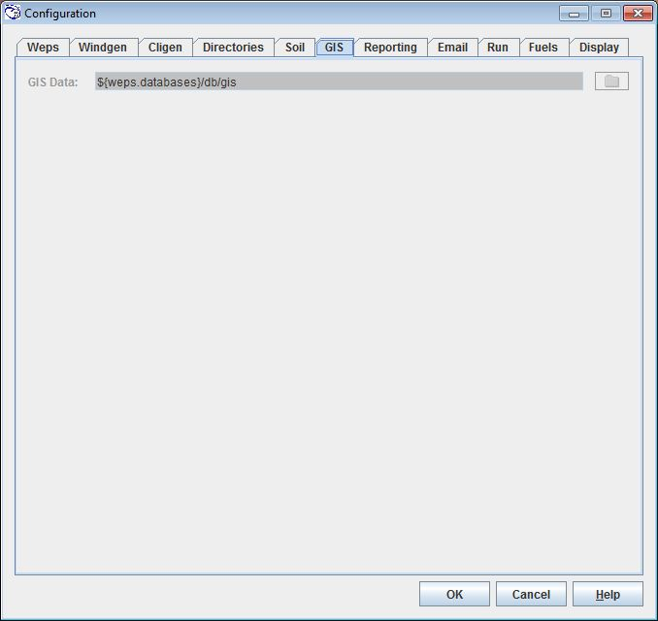
Figure 2-70 WEPS Configuration Panel displaying the GIS tab.
GIS Data – Sets the directory location that the GIS files used by the MAP component, which is accessed from the WEPS Interface screen. The folder icon can be clicked on to display a file chooser to select an alternative location, if desired.

Configuration Panel – Reporting Tab

The Reporting tab (Figure 2-71) allows the user to specify additional WEPS science model output. The additional output is specified by setting the values to numbers greater than zero for the selected submodels. Larger numbers produce reports with more detail, if the submodel has multiple levels of reports. There are two levels of reports, Detail and Debug. The specific type of output produced at the different levels are provided here:

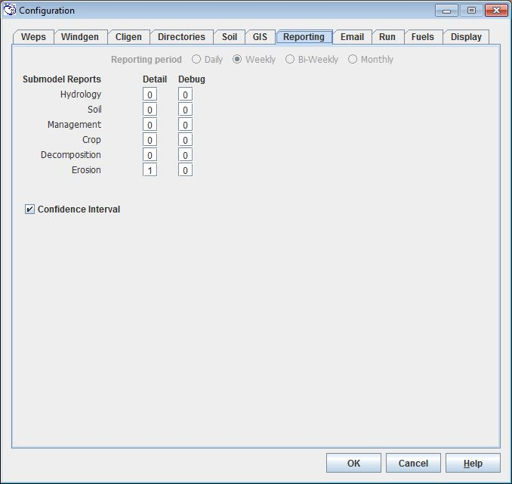
Figure 2-71 WEPS Configuration Panel displaying the Reporting tab.
Confidence Interval – Determines whether the WEPS interface Confidence Interval report is made available to users or not.

Configuration Panel – Email tab

The Email tab (Figure 2-72) allows the user to specify the necessary information for the built-in WEPS email client and the Mantis bug/comment reporting system.

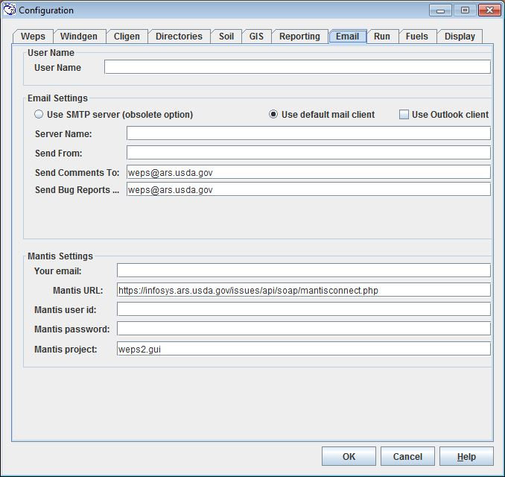
Figure 2-72 Configuration Panel displaying the Email tab.
User Name – Contains the user name. It is normally set from the WEPS Wizard that runs the first time a user executes the WEPS interface and requests their name and email address.

Email Settings

Use SMTP server (obsolete option) – Selecting this option allows the user to use the SMTP server specified in the fields immediately below this option.

Use default mail client – Selecting this option allows the user to use their default email client, such as Thunderbird, for sending email messages from WEPS. Note that this setting does not work for all clients.

Use Outlook client – Selecting this option allows the user to use their Microsoft Outlook email client when sending email messages from WEPS. This is the preferred setting for NRCS users.

Server Name – The default name of the email server to use.

Send From – The default name of the individual sending the email message.

Send Comments To – The default email address for sending email comments regarding WEPS.

Send Bug Reports … - The default email address for sending email bug reports regarding WEPS.

Mantis Settings

Your email – The user’s email address.

Mantis URL – The URL internet address for the WEPS Mantis ticket system.

Mantis user id – The Mantis user id (tickets are submitted anonymously from WEPS so it is not required to fill out this field). Note that the user can be identified and replied to if they complete the User Name and Your email fields above.

Mantis Password The Mantis user’s password (since tickets are submitted anonymously, it is also not required to fill out this field).

Mantis project- The default Mantis project that submitted tickets are assigned to.

Configuration Panel – Run tab

The Run tab (Figure 2-73) allows the user to specify default required WEPS runtime configuration settings.

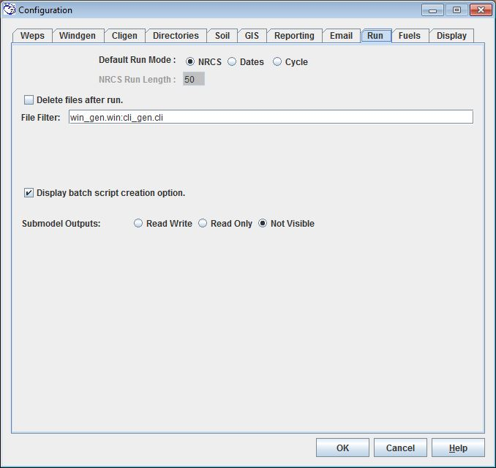
Figure 2-73 Configuration Panel displaying the Run tab.
Default Run Mode options are:

NRCS – This mode is specified for NRCS users. Note that if this mode is selected, the user cannot change the run mode from the WEPS interface screen nor change the number of cycles that are simulated in a WEPS Run.

Dates – This mode allows the user to set the beginning and ending dates for a simulation run. It is intended for advanced users and developers who may be wanting to compare real world field results with what WEPS is sumulating. Thus, it is generally used with real weather data rather than generated data. Note that the beginning date should be set to January 1 of the calendar year selected and the ending date being December 31 of the calendar year selected. Also, the user must be aware that the WEPS interface reports assume that the length of a management cycle divides evenly into the total simulation runtime length in years. If not, then those reports will likely be in error.

Cycle – The mode that ensures that the total WEPS simulation length gets set to a value that is evenly divisible by the length of the management rotation (rotation years). The number of “cycles” can be specified by the user on the main WEPS interface screen. Note that the NRCS mode is identical to Cycle mode, except the number of cycles is fixed and not allowed to be changed.

NRCS Run Length – The length of a WEPS simulation run in management rotation “cycles” for an NRCS mode WEPS run.

Delete files after run – If checked, delete the files listed in the File Filter field at the conclusion of a WEPS run.

File Filter – The list of files that are to be deleted if the Delete files after run option is enabled.

Display batch script creation option – Determines if the batch script option is presented at the start of a WEPS run.

Submodel Outputs – Specifies whether the submodel output options are presented to the user at the start of a WEPS run. The options are: Read Write, Read Only and Not Visible.

Configuration Panel – Fuels tab

The Fuels tab (Figure 2-74) allows the user to specify default related information in WEPS.

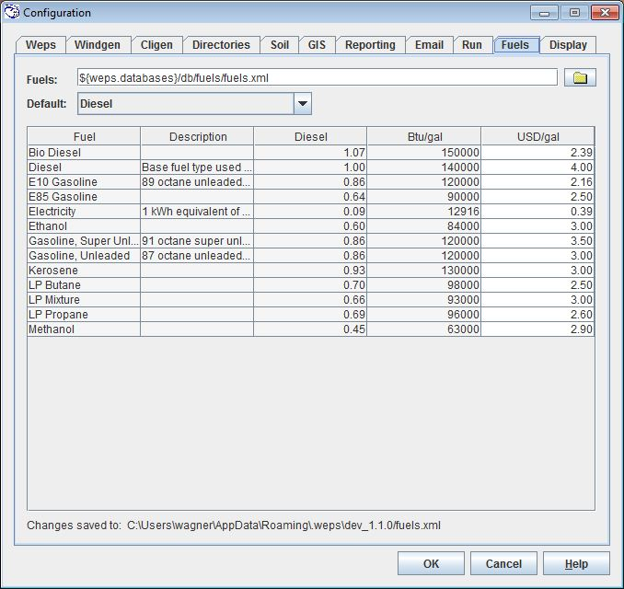
Figure 2-74 Configuration Panel displaying the Fuels tab.
Fuels - Sets the directory location and name for the fuel data file. The folder icon can be clicked on to display a file chooser to select an alternative location and file, if desired.

Default – The default fuel type to use for displaying operation fuel usage in WEPS.

Fuel Table – The fuel table consists of the following columns:
Column 1 – Fuel type.
Column 2 – Description of fuel type.
Column 3 – Diesel energy equivalent of fuel type.
Column 4 – Btu/gal for the specified fuel type.
Column 5 – USD/gal for the specified fuel type.

Configuration Panel - Display Tab
The Display tab is shown here (Figure 2-75). It consists of general configuration options for the WEPS interface.

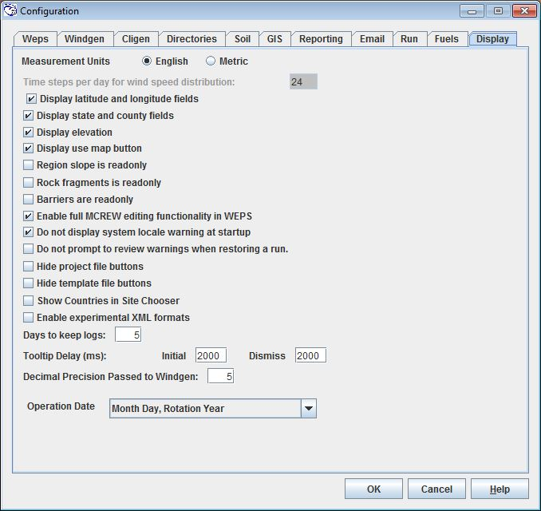
Figure 2-75 WEPS Configuration Panel displaying the Display tab.
Measurement Units - Display either Metric (SI) or English units on WEPS screens.

Time steps per day for wind speed distribution - Enter the number of time steps used for the daily distribution of simulated wind speed. It cannot be changed and should be greyed out.
Display latitude and longitude fields - Check box to display the latitude and longitude fields in the Location Information panel on the Main screen. Un-check the box to hide these fields.

Display state and county fields - Check box to display the state and county fields in the Location Information panel on the Main screen. Un-check the box to hide these fields.

Display elevation - Check box to display the elevation field in the Location Information panel on the Main screen. Un-check the box to hide this field.

Display use map button - Check box to display the Use Map button in the Location Information panel on the Main screen. Un-check the box to hide this button.

Region slope is read only - Check box to only display the simulation region slope field on the main WEPS interface screen and not allow it to be edited.

Rock fragments is read only - Check box to only display the rock fragments field on the main WEPS interface screen and not allow it to be edited.

Barriers are read only - Check box to only display the barriers information and not allow them to be edited.

Enable full MCREW editing functionality in WEPS - Check box to enable the full MCREW editing functionality in WEPS. Allows additional editing functionality of MCREW. Un-check the box to disable this functionality. When this functionality is disabled, the MCREW File Open and Open Copy of Template menu items are disabled.

Allow estimations in the Soil UI - Check box to enable the estimation of soil parameters in the WEPS Soil user interface (UI) when they are missing from the soil database.

Do not display system locale warning at startup - Check box to turn off the display of a warning when WEPS is installed in a non-US locale. To avoid problems, WEPS is always installed using the "US locale", regardless of the local PC settings. The following is an example of the warning message displayed if the box is not checked and WEPS is installed in a non-US locale.
WEPS has detected that this machine is using the German (Germany) locale. WEPS uses the English (United States) locale. You do not need to change your machine's locale, but be aware that numbers will be formatted in the English (United States) style.
  - For more info about what a "locale" is, see:
  - www.microsoft.com/globaldev/DrIntl/faqs/Locales.mspx
Do not estimate missing soil values from SSURGO database - Check box to disable the estimation of soil parameters in the user interface when they are missing from the soil database.
Organic matter fraction minimum- enter the minimum fraction of organic matter in the soil surface
Do not prompt to review warnings when restoring a run - Check box to turn off warnings displayed from a previous WEPS Run when it is restored.

Hide project file buttons – Check box to turn off the Project button displayed on the Man and Soil fields on the main WEPS screen.

Hide template file buttons – Check box to turn off the Template button displayed on the Man and Soil fields on the main WEPS screen.

Show Countries in Site Chooser – Check box to turn on the Country field above the State and County fields on the main WEPS screen.

Enable experimental XML formats – Check box to turn on use of XML formatted files. This field should not be checked, if displayed for normal WEPS users.

Tooltip Delay - Sets the delay time for the initial appearance of the tooltip and for the dismissal of the tooltip box from the screen. The units are in milliseconds. To disable tooltip display, set the “Initial” value to 1000 (1 second) and the “Dismiss” value to zero.

Decimal Precision Passed to Windgen – Sets the number of digits right of the decimal to be passed for writing out the lat/lon values in the weps.run file and for use in the interpolation functions. This value should be set to 5 for WEPS releases 1.5 or greater. A value of 2 should be used if strict compatibility with WEPS version 1.5 is required.

Operation Date - Click the down arrow to the right of the box displays a list of available formats for the operation date. The format is displayed on this tab, next to “Operation Date” when a format is selected.

Search Radius- enter the search radius for the climate station choice lists (kilometers or miles, depending upon the “Measurement Units” setting). The user usually will want the nearest station to their simulation site. The user may want to select a different station more typical of the climate for the field being simulated if the nearest station doesn’t meet their criteria. An example of not selecting the closest station might occur in mountainous areas where the nearest station does not always typify the climate for the simulated field.

We use the term “centroid” in this document, but if the county polygon is shaped such that the true centroid is located outside the county, we adjust the coordinates such that the lat/lon displayed will always fall within the county boundary.
The NRCS Crop Management Zones (CMZs) are geographical regions within the U.S. that NRCS has defined as having common enough management practices and planting/harvesting dates to be grouped together. They have developed a series of “template” management practices by CMZ that can be used by WEPS as initial starting points when developing WEPS management rotation files.

