SCIENCE OVERVIEW



Interface and Science Model Implementation

Interface
This section describes the WEPS 1.5 User Interface program implementation and how it interacts with the WEPS science model. The WEPS ‘science’ model refers to the computer code and executable program that performs the actual calculations of field conditions and erosion processes for a simulation run. A simple flow diagram of the WEPS science model and User Interface is shown in Figure 5-1. A detailed description of how to operate the WEPS 1.3.9 User Interface is described elsewhere in the WEPS User’s Guide in a chapter titled ‘Interface Reference’.
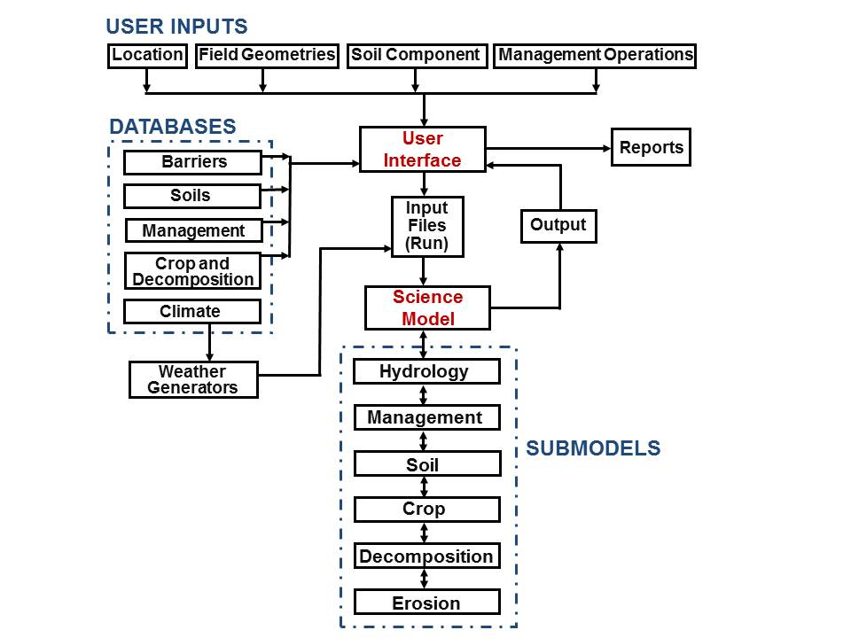
Figure 5-1 A flow diagram of the WEPS science model and User Interface.
A simplified description of the science model is provided later in this chapter. The inputs to the science model reside in a series of ASCII input files. These input files are: a Windgen file (*.win), a Cligen file (*.cli), an initial field conditions file (*.ifc), a management file (*.man), and a run file (weps.run). The science model can be executed from the command line or through the interface. When WEPS is executed, the science model reads the input files, calls each submodel performing daily time-step simulations, and writes output files. The output is written to one or more ASCII files. Building input files by hand, executing the model on the command line, and interpreting the output files can be time consuming and confusing; the WEPS 1.3.9 User Interface simplifies this process.

The WEPS 1.3.9 User Interface is written in Java. The interface can be thought of as a ‘shell’ or ‘wrapper’ around the science model, which does not affect the execution of the science model. Through the interface program, the user can easily enter the information necessary to create and edit the input files. A description of how to enter this information is given elsewhere in the WEPS User’s Guide in a chapter titled ‘Interface Reference’. Once the field, location, soil, and management are described, pressing the ‘Run’ button performs a series of commands to execute the science model. The interface first calls the CLIGEN and WINDGEN weather generators, which create the WINDGEN and CLIGEN files for the simulation. Then the WEPS science model is called and executed as described earlier. When the science model is finished, the interface reads and displays the output.

Main Program
The MAIN program is the portion of the science model that controls the initialization and execution of a WEPS simulation run. It calls subroutines that read input data and generates the summary and other reports. In addition, MAIN calls submodels on a daily basis, which update the field conditions. If the maximum wind speed for the day exceeds a set velocity great enough to cause soil movement (i.e., 8 m/s or 18 mi/hr), MAIN then calls the EROSION submodel to simulate erosion processes. The current version of WEPS reads in the climate data produced by the WEATHER submodel; performs daily simulation of the hydrologic and soil conditions, crop growth, and residue decomposition; and accounts for management effects. Finally, the model determines soil erosion by wind for the desired simulation period.

Program Description
The current version of MAIN requires the following files for a WEPS simulation run: a) a simulation run file that describes the field shape and barriers, simulation period, location of other input files, and types of output ; b) an initial field conditions file that describes soil conditions at the start of a simulation; d) a tillage/management file that describes the management system; and e) two climate files, one each in the CLIGEN and WINDGEN formats, that provide climate data on a daily basis.

The MAIN program begins by initializing local variables and then calls the subroutine INPUT, which reads the simulation run file and the initial field conditions file. The simulation then is executed as a daily loop that controls the counters for the current day. The model can perform any length of simulation on a daily time step, but WEPS performs a simulation for one rotation cycle to initialize surface conditions before simulations of wind erosion are performed. For each simulation day, the daily weather is read from the CLIGEN and WINDGEN data files. As some of the submodels are executed, summary information may be compiled for output. All submodels except EROSION are called within the subregion loop. Once field conditions are updated, if maximum wind speed for the day exceeds a set minimum (i.e., 8 m/s), the EROSION submodel then is called to determine threshold conditions and compute soil erosion. Finally, the MAIN program calls routines to account for field conditions and soil loss for periods throughout the rotation.

The “WEPS Technical Description” provides a more detailed description of the science behind WEPS and is available from WERU. The current WEPS science model is coded in FORTRAN conforming to the ANSI FORTRAN 77 and Fortran 95 standards. The inputs to the science model reside in a series of ASCII input files. These input files are: a WINDGEN file (*.win), a CLIGEN file (*.cli), an initial field conditions file (*.ifc), a management file (*.man), and a run file (weps.run). The science model can be executed from the command line or the interface. When WEPS is executed, the science model reads the input files, accesses necessary databases, calls each submodel daily and performs the simulation, and writes output files. The output is written to one or more ASCII files.

Weather Generators and Databases

WEPS requires wind speed and direction to simulate the process of soil erosion by wind. These and other weather variables (precipitation, air temperature, and solar radiation) are also needed to drive temporal changes in hydrology, soil erodibility, crop growth, and residue decomposition in WEPS.

Often it is not practical to use measured historical wind data with WEPS, because many wind records have missing data. Also, one may want to simulate wind erosion for a longer period than the length of the measured data record (e.g., for 40 years, is the length of a typical WEPS simulation run). In addition, the measured data require much more computer disk space than do wind summary statistics combined with a stochastic wind generator. Therefore, a stochastic wind generator is often more appropriate for use with WEPS than is using the measured data directly.

WINDGEN was developed specifically for use with WEPS. It stochastically generates daily wind direction and hourly wind speed (van Donk et al., 2004). An earlier version of WINDGEN was described by Skidmore and Tatarko (1990). CLIGEN is the weather generator developed for the Water Erosion Prediction Project (WEPP) family of erosion models (Nicks et al., 1987). It is used by WEPS to stochastically generate daily precipitation, maximum and minimum temperature, dew point temperature, and solar radiation. Those interested in CLIGEN and how it simulates these variables should consult the WEPP documentation (Nicks et al., 1995) and the CLIGEN web site (USDA, 2004). Both CLIGEN and WINDGEN are executed under the WEPS user interface.

Statistical distributions of weather variables are needed by stochastic weather generators to be able to generate data. There are two steps in the stochastic generation of wind data. First, statistics need to be calculated from a historical record of measured data, describing the distributions of wind direction and speed. Second, the wind data are stochastically generated from these statistics.

Calculation of statistics used for stochastic wind generation
A quality-controlled hourly wind data set (TD-6421, version 1.1), including 1304 stations in the 48 contiguous states of the USA, was obtained from the National Climatic Data Center (NCDC). Stations with less than 5 years of data were excluded, leaving 971 stations for use with a stochastic generator. Wind direction frequencies were calculated for each of 16 directions for each month. Wind speeds less than or equal to 0.5 m/s were treated as ‘calm’. For the wind speeds that were not calm, the fraction less than or equal to certain wind speeds was calculated for each month-direction combination (12*16 = 192 combinations per station). The wind speeds used were 0.5, 1.5, 2.5, ..., 20.5, 25.5, ..., and 45.5 m/s. Rather than using the Weibull model, we chose to use the measured wind speed distributions themselves, without fitting to any model, but instead using linear interpolation between the measured distribution points. The reasons for this choice are described by van Donk et al. (2004).

Stochastic wind generation
First, one of the 16 cardinal wind directions or calm is selected by using a random number generator with the distribution for the current month. The selected direction is applied for an entire day. Next, 24 hourly wind speeds are generated for this day. If calm was selected in the previous step, 24 wind speeds of 0 m/s are generated. Otherwise, if one of 16 directions was selected, 24 wind speeds are generated from the cumulative wind speed distribution. The distribution for the current month and wind direction is selected, and a wind speed is generated from the linearly interpolated distribution, by using a random number generator.

For more detail on the science behind this submodel, please see the WEPS technical documentation.

References
Nicks, A.D., L.J. Lane, and G.A. Gander. 1995. Chapter 2. Weather generator. In USDA – Water erosion prediction project: Hillslope profile and watershed model documentation, D.C. Flanagan and M.A. Nearing, eds. NSERL Report No. 10, USDA-ARS, National Soil Erosion Research Laboratory, West Lafayette, IN (http://topsoil.nserl.purdue.edu/nserlweb/weppmain/docs/chap2.pdf).

Nicks, A.D., J.R. Williams, C.W. Richardson, and L.J. Lane. 1987. Generating climatic data for a water erosion prediction model. Paper No. 87-2541, International Winter Meeting ASAE, December 15-18, Chicago, IL.

Skidmore, E.L., and J. Tatarko. 1990. Stochastic wind simulation for erosion modeling. Transactions of the ASAE. 33(6): 1893-1899.

USDA. 2004. Cligen Weather Generator, expanded and improved by USDA Agricultural Research Service and U. S. Forest Service. http://horizon.nserl.purdue.edu/Cligen

Van Donk, S.J., L.E. Wagner, E.L. Skidmore, and J. Tatarko. 2004. Stochastic wind generation, comparing the Weibull model with a more direct approach. Submitted to Transactions of the ASAE.

Hydrology Submodel

HYDROLOGY submodel of the Wind Erosion Prediction System (WEPS) uses inputs generated by other WEPS submodels, such as WEATHER, CROP, SOIL, MANAGEMENT, and DECOMPOSITION, to predict the water content in the various layers of the soil profile, and at the soil-atmosphere interface, throughout the simulation period. Accurate simulation by the other WEPS submodels requires prediction of the daily changes in soil water profiles. Estimating soil wetness at the soil-atmosphere interface is emphasized however, because it significantly influences the susceptibility of the soil to wind erosion.

The HYDROLOGY submodel of WEPS maintains a continuous, daily, soil water balance by using the equation:
 | $$SWC=SWCI+(PRCP+DIRG) + SNOW-RUNOFF-ETA-DPRC$$ | Equation 5.1
where SWC is the amount of water on the soil profile in any given day, SWCI is the initial amount of water in the soil profile, PRCP is the amount of daily precipitation, DIRG is the amount of daily irrigation, SNOW is the daily snow melt minus daily snow accumulation, RUNOFF is the amount of daily surface runoff, ETA is the amount of daily actual evapotranspiration, and DPRC is the amount of daily deep percolation.

The amount of daily precipitation (PRCP) is partitioned between rainfall and snowfall on the basis of the average daily air temperature. If the average daily temperature is 0̊C or below, the precipitation takes the form of snowfall; otherwise, it takes the form of rainfall.

The snow term (SNOW) can be either positive, equaling the daily snow melt, or negative, equaling the daily snow accumulation. The melted snow is treated as rainfall and added to the precipitation term in Equation 5.1 when accounting for daily runoff and infiltration. On the other hand, the accumulated snow is subtracted from the daily precipitation during the estimation of the daily soil water balance with Equation 5.1.

Simulation of soil-water dynamics on a daily basis by the HYDROLOGY submodel involves three major sequences. First, the submodel partitions the total amount of water available from precipitation, irrigation, and/or snow melt into surface runoff and infiltration. The submodel stores the daily amount of water available for infiltration into the soil profile. Second, the submodel determines the influence of ambient climatic conditions by calculating the potential evapotranspiration. Third, the submodel redistributes soil water in the soil profile on an hourly basis, which provides hourly estimations of water content in the soil profile. The submodel estimates the actual rate of evapotranspiration by adjusting the potential rate on the basis of soil water availability. Deep percolation from the soil profile is estimated to be equal to the conductivity of the lowermost simulation layer, assuming a unit hydraulic gradient.

HYDROLOGY submodel estimates surface runoff and infiltration for each simulation day that has precipitation and/or irrigation. The submodel estimates the daily amount of water available for infiltration into the soil by subtracting the amount of daily surface runoff from the amount of daily precipitation, snow melt, and/or irrigation. The infiltration water is stored in the uppermost simulation layer, until its water content reaches field capacity. Any excess water then is added to the succeeding lower layer, where it is stored with the same maximum storage restriction. This is repeated until complete water storage is obtained. Any excess water that flows out from the lowest simulation layer becomes a part of deep percolation.

Potential evapotranspiration is calculated by using a revised version of Penman's combination method (Van Bavel, 1966). The total daily rate of potential evapotranspiration then is partitioned on the basis of the plant leaf area index into potential soil evaporation and potential plant transpiration. The potential rate of soil evaporation is adjusted to account for the effect of plant residues in the simulation region. Furthermore, the daily potential rates of soil evaporation and plant transpiration are adjusted to actual rates on the basis of water availability in the soil profile.

The HYDROLOGY submodel uses a simplified, forward finite-difference technique to redistribute soil water with the one-dimensional Darcy equation for water flow. The time step of the soil water redistribution is 1 hour, which allows for an hourly estimation of soil wetness as needed for WEPS. Knowledge of the relationship between unsaturated hydraulic conductivity and soil water content is required for solving the governing transport equations of water movement through the soil. The submodel uses Campbell's (1974) method to calculate the unsaturated hydraulic conductivity of the soil from the more readily available soil water characteristic curve and saturated hydraulic conductivity data. Because water release curve data of the soil are not always available, the submodel provides alternative options to estimate the hydraulic parameters of the water release curve that are needed as inputs to run the soil water redistribution segment of the submodel.

The HYDROLOGY submodel predicts, on an hourly basis, soil wetness at the soil-atmosphere interface by using a combination of two techniques. The submodel extrapolates water content to the soil surface from the three uppermost simulation layers. A numerical solution known as Cramer's rule (Miller, 1982) is used to obtain an estimate of the extrapolated water content at the soil surface by solving the three simultaneous equations that describe the relationship between water content and soil depth for the three uppermost simulation layers. The submodel also interpolates the functional relationship between surface-soil wetness and the hourly evaporation ratio.

References
Campbell, G. S. 1974. A simple method for determining unsaturated conductivity from moisture retention data. Soil Sci. 117(6):311-314.

Miller, A. R. 1982. FORTRAN programs for scientists and engineers. SYBEX Inc., Berkeley, CA.

Van Bavel, C. H. M. 1966. Potential evaporation: the combination concept and its experimental verification. Water Resources Res. 2(3):455-467.

Management Submodel

Introduction
WEPS is expected to reflect effects of various management practices upon wind erosion. The diversity of current practices applied to crop land by land managers makes this a daunting task, but WEPS must adequately simulate typical cultural practices to accurately assess their effects upon wind erosion control. The MANAGEMENT submodel is assigned the task of handling the cultural practices that affect the soil/surface "state" within WEPS.

Purpose
All cultural practices are by definition "human initiated". These human-controlled processes affecting the soil and field surface "state" are initiated by typical management practices such as tillage operations, planting, harvesting, irrigation, etc. Therefore, the purpose of the MANAGEMENT submodel is to model what are considered the major human-controllable actions that can affect the "system state" within WEPS, in particular the system state variables defining the temporal soil and surface conditions.

Objectives
The MANAGEMENT submodel objectives are:

- To model the primary human-initiated processes that can affect a site's susceptibility to wind erosion.
- To provide the framework necessary to process a list of specified human-initiated actions (i.e., the cultural practices applied to a field such as a tillage/crop rotation sequence).

Keeping with the WEPS philosophy, The MANAGEMENT submodel simulates processes via a physical basis if possible, incorporates the conservation of mass and energy concepts, and uses a minimum number of parameters with readily available and/or attainable values.

Assumptions and Limitations
Several assumptions and limitations have been imposed on the MANAGEMENT submodel. The reasons range from simply limiting the scope of the submodel, to inadequate knowledge of specific processes that may have a significant impact on the soil and/or surface. Here is the list of current assumptions and limitations, provided in no particular order, that impact the MANAGEMENT submodel:Total soil water content within the current tillage zone is assumed to be unaffected by a tillage operation.

- The HYDROLOGY submodel is expected to handle changes in surface water content and, therefore, appropriately represent the usual rapid drying of the surface layer after tillage.
- Tillage depth is assumed not to influence how a tillage operation affects the soil and surface, except for determining which soil layers are directly affected by a tillage operation.
- Effects of tillage operations on soil layers below the tillage depth are not considered, (i.e., subsoil compaction below the tillage zone due to tillage).
- Effects of a management operation are assumed homogeneous within a subregion. Effects due to tractor tires will not be considered (except where they may knock down a significant proportion of standing residue). Certain zone-related tillage operations, such as row cultivator, will be treated in a manner such that the result will be "averaged" or "equivalent" values that represent the homogeneous region.
- Ridge and dike geometric specifications (oriented roughness) will be provided by the user. If the tillage depth specified is not sufficient to create or destroy them (for a particular tillage operation that does so), the MANAGEMENT submodel will modify the tillage depth accordingly to obtain the desired ridge and/or dike specifications. Tillage operations that do not modify the current ridge and/or dike specifications will not do so (i.e., ridge tillage equipment).
- Soil tillage depths will be adjusted to the nearest soil layer boundary. This will ensure that the most recent tillage operation modifications on the soil "state" are adequately represented.
- Aggregate stability and aggregate density are assumed to be unaffected by tillage operations. This decision is based on limited field data analysis. Future research may provide statistically significant affects that could then be modeled. These properties may still change among soil layers within the tillage zone due to aggregate mixing among layers caused by tillage operations.

Submodel Description
The approach taken within the MANAGEMENT submodel to deal with the variety of land management actions was to:

- Identify the primary physical processes involved.
- Represent individual management operations as a sequence of those primary physical processes.
- Develop a MANAGEMENT file format allowing the input of user-specified sequences of management operations (i.e. a management practices/crop rotation file). All operations modeled within the MANAGEMENT submodel fall within the defined management categories as listed in (Table 5.1).

Table 5.1 Management Operation Classes
Operation Class | Description
Primary Tillage | Tillage performed to primarily reduce surface residue, increase short-term infiltration rates, loosen subsoil hardpans, and control weed growth. After-harvest tillage operations usually fall in this category.
Secondary Tillage | Tillage typically performed in preparation for seeding or planting operations. These operations usually are intended to smooth the soil surface, reduce the average aggregate size, and control weed growth, if present.
Cultivation | Tillage specifically designed to eliminate weed growth after crop germination.
Planting/Seeding | Operations required to plant or seed a crop into a field.
Harvesting | Operation to remove biomass from a field. Biomass removed may be grain, root material, or the entire above-ground biomass.
Irrigation | The artificial application or addition of water to the soil.
Fertilization | The application or addition of specific nutrients to a soil.
Burning | The removal of surface biomass via burning.

When a management or tillage operation is performed, it is simulated through a group of individual physical processes that represent the total effects of that operation. The basic individual physical processes to be modeled within the MANAGEMENT submodel of WEPS have been grouped according to the target of their actions and outlined in Table 5.2.

Table 5.2 Management Submodel Processes.
Action | Process | Description
Soil Mass Manipulation | Crush | The application of forces to the soil to modify the soil aggregate structure by breaking down soil aggregates.
Soil Mass Manipulation | Loosen / Compact | The process of decreasing soil bulk density and increasing porosity (incorporation of air), or the inverse process of increasing soil bulk density by removing air from the soil.
Soil Mass Manipulation | Mix | The process of uniting or blending of soil layer properties, including biomass.
Soil Mass Manipulation | Invert | The reversing of the vertical order of occurrence of soil layers within the current specified tillage zone.
Surface Manipulation | Ridge / Dike | The process of creating or destroying ridges and/or dikes (oriented surface roughness).
Surface Manipulation | Roughen | The process of modifying the random surface roughness
Surface Manipulation | Crush | The process of modifying the soil surface crust characteristics.
Biomass Manipulation | Bury / Lift | The process of moving above-ground biomass into the soil, or the inverse process of bringing buried biomass to the surface.
Biomass Manipulation | Cut | The process of cutting standing biomass to a prescribed height.
Biomass Manipulation | Drop | The process of moving a portion of the standing biomass to the soil surface.
Biomass Manipulation | Kill | The death of live biomass.
Biomass Manipulation | Remove | The removal of biomass from the system (harvest, grazing, and burning).
Soil Amendments | Plant | Addition of seeds/plants to the soil.
Soil Amendments | Irrigate | Addition of water to the soil.

The underlying philosophy behind the MANAGEMENT submodel was to attempt to develop representations based on physical law, if possible, for each of the chosen physical processes. These processes are assumed to be independent with respect to each other and are to be simulated sequentially, even though many of them occur simultaneously in the real world. The order they are initiated in the submodel is dependent upon the specific operation.

The list of management operations performed for a given management plan (crop rotation or cyclical management practices) is specified in a MANAGEMENT input file. The MANAGEMENT submodel checks on a daily basis for any operations to be performed on that day. If operations are needed, the MANAGEMENT submodel will execute the specified routines required to simulate the effects of those operations as instructed in the MANAGEMENT input file. When the last operation is performed for that particular crop rotation cycle, the same sequence will be repeated for the next year(s) of simulation.

A single MANAGEMENT input file may include multiple management operation lists, one for each subregion being simulated.

Crop Submodel

Introduction
The primary purpose of the WEPS plant growth submodel (CROP) is to obtain realistic estimates of plant growth so that the influence of vegetative cover on soil loss by wind erosion can be properly evaluated. The CROP submodel (Retta and Armbrust, 1995) was adapted from the Erosion Productivity Impact Calculator (EPIC) crop-growth model (Williams et al., 1990). Additional capabilities and modifications have been developed and incorporated into the CROP submodel to meet the need for predicting effects of a growing crop on wind erosion.

Young seedlings provide some protection from wind erosion, but not all plant parts are equally effective. Stems of young plants, on a per-unit area basis, are roughly 10 times more effective than leaves in depleting wind energy. Other differences between leaves and stems are that: a) leaves are more sensitive to sandblast damage than are stems; and b) leaf and stem residues decompose at different rates. To properly account for these differences, the CROP submodel gives daily estimates of leaf and stem growth in mass and area. At harvest, the ‘grain’ is removed and the ‘straw’ may consist of leaves, stems, and ‘chaff’. In most cases, the leaf and ‘chaff’ residue is short-lived, and only the stem residue may provide protection on a longer-term basis. The CROP submodel gives estimates of the amount of leaf, stem, ‘grain’, and ‘chaff’ mass produced on a daily basis.

An important consideration is the effect of plant density on the amount of cover provided by growing seedlings during the early vegetative growth period. Many management practices leave the soil vulnerable to the forces of wind erosion from before seeding until the growing plants develop sufficient cover. During the period from emergence to the development of adequate cover, the amount of cover is directly proportional to the number of seedlings per unit area. The greater the number of plants per unit area, the greater the cover provided by the growing vegetation. To account for the differences in cover due to initial plant density, the leaf and stem area indexes at emergence (which are used by the EROSION submodel in computations of soil loss) are calculated by multiplying the initial areas per plant by the number of seedlings per unit area. Thus, the greater the number of seedlings per unit area at emergence, the greater the protection provided by the young seedlings from wind erosion.

The CROP submodel uses data inputs of plant, weather, hydrology, and management to estimate leaf mass, stem mass, reproductive mass, yield mass, ‘chaff’ mass, and root mass of ‘live’ plants (crops) on a daily basis. Other plant characteristics estimated daily are root mass by soil layer, rooting depth, plant height, and canopy cover.

Phenological development
Phenological development of the crop is based on growing-degree-day (GDD) accumulation. The crop growth parameters, for each crop, consist of: a) the potential GDD from planting to physiological maturity; and b) the relative GDD from planting to emergence, to the start of the reproductive phase, and to the start of leaf senescence. CROP uses the same procedures as EPIC for simulating annual or perennial plants and winter or summer crops. Annual plants 'grow' from planting to the date when the accumulated GDD equal the potential GDD for the crop. For annual winter crops, such as wheat, GDD accumulation (therefore growth) does not occur during the period of dormancy. Perennial crops maintain their root systems throughout the year, although the plant may become dormant after a frost. After the end of dormancy, plants start growing when the average daily air temperature exceeds the base temperature of the plant.

Emergence
Emergence occurs when the GDD accumulation from date of planting equals 6% of the seasonal GDD. The CROP submodel does not account for effects of soil temperature, soil water, soil crusting, soil strength, seeding depth, or soil removal or deposition caused by wind erosion, any of which can influence germination, seedling emergence, survival, and growth.

Biomass Production
Biomass production is determined on the basis of a) the amount of shortwave radiation received, which is used to estimate the amount of photosynthetically active radiation (PAR) intercepted by the canopy; and b) the biomass efficiency factor assigned to the crop.

Growth Constraints
Potential growth and yield seldom are achieved, because of stress caused by sub-optimal conditions. The CROP submodel adjusts daily biomass and area growth for water and temperature stresses. Water and temperature stress factors range from 0, where no growth will occur, to 1, no limitation in normal growth. For any simulation day, the minimum value of the water or temperature stress factor determines the adjustment to daily produced biomass.

References
Retta, A. and D.V. Armbrust. 1995. WEPS technical documentation: Crop submodel. Proceedings of the WEPP/WEPS Symposium. Soil and Water Conservation Society, Ankeny, IA.

Williams, J.R., C.A. Jones, and P.T. Dyke. 1990. The EPIC Model. An Erosion/Productivity Impact Calculator: 1. Model Documentation. eds. A.N. Sharply and J.R. Williams. USDA Tech. Bulletin No. 1768.l 235pp.

Residue Decomposition Submodel

This submodel simulates the decrease in crop residue biomass due to microbial activity. The decomposition process is modeled as a first-order reaction with temperature and moisture as driving variables. Decomposition is a function of decomposition days. Under optimum temperature and moisture conditions, one decomposition day per day is accumulated. Only a fraction of a decomposition day is accumulated if conditions are less than optimum. Biomass remaining after harvest is partitioned between standing, flat, buried, and root pools. Below-ground biomass decomposition is calculated for each soil layer.

Residue from different crops may decompose at different rates. Because residue decomposition can require a long period of time, crop residue biomass from sequential harvests is accounted for in three separate pools. Biomass from the most recently harvested crop will be in pool one, biomass from the penultimate crop in pool two, and there is a third pool for biomass from the oldest crop(s). After harvest, any residue biomass remaining from a previous crop is moved into the older age pools, and residue from the just harvested crop is moved into the first residue-decomposition pool.

Standing residue losses not only result from microbial activity, but also from physical forces. Physical transfer of crop residue from the standing biomass pool will reduce both the stem population and standing biomass. A daily estimate of the standing stem population is required to evaluate the vertical stem area that the wind encounters. This area is quantified by the stem area index, which is calculated from standing stem number, stem height, and stem diameter. It affects aerodynamic resistance and, ultimately, wind erosion. Stems start to fall over after a threshold of cumulative decomposition days since harvest has been reached. Stem area index decreases proportionally with decreasing standing stem number.

Both standing and flat crop residue provide cover to the soil surface, protecting it against wind erosion. Soil cover from standing residue is typically small. It is calculated from stem number and stem diameter. Soil cover from flat residue is calculated from flat residue mass. Tillage may alter the amount of residue in the different pools.

For more detail on the science behind this submodel, please see the WEPS technical documentation.

Soil Submodel

Introduction
All the soil properties that control soil wind erodibility vary with time. Hence, the objective of the soil submodel is to simulate these temporal soil properties on a daily basis in response to various driving processes. On days when wind erosion or management activities occur, the EROSION and MANAGEMENT submodels may also update some of the same temporal variables. The driving processes that change soil temporal properties are mostly weather related; hence, the sequence of occurrence of individual driving processes is highly variable. Thus, the submodel must be able to update the soil variables, given an arbitrary driving process and the soil conditions for the prior day. This section provides a brief overview of the major processes that are simulated, and the temporal variables that are updated by the SOIL submodel. For an in-depth discussion of the equations used in the SOIL submodel, see the SOIL Submodel Technical Document (Hagen et al., 1995).

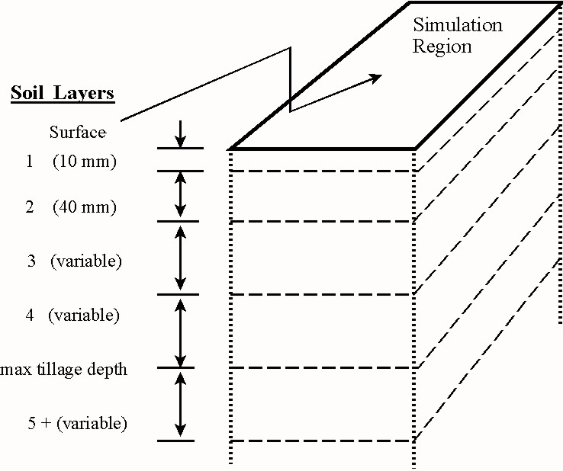
Figure 5-2 Diagram representing the spatial domain of the SOIL submodel

Spatial Regime
In the SOIL submodel, the spatial regime is considered to be uniform in the horizontal direction over the simulation region, but non-uniform in the vertical direction (Figure 5-2). Hence, the vertical direction is divided into layers in each soil profile. Some of the layer boundaries are selected to coincide with the layers determined by the NRCS Soil Survey of each soil. Layers one and two are initially set at 10 and 40 mm (0.39 and 1.57 inches), respectively, to allow simulation of sharp gradients in temporal soil properties near the surface.

Soil Layering Scheme
The HYDROLOGY and CROP submodels of WEPS depend upon the soil being stratified by layers. Hydrology moves water up and down within the soil in response to the relative wetness of adjacent layers. The CROP submodel estimates of plant growth are based upon several factors, one of the most important being availability of water within the root zone. It is important that WEPS keep track of how much water is available at various soil depths. Hence, WEPS views the soil as a series of layers, each layer possibly having distinct physical characteristics.

WEPS divides the soil into layers on the basis of the National Soil Information System (NASIS) input data. The layering scheme respects the underlying NASIS data. That is, no NASIS layers are combined when creating WEPS layers. Much of the complexity of the layering process is due to the creation of the very thin top layers. The design criteria are:

- Preserve NASIS layering, (i.e., a WEPS layer cannot cross a NASIS layer boundary).
- Define the first three layers to be 10, 40 and 50 mm, if possible.
- Preserve the relative sizes, 1:4:5:5, of the top layers if the absolute size cannot be attained.
- Divide the remaining layers into relatively uniform thicknesses, somewhat thinner at the top and thicker as depth increases.

Processes Simulated and Variables Updated
The processes simulated and the variables updated are summarized in Table 5.3. The effect of the processes on roughness is always to reduce the roughness. In contrast, many of the other variables either increase or decrease in value depending upon the prior-day value, soil intrinsic properties, and the driving process. To simulate the dry stability and aggregate size distribution for a wide range of soils, these variables were first normalized by using the means and standard deviations of the variables for each soil series to give a range from 0 to 1 for each variable. The driving processes were then applied to the normalized ranges to determine the change in the normalized variable. Finally, the updated normalized values were converted to the real values of these variables

Table 5.3 SOIL submodel variable and process matrix.
 | Surface Processes |  |  | Layer Processes
Soil Temporal Variables | Rain | Sprinkler Irrigation | Snow Melt | Wet/dry | Freeze/thaw | Freeze/dry
Roughness
Ridge Height | X | X | X
Dike Height | X | X | X
Random | X | X | X
Crust
Depth | X | X | X
Cover fraction | X | X | X
Density | X | X | X
Stability | X | X | X | X | X | X
Loose mass | X | X | X
Loose cover | X | X | X
Aggregates
Size distribution | X | X | X | X | X | X
Dry stability | X | X | X | X | X | X
Density | X | X | X | X | X | X
Layers
Bulk density | X | X | X

In summary, the Soil submodel outputs updated values on a daily basis for each of the variables listed in Table 5.3 in response to the occurrence of the various driving processes.

References
Hagen, L.J., T.M. Zobeck, E.L. Skidmore, and I. Elminyawi. 1995. WEPS technical documentation: soil submodel. Proceedings of the WEPP/WEPS Symposium, Soil and Water Conservation Society, Ankeny, IA.

Erosion Submodel

Introduction
The objective of the EROSION submodel is to simulate the components of soil loss/deposition over a rectangular field in response to wind speed, wind direction, field orientation, and surface conditions, on a sub-hourly basis (Figure 5-3). In WEPS 1.3.9, barriers may be placed on any or all field boundaries. When barriers are present, the wind speed is reduced in the sheltered area on both the upwind and downwind sides of the barriers. The submodel determines the threshold friction velocity at which erosion can begin for each surface condition. When wind speeds exceed the threshold, the submodel calculates the loss/deposition over a series of individual grid cells representing the field. The soil/loss deposition is divided into components of saltation/creep and suspension, because each has different transport modes, as well as off-site impacts. Finally, the field surface is periodically updated to simulate the changes caused by erosion. This paper provides users with a brief overview of the submodel. For an in-depth description of the equations used in this submodel, see the WEPS Erosion Submodel Technical Description (Hagen, 1995).
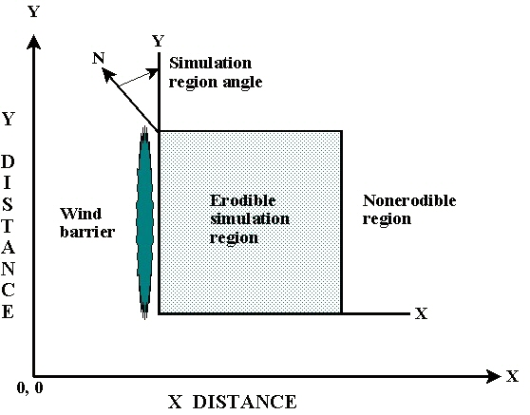
Figure 5-3 Schematic of simulation region geometry. Field orientation, end points of barriers, and opposite corners of the rectangular simulation region are input to the EROSION submodel.

Parameters Describing Soil Surface Conditions
Surface roughness is represented by both random roughness and oriented roughness. The parameters used are standard deviation of the surface heights for random roughness and the height, width of ridge tops, and spacing of ridges for oriented roughness.

Surface cover is represented on three levels (Figure 5-4). In the first level, surface rock, aggregates and crust compose 100 percent of the cover. In the second level, the parameter is the fraction of the crusted surface covered with loose, erodible soil. When there is no crust, this parameter is always zero. In the third level, the parameter is the fraction of total surface covered by flat, random biomass.
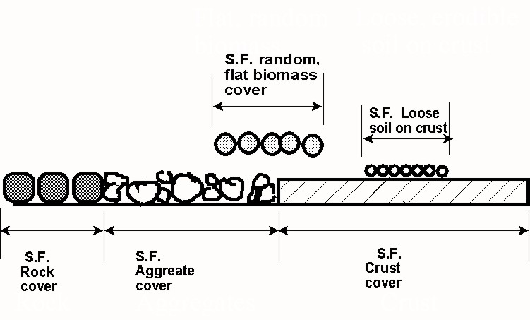
Figure 5-4 Diagram illustrating components of flat surface cover inputs to the EROSION submodel.
The aggregate density and size distribution are soil parameters that indicate soil mobility. The dry mechanical stability of the clods/crust are input parameters that indicate their resistance to abrasion from impacts by eroding soil. Surface soil wetness is also input and used to increase the threshold friction velocity at which erosion begins.

Uniformly distributed standing biomass is 5 to 10 times more effective in controlling wind erosion than is flat biomass, and thus, standing biomass is treated separately. The wind friction velocity above standing biomass is depleted by the leaves and stems to obtain the friction velocity at the surface that is used to drive erosion (Figure 5-5). Leaves are represented by a leaf area index and stems are represented by a stem silhouette area index.
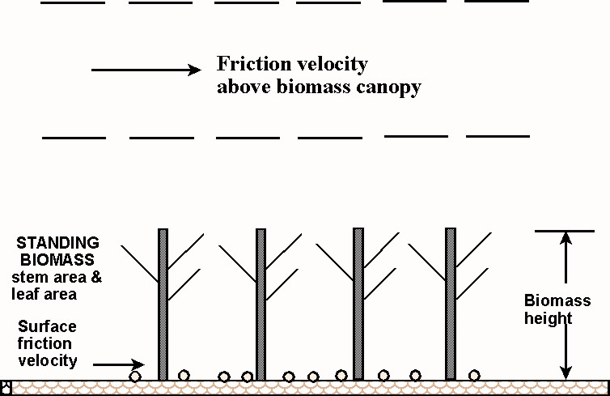
Figure 5-5 Diagram illustrating friction velocity above standing biomass that is reduced by drag of stems and leaves to the surface friction velocity below the standing biomass.

Erosion Processes Simulated
Soil transport during wind erosion occurs in three modes: creep-size aggregates, 0.84 to 2.0 mm (0.033 - 0.079 in.) in diameter, roll along the surface; saltation-size aggregates, 0.10 to 0.84 mm (0.004 - 0.033 in.) in diameter, hop over the surface; and suspension-size aggregates, less than 0.10 mm (0.004 in.) in diameter, move above the surface in the turbulent flow. Variations in friction velocity, aggregate density, and sediment load obviously may change the mass of aggregates moving in a given mode. Saltation and creep are simulated together because they have a limited transport capacity that depends mainly upon friction velocity and surface roughness. The suspension component is simulated with no upper limit on its transport capacity at the field scale. A portion of the suspension component also is simulated as PM-10 (i.e., particulate matter less than 10 micrometers (0.0004 in.) in diameter), which is regulated as a health hazard.

Multiple physical erosion processes are simulated in the erosion submodel, and these are illustrated for a single grid cell in Figure 5-6. The two sources of eroding soil are emission of loose soil and entrainment of soil abraded from clods and crust. These sources are apportioned between saltation/creep and suspension components on the basis of the source process and soil characteristics. Three processes deplete the amount of moving saltation/creep. These include trapping in surface depressions, interception by plant stems/leaves, and breakage of saltation/creep size particles and aggregates into suspension-size.
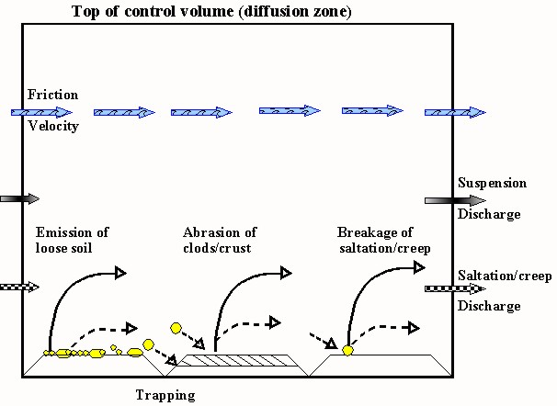
Figure 5-6 Diagram illustrating processes simulated by the EROSION submodel on a bare soil surface in an individual grid cell.
Simulation of surface rearrangement is accomplished by allowing emissions to deplete the loose soil and armor the surface in the upwind field area. In contrast, processes such as abrasion of the protruding aggregates and trapping in depressions dominate in downwind areas and lead to smoothing the surface and a build-up of loose saltation/creep. A build-up of saltation/creep often occurs, because the transport capacity may be satisfied, but abrasion of clods/crust continues to create additional saltation/creep-size soil.

Typical behavior of the downwind soil discharge simulated along a line transect for the saltation/creep and suspension components is illustrated in Figure 5-7. The suspension component keeps increasing with downwind distance, even though saltation/creep reaches transport capacity. This is because the sources for suspension-size soil are usually active over the entire field. These sources include emissions from impacts on loose soil, abrasion from clods/crust, and breakage from impacting saltation/creep-size aggregates. Moreover, the suspension component has a transport capacity many times larger than that of saltation/creep, so on large fields it is the ‘freightliner’ for moving soil whereas saltation/creep is merely the ‘pickup truck’.

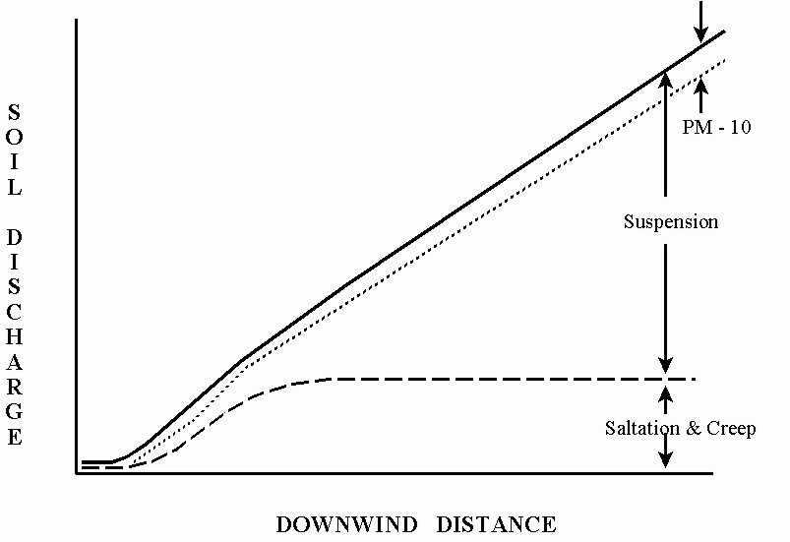
Figure 5-7 Diagram illustrating downwind transport capacity for saltation & creep, but a continuing increase in transported mass of suspension-size soil downwind.

Outputs
The EROSION submodel calculates total, suspension, and PM-10 soil loss/deposition at each grid cell in the field. The grid cell data are summarized in other parts of WEPS and reported to users as averages over the field for selected periods. The submodel also calculates the components of soil discharge crossing each field boundary. These are reported to users, according to the size ranges of aggregates as saltation/creep, suspension, and PM-10. These latter outputs are useful for evaluating off-site impacts in any given direction from the eroding field.

